Drug advice
Toxic ‘alkaloid’ poppies diverted from a regulated crop
Alkaloid poppies produce unpredictable, potentially life-threatening effects
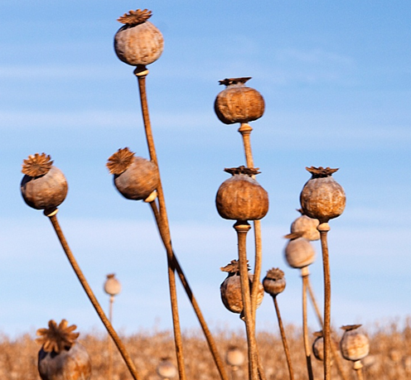
A significant quantity of alkaloid poppy plant ‘heads’ (pictured), grown for the pharmaceutical industry, was recently stolen from a property in Victoria. These poppies are very different from traditional opioid poppies and contain dangerously high concentrations of thebaine and oripavine, with risk of life-threatening toxicity. They contain only tiny (‘trace’) amounts of traditional opioids like morphine and codeine.
Thebaine is very different from the opioids in traditional opium-poppies. Thebaine does not produce pain relief, sedation or euphoria. Thebaine stimulates the nervous system and can lead to seizures, high body temperature, and life-threatening toxicity. Any exposure to thebaine may cause toxicity.
Oripavine has some opioid activity but is different from morphine and codeine. Oripavine can produce opioid-like effects such as sedation, slowed breathing, and small pupils. However, oripavine is not used medically because it can also cause severe toxicity (agitation, seizures) and life-threatening complications at high doses. The effects may be unpredictable, particularly when combined with thebaine.
Naloxone will reverse the opioid effects of oripavine but will not reverse the toxic stimulant effects. Naloxone will not reverse thebaine toxicity.
Be cautious of any dried, powdered, or liquid poppy flower product
Poppy plant products may include dried flower heads (without petals), ground poppy-plant material, or liquid preparations derived from poppy plants. These products may contain high concentrations of thebaine and oripavine that lead to life-threatening toxicity.
In 2022-2023 at least 40 people experienced life-threatening effects following consumption of thebaine-contaminated poppy seed ‘tea’ – including agitation, muscle twitching, high body temperature and seizures.
Reduce the risk of harm
If you experience toxic drug effects, or are present when someone has an unexpected reaction, seek help immediately by calling Triple Zero (000).
All alcohol and other drug use comes with risks, so:
- Be aware that other false or contaminated drug products may circulate in Victoria, even if no specific warning has been issued about them.
- Get free naloxone and carry it with you – no matter what drugs you think you’re getting.
- Start low and go slow, and make sure you’re in a safe environment with people you trust.
- Remember, even ‘pure’ drugs can produce serious side effects and death and can interact dangerously with medications/pharmaceutical drugs. Get the facts from the Alcohol and Drug Foundation website.
Contact Harm Reduction Victoria’s DanceWize team for anonymous support and education from peers. Talk to DanceWize volunteers by email at info@dancewize.org.au.
If you or someone you know needs help with alcohol or drug use, call DirectLine on 1800 888 236 or visit directline.org.au for information and support to access treatment.

