
Victorian Integrated Non-Admitted Health Minimum Data Set (VINAH MDS)
Frequently Asked Questions
1st edition, December 2025
Version 1.0
OFFICIAL

To receive this document in another format email HDSS helpdesk <hdss.helpdesk@health.vic.gov.au>.
Authorised and published by the Victorian Government, 1 Treasury Place, Melbourne.
© State of Victoria, Australia, Department of Health, December 2025.
Except where otherwise indicated, the images in this document show models and illustrative settings only, and do not necessarily depict actual services, facilities or recipients of services. This document may contain images of deceased Aboriginal and Torres Strait Islander peoples.
In this document, ‘Aboriginal’ refers to both Aboriginal and Torres Strait Islander people. ‘Indigenous’ or ‘Koori/Koorie’ is retained when part of the title of a report, program or quotation.

ISBN 978-1-76131-922-8 (pdf/online/MS word)
Available at VINAH minimum data set <https://www.health.vic.gov.au/data-reporting/victorian-integrated-non-admitted-health-vinah-dataset>
Contents
Foreword 4
Q1: How do referral in and episode messages relate to referral acceptance/non-acceptance? 4
Q2: I don’t understand the different types of messages sent in the VINAH MDS extract. Can you please explain? 5
Q3: Why am I receiving E022 validation errors relating to consolidation? 7
Q4: What is the purpose of submitting a VINAH MDS Late Data Notification Form? 8
Q5: What is the purpose of submitting a VINAH MDS Aggregate Data Submission form? 8
Q6: Where do I find the end of year consolidation date? 8
Q7: How do I reconcile HBD\HEN\TPN\Home ventilation patient activity? 9
Q8: How do I report subcutaneous immunoglobulin (SCIg)? 10
Q9: How do I report a scheduled appointment/s that was not attended? 11
Q10: How do I report telehealth video contacts? 11
Q11: How do I report secure messaging interactions when communication is one way only? 12
Q12: Why is only one Contact Professional Group code appearing in the contact reconciliation report, even though the extract includes multiple Contact Professional Groups? 13
Q13: I have registered a new clinic and have begun reporting contacts. The clinic identifier code is correct. Can you explain why I am getting E004 invalid code supplied errors? 14
Q14: A HITH patient has attended a non-admitted appointment. Which Contact Inpatient Flag is reported? 15
Q15: HITH procedures - are they reportable to VINAH? 15
Q16: How do I assign a Tier 2 Non-Admitted class in NACMS? 15
Q17: Which Tier 2 Non-Admitted class do I assign in NACMS? 16

Foreword
This Frequently Asked Questions document has been developed to support health services in understanding the Victorian Integrated Non-Admitted Health Minimum Data Set (VINAH MDS) reporting. It aims to clarify common queries, provide practical examples, and reinforce key reporting principles to ensure accurate and consistent data submission across the sector.
Always refer to the VINAH MDS manual for comprehensive reporting guidelines, technical specifications and business rules.

Q1: How do referral in and episode messages relate to referral acceptance/non-acceptance?
Answer:
The various stages of referral processing are outlined in Section 2 – Concepts and derived items of the VINAH MDS manual, as outlined in the concept process diagrams.
For a referral other than for palliative care, this briefly looks like:
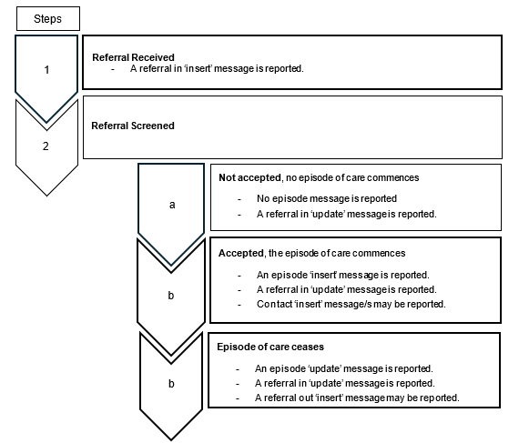

For a referral for palliative care, this briefly looks like:
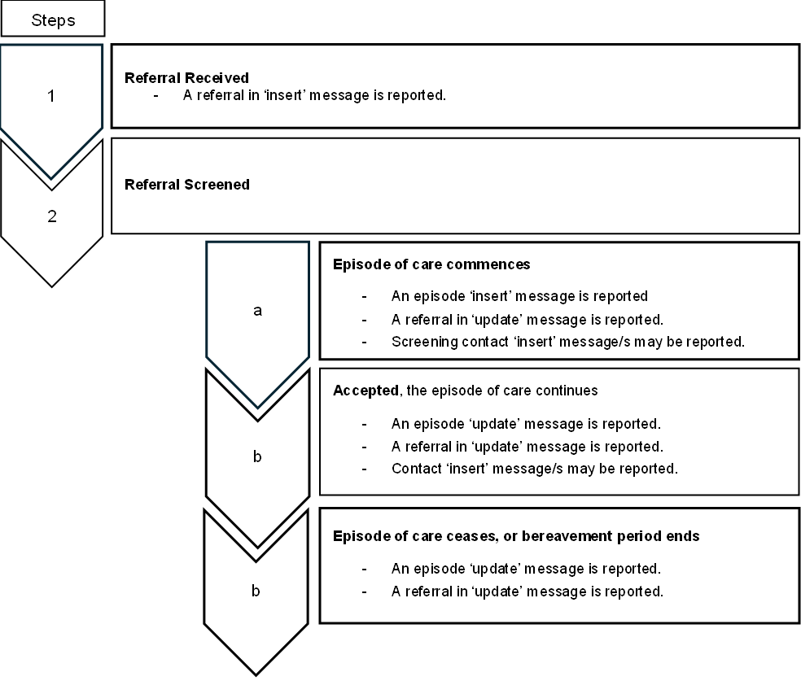

Q2: I don’t understand the different types of messages sent in the VINAH MDS extract. Can you please explain?
Answer:
It is essential to understand the types of messages and how message actions apply to each type
- Insert: Creates a new record in the VINAH repository.
- Update: Modifies an existing record in the VINAH repository. An update cannot be sent if an insert has not previously been sent and accepted into the VINAH repository.
- Delete: Removes a record from the VINAH repository.
- Merge: Combines two previously accepted patient/client records into a single record.
Patient/client, referral in, episode, contact and referral out messages make up your VINAH MDS extract. These messages can be sent across multiple extracts. The sequencing/order of how/when these are reported is important and this sequencing is checked by the VINAH validation engine.

There are different message types that are reported to the department in your VINAH MDS extract:
- patient/client (insert, update, merge)
  - Patient/client information is registered, created or inserted in the Patient Administration System (PAS) or Electronic Management Record (EMR). A patient/client ‘insert’ message is sent for patients/clients who have activity (referrals, episodes, contacts).
- referral in (insert, update, delete)
  - A referral is received – a referral in ‘insert’ message is sent.
  - Any changes to the referral are reported via a referral in ‘update’ message, including referral acceptance.
A referral in ‘insert’ or ‘update’ message cannot be sent if no patient/client ‘insert’ message has been sent and accepted into the VINAH repository.
A referral in ‘update’ message cannot be sent without a referral in ‘insert’ message having first been sent and accepted into the VINAH repository.
In other words, you can’t insert or update referral in details if the patient/client details have not already been sent (and accepted).
- episode (insert, update, delete)
  - For program/streams (other than palliative care) an episode ‘insert’ message is sent on referral acceptance i.e. the episode of care has started.
For palliative care an episode ‘insert’ message is sent when the referral is in the screening phase (Referral In Outcome code of ‘50’).
  - Any changes to the episode are reported via an episode ‘update’ message
For palliative care when the referral is accepted (Referral In Outcome code of 1 or 3) an episode ‘update’ message is sent (including when the episode of care ends - before or after the bereavement period).
An episode ‘insert’ message cannot be sent prior to the referral being accepted. It also cannot be sent prior to the referral in (insert/update) message being sent and accepted into the VINAH repository.
An episode ‘update’ message cannot be sent without an episode ‘insert’ message having first been sent and accepted into the VINAH repository.
- contact (insert, update, delete)
  - Screening contact/patient is seen/patient did not attend/an indirect contact/bereavement contact is recorded, and a contact ‘insert’ message is sent.
  - Any changes to a contact are reported via a contact ‘update’ message.
A contact ‘insert’ message cannot be sent prior to the referral being accepted and the episode starting i.e. referral in and episode insert/update messages sent and accepted into the VINAH repository.
A contact ‘update’ message cannot be sent without a contact ‘insert’ message having first been sent and accepted into the VINAH repository.
- referral out (insert, update, delete).
  - If a patient is referred to another area/organisation a referral out ‘insert’ message is sent.
  - Any changes to that referral out are sent via a referral out ‘update’ message.
A referral out ‘insert’ message cannot be sent prior to the referral being accepted and the episode starting i.e. referral in and episode insert/update messages sent and accepted into the VINAH repository.
A referral out ‘update’ message cannot be sent without a referral out ‘insert’ message having first been sent and accepted into the VINAH repository.
For further information it is recommended to read the VINAH MDS manual:
- Section 2 – Concepts and derived items which includes some concept process diagrams including the community palliative care concept process diagrams with the screening, episode of care and bereavement period.
- Section 3 – Data definitions, Part II: Transmission data elements, under the sub-heading message type.
- Section 5b – Transaction implementation guide discusses message actions, batches and record rejection/acceptance.
- Section 5d – HealthCollect portal manual submission process outlines how the extract is submitted manually and how to download return reports.

Q3: Why am I receiving E022 validation errors relating to consolidation?
Answer:
Consolidation is where the department closes reporting data for a financial year. For the VINAH MDS this relates to reporting of Referral In/Episode/Contact/Referral Out messages (refer to Q2: ‘I don’t understand the different type of messages sent in the VINAH MDS extract. Can you please explain?’). Once the financial year is closed no data for that financial year will be accepted. If you submit data for a financial year once it is closed, you will receive E022 errors.
The below describes when the different message types must be reported.
- Referral In ‘insert’ messages are required to be reported when the referral is received and must be reported in the financial year in which the referral is received, that is the Referral In Received Date.
- Episode ‘insert’ messages must be reported when the episode of care commences and must be reported in the financial year in which the episode of care commences, that is the Episode Start Date.
- Episode ‘update’ messages must be reported in the financial year in which the episode of care ceases, that is the Episode End Date.
- Contact messages must be reported in the financial year in which the contact occurred, that is the Contact Start/End Date/Time.
- Referral Out messages must be reported in the financial year in which an episode of care ceases, that is the Episode End Date.
Health services are expected to coordinate their data submission and reconciliation processes internally between teams (both clinical and administrative where necessary) to ensure that mandatory reporting to the department is accurate, complete, and reported in line with the compliance schedule (as published in section 5 of the VINAH MDS manual).
It is important that organisations conduct regular reconciliations against the data held within their PAS/EMR and the data that has been reported and accepted into the VINAH repository. This should also include data that is rejected, corrected, and resubmitted as well as data that has been updated within the PAS/EMR. Noting that there may be a delay between when data is updated in hospital systems and when data is submitted/resubmitted to the department.

Q4: What is the purpose of submitting a VINAH MDS Late Data Notification Form?
Answer:
The VINAH MDS Late Data Notification Form is to be completed when a health service determines that monthly data cannot be submitted on time or will be incomplete.
If data cannot be submitted by the deadline, the health service must notify the Department using this form. The purpose is to formally advise of delays and outline reasons for late submission - this information is communicated within the Department. If there are outstanding errors on the date the data is due, the data is considered incomplete.

Q5: What is the purpose of submitting a VINAH MDS Aggregate Data Submission form?
Answer:
Aggregate data must be reported by the 14th of the following month in these cases:
- When data cannot be submitted at all, or
- When data is incomplete for any reason, including due to unresolved errors.
The VINAH MDS Aggregate Data Submission Form is used to provide summary-level data for the reporting period. This ensures compliance with reporting requirements even when detailed contact data is unavailable. This aggregate data must include a total of all data expected to be submitted for the month per program. That is, it includes a total of all data submitted and all data yet to be submitted.

Q6: Where do I find the end of year consolidation date?
Answer:
Consolidation is where the department closes reporting data for a financial year. The end of year consolidation date for the VINAH MDS is usually 24 August for the prior financial year. The consolidation date must be confirmed by checking the Policy & Funding Guidelines <https://www.health.vic.gov.au/policy-and-funding-guidelines-for-health-services> each year.
HDSS may also publish reminders in the HDSS bulletin. The bulletins are published in the HDSS communications <https://www.health.vic.gov.au/data-reporting/health-data-standards-and-systems-communications> webpage, along with a link to ‘subscribe to the HDSS mailing list’. If you and your manager are not already receiving these bulletins, please complete the subscription form.

Q7: How do I reconcile HBD\HEN\TPN\Home ventilation patient activity?
Answer:
For HBD\HEN\TPN\Home ventilation - each month that the patient is ‘active’ the patient’s episode is counted once. It is imperative that the Episode Start Date (when the patient commences) and Episode End Date (when the patient ceases) are reported correctly in the VINAH MDS.
For example, in the 2025/2026 financial year (FY):
Pt xxxxx, commences 15 Oct 2025, not yet ceased/still active.
Pt xxxxx would be counted as being ‘active’ for Oct, Nov, Dec, Jan, Feb, Mar, Apr, May, Jun (and will continue to be counted in 26/27 FY for each month they are active)
Pt yyyyy, commences 20 Feb 2026, ceases 28 May 2026.
Pt yyyyy would be counted as being ‘active’ for Feb, Mar, Apr and May.
Pt zzzzz, commences 1 June 2026, ceases 15 June 2026.
Pt zzzzz would be counted as being ‘active’ for June.

The total active patients/service events for each given month would look like this:
 | JUL 25 | AUG 25 | SEP 25 | OCT 25 | NOV 25 | DEC 25 | JAN 26 | FEB 26 | MAR 26 | APR 26 | MAY 26 | JUN 26
pt xxxxx |  |  |  | 1 | 1 | 1 | 1 | 1 | 1 | 1 | 1 | 1
pt yyyyy |  |  |  |  |  |  |  | 1 | 1 | 1 | 1
pt zzzzz |  |  |  |  |  |  |  |  |  |  |  | 1
TOTAL | 0 | 0 | 0 | 1 | 1 | 1 | 1 | 2 | 2 | 2 | 2 | 2
For VINAH MDS the reporting would look like this:
 | Episode Start Date | Episode End Date
pt xxxxx | 15/10/2025
pt yyyyy | 20/02/2026 | 28/05/2026
pt zzzzz | 1/06/2026 | 15/06/2026
It is recommended for every patient that has an episode ‘start’ date, but no episode ‘end’ date, the health service confirms that the patient is still ‘active’. That is, the patient is still self-administering HBD\HEN\TPN\ventilation at home. If not, an episode end date must be reported.
Health services are expected to coordinate their data submission and reconciliation processes internally between teams (both clinical and administrative where necessary) to ensure that mandatory reporting to the department is accurate, complete, and reported in line with the compliance schedule (as published in section 5 of the VINAH MDS manual).
It is important that organisations conduct regular reconciliations against the data held within their PAS/EMR and the data that has been reported and accepted into the VINAH repository. This should also include data that is rejected, corrected, and resubmitted as well as data that has been updated within the PAS/EMR. Noting that there may be a delay between when data is updated in hospital systems and when data is submitted/resubmitted to the department.
Please refer to the flowchart below for a visual guide:
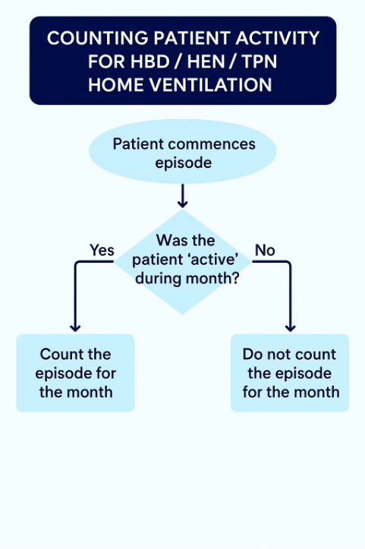

Q8: How do I report subcutaneous immunoglobulin (SCIg)?
Answer:
Subcutaneous immunoglobulin (SCIg) is self-administered by the patient or their carer at home, without the presence of a healthcare professional. It is not a specialist clinic, is not reported under the Specialist Clinics (Outpatients) program/stream and a clinic is not required to be registered in NACMS.
It is reported under the Infusion Therapy (IT) program/stream using code 951 – Subcutaneous immunoglobulin infusion therapy.
While SCIg is similar to other self-administered home-delivered programs such as HEN, TPN, HBD, and home ventilation, it differs in that contacts must be reported.
When reporting SCIg contacts:
- Use Contact Delivery Mode code ‘1 – In person’, as the patient is physically present to self-administer the therapy.
- Do not use Contact Delivery Mode code ‘9 – Not applicable’, as this is reported when a patient does not attend a scheduled appointment or was not present.
For further information it is recommended to read the VINAH MDS manual sections 2 and 3.
For additional context, see the SCIg access program <https://www.health.vic.gov.au/patient-care/subcutaneous-immunoglobulin-scig-access-program>, which includes the document ‘Subcutaneous immunoglobulin (SCIg) infusion therapy – home delivered’.

Q9: How do I report a scheduled appointment/s that was not attended?
Answer:
Follow the reporting guidance as provided in Section 2: concepts and derived items, sub-heading Contacts where a patient/client/carer/relative does not attend a scheduled appointment.
Contacts that are scheduled but not attended are reported using the following values:
- Contact Client Present Status: 32 - Patient/Client/Carer(s)/Relative(s) not present: Scheduled appointment not attended;
- Contact Delivery Mode: 9 - not applicable;
- Contact Delivery Setting: 98 - not applicable - Patient/Client not present.
Note: the following data elements should be reported as scheduled, even though the contact did not occur:
- Contact End Date/Time
- Contact Main Purpose
- Contact Professional Group
- Contact Session Type
- Contact Start Date/Time.

Q10: How do I report telehealth video contacts?
Answer:
Non admitted activity delivered to a patient using videoconference i.e. Skype, FaceTime, Healthdirect video conference or other similar video application is in scope for VINAH MDS reporting provided it meets the criteria for a contact. Telehealth video is considered a mode of delivery and is used in conjunction with the contact delivery setting to identify where the patient/client experiences the telehealth video contact.
Example 1
The contact is delivered by the health care provider to the patient/client at home or another non-hospital setting.
- Contact Client Present Status: 13 - Patient/client via telehealth video;
- Contact Delivery Mode: 3 - Telehealth video;
- Contact Delivery Setting: 31 - Home or other applicable code.
Example 2
The contact is delivered between a health care provider located at one health service and the patient and health care provider are located at another health service.
Provider
- Contact Client Present Status: 13 - Patient/client via telehealth video;
- Contact Delivery Mode: 3 - Telehealth video;
- Contact Delivery Setting: The location of the patient i.e. Hospital setting clinic/centre, Community based health facility or other applicable code.
Provider where the patient is physically present
- Contact Client Present Status:10 - Patient/client present with or without carer(s)/relative(s), 11-Patient/client present only or 12 - Patient/client present with carer(s)/relative(s);
- Contact Delivery Mode: 3 - Telehealth video;
- Contact Delivery Setting: The location of the patient. i.e. Hospital setting clinic/centre, Community based health facility or other applicable code.
Example 3
The contact is delivered between a health care provider at one location ‘campus A’ and the patient and health service provider at another location ‘campus B’. Both health care providers are from the same health service and clinic. Report one contact only. The contact should be reported by campus A.
- Contact Client Present Status: 13 - Patient/client via telehealth video;
- Contact Delivery Mode: 3 - Telehealth video;
- Contact Delivery Setting: 12 – Hospital setting – clinic centre or other applicable code;
- Contact Professional Group: Report one code for each participating health care provider.

Q11: How do I report secure messaging interactions when communication is one way only?
Answer:
Secure messaging (Contact Delivery Mode 8) refers to interactive two-way clinical communication between a healthcare provider and a patient/client using instant messaging platforms (e.g., phone messaging). According to Section 3 of the VINAH MDS manual (Contact Delivery Mode 8 – Secure Messaging), this interaction must meet the following criteria:
- Be synchronous and of a clinical nature;
- Serve as a substitute for a face-to-face clinical contact;
- Be documented in the patient/client’s medical record;
- Be reported as one service event for the entire exchange.
One way or one-directional communication is not considered synchronous and does not meet the reporting requirements for the use of secure messaging and therefore is not to be reported.
Refer to the Tier 2 Non-Admitted Services Compendium 2024-25 <https://www.ihacpa.gov.au/resources/tier-2-non-admitted-services-2024-25>, specifically Section 2.5 – Services delivered via information and communication technology, which provides further guidance and examples.

Q12: Why is only one Contact Professional Group code appearing in the contact reconciliation report, even though the extract includes multiple Contact Professional Groups?
Answer:
This typically occurs when the HL7 file includes multiple professional groups in a single ROL (Role) segment rather than reporting separate segments for each group. The VINAH repository will look at the first code in the single ROL segment and ignore the remainder codes.
While multiple codes can be reported, they must be reported separately. That is, they are a repeatable item, but not repeatable in a single segment.
Example of incorrect HL7 ROL Segment:(multiple groups reported in one segment):
ROL|1|AD||2^^^^^^^990035|||||253315^^990013~254400^^990013~2515^^990013~251111^^990013|9
Correct Format (one ROL segment per professional group):
ROL|1|ADD|||||||253315
ROL|2|ADD|||||||254400
ROL|3|ADD|||||||2515
ROL|4|ADD|||||||251111
For further information it is recommended to read the VINAH MDS manual Section 3 – Data Elements, Part II: Transmission Data Elements, under the subheading: Contact Professional Group Sequence Number and Section 5c – HL7 reference and implementation guide.
Action Required:
This issue needs to be addressed by health service’s HL7 data vendor or software provider. Ensure ROL segments are populated and formatted according to VINAH MDS business rules and technical specifications to allow accurate reporting.

Q13: I have registered a new clinic and have begun reporting contacts. The clinic identifier code is correct. Can you explain why I am getting E004 invalid code supplied errors?
Answer:
Only Specialist Clinics (Outpatients) are required to register clinics in NACMS as outlined in the NACMS manual <https://www.health.vic.gov.au/data-reporting/agency-information-management-system-aims> and report a Contact Clinic Identifier.
When the Contact Clinic Identifier is reported it must match the clinic identifier as registered in NACMS.
The date of clinic commencement, as registered in NACMS, is also a consideration when matching the reported clinic identifier to the registered clinic identifier. The contact date cannot be before the clinic commencement date as registered in NACMS.
Example 1:
Clinic identifier CLINICA is registered in NACMS as commencing on 8/9/2025.
Prior to 8/9/2025 CLINICA would not be considered a valid value to report. That is, the clinic identifier would not be listed in the code table 990100 until 8/9/2025. Therefore, any contacts for CLINICA dated prior to 8/9/2025 would reject.
Check the dates of the contacts you are reporting and check the NACMS clinic registration. Refer to the NACMS manual <https://www.health.vic.gov.au/data-reporting/agency-information-management-system-aims> regarding clinic registration processes.
Please refer to the flowchart below for a visual guide:
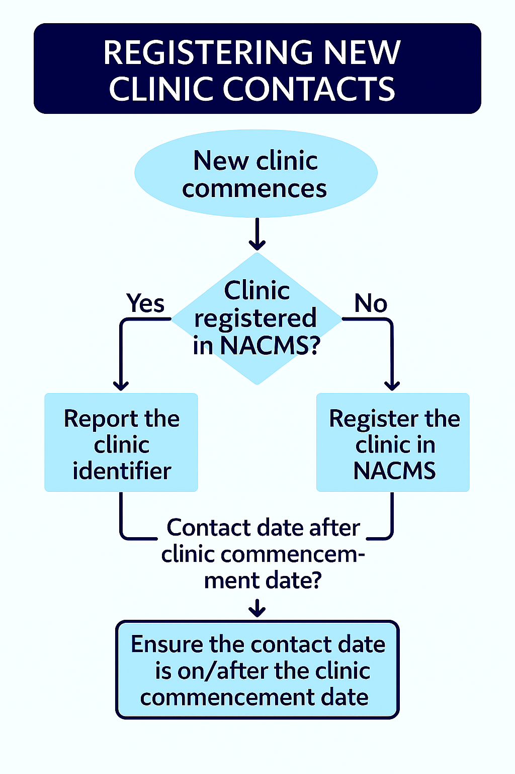

Q14: A HITH patient has attended a non-admitted appointment. Which Contact Inpatient Flag is reported?
Answer:
A patient is considered an admitted patient from the date/time of formal Admission to the date/time of formal Separation, please refer to the Victorian Admitted Episodes Dataset manual <https://www.health.vic.gov.au/data-reporting/victorian-admitted-episodes-dataset>.
The Contact Inpatient Flag is an indication of whether the patient/client is an inpatient (admitted) at the time of the contact.
If the contact dates/times are on or between the admission and separation dates/times, then a Contact Inpatient Flag of I – Yes (Inpatient/Admitted) is reported to the VINAH MDS. There are no exclusion criteria.

Q15: HITH procedures - are they reportable to VINAH?
Answer:
- HITH guidelines are available on the department’s website at: Hospital in the Home <https://www.health.vic.gov.au/patient-care/hospital-in-the-home> The guideline provides information on minimum requirements, service delivery and discusses wound care, port maintenance etc.
- If a patient is admitted to HITH (Hospital In The Home), then the ‘HITH procedure’ (whatever that is) should not be reported to the VINAH MDS, as it is considered part of the admitted episode.
- If a patient is receiving care by the HITH team and the patient is not admitted, then the ‘HITH procedure’ can be reported to the VINAH MDS.
- If a patient’s non-admitted care is delivered in the patient’s home, then a Contact Delivery Setting of either ‘23 – residential care’, ‘24 – supported accommodation setting’ or ‘31 – home’ would be reported in the VINAH MDS.
- The non-admitted data collection (VINAH MDS) is referral based, and the referrals must be managed in line with the Managing referrals to non-admitted specialist services in Victorian public health services policy <https://www.health.vic.gov.au/publications/managing-referrals-to-non-admitted-specialist-services-in-victorian-public-health>.

Q16: How do I assign a Tier 2 Non-Admitted class in NACMS?
Answer:
The assigning of Tier 2 classes within NACMS is outlined in the NACMS manual <https://www.health.vic.gov.au/data-reporting/agency-information-management-system-aims>. After reviewing the manual, please any questions related to NACMS are best directed to the NACMS team via email to NACMS@health.vic.gov.au.

Q17: Which Tier 2 Non-Admitted class do I assign in NACMS?
Answer:
Only Specialist Clinics (Outpatients) are required to register clinics in NACMS as outlined in the NACMS manual <https://www.health.vic.gov.au/data-reporting/agency-information-management-system-aims>.
For guidance it is best to refer to your clinical team/s in the first instance. Further guidance can be found in the IHACPA Tier 2 <https://www.ihacpa.gov.au/resources/tier-2-non-admitted-services-version-91-2025-26> definitions, compendium or national index documents.
After reviewing these documents, any questions relating to assigning Tier 2 classes are best directed to the NACMS team via email to NACMS@health.vic.gov.au.

Version History
Version | Date | Description of Changes
1.0 | December 2025 | Publication

