

Cold chain management
Guidance for immunisation providers
OFFICIAL
Contents
1. Introduction 2
Strive for 5 2
2. Cold chain system 2
What is the cold chain system? 3
What is a cold chain breach? 3
Who is responsible for cold chain management? 3
3. Vaccine storage and monitoring 3
Vaccine refrigerators 3
Vaccine storage management 3
Vaccine temperature charts 4
Minimum/maximum digital thermometer 4
Temperature data loggers 4
4. Vaccine monitoring – start of the day 7
The start of the day 7
Cold chain breach reporting 7
5. Receiving deliveries 8
Assessing the vaccine delivery 8
6. Use of portable coolers 9
7. Vaccine monitoring – end of the day 11
8. Vaccine monitoring – loss of power 11
When the power goes off 11
When the power is returned 12
9. Annual cold chain activities 12
Equipment maintenance checklist 12
Performing a slush test 13
Review cold chain protocols 14
Complete a vaccine storage self-audit 14
Update staff knowledge 14
10. Requirements for immunisation services 15

1. Introduction
This document provides guidance for all clinical staff, practice managers and vaccine coordinators with primary and back-up responsibility for vaccine delivery and cold chain management.
The aim of this guideline is to support government-funded vaccine immunisation providers to:
- understand the cold chain system
- identify the equipment required for cold chain management of vaccines
- follow the correct processes to monitor vaccine refrigerator temperature and ensure vaccine potency
- identify the appropriate steps to receive and stock vaccines
- identify and follow the required steps to prevent and manage a cold chain breach
- perform cold chain self-audits and annual maintenance activities
- know where to find more information about vaccine storage and cold chain management.

Strive for 5
This document is based upon the National Vaccine Storage Vaccine Guidelines ‘Strive for 5’ (4th edition) 2025.
‘Strive for 5’ provides guidance and governance standards for best practice in vaccine storage to maintain cold chain. In Victoria, registered immunisation providers must adhere to these Australian guidelines to receive government funded vaccines.
Review the Australian Government National Vaccine Storage Guidelines resource collection to access ‘Strive for 5’ guidelines and resources for health practices. <https://www.health.gov.au/resources/collections/national-vaccine-storage-guidelines-resource-collection>

2. Cold chain system
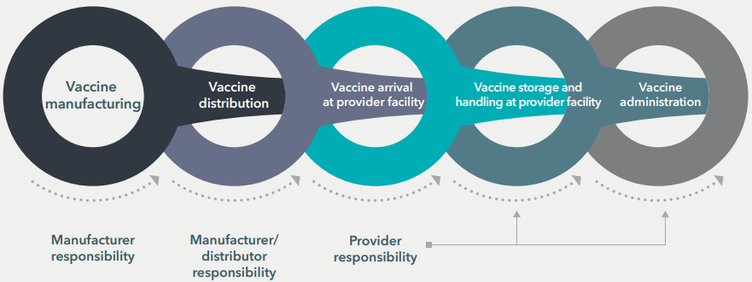
Cold chain flowchart. Image source: Centre for Disease Control and Prevention 2023
(Image description: a flowchart illustrating the vaccine cold chain system divided into five interconnected stages: 1. vaccine manufacturing (manufacturer responsibility); 2. vaccine distribution (manufacturer/distributor responsibility); 3. vaccine arrival at provider facility (provider responsibility); 4. vaccine storage and handling at provider facility (provider responsibility); and 5. vaccine administration (provider responsibility). Arrows and labels show the transition of responsibilities from manufacturers to providers.)

What is the cold chain system?
The ‘cold chain’ is the system of transporting and storing vaccines within the safe temperature range of +2°C to +8°C. The cold chain begins from the time the vaccine is manufactured, continues through to the vaccine distribution centres and immunisation service providers, and ends when the vaccine is administered.
The optimal storage temperature for vaccines is +5°C.
Vaccines are delicate biological substances. They can become less effective or destroyed if they are:
- frozen or exposed to temperatures below +2°C
- exposed to temperatures above +8°C
- exposed to direct sunlight or ultraviolet (UV) light, including fluorescent light.
Note: Poor cold chain management may result in a loss of confidence in immunisation providers and distress if people have to be revaccinated after receiving vaccines that may have been compromised.

What is a cold chain breach?
A ‘cold chain breach’ occurs when vaccine storage temperatures are outside the recommended range of +2°C to +8°C. This does not include temperature deviations in which the temperature reaches a maximum of up to +12°C for 15 minutes or less.

Who is responsible for cold chain management?
All people who handle vaccines (including receipt of deliveries) are responsible for maintaining the cold chain. All government funded vaccine account holders are required to nominate a vaccine coordinator in each facility to oversee vaccine management and appoint a back-up person to act in the coordinator's absence. The vaccine coordinator and back-up person must understand and comply with all requirements for managing the cold chain of vaccines.
Watch this short, animated Melbourne Vaccine Education Centre video (3:38), Journey of the cold chain: What is the cold chain? to understand the importance of the cold chain and your responsibilities <https://mvec.mcri.edu.au/references/cold-chain-helpful-resources/>.

3. Vaccine storage and monitoring

Vaccine refrigerators
Vaccines should only be stored in purpose-built vaccine refrigerators (PBVR), specifically designed to store vaccines between +2°C and +8°C. Some PBVR have an inbuilt data logger and/or digital temperature indicators (current, minimum and maximum temperature displays).
- Domestic refrigerators (including bar refrigerators) are not built or designed to store vaccines and must not be used for vaccine storage.
- Food and drinks must not be stored in this refrigerator.
- Vaccine refrigerators must be serviced at least every 12 months.

Vaccine storage management
When ordering and storing vaccines:
- order government funded vaccines monthly to control stock levels and maintain a small buffer
- do not crowd the vaccines by overfilling the shelves
- store vaccines in their packaging to protect them from temperature fluctuations and UV light
- ensure space between vaccine boxes to allow air circulation
- label each basket or shelf clearly so it can be clearly seen through the glass door
- if the vaccine refrigerator does not have a glass door, place a refrigerator map on the door to help locate vaccines quickly.
Refer to Chapter 5 of the ‘Strive for 5’ for further guidance on vaccine storage management.

Vaccine temperature charts
Use a standardised chart to document the vaccine refrigerator temperatures. This example can be downloaded from the ‘Strive for 5’ guidelines resources collection.  You must record the vaccine refrigerator temperatures (current, minimum, and maximum) at least twice a day: before the refrigerator is used for the first time and at the end of each day. Reset the thermometer after each reading.  Image: ‘Strive for 5’ - Vaccine fridge temperature chart poster  (Image description: a vaccine refrigerator temperature chart to keep track of the temperature of your vaccine fridges. On the chart, immunisation providers can document the relevant month and year, the temperature in the morning and afternoon for each day of the month, the time checked, the initials of the person doing the checking, comments.) | 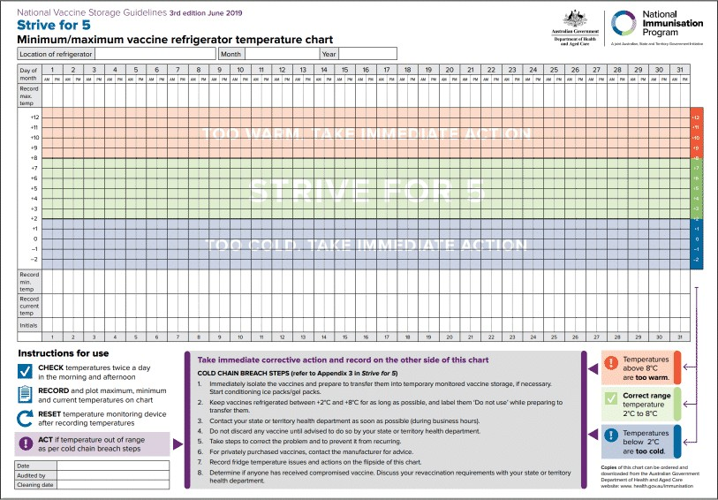

Minimum/maximum digital thermometer
A portable minimum/maximum thermometer is required if the vaccine refrigerator's inbuilt temperature-monitoring system does not have a battery back-up, generator back-up or uninterrupted power supply.  This ensures that vaccine refrigerator temperatures can be monitored in the event of a power failure.  Image: Example of minimum/maximum thermometer  (Image description: a digital fridge/freezer thermometer displaying a temperature of 21.2°C with probe and control buttons.) | 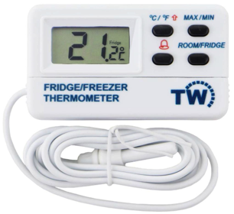
Portable minimum/maximum thermometers are also used for outreach or mobile vaccination clinics:
- Batteries must be changed at least every 12 months, and the date recorded.
- Portable minimum/maximum thermometers must be checked for accuracy annually (refer to Chapter 4 of the ‘Strive for 5’ guidelines).

Temperature data loggers
Temperature data loggers are small electronic devices that measure temperatures at pre-set time intervals.  ‘Strive for 5’ guidelines require that data loggers must be set to record temperatures at 5-minute intervals.  If the PBVR does not have an inbuilt data logger, a battery-powered data logger can be purchased separately and used to continuously monitor temperatures.  Image: Examples of data loggers | 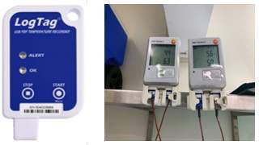
(Image description: Two different types of data loggers - a LogTag USB data logger on the left, and another type connected to a vaccine fridge via cables on the right.)
Remember to:
- Change the battery according to the manufacturer’s recommendation, or when the battery life screen is low.
- Calibrate at least every 12 months.

Setting up and using data loggers
Vaccine coordinators must set the data logger to record vaccine refrigerator temperatures at 5-minute intervals and set the alarm system to alarm outside the +2°C to +8°C range.
Review the following steps to learn more.
- Placement: place the portable data logger in the middle shelf between boxes of the vaccines and ensure it can be easily accessed.
- Educate: all staff involved in cold chain management must be trained to use and download data on a data logger.
- Connect: connect the data logger to your computer using a USB, cable, or wireless transmission to download data.
- Download: download data at least weekly or in the event of vaccine refrigerator temperature fluctuations.
- Assess the data: review the graph and the 5-minute intervals on the data log report (or summary report) and check for any breaches in the cold chain.
- Check: ensure vaccines have been maintained within the recommended +2°C to +8°C cold chain range.
- Assess cold chain breaches: identify any episodes where vaccine refrigerator temperature has been outside of the recommended cold chain range of +2°C to +8°C. Assess duration and extent of temperature fluctuation.
- Report cold chain breaches: follow the guidance on the Victorian Department of Health (the department) Cold chain breach reporting web page to report breaches.

Example
Below is an example of downloaded data logger information that shows a cold chain breach.
Image description: example of a data logger download showing a cold chain breach due to mechanical failure. Temperature rose sharply on 18/12/2022, peaking at ~27°C by 19/12/2022. Vaccines were relocated to another fridge on 19/12/2022. | 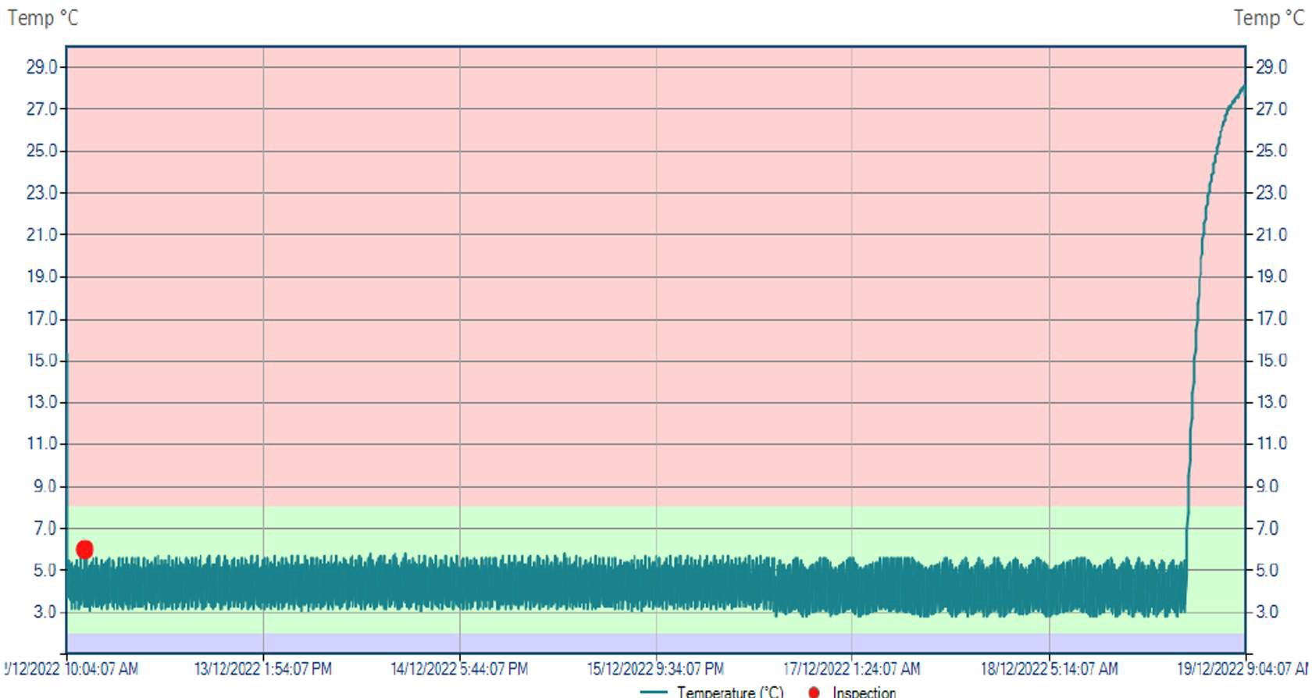
Image description: Section from a data logger download showing vaccine refrigerator temperature readings at 5-minute intervals. The breach begins around 8:44 PM on 18/12/2022, indicated by abnormal or corrupted data entries following a steady temperature range. | 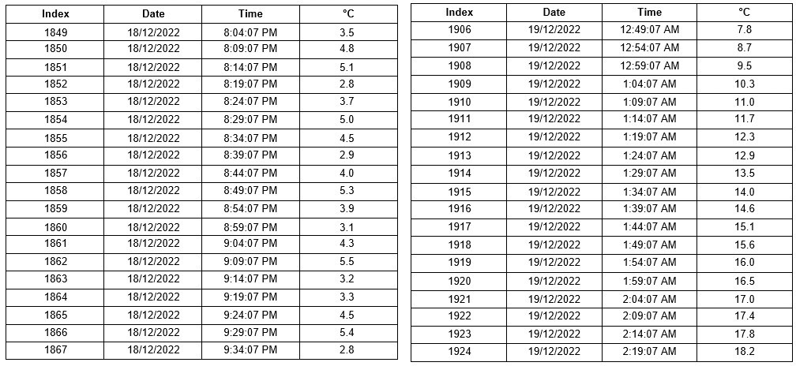

The National Vaccine Storage Guidelines ‘Strive for 5’ require that:
- All vaccine refrigerators that store vaccines must have a data logger in place.
- Data loggers are to be set to record temperatures at 5-minute intervals.
- Information from the data logger is to be downloaded and reviewed at least weekly or in the event of a temperature fluctuation.
- Twice-daily current, minimum and maximum temperatures must be manually recorded.
Refer to Chapter 4 of the ‘Strive for 5’ guidelines for further information on data loggers.

4. Vaccine monitoring – start of the day

The start of the day
The first action of every shift must be to check the temperature of the vaccine refrigerator. This must occur before any vaccines can be used.
- Check and record the current, minimum, and maximum refrigerator temperatures on your vaccine temperature chart.
- Ensure temperatures have been within +2°C to +8°C range since last recordings.
- Reset your vaccine refrigerator thermometer.
- Ensure the vaccine refrigerator door is closed securely and that the plug is connected to the power source.

- Current temperature showing +5.1°C.  - Press ▲ to identify maximum temperature.  - Press ▼ to identify minimum temperature.  Image: Example of inbuilt temperature display.  (Image description: control panel of a Lec Medical refrigerator showing a temperature reading of 5.1°C. Buttons for menu navigation and temperature adjustment are visible beside the display.) | 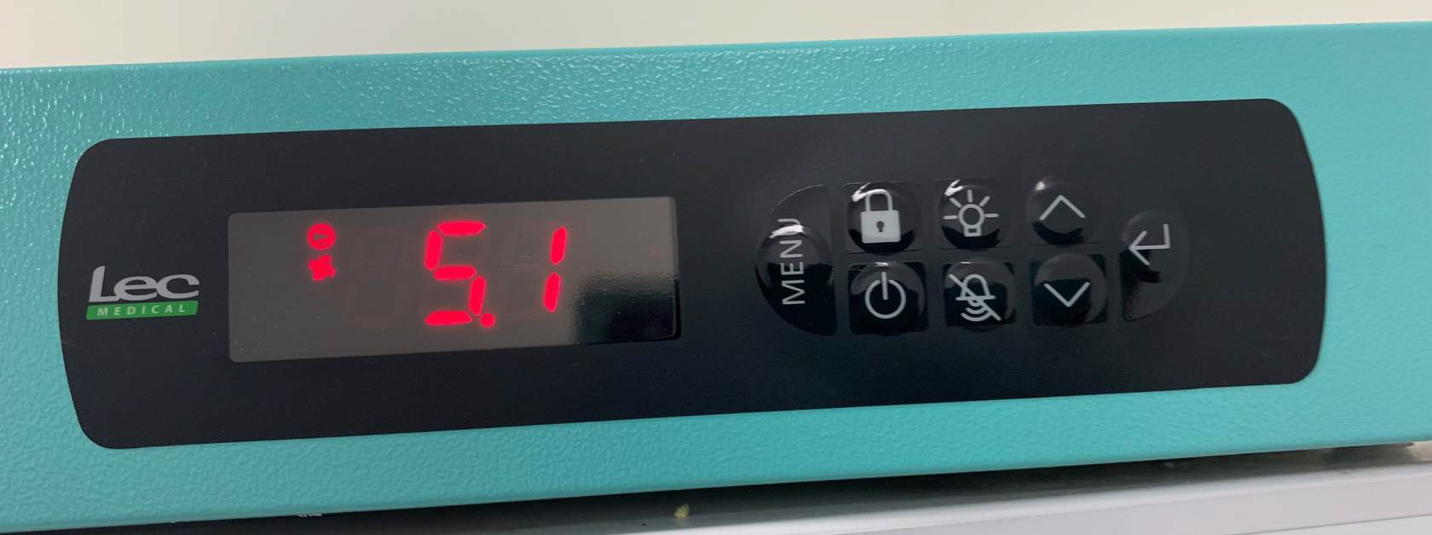
Remember:
- Document all readings on your vaccine temperature chart, including the time and date.
- Always reset the thermometer and document the time on the temperature chart.
- Any temperature outside of the recommended range of +2°C to +8°C is a cold chain breach.

Cold chain breach reporting
You will remember that a ‘cold chain breach’ occurs when vaccine storage temperatures deviate outside the recommended range of +2°C to +8°C.
This does not include temperature deviations in which the temperature reaches a maximum of up to +12°C for 15 minutes or less.
Cold chain breaches must be managed by the vaccine coordinator or a nominated back-up person.
In the event of a suspected cold chain breach, you must always take the following actions:
- immediately notify the vaccine coordinator (or back-up person)
- put a sign on the vaccine refrigerator door: ‘DO NOT USE OR DISCARD VACCINES’
- download the data logger (if you have received training), check readings and report findings to the vaccine coordinator (or back- up person) immediately
- the vaccine coordinator must assess data for a cold chain breach and follow the department’s cold chain breach reporting procedures for government funded vaccines
- if the vaccine coordinator (or back-up person) is not available, contact the department for advice via email on immunisation@health.vic.gov.au
- contact the manufacturer for advice for privately purchased vaccines
- record the date, duration and any actions taken
- follow the instructions provided by the vaccine coordinator (or the department)
- determine the cause of the breach to reduce the risk of recurrence (e.g. check the electricity plug).

Cold chain management
Read the department’s Cold chain management web page and save it to ‘Favourites’ in your web browser <https://www.health.vic.gov.au/immunisation/cold-chain-management>.

Cold chain breach reporting
Read the department's Cold chain breach reporting web page for details of reporting criteria, and to download the template for reporting <https://www.health.vic.gov.au/immunisation/cold-chain-breach-reporting>.

5. Receiving deliveries
All vaccine deliveries must be opened and checked as soon as they arrive to prevent temperature breaches and loss of potency.
If you have not been trained to receive a vaccine delivery and assess cold chain, you must immediately notify the vaccine coordinator.

Assessing the vaccine delivery
Every delivery of government funded vaccines will have a single use cold chain indicator (TagAlert®) in the box and a form to complete in the event of a cold chain breach. The TagAlert® electronically records the vaccine temperature during transport.
If there is no TagAlert® in the delivery, contact Onelink immediately (see delivery receipt for contact details).
An alarm is triggered if a heat or freeze breach occurs during transport from the warehouse to the immunisation provider.
Delivery within cold chain range | Cold chain breach
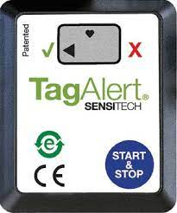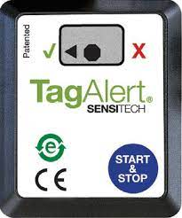  Left: TagAlert® in operation – no breach  Right: TagAlert® stopped - vaccines viable  (Image description: Left – TagAlert® in operation, with an arrow pointing at the green tick indicating no breach. Right – TagAlert® stopped, showing a dot next to the arrow pointing at the green tick, indicating vaccines are viable.) | 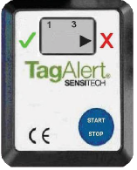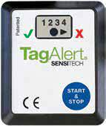  Left: TagAlert® in operation - encountered a breach  Right: TagAlert® stopped - encountered a breach  (Image description: Left – TagAlert® in operation, with an arrow pointing at the green tick indicating no breach. Right – TagAlert® stopped, showing a dot next to the arrow pointing at the red cross, indicating a breach was encountered.)

Always follow these steps
- Sign the vaccine delivery receipt and return to the courier.
- Remove the TagAlert® immediately on receipt of the vaccines.
- Stop the device by pressing and holding the “Start & Stop” button for 5 seconds until an octagon appears.
- Some deliveries come with multiple boxes; remove and stop all TagAlert® devices.
- If the TagAlert® screen displays a black octagon and an arrow pointing to the green ✓, the vaccines are safe to use. Notify the vaccine coordinator immediately of the delivery and ensure all vaccines are placed in the vaccine refrigerator.
- If the TagAlert® screen displays a black octagon and an arrow points to a red X, the TagAlert® has alarmed. Notify the vaccine coordinator immediately and ensure they follow the instructions on the enclosed form and submit to Onelink.
- If a breach has occurred, isolate the vaccines in the vaccine refrigerator (add sign ‘DO NOT USE OR DISCARD VACCINES’) until advice is received from the department.

6. Use of portable coolers
Portable coolers are used for mobile clinics and for back-up in the event of a loss of power.
Condition ice/gel packs and prepare portable coolers according to Chapter 8 of the ‘Strive for 5’ guidelines.
- Place ice/gel packs inside the cooler.  (Image description: person placing ice packs into a blue and white cooler containing similar packs, on a beige patterned floor.) | 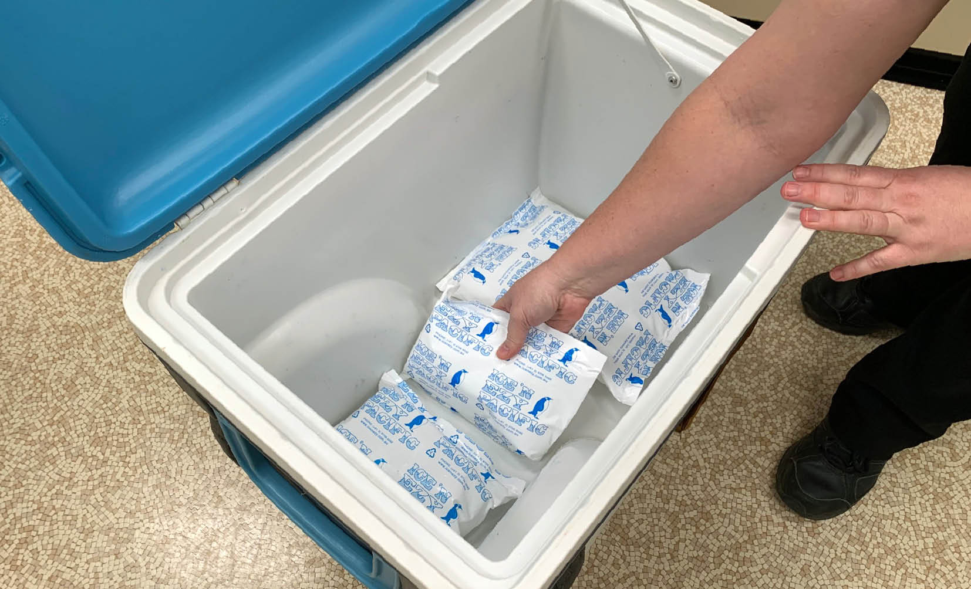
- Cover with insulating material.  (Image description: cooler with a blue lid and white interior, filled with ice, placed on a carpeted floor.) | 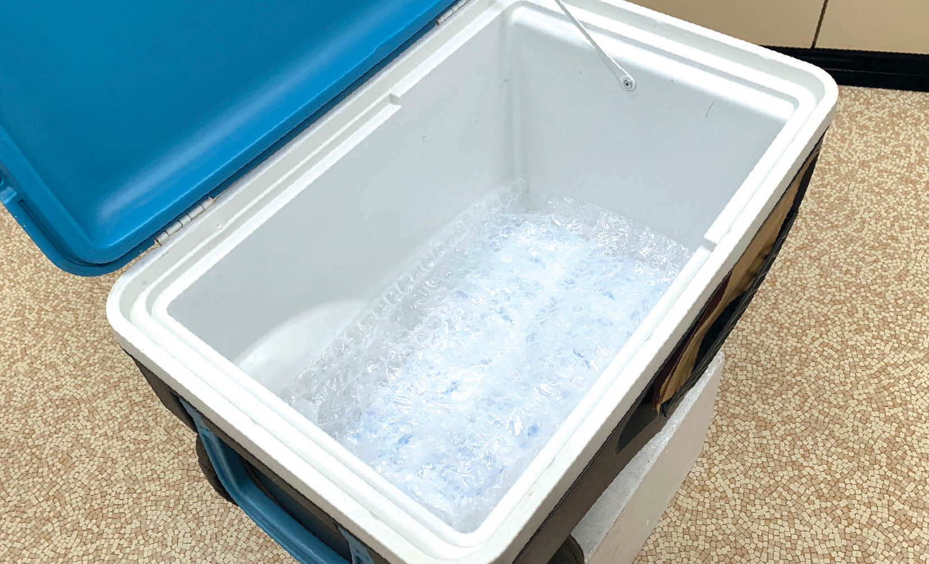
- Place the vaccines in the cooler.  (Image description: open cooler containing boxes of medical supplies labelled “Boostrix” and “Gardasil 9”.) | 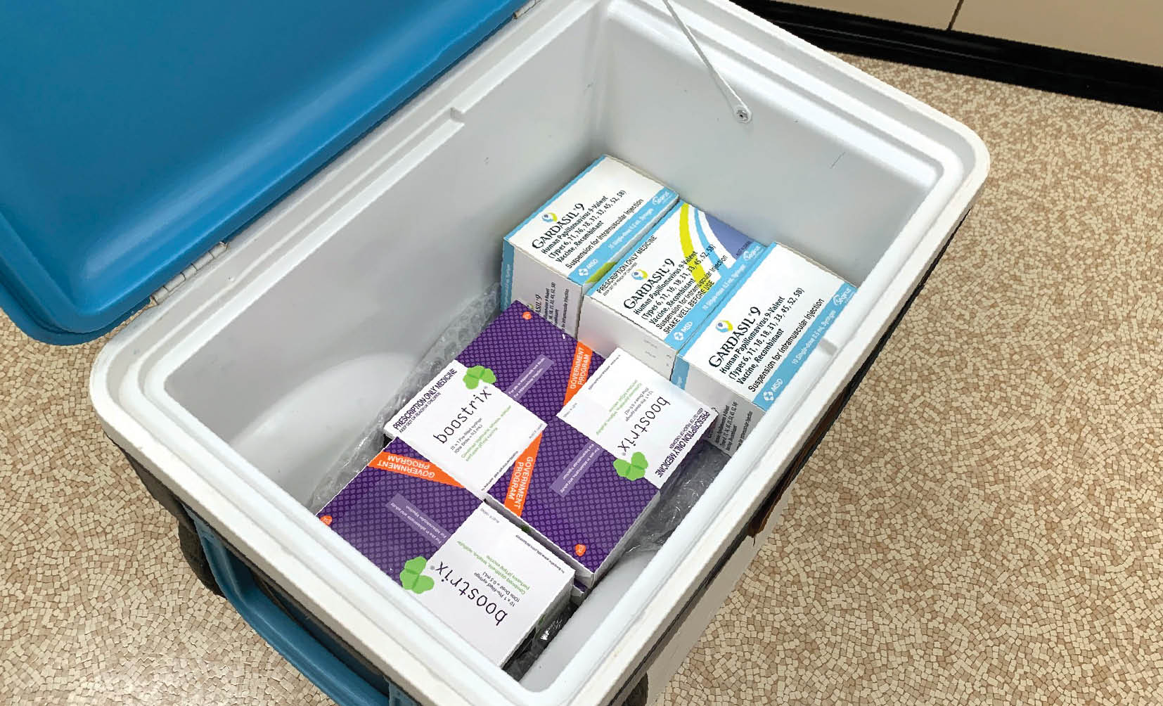
- Place minimum/maximum thermometer in the centre of the vaccines, cover vaccines with insulating material and more ice/gel packs. Close the cooler lid and attach the battery-operated minimum/maximum thermometer to the outside of the cooler.  (Image description: open cooler containing boxes labelled “Boostrix” and “Gardasil 9” with a digital thermometer placed on top and a wire extending out.)  Image source: National vaccine storage guidelines - 'Strive for 5' | 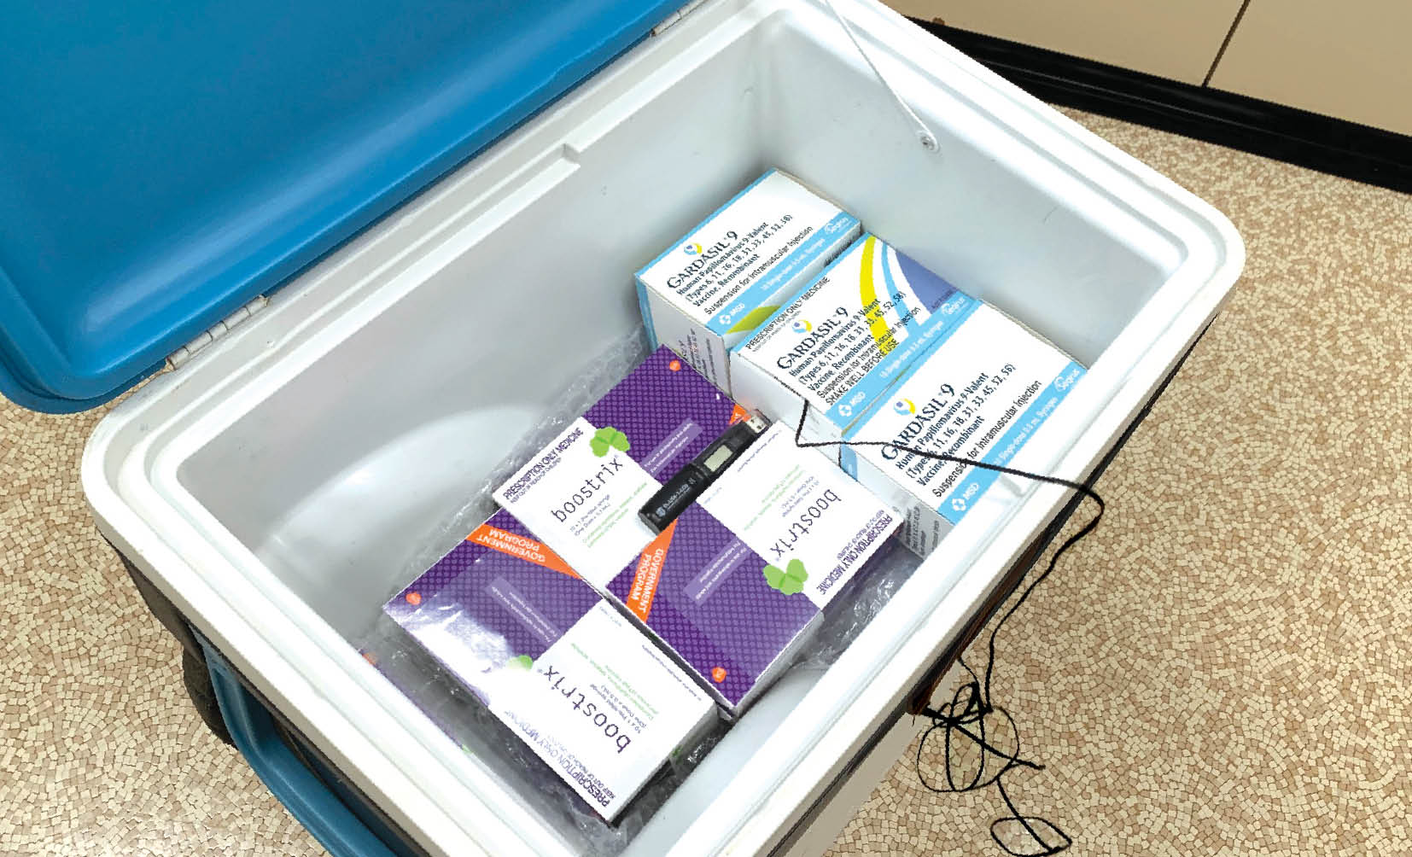

Monitor and record the temperature:
- every 15 minutes for the first 2 hours
- then at least hourly (provided that temperatures are stable).
- the thermometer must be reset after each reading for accuracy.
Download and print out Appendix 6: Checklist and temperature chart, from the 'Strive for 5' Guidelines, for mobile or outreach immunisation clinics, or emergency storage of vaccines.
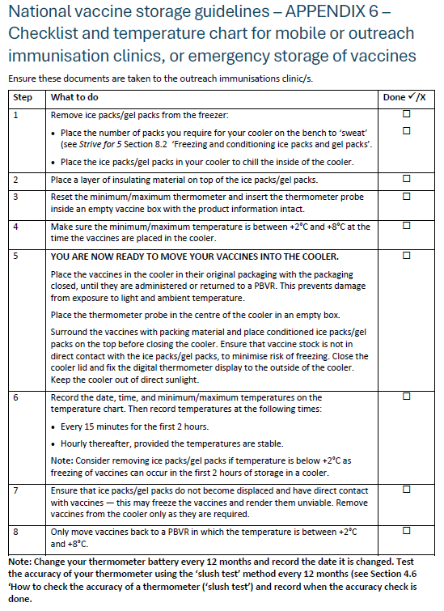
Image: National vaccine storage guidelines 'Strive for 5’
(Image description: checklist and temperature chart for mobile or emergency vaccine storage, detailing steps for preparing a cooler with ice packs, insulation, and a thermometer.)

7. Vaccine monitoring – end of the day
At the end of your shift, you must:
- Check and record the current, minimum, and maximum vaccine refrigerator temperatures on your vaccine temperature chart.
- Ensure temperatures have been within +2°C to +8°C range since last recordings.
- Reset your vaccine refrigerator thermometer.
- Ensure the vaccine refrigerator door is closed securely.
- Check the vaccine refrigerator plug is connected to the power source, and a there is a warning sign not to remove the plug.
- If vaccine refrigerator temperature recordings are outside the +2°C to +8°C range, follow the department's cold chain breach procedure.

8. Vaccine monitoring – loss of power
An interruption to power supply may be sudden and unavoidable, due to power failure or mechanical failure of the vaccine refrigerator. Vaccine coordinators must have a back-up plan including an alternative storage arrangement to maintain cold chain storage of vaccines. This may involve a back-up power supply (such as a generator or battery), use of an alternative PBVR or portable coolers.
Clinics should have the following checklists accessible to guide actions in the event of a power loss.
Download, review the following resources.
- ‘Strive for 5’ Appendix 7 - Checklist for managing a power failure
- ‘Strive for 5’ Appendix 6 - Checklist: Mobile and emergency storage
All actions involving vaccine management during power outages must be instructed by the vaccine coordinator.

When the power goes off

Initial steps
- immediately notify the vaccine coordinator
- confirm the vaccine refrigerator electrical plug is connected
- place a sign on the door of the vaccine refrigerator ‘Power out - Do not use vaccines. Keep refrigerator door closed’
- place a battery-operated digital minimum/maximum thermometer temperature probe into a vaccine box in the middle of the vaccine refrigerator (place close to data logger)
- place the external display of the minimum/maximum thermometer on the outside of the vaccine refrigerator to limit the need to open the door
- leave the vaccines in the vaccine refrigerator and ensure the door is closed securely
- closely monitor the vaccine refrigerator temperature arrange urgent service if there is mechanical failure.

Plan ahead
- identify an alternative PBVR or portable cooler
- begin to condition icepacks/gel packs for your portable cooler to prevent freezing of vaccines
- place a minimum/maximum thermometer into the portable cooler to monitor temperature
- follow ‘Strive for 5’ Appendix 7 - Checklist for managing a power failure.

Vaccine temperature outside +2°C to +8°C range
- the vaccine coordinator must move vaccines to an alternative PBVR or prepared cooler
- refer to ‘Strive for 5’ Appendix 6 - Checklist: Mobile and emergency storage
- move the portable data logger into the cooler (if possible)
- record the cooler temperature (current, minimum, and maximum) every 15 minutes for the first 2 hours, then at least hourly (provided the temperatures are stable)
- do not open the cooler until vaccines can be transferred to a PBVR
- consider another health service site such as a pharmacy or hospital if power will be out for greater than 24 hours.
Vaccines must never be transferred to another vaccine refrigerator or cooler without a minimum/maximum thermometer or data logger to monitor the temperature.

When the power is returned
Next steps
- Record the vaccine refrigerator temperature and reset the minimum/maximum thermometer.
- Ensure that the vaccine refrigerator temperature has returned to between +2°C and +8°C before returning vaccines.
- Download data from the portable data logger (if used).
- If the data shows temperatures outside the +2°C to +8°C range, isolate and clearly mark vaccines ‘DO NOT USE OR DISCARD VACCINES' and keep vaccines refrigerated between +2°C and +8°C
- Follow the cold chain breach reporting procedure where indicated.
- Clinical staff must not use or discard any vaccines until the cold chain breach has been assessed, and advice received from the department.
- Monitor the vaccine refrigerator closely (e.g. hourly) to ensure that the temperature is consistently stable, then return to twice-daily monitoring.

9. Annual cold chain activities
All Victorian government funded vaccine account holders are required to nominate a vaccine coordinator to oversee vaccine management in each facility and appoint a back-up person to act in the key person’s absence.
Vaccine coordinators must ensure there are written policies and procedures for vaccine management and to record equipment maintenance, vaccine transport and staff education.
These should be reviewed at least every 12 months.

Equipment maintenance checklist
- Check the due date for your vaccine refrigerator service and book an appointment.
- If a back-up generator is used, book a service.
- Ensure the vaccine refrigerator is placed away from direct sunlight and heat.
- Elevate the front footings to tilt the vaccine refrigerator back and help doors to shut.
- Place a sign above the refrigerator power point that reads ‘Vaccine refrigerator – do not turn off or disconnect.’
- Display contact details for the refrigerator/generator servicing for easy access.
- Check supply of portable coolers and ice/gel packs for power outages or mobile clinics.
- Replace batteries in the portable data logger & recalibrate (see manufacturer’s instructions).
- Replace batteries in the minimum/maximum thermometers.
- Check accuracy of the minimum/maximum thermometers by using a ‘slush test.’

Performing a slush test
A slush test checks the accuracy of a minimum/maximum thermometer. To start, collect a polystyrene or plastic cup and two-thirds fill with cold water.
- Place the cup in the vaccine refrigerator freezer until a fine layer of ice forms on the top and small sections of ice form within the fluid (this may take up to 2½ hours).  (Image description: a white cup containing water and ice.) | 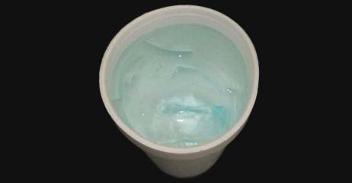
- Place the temperature probe into the middle of the container (be careful not to let the probe touch the container).  (Image description: a white cup containing water and ice and a temperature thermometer probe.) | 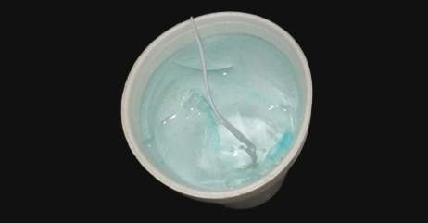
- Observe the temperature on the display screen after 2 minutes.  (Image description: a white cup containing water and ice and a temperature thermometer probe.) | 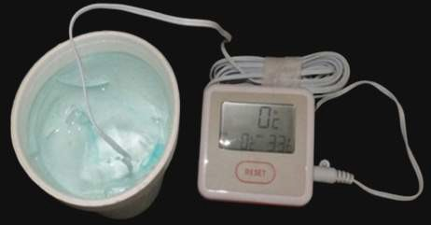
- Document the date of the Slush test.  (Image description: a white cup containing water and ice, with a temperature probe submerged and connected to a digital thermometer displaying 0°C.) | Image source: NSW Health
The thermometer must be accurate to ±1°C or better. If the temperature reading is more than 1°C above or below 0°C at 2 minutes, replace the battery (and record the date the battery was changed) and test again. If the temperature reading is still not within range, replace the thermometer.
A check of the accuracy of your minimum/maximum thermometer is recommended after the battery is changed (indicated when display is flashing or dull), at least every 12 months, for auditing purposes and if there are cold chain problems.

Review cold chain protocols
An effective vaccine management protocol will ensure safe management of vaccines before an emergency occurs. Vaccine coordinators must ensure that the following are included in the health service's protocol:
- a trained, designated person (and back-up person) is responsible for vaccine storage and cold chain protocol
- all staff are trained to manage vaccine delivery requirements, storage, and cold chain processes
- contact details for reporting cold chain breaches, equipment issues, or power failures
- back-up vaccine storage options are documented and tested
- orientation for all new staff includes the vaccine management protocol.
Refer to ‘Strive for 5’ Appendix 1 - Vaccine management protocol for help with writing or reviewing your vaccine management protocol.

Complete a vaccine storage self-audit
Routine self-auditing helps to ensure that your health service is administering potent vaccines. All government funded vaccine account holders must:
- review and complete a ‘Victorian vaccine storage self-audit’ vaccine self-audit at least every 6-12 months, and more frequently if there have been problems with equipment or cold chain breaches to continue to receive government funded vaccines
- store documentation for your reference or auditing by the department.
The Victorian vaccine storage self-audit form is also available at Cold chain management - provider resources).

Update staff knowledge
Vaccine coordinators must ensure:
- all staff understand cold chain procedures and can access the ‘Strive for 5’ guidelines
- new staff are educated about cold chain protocols
- all staff can identify the vaccine coordinator and the back-up person responsibility for vaccine delivery and cold chain management
- responsibility for cold chain management is defined in the relevant staff member’s position description.
Vaccine coordinators should:
- be familiar with the National Vaccine Storage Guidelines ‘Strive for 5’ resource collection web page
- regularly review of the department’s Cold chain management web page for any updates
- subscribe to the department’s Heat health warnings <https://www.health.vic.gov.au/subscribe>.

10. Requirements for immunisation services
Cold chain is critical to maintain potency of vaccines.
Providers must adhere to the National Vaccine Storage Guidelines ‘Strive for 5’.
Ensure your health service has current, documented vaccine cold chain policies and procedures for the following:
- cold chain monitoring and breach processes
- delivery and receipt of vaccines
- a plan for loss of power
- staff orientation and training
- equipment maintenance.

Appendix 1. Victorian vaccine storage self-audit
The National Vaccine Storage Guidelines ‘Strive for 5’ (‘Strive for 5’) provides authoritative guidance to support compliance with cold chain management protocols. In Victoria, registered immunisation providers must adhere to ‘Strive for 5’ to receive government funded vaccines.
A vaccine storage self-audit must be undertaken by immunisation providers at least every 6-12 months, or as required. The completed self-audit form must be kept on file for review when requested by the Victorian Department of Health. Self-audits must be conducted more frequently if there have been equipment issues or cold chain breaches.
Note: some vaccines have a shorter shelf life than others and are often received by immunisation service providers with only 9-12 months of shelf life remaining. Ensure vaccines with newer expiry are placed to the back.

Why is it important?
Self-auditing is important because:
- it is part of routine quality assurance and as part of risk management processes as issues are highlighted as soon as they occur.
- it enables staff to have confidence that they are providing a safe and effective vaccine.
Nominated person responsible for vaccine management:
Nominated back-up person for vaccine management:
Make and model of purpose-built vaccine refrigerator (PBVR):
Date of self-audit:
Person conducting audit:
Person conducting audit signature:

Procedures
- Checklist for safe vaccine handling and storage
Have all staff received orientation and/or an annual update on vaccine management? | ☐
Have vaccine management policies been reviewed in the past 12 months to ensure that procedures are up to date? | ☐
Is the cold chain breach reporting protocol readily accessible for all staff members? | ☐
- Date of last revision
Is graph/logbook/chart for temperature recording readily available? | ☐
Is the temperature of the PBVR recorded twice a day when the facility is open? | ☐
Are the contact details to report a cold chain breach easily accessible? | ☐
Were all temperature excursions outside the +2°C to +8°C range documented and reported to the Victorian Department of Health? | ☐

Equipment
- Purpose-built vaccine refrigerator
Has the PBVR shown evidence of malfunction (e.g. poor seals so that the door opens too easily)? | ☐
Is there an appropriate gap between the vaccines and the walls of the PBVR? | ☐
Can the PBVR continue to store the required volume of vaccines safely according to these guidelines? (This includes times of increased demand during the influenza season)  If ‘No,’ what action is being taken: | ☐
Date PBVR was last serviced:
If the PBVR has a solid door, is there a map or guide to where vaccines are stored located on the outside of the door? | ☐
Does the power outlet have a sticker ‘Do not turn off power or disconnect this refrigerator?’ Refer to ‘Strive for 5’ - Appendix 8 ‘Resource collection’¹ to order this sticker from the Department of Health, Disability and Ageing website. | ☐
- Monitoring equipment
Date the minimum/maximum thermometer/s was purchased:
Date the battery for the minimum/maximum thermometer/s was last changed:
Date and results of thermometer accuracy check at 0°C:
See ‘Strive for 5’ - Section 4.6 ‘How to check the accuracy of a thermometer (‘slush test’)1
Is the minimum/maximum thermometer temperature probe/s placed correctly? | ☐
Date the data logger/s battery was last changed:
Date data logger/s was last serviced:
- Alternative vaccine storage
Is there a readily accessible written procedure for what to do during a power failure? | ☐
Is sufficient alternative storage (e.g. cooler, other monitored PBVR) available for vaccine storage, if necessary (e.g. vaccine PBVR breakdown or power failure)? | ☐
Are ice packs/gel packs at the correct temperature available? | ☐
Is appropriate equipment available to transport vaccines off-site if required e.g. minimum/maximum thermometer and ice/gel packs for each cooler? | ☐
Is there enough insulating material e.g. bubble-wrap or polystyrene chips in the bottom of each cooler? | ☐

To receive this document in another format, email the Immunisation Program <immunisation@health.vic.gov.au>.
Authorised and published by the Victorian Government, 1 Treasury Place, Melbourne.
© State of Victoria, Australia, Department of Health, December 2025.
ISBN 978-1-76131-799-6 (online/PDF/Word)
Available at <https://www.health.vic.gov.au/immunisation/cold-chain-management>.

