
Household pesticides
Community factsheet
Updated December 2024

Sometimes you might have pest problems that require the use of a household pesticide. Using chemicals to treat the problem may create a risk to health. Therefore, you should ensure that you take certain precautions when handling these products.

What are pesticides?
Pesticides are substances used to manage pests and
include insecticides used for insect control, herbicides
used for weed control, and rodenticides used for rodent
control. Pesticides may contain a mixture of chemicals
but it is the ‘active constituent’ which targets the pest.
Although pesticides may be easily obtained from supermarkets and hardware stores, they are toxic and if used carelessly they may damage the health of the person applying the pesticide, the health of other people in the community and the environment.

Pest identification
Pesticides are designed to target different
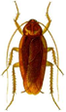pests and are often ineffective on other species. Therefore it is important to correctly
identify the pest causing the problem in your home
so the most appropriate treatment method can
be selected.
If you are having trouble identifying the pest, Museums
Victoria offers an identification service. You can submit an online enquire form via https://museumsvictoria.com.au/.
An alternative is to employ a licensed pest control operator trained in the identification and management of pests. For more information about pest control licensing contact the Pest Control Program via email – pesticidesafety@health.vic.gov.au

Non-chemical pest prevention and control
The best way to control pests is to prevent them from
becoming a problem. Preventative non-chemical
measures are recommended before resorting to the use of pesticides. Avoiding pesticide use reduces the risk of experiencing adverse health effects.
Non-chemical pest prevention and control
measures include:
• keeping the house clean and free of potential sources
of food, water and shelter
• installing screens in doors and windows and sealing
any gaps
• ventilating areas to prevent moisture build up and
fixing any leaks in plumbing
• ensuring that litter does not accumulate around
your home
• keeping tree branches and shrubbery well-trimmed
and clearing gutters regularly
• storing firewood away from the house and off
the ground
• bathing pets regularly and ensuring that their living
environment is clean and tidy
• using manual pest control methods such as fly
swatters and traps.

Health concerns
Some pests may carry diseases (for example
cockroaches) or cause damage to our homes
(for example termites) while others may just be
irritating or unpleasant (for example daddy long-legs spiders).
If the non-chemical measures fail to control the pest
problem the use of a pesticide may be necessary.

Applying pesticide safely
Pesticides can take the form of a solid, liquid or
powder. The form will influence the way in which the
pesticide can enter the body through swallowing,
inhaling, or contact with the skin or eyes. The individual
applying the pesticide is at the greatest risk of
exposure and should take precautions when using
pesticide. These include:
• selecting the right type of pesticide for the
pest problem
• reading the label thoroughly before application
and following all label directions including the
safety information
• using the appropriate personal protective equipment as
specified on the label. This may include gloves, boots,
overalls, eye protection, face shield or a respirator.
• ensuring all people and pets leave the area
being treated
• ensuring food, clothes, toys, toothbrushes, bedding,
towels, vegetable gardens, barbeques, pet bowls, fish
ponds, clotheslines and cooking utensils are covered
or removed from the area to be treated
• closing doors and windows before applying
pesticide outdoors
• not spraying outdoors on windy or rainy days as this
may cause harm to other people or the environment
• ensuring adequate ventilation if applying a pesticide
in a confined space
• placing baits only where they cannot be accessed by
children, pets or wildlife
• not eating, drinking or smoking while working
with pesticides
• keeping emergency numbers, such as that for the
poisons information centre (13 11 26) nearby
• if the pesticide has been applied indoors, ensure that
benchtops and kitchen utensils are thoroughly
cleaned prior to food preparation
• washing hands immediately after using pesticides.

Safe disposal and storage of pesticides
Dispose of empty pesticide containers according to
the directions on the label. When purchasing
pesticides it is important to obtain only the amount
required for immediate use. Never dispose of unused
pesticide down the drain or on the ground. If a spill
occurs it should be cleaned up promptly by covering
it with sand or kitty litter before sweeping it up and
storing it in a sealed, rigid container for appropriate
disposal. For more information regarding disposal of
unused pesticides contact your local council or the
Environment Protection Authority on 1300 372 842.
If necessary, pesticides should be stored according to the instructions on the label. The containers should be closed tightly and placed out of reach of children and pets. They should be stored away from food and medical supplies, in a well-ventilated area and out of direct sunlight.
Flammable liquids should be stored away from
ignition sources. Pesticides should not be transferred
to different containers unless the original container is
damaged. The new container should be clearly
labelled. Never reuse empty pesticide containers.

Understanding a pesticide label
All pesticide labels contain valuable information. It is important to read and understand this information particularly
instructions relating to application and safety. Following the instructions on the label will ensure that the treatment is effective against your pest problem and minimise the risk of adverse health effects resulting from exposure.
Here is an example of a pesticide label:
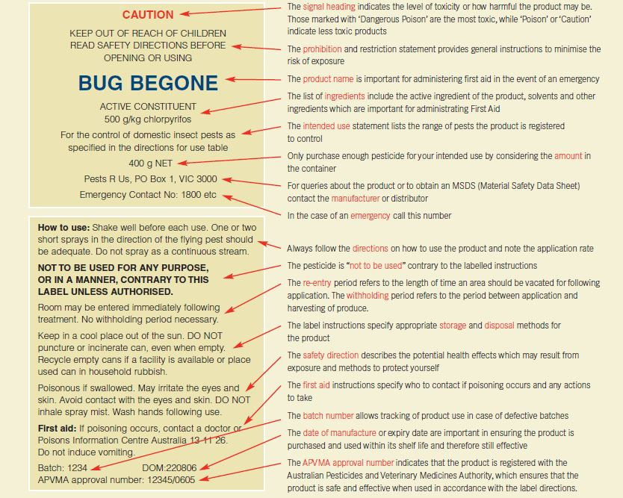
To receive this publication in an accessible format email pesticidesafety@health.vic.gov.au
Authorised and published by the Victorian Government, 1 Treasury Place, Melbourne.
© State of Victoria, Department of Health December, 2024
Available at Pesticide use and pest control <https://www.health.vic.gov.au/environmental-health/pesticide-use-and-pest-control>

