
Forensic Leave Panel
Annual report 2024
OFFICIAL

To receive this document in another format, phone 1800 222 987, using the National Relay Service 13 36 77 if required, or email the Forensic Leave Panel <flp@health.vic.gov.au>.
Authorised and published by the Victorian Government, 1 Treasury Place, Melbourne.
© State of Victoria, Australia, Department of Health, October 2025
ISSN 2206-5962 (Online/PDF/Word)
Available from the Forensic Leave Panel’s webpage <https://www.health.vic.gov.au/mental-health-services/forensic-leave-panel>


3 October 2025

Sonya Kilkenny MP
Attorney-General
Level 26, 121 Exhibition Street
Melbourne VIC 3000

Dear Attorney-General
In accordance with s 63 of the Crimes (Mental Impairment and Unfitness to be Tried) Act 1997 (Vic), I am pleased to submit the annual report on the operations of the Forensic Leave Panel for the year ending 31 December 2024 for tabling in parliament.
A copy of this report has also been provided to the Minister for Mental Health, the Hon. Ingrid Stitt MP and the Minister for Disability, the Hon. Lizzie Blandthorn MP, who are also responsible in part for the operation of the Act.
Yours sincerely
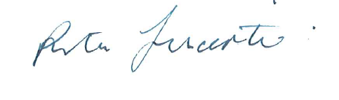
The Hon. Justice Rita Incerti
President
Forensic Leave Panel

Acknowledgements

Acknowledgement of Country
The Victorian Government proudly acknowledges Victoria’s Aboriginal communities and their rich culture and pays respect to their Elders past and present. We acknowledge Aboriginal peoples as Australia’s first peoples and as the Traditional Owners and custodians of the land and water on which we live, work and play. We recognise and value the ongoing contribution of Aboriginal people and communities to Victorian life and how this enriches our society more broadly. We embrace self-determination and reconciliation, working towards equality of outcomes and ensuring an equitable voice.

Recognition of lived and living experience
We recognise all people with lived and living experience of mental illness, psychological distress and substance use, and their families, carers, and supporters. We would like to thank them for working in partnership with Victoria’s clinical and non-clinical workforces to transform the mental health system.

Contents
Acknowledgements 4
Acknowledgement of Country 4
Recognition of lived and living experience 4
President’s report 6
Promoting respect, responsiveness and human rights through online hearings 6
Case example: Revocation of a non-custodial supervision order 6
Acknowledgements 7
Forensic Leave Panel 8
Purpose 8
How we do it 8
What we do 9
Who we are 11
Forensic patients: 2024 activities and outcomes 13
Applicants and hearings 13
Court orders 13
Leave decisions 13
Oversight and safeguards 13
Participation and support 13
Appeals 14
Forensic patients: Activity summary at a glance 15
Forensic residents: 2024 activity and outcomes 18
Applicants and hearings 18
Applications and leave purposes 18
Leave decisions 18
Oversight and safeguards 18
Participation and support 18
Appeals 19
Forensic residents: Activity summary at a glance 20
Appendix 1: Glossary and abbreviations 22
Appendix 2: The legal framework 23

President’s report
I am pleased to present the annual report of the Forensic Leave Panel for 2024 – my third annual report as president of the panel in my sixth year as a judicial panel member.
I would like to thank the Chief Psychiatrist, Associate Professor Sophie Adams, for her assistance and Dr David Huppert in his role as Acting Chief Psychiatrist.

Promoting respect, responsiveness, and human rights through online hearings
In response to the coronavirus pandemic, the panel transitioned to online operations in 2020. This shift marked a significant step forward in improving accessibility and inclusivity for forensic patients and residents, their families, and their supporters, who may otherwise have faced challenges in attending due to travel and scheduling constraints.
The online format also offers greater flexibility and responsiveness for patients, families, and supporters if unforeseen changes in scheduling and availability occur on the day of the hearing.
The panel’s ongoing commitment to enhancing the hearing experience for forensic patients and residents, families and supporters aligns with the Victorian Government’s commitment to the values of integrity, respect, accountability, responsiveness, and support for human rights while promoting the mental health, wellbeing, and safety of the Victorian Community.

Case example: Revocation of a non-custodial supervision order
This case highlights the importance of the Forensic Leave Panel’s work and the critical role it plays in both rehabilitating applicants and minimising risk and harm to the community.

From the president
Earlier this year, I heard an application to revoke a non-custodial supervision order, pursuant to s 33 of the Crimes (Mental Impairment and Unfitness to be Tried) Act 1997. I subsequently made an order revoking the order.
The court considered the applicant’s progress over an 11-year period. Central to his rehabilitation was the vital support he received from medical and psychosocial services at Thomas Embling Hospital, as well as from the community and his family. His gradual, safe reintegration into the community was underpinned by his leave applications, which provided a structured pathway to recovery and independence.
At the end of the hearing, the applicant addressed the court and expressed his gratitude to all the stakeholders who had supported him to reach this critical milestone.

Acknowledgements
The panel acknowledges the expertise and commitment of its members and thanks them for their significant contribution to its operations. The panel also acknowledges the significant role of Disability Justice Australia Inc. and Victoria Legal Aid in providing legal representation and advice to applicants. Appreciation is also extended to the staff of Forensic Residential Services, the Thomas Embling Hospital and the Department of Health’s Mental Health and Wellbeing Division for their ongoing dedication and support.
The Hon. Justice Rita Incerti
President

Forensic Leave Panel

Purpose
The Forensic Leave Panel makes decisions about leave for people on supervision orders under the Crimes (Mental Impairment and Unfitness to be Tried) Act.
The panel’s role is to balance 2 key responsibilities: keeping the community safe and supporting patients’ recovery and rehabilitation. Leave is a crucial step towards independence, connection with the community and living in less restrictive settings.
The panel undertakes this work because it makes a meaningful difference – for patients, their families, and the wider community. To demonstrate the outcomes of this work, Forensicare provided brief vignettes. To protect the identity of patients and residents, substitute initials have been used instead of real ones.

From a forensic residential service
TP successfully transitioned to the community over time, marking a life-changing step as he begins a new phase of life outside the residential treatment facility.
TP has reconnected with family in the community and recently stepped down to one-to-one staffing. His family has acknowledged this as a positive change, allowing for more enjoyable time together.

How we do it
The panel conducts hearings by videoconference, which bring together legal, clinical and community expertise. Panels for forensic patient hearings include a judge, the Chief Psychiatrist or nominee, a forensic psychiatry expert and a community member. Panels for forensic residents include a judge, a psychologist with expertise in intellectual disability and forensic psychology and a community member. Supporters – such as family members, legal representatives, and interpreters – may also join via secure a video link with prior agreement.

Hearing process
Hearings are usually closed to the public and involve discussions with the patient or resident and their treating team, focusing on clinical reports, risk assessments, offence details and supervision orders, with input from the person, their clinician and, where appropriate, families and carers. All decisions are made under the Crimes (Mental Impairment and Unfitness to be Tried) Act, balancing safety with recovery.

Interpreters
Interpreters or other specialists are engaged as needed. In 2024, interpreters were used 9 times in the following languages: Arabic, Auslan, Cantonese, Dinka, Filipino, Mandarin, Turkish and Vietnamese.

Legal representation
Applicants have the right to legal representation, which was exercised 25 times in 2024. Decisions are provided verbally at the end of each hearing, with a written determination issued afterwards outlining whether leave is granted, varied, or not granted, including any conditions. Patients/residents may also request a written statement of reasons. Four requests were made in 2024.
The panel operates in line with the Act but is also guided by equity, good conscience, and the principles of natural justice. It may request extra information or summon attendees if required.

Progression of leave
Leave is granted incrementally, beginning with closely supervised outings (for example, brief escorted trips) and gradually increasing in scope and duration as progress is demonstrated. Progression is tailored to each person and adjusted according to treatment response.

Suspension of leave
Regular monitoring and review of leave takes place to ensure the safety of each patient or resident and to ensure the public is not seriously endangered. Before forensic patients or residents may access leave granted by the panel, they are subject to a clinical assessment.
The Act has provisions that allow the Chief Psychiatrist (in the case of patients) and the Secretary of the Department of Families, Fairness and Housing (in the case of residents) to suspend leave granted if they are satisfied that the safety of the person or members of the public will be seriously endangered if leave is not suspended.
In 2024, 5 patients and one resident each had their leave wholly suspended once, and 17 patients each had their leave partially suspended on one occasion.

Operational and financial support
The Department of Health’s Mental Health and Wellbeing Division provided all operational support to the panel, managed the panel’s budget, and maintained accounts and records. The department’s audited financial statements include the panel’s expenditure, which is reported in the department’s annual report.

What we do
The panel decides if people on supervision orders can have leave from secure facilities or residential settings. It reviews applications, sets conditions and monitors how leave is used to ensure the process is safe, fair, and consistent. In doing so, the panel supports recovery, rehabilitation, and safe progression through supervision orders.
The panel also reviews:
- appeals regarding refused special leave applications
- transfers between mental health services.
Until 2022, the panel was also responsible for assessing on-ground leave applications. These on-ground areas are now accessible to patients and residents through other provisions.

The leave framework
The panel oversees the granting of limited off-ground leave under the Act. This leave may be approved for periods of up to 6 months, after which patients or residents can reapply.

Limited off-ground leave
Patients and residents may be granted leave from custody between 6:00 am and 9:00 pm or, in some cases, for periods of up to 3 days within a 7-day period. All leave applications must align with the person’s treatment and recovery plan and may include activities such as:
- attending medical, legal, or allied health appointments
- completing daily tasks (for example, shopping, banking, exercise)
- reconnecting with family and friends
- taking part in therapy, education, or paid work.

Criteria for granting leave
The panel grants limited off-ground leave only when:
- it supports the person’s rehabilitation
- it does not pose a serious risk to public or individual safety.

Conditions attached to leave
The panel may impose conditions on leave, such as:
- supervision requirements
- duration and frequency of leave
- approved or restricted destinations
- people that the person may meet with during leave
- travel arrangements to and from the leave destination
- drug and alcohol testing following leave.

From a forensic residential service
TF’s community visits have allowed him to take part in activities he enjoys, such as spending time with his family, playing golf and shopping for cricket gear. These activities have been both positive and motivating, playing an important role in his weekly routine, and supporting his overall wellbeing.

From a forensic disability service
JM’s leave has enabled him to engage in meaningful activities that he greatly values. Attending training and games with a local football team is the highlight of his week, and he speaks with fondness and detail about these experiences. These outings allow him to connect with family and prosocial peers, which he really enjoys.
JM also attends drug and alcohol counselling. He has responded positively to the culturally safe environment and is enthusiastic about spending time in the garden area with his counsellor and other clients.

Who we are
The Forensic Leave Panel is an independent statutory body established under the Crimes (Mental Impairment and Unfitness to be Tried) Act. Its members include a Supreme or County Court judge, psychiatrists, and community representatives, all appointed to ensure decisions are legally sound, clinically informed, and socially responsible.
The structure of the panel is outlined in Figure 1, and an overview of membership in 2024 is provided in the table that follows. This includes membership type and appointment dates.
The panel is supported by a manager and executive officer from the Department of Health’s Mental Health and Wellbeing Division.
Figure 1: Panel membership
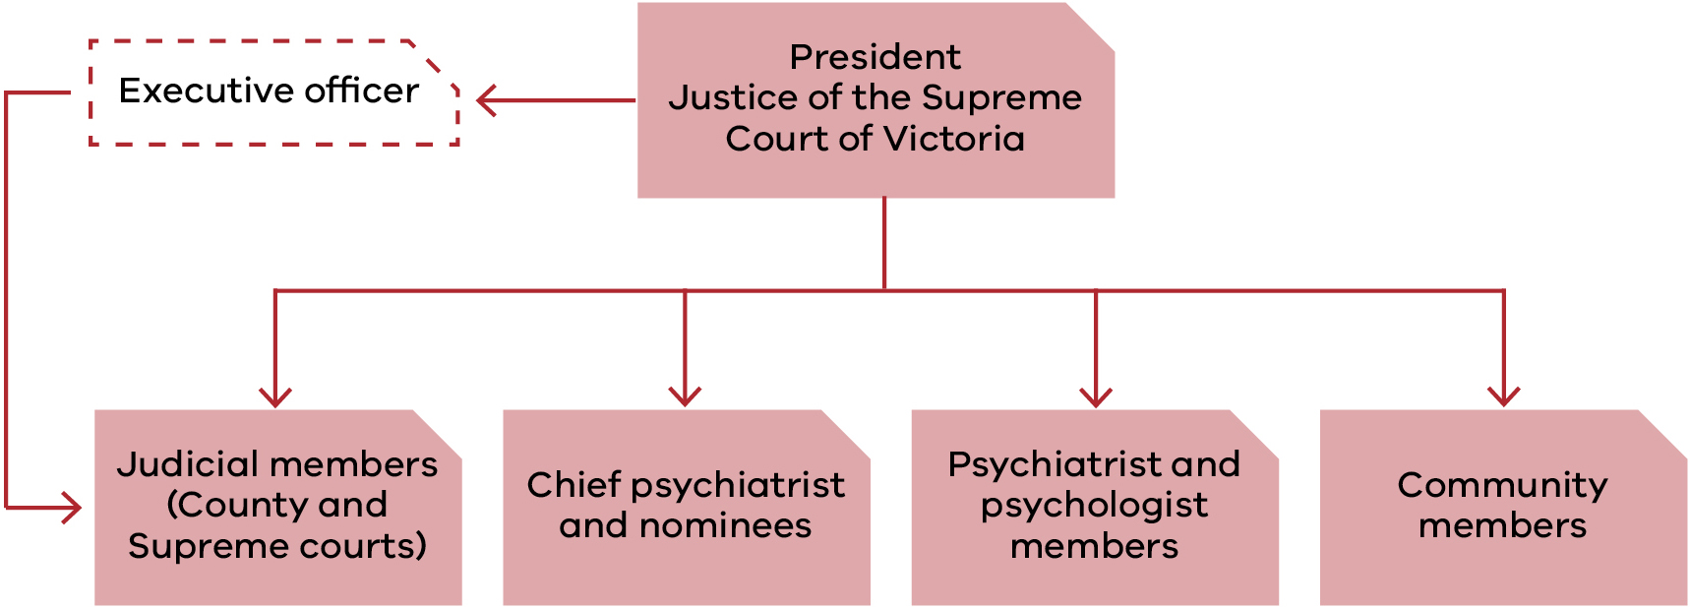

Panel membership in 2024
Name | Membership type | Appointment / re-appointment date | Appointment expiry date
Justice Rita Incerti | FLP President, Supreme Court | 28/05/2024 | 27/05/2029
Justice Jane Dixon | Supreme Court | 18/10/2022 | 17/10/2027
Justice Andrew Keogh | Supreme Court | 18/10/2022 | 17/10/2027
Justice Michael Croucher | Supreme Court | 17/02/2015 | 16/02/2025
Justice Kevin Bell | Supreme Court | 01/04/2019 | 31/03/2024
Judge Rosemary Carlin | County Court | 12/05/2020 | 11/05/2025
Judge Sandra Davis | County Court | 7/06/2022 | 6/06/2027
Judge Douglas Trapnell | County Court | 31/10/2022 | 31/10/2027
Dr Jennifer Torr | Psychiatrist member | 3/10/2023 | 2/10/2027
Dr Ahmed Mashhood | Psychiatrist member | 1/07/2022 | 30/06/2026
Ms Janina Tomasoni | Psychologist member | 1/07/2022 | 30/06/2026
Dr Michelle Noon | Psychologist member | 1/07/2022 | 30/06/2026
Dr Marilyn McMahon | Psychologist member | 3/10/2023 | 2/10/2027
Mr Paul Newland | Community member | 3/10/2023 | 2/10/2027
Mr Jack Nalpantidis | Community member | 1/07/2022 | 30/06/2026
Mr George Jiang | Community member | 1/07/2022 | 30/06/2026
Dr Patricia Mehegan | Community member | 1/07/2022 | 30/06/2026
Dr Leslie Cannold | Community member | 3/10/2023 | 2/10/2027
Dr Genevieve Grant | Community member | 3/10/2023 | 2/10/2027
Assoc. Prof.  Sophie Adams | Chief Psychiatrist | 15/07/2024 | Ongoing
Dr Vinay Lakra | Chief Psychiatrist nominee | 18/07/2016 | Ongoing
Dr Steve Macfarlane | Chief Psychiatrist nominee | 9/11/2012 | Ongoing
Dr Paul Robertson | Chief Psychiatrist nominee | 12/12/2022 | Ongoing
Dr Roth Trisno | Chief Psychiatrist nominee | 5/08/2024 | Ongoing
Dr David Huppert | Chief Psychiatrist nominee | 4/09/2020 | Ongoing
Dr Sabah Khalid | Chief Psychiatrist nominee | 29/08/2024 | Ongoing
Dr Jennifer Babb | Chief Psychiatrist nominee | 11/05/2020 | 05/07/2024
Dr Teresa Flower | Chief Psychiatrist nominee | 07/06/2022 | 06/06/2024
De Leeanne Fisher | Chief Psychiatrist nominee | 12/12/2022 | 13/09/2024

Forensic patients: 2024 activities and outcomes
While the number of applicants remains steady, 2024 saw fewer applications overall, more focused requests and more tailored decisions than in 2023. Oversight increased significantly, ensuring community safety and patient wellbeing, while supports for applicant participation remained strong. A summary of 2024 data compared with 2023 is provided below.

Applicants and hearings
- 106 applicants in 2024, almost identical to 2023 (105)
- 93 male and 13 female, a consistent gender profile
- First-time applicants dropped significantly: 3 in 2024 versus 13 in 2023
- Applications received decreased from 213 to 150, and hearings declined from 34 to 25
- The number of individual leave purposes requested also decreased: 689 (down from 928)
Insight: The pool of applicants remained stable in 2024, but applications were fewer and more focused, reflecting a more experienced applicant group.

Court orders
- Supreme Court orders: 56 (down by 1)
- County Court orders: 50 (up by 2)
Insight: The balance between Supreme and County Court applicants remains steady.

Leave decisions
- Leave granted without modification: 76% (up from 70%)
- Leave granted with modification: 24% (up from 21%)
- Total leave granted: 89% (slightly down from 92%)
- Leave refused: 11% (up from 10%)
Insight: Decision-making is becoming more tailored, with more leave granted outright, but overall approvals were slightly lower.

Oversight and safeguards
- Leave suspensions by the Chief Psychiatrist: 23 in 2024, compared with 4 in 2023
Insight: The substantial increase in formal suspension of leaves over the past year is noted in the following quote from Forensicare:
There does not appear to be clear rationale and likely reflects usual variation from year to year. Forensicare has committed to collecting more detailed data going forward so a more longitudinal picture is available with analysis of the rationale for suspensions possible.

Participation and support
- Interpreter assistance: 9 occasions (down from 17)
- Languages used: 8 (unchanged)
- Legal representation: 19 cases (up from 16)
Insight: Applicants continued to receive strong support, with consistent language access but increasing reliance on legal advocacy.

Appeals
No appeals were lodged against refusals of special leave in either 2023 or 2024.
Table 1 summarises changes, between 2023 and 2024, in key activities and outcomes for forensic patients.
Table 1: Forensic patients: summary of changes between 2023 and 2024
Measure | 2024 | 2023 | Change
Applicants | 106 | 105 | +1
Male applicants | 93 | 92 | +1
Female applicants | 13 | 13 | 0
Applicants on Supreme Court orders | 56 | 57 | –1
Applicants on County Court orders | 50 | 48 | +2
First-time applicants | 3 | 13 | –10
Hearings | 25 | 34 | –9
Applications received | 150 | 213 | –63
Individual leave purposes requested | 689 | 928 | –778
Applications for limited off-ground leave | 150 | 213 | –63
Leave granted without modification | 76% | 70% | +6%
Leave granted with modification | 24% | 21% | +4%
Total leave granted | 89% | 92% | –3%
Leave refused | 11% | 10% | +1%
Leave suspensions by the Chief Psychiatrist | 23 | 4 | +19
Times an interpreter assisted a patient | 9 | 17 | –8
Languages used | 8 | 8 | 0
Legal representation | 19 | 16 | +3
Appeals against refusal of special leave | 0 | 0 | 0

Forensic patients: Activity summary at a glance
Figures 2 to 7 summarise forensic patient activity in 2023 and 2024, including:
- percentage of male and female patients with leave applications before the panel (Figure 2)
- number of hearings heard by a Supreme Court judge and a County Court judge (Figure 3)
- number of leave suspensions (Figure 4)
- outcomes of leave applications (Figure 5)
- number of cases where there was legal representation and interpreters used (Figure 6)
- trends in applications and hearings (Figure 7).
Figure 2: Percentage of female and male forensic patients before the panel

Figure 3: Number of hearings before Supreme Court and County Court judges

Figure 4: Number of leave suspensions

Figure 5: Outcomes of leave applications

Figure 6: Participation and support

Figure 7: Applications and hearing trends

Forensic residents: 2024 activity and outcomes
The panel’s activity in relation to residents in 2024 showed both continuity and some changes when compared with 2023.

Applicants and hearings
- 5 applicants in 2024, down from 8 in 2023
- All applicants were male, consistent with last year
- 3 applicants were subject to Supreme Court orders (unchanged), while County Court applicants decreased from 5 to 2
- No first-time applicants in 2024 (down from 2 in 2023)
- Despite fewer applicants, the number of hearings increased from 7 to 9, reflecting the complexity of matters considered
Insight: The resident applicant group remains small, but the increase in hearings suggests a more intensive review process for each application.

Applications and leave purposes
- Applications received: 10 (down from 13)
- Individual leave purposes requested: 58 (down from 85)
- Applications for limited off-ground leave: 10 (down from 13)
Insight: Applications were fewer and more targeted, with residents seeking a smaller range of leave purposes compared with 2023.

Leave decisions
- Leave granted without modification: 76% (down from 87%)
- Leave granted with modification: 24% (up from 13%)
- Total leave granted: 88% (down from 100%)
- Leave refused: 12% (up from 0%)
Insight: While most applications were approved, outcomes showed greater tailoring, with more leave granted subject to modification. For the first time in 2 years, a small proportion of applications were refused.

Oversight and safeguards
- Leave suspensions by the Secretary of the Department of Families, Fairness and Housing: 1 (unchanged from 2023)
- Leave suspensions by the Chief Psychiatrist: Not applicable
Insight: Oversight mechanisms remained stable, with no change in the number of suspensions issued.

Participation and support
- Interpreter assistance: Not required in 2024
- Languages used: Not applicable
- Legal representation: 6 cases, slightly down from 7 in 2023
Insight: Residents continued to be well supported in hearings, with a consistent level of legal advocacy and no additional language needs arising.

Appeals
Appeals against refusal of special leave: To be confirmed (none in 2023).
Table 2 summarises changes, between 2023 and 2024, in key activities and outcomes for forensic residents.
Table 2: Forensic residents: summary of changes between 2023 and 2024
Measure | 2024 | 2023 | Change
Applicants | 5 | 8 | –3
Male applicants | 5 | 8 | –3
Female applicants | 0 | 0 | 0
Applicants on Supreme Court orders | 3 | 3 | 0
Applicants on County Court orders | 2 | 5 | –3
First-time applicants | 0 | 2 | –2
Hearings | 9 | 7 | +2
Applications received | 10 | 13 | –3
Individual leave purposes requested | 58 | 85 | –27
Applications for limited off-ground leave | 10 | 13 | –3
Leave granted without modification | 76% | 87% | –11%
Leave granted with modification | 24% | 13% | +11%
Total leave granted | 88% | 100% | –12%
Leave refused | 12% | 0% | +12%
Leave suspensions by the Chief Psychiatrist | N/A | N/A | N/A
Leave suspensions by the Secretary of the Department of Families, Fairness and Housing | 1 | 1 | 0
Times an interpreter assisted a resident | 0 | 0 | 0
Languages used | N/A | N/A | N/A
Legal representation | 6 | 7 | –1
Appeals against refusal of special leave | TBC | 0

Forensic residents: 2024 activity and outcomes
Figures 8 to 11 provide a summary of activity across forensic residents in 2023 and 2024, including:
- number of hearings heard by a Supreme Court judge and a County Court judge (Figure 8)
- number of cases where legal representation was used (Figure 9)
- trends across applications and hearings (Figure 10)
- outcomes of leave applications (Figure 11).
Figure 8: Applicants by court orders

Figure 9: Legal representation

Figure 10: Applications and hearing trends

Figure 11: Leave decisions

The panel’s statistical information has remained constant over recent years. Although variations occur in the number of hearings, applicants and applications, these differences are consistent with changes in the forensic patient and resident population. Access previous Forensic Leave Panel annual reports <https://www.health.vic.gov.au/mental-health-services/forensic-leave-panel> online.

Appendix 1: Glossary and abbreviations
Term | Definition
The Act | Crimes (Mental Impairment and Unfitness to be Tried) Act 1997
Custodial supervision order (CSO) | Custodial supervision order under the Mental Health and Wellbeing Act 2022 or Disability Act 2006
Forensicare | Victorian Institute of Forensic Mental Health, including Thomas Embling Hospital
Forensic patient / patient | Person in custody under the Mental Health and Wellbeing Act 2022
Forensic resident / resident | Person in custody under the Disability Act 2006
Non-custodial supervision order (NCSO) | Non-custodial supervision order allowing supervised community living
Panel | Forensic Leave Panel
Purpose of leave | Activities undertaken during leave
Residential treatment facility (RTF) | Bundoora RTF and Fairfield RTF – under the Victorian Department of Families, Fairness and Housing

Appendix 2: The legal framework
Overview of the Crimes (Mental Impairment and Unfitness to be Tried) Act
The Act governs the management, supervision and release of people found unfit to stand trial or not guilty because of mental impairment (Figure 12).
Supervision orders under the Act include:
- Custodial supervision orders (CSOs): Custody in a designated mental health service (Mental Health and Wellbeing Act 2022), a residential facility (Disability Act 2006) or, where no practicable alternative exists, prison.
- Non-custodial supervision orders (NCSOs): Residence in the community subject to conditions determined by a court.
- Unconditional release: The person is released into the community, without conditions.
Forensic patients/resident submit applications for limited off-ground leave to the Forensic Leave Panel to support recovery and rehabilitation. The court may grant leave for up to 12 months. After successfully completing 12 months leave in the community, the person can apply to the court to vary the CSO to an NCSO. Finally, the court revokes the NCSO, at which point, the person is no longer subject to the order.
Figure 12: Progression through the system and the panel’s role
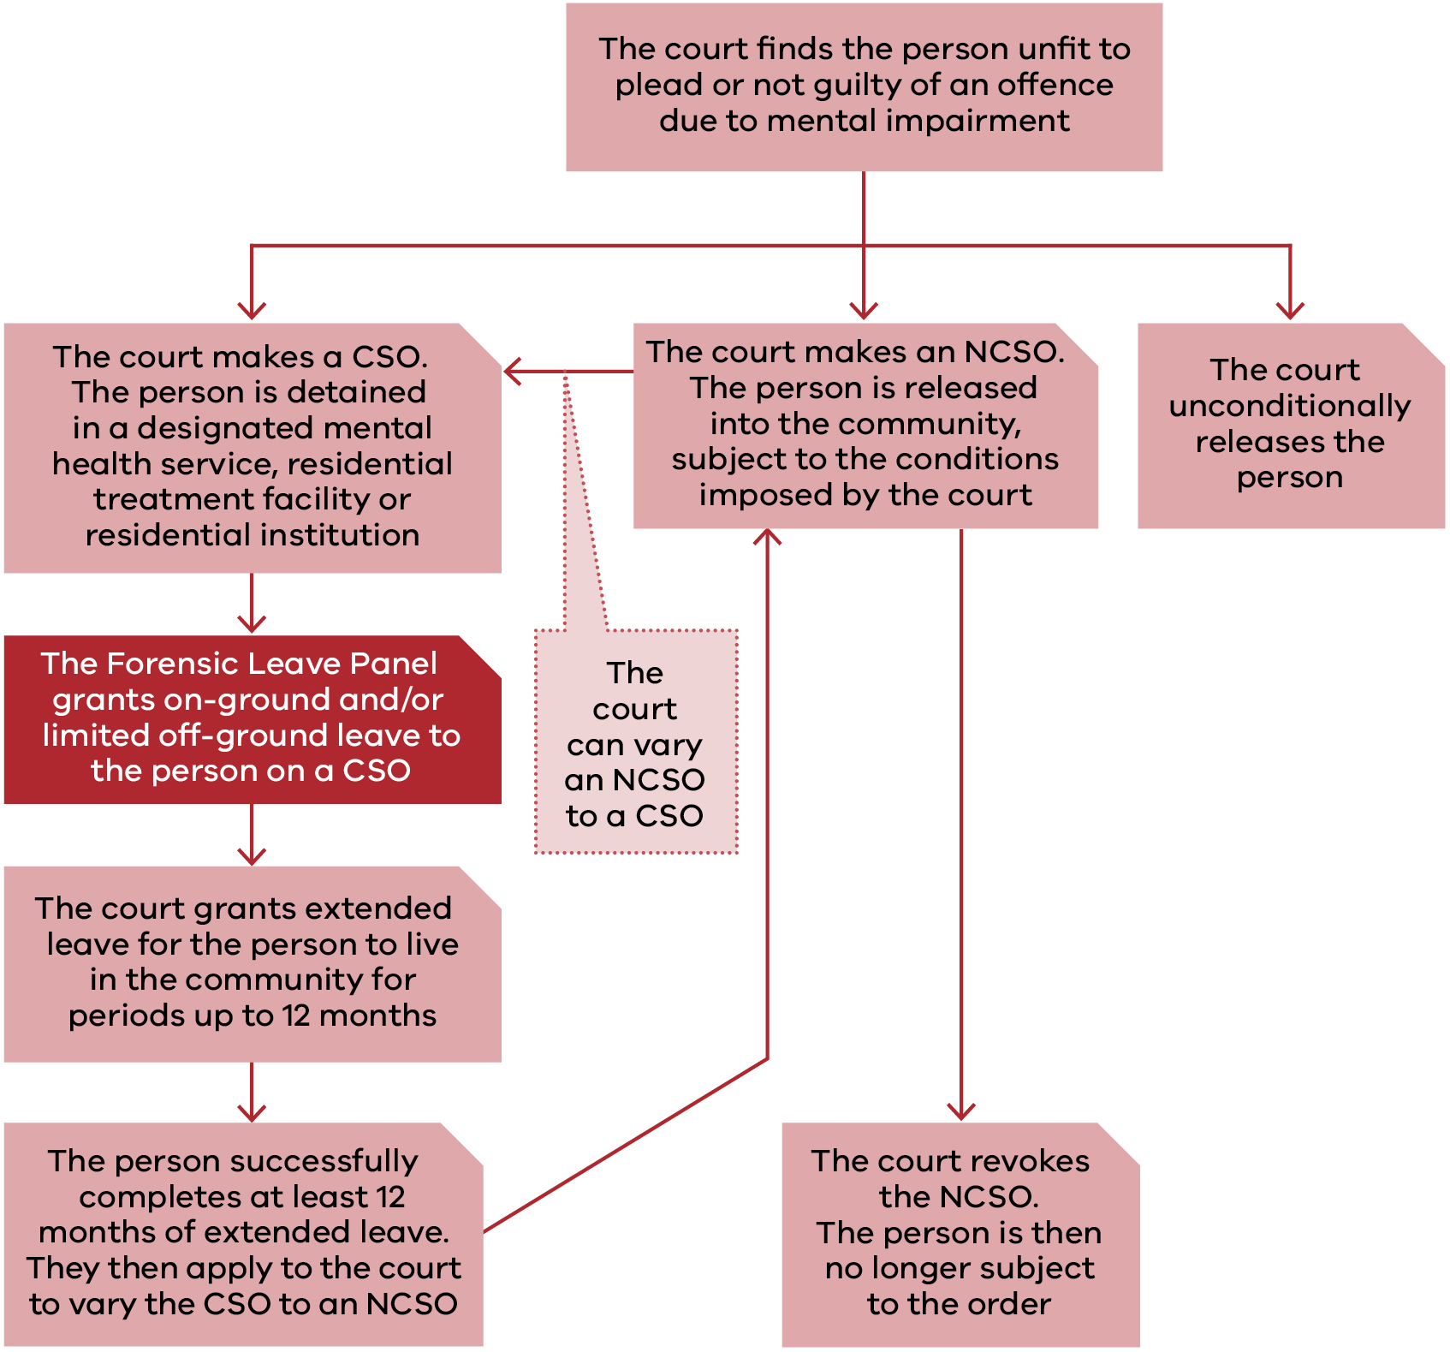

There was a request for another 8 patients to be listed for a hearing in 2023, and these applications were considered in 2024.
The percentage of leaves granted, modified or refused by the panel may not always total 100 per cent because at hearings applicants may withdraw leave requests, the panel may grant modified leave requests or, on occasion, grant additional leave requests.
In 2023 the panel granted off-ground leave to 9 forensic residents. Of these, 8 had applications in 2023 and one was granted off-ground leave in late 2022.
The percentage of leaves granted, modified or refused by the panel may not always total 100 per cent because at hearings applicants may withdraw leave requests, the panel may grant modified leave requests or, on occasion, grant additional leave requests.

