Drug advice
High-dose MDMA capsules and pills are circulating in Victoria
Various products – containing up to 2-3 typical doses of MDMA – are being sold
MDMA (‘ecstasy’) is an empathogen stimulant with effects including euphoria and increased sociability, but also increased body temperature, heart rate and blood pressure. Higher doses can lead to life-threatening hyperthermia.
Recent testing of multiple products obtained in Victoria (pictured) showed MDMA doses of up to 233 milligrams of MDMA (measured as ‘free base’). A typical dose of MDMA is 70-100 milligrams. The products include a blue ‘ghost’ capsule, yellow ‘Boba Fett’ capsule, blue hexagon-shaped ‘Philipp Plein’ tablet, yellow sparkly ‘Facebook’ tablet, and green skull-shaped tablet.
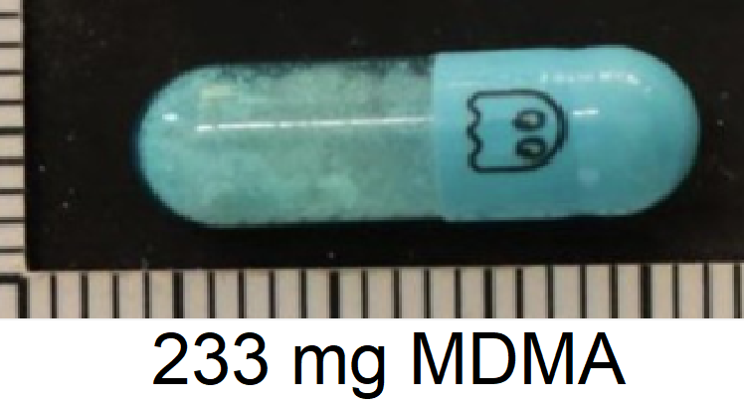
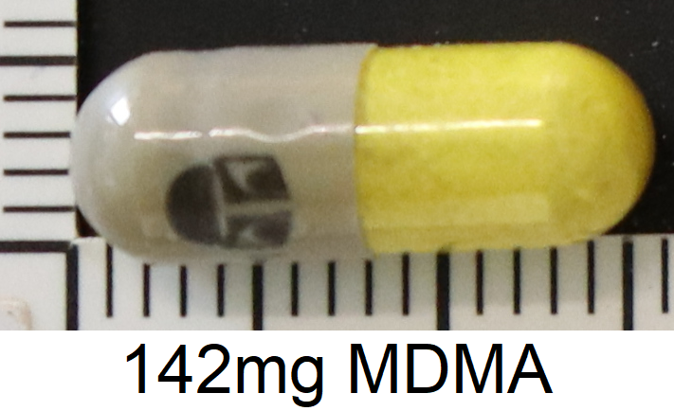
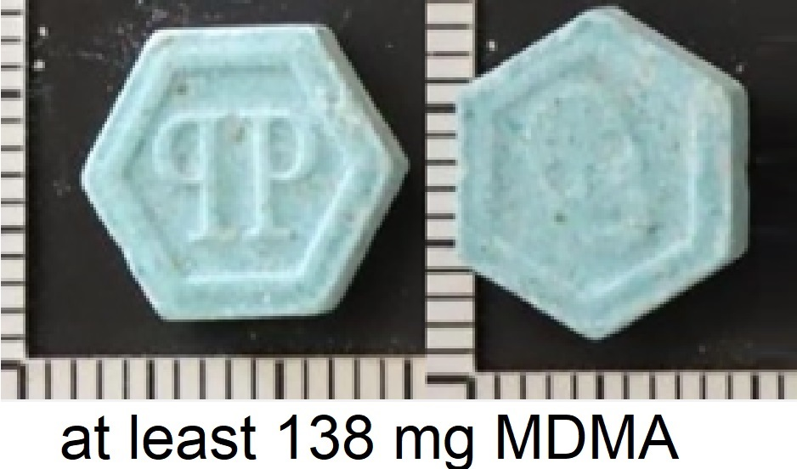
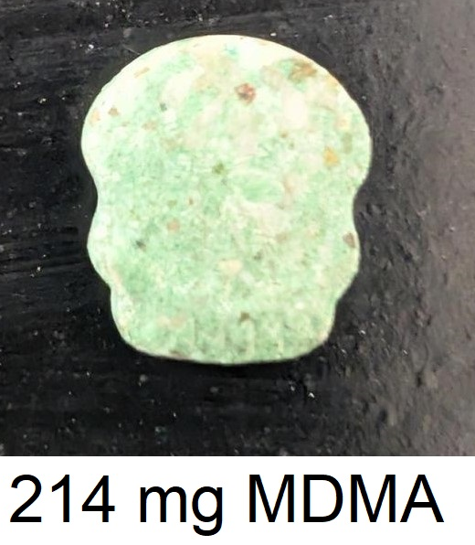
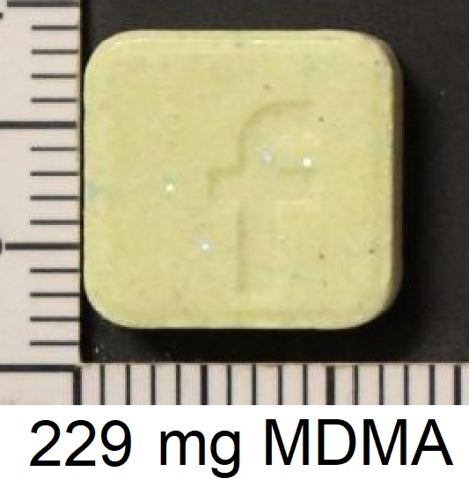
It’s very unusual for multi-dose capsules of MDMA to be sold as ‘ready for consumption’.
Start low and go slow with MDMA dosing – and know the signs of toxicity
The amount of MDMA in a capsule or pill can vary significantly, even within the same batch. If you choose to use MDMA, start low and go slow with dosing. If consuming any other substance or redosing, wait until peak effects have passed.
Very hot, crowded and humid environments can also make your ‘normal’ MDMA dose hazardous. Mixing with other substances – especially stimulants like cocaine or amphetamines or medications for anxiety and depression such as ‘SSRIs’, ‘SNRIs’ and ‘TCAs’ – can increase the chance of life-threatening hyperthermia or other unpredictable or toxic effects.
Signs of drug-related hyperthermia include feeling uncomfortably hot and sweaty, nausea and vomiting, feeling light-headed, excessive thirst, confusion, agitation, muscle spasms, seizures or losing consciousness.
Reduce the risk of harm
If you experience any unusual or unexpected effects, or notice someone appearing confused or unwell, seek urgent medical attention by calling Triple Zero (000) or finding the First Aid Service if you’re at a festival. Don’t delay seeking help – getting help early can be the difference between life and death. You won’t get into trouble for seeking help.
All alcohol and other drug use comes with risk, so:
- Use the Victorian Pill Testing Service to get free, confidential testing and health advice.
- Make sure you’re in a safe environment with people you trust.
- Sip water to stay hydrated and take breaks from dancing, especially in hot or humid conditions.
- Remember, even ‘pure’ drugs can produce serious side effects and death. Get the facts at: adf.org.au/drug-facts/
- Seek information about your medications before mixing with other drugs: adf.org.au/insights/mix-antidepressants-aod/.
Contact Harm Reduction Victoria’s DanceWize team for anonymous support and education from peers. Talk to DanceWize volunteers by email at info@dancewize.org.au.
If you or someone you know needs help with alcohol or drug use, call DirectLine on 1800 888 236 or visit directline.org.au for information and support to access treatment.

