


Contents

Victorian Respiratory Surveillance Report
31 October 2025
About this report 1
Summary 2
Laboratory surveillance 3
Case notifications 3
Testing 8
Community surveillance 9
FluTracking 9
How to use this report 12
Data sources 12
Interpretation of data 12
Definitions 12

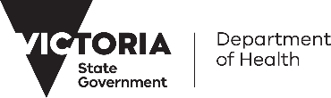
About this report
The Victorian Respiratory Surveillance Report summarises the latest surveillance information on COVID-19, influenza and respiratory syncytial virus (RSV) in Victoria. This report provides an overview of the current levels and trends of acute respiratory illness from these conditions in the community. Please see the section on How to use this report for more information.
Measurements of the greatest value for summarising respiratory illness in Victoria are presented in this report. Other systems are also reviewed by the Department of Health to understand patterns of respiratory disease in Victoria which inform the overall summaries presented.
Data are presented as at 29 October 2025 for the week ending 25 October 2025.
Each report reflects the data available at the time the report was prepared. Information may differ from previous reports as new data are received or updated.

Victorian Respiratory Surveillance Report | Summary | 31 October 2025 2

Summary

In Victoria, activity of COVID-19, influenza and RSV has decreased from winter peaks.
Increases in respiratory disease activity are typical during the winter period in Victoria. COVID-19 activity increased in May, peaked in June, and then started to decline. Trends stabilised throughout August then continued to decrease across September and early October, returning to similar levels following waves in previous years. Influenza activity increased in May and peaked in early July. This was followed by a brief decline, with activity stabilising at elevated levels from mid-July to August, before continuing to decline in September and October. RSV activity also increased in May and peaked in early July, and has continued to steadily decline since the peak.

COVID-19
NOTIFICATIONS LAST 12 WEEKS
TEST POSITIVITY
The percentage of tests that were positive have remained stable

CASE TREND
Notifications have increased

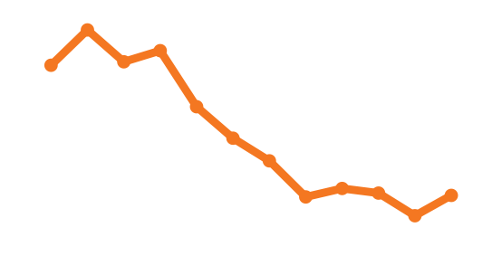
Influenza
NOTIFICATIONS LAST 12 WEEKS
TEST POSITIVITY
The percentage of tests that were positive have increased

CASE TREND
Notifications have increased
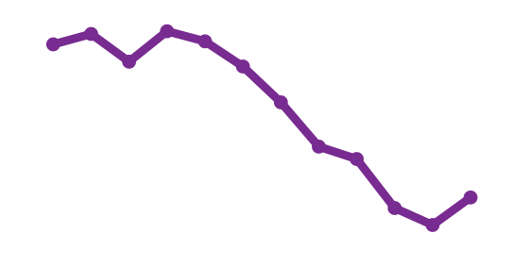
RSV
NOTIFICATIONS LAST 12 WEEKS
TEST POSITIVITY
The percentage of tests that were positive were stable

CASE TREND
Notifications have continued to decrease

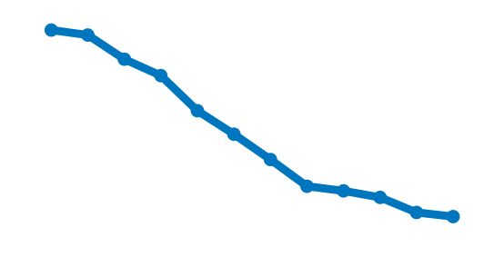

Laboratory surveillance

Case notifications
Laboratory-confirmed cases of COVID-19, influenza and RSV are notified to the Victorian Department of Health. Notified infections that are diagnosed through laboratory testing are only a subset of the total number of infections in the community. Trends in notifications may be impacted by changes in testing.

Summary
In the past week, COVID-19 notifications have increased (+15%), influenza notifications have increased (+19%) and RSV notifications have continued to decrease (-8%).
COVID-19
15% increase

RSV
8% decrease
19% increase
Influenza

COVID-19

Figure 1: COVID-19 notified cases by week, Victoria, 27 October 2024 to 25 October 2025
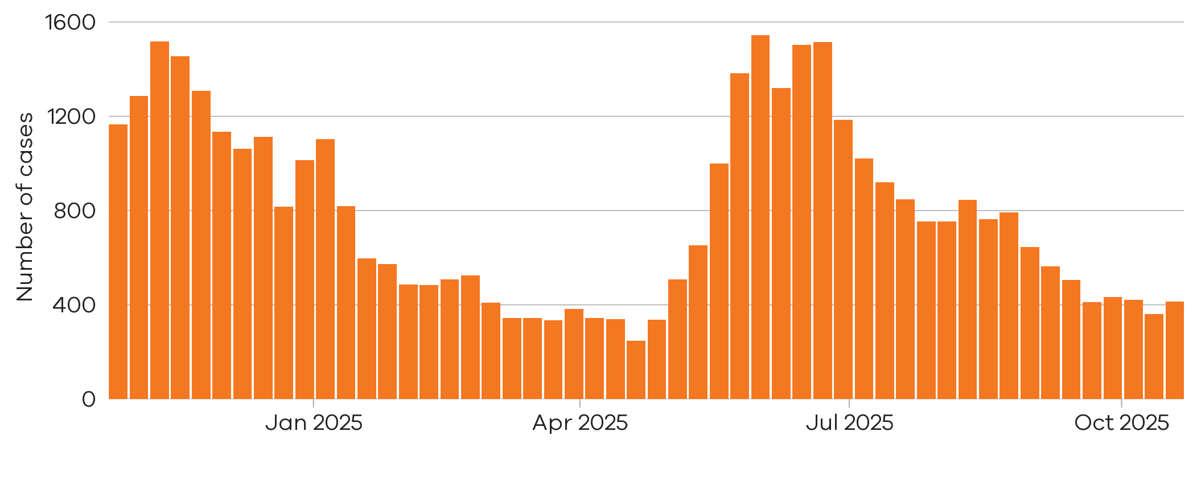
There were 362 notified COVID-19 cases two weeks ago

12 Oct 2025 to 18 Oct 2025

15% increase
There were 415 notified COVID-19 cases last week
19 Oct 2025 to 25 Oct 2025

Figure 2: COVID-19 trends in notified cases (7-day rolling average), Victoria, 1 January 2023 to 25 October 2025
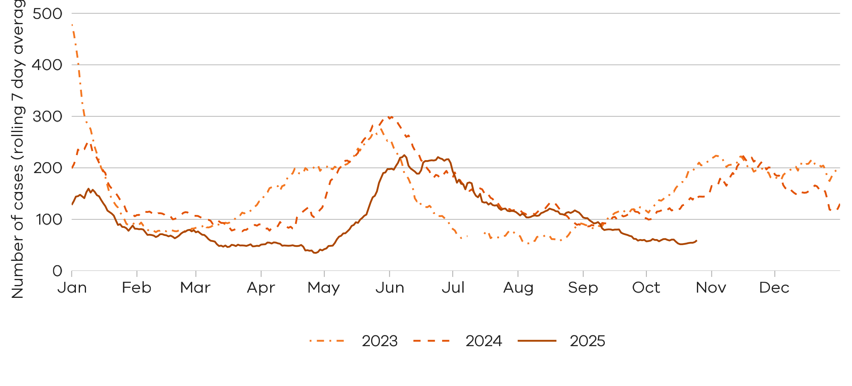

Notified COVID-19 cases have returned to inter-wave levels.

Influenza

Influenza notifications presented in this report are reported from a subset of laboratories in Victoria, generally comprising around 85% of total influenza notifications.
Figure 3: Influenza notified cases by week, Victoria, 27 October 2024 to 25 October 2025
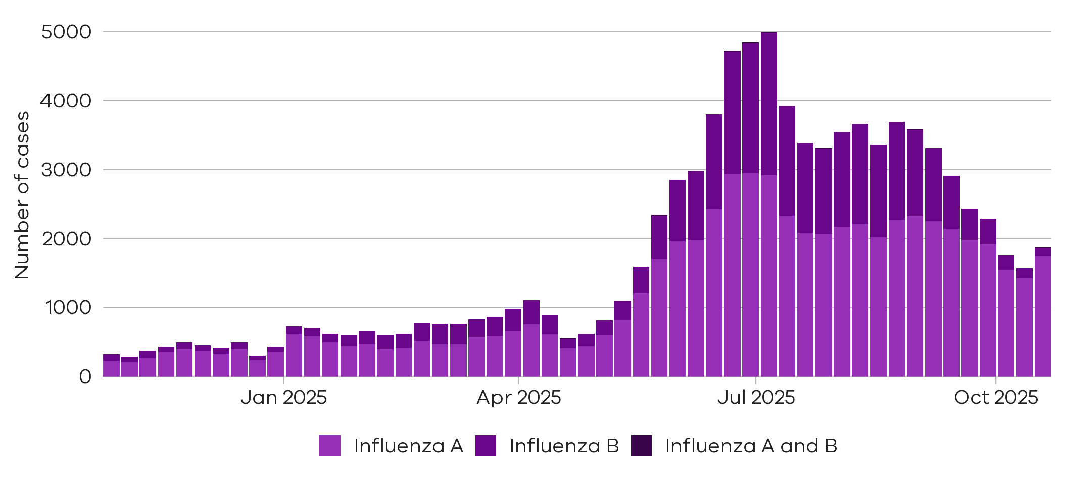
There were 142 cases of influenza B notified two weeks ago

12 Oct 2025 to 18 Oct 2025
There were 1424 cases of influenza A notified two weeks ago
12 Oct 2025 to 18 Oct 2025
There were 1745 cases of
influenza A notified last week
19 Oct 2025 to 25 Oct 2025
There were 121 cases of
influenza B notified last week

19 Oct 2025 to 25 Oct 2025
23% increase

15% decrease


Figure 4: Influenza A trends in notified cases (7-day rolling average), Victoria, 1 January 2023 to 25 October 2025
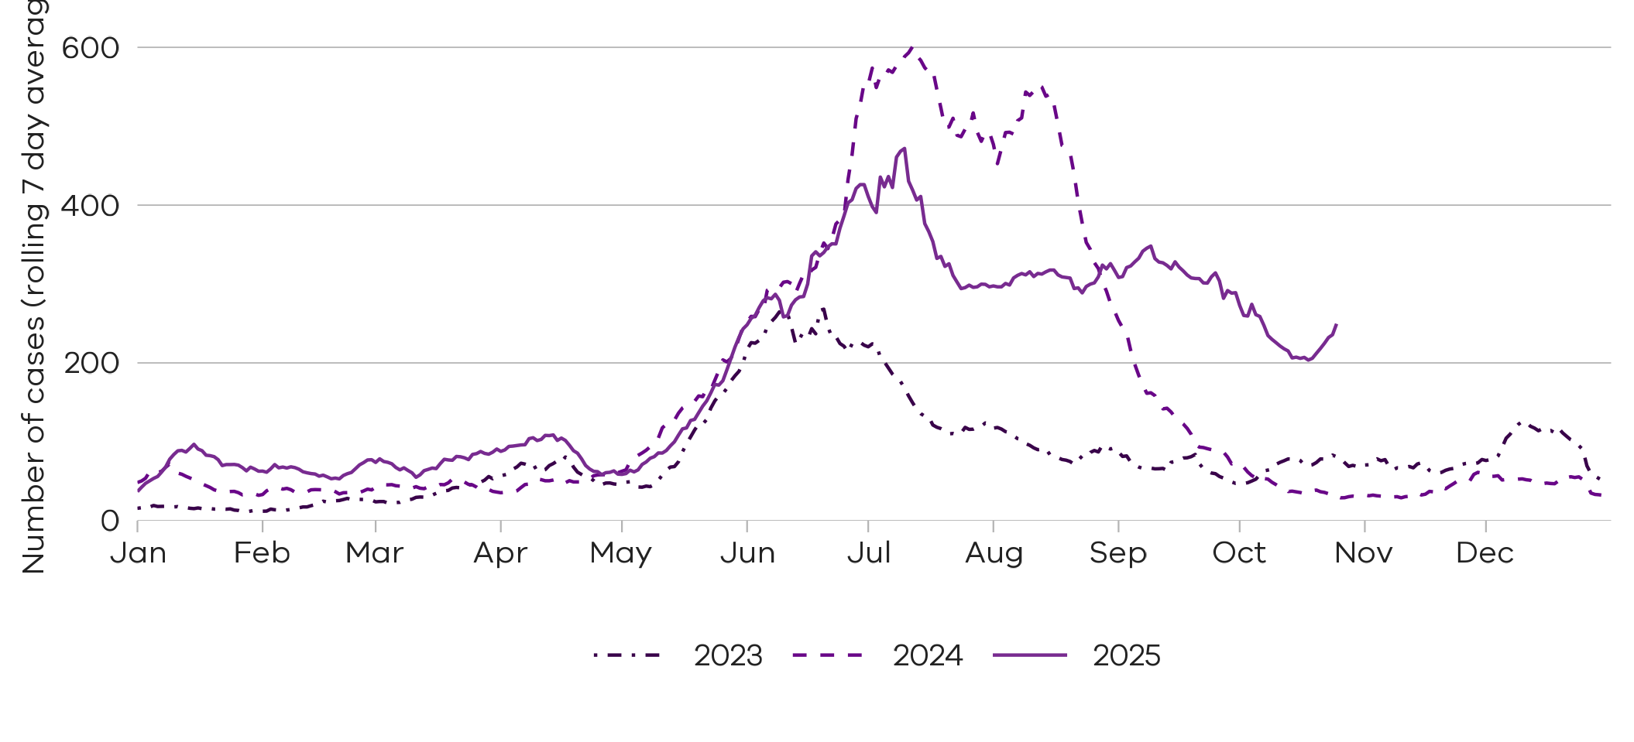

Notified influenza A cases remain higher than the same time in the past two years

Figure 5: Influenza B trends in notified cases (7-day rolling average), Victoria, 1 January 2023 to 25 October 2025
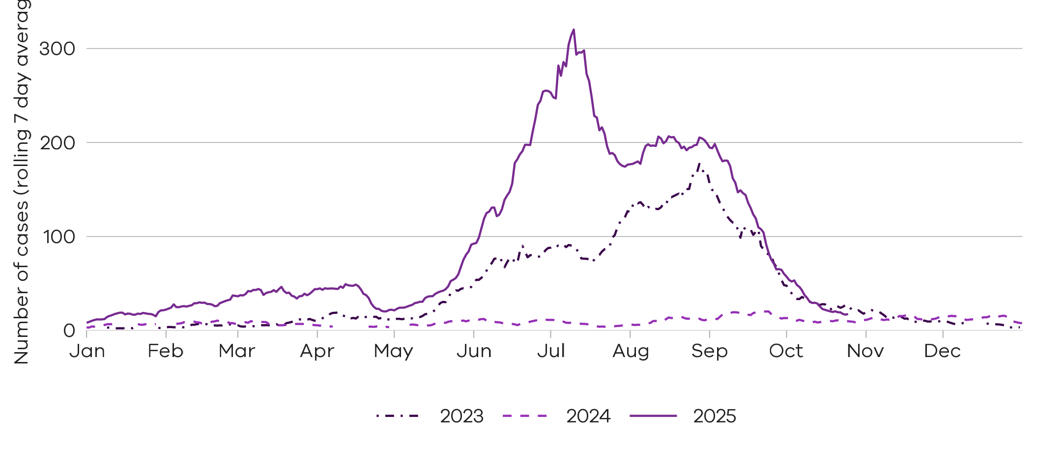
Notified influenza B cases have returned to inter-seasonal levels, similar to two years ago

Respiratory Syncytial virus (RSV)

RSV notifications presented in this report are reported from a subset of laboratories in Victoria, generally comprising around 85% of total RSV notifications.
Figure 6: RSV notified cases by week, Victoria, 27 October 2024 to 25 October 2025
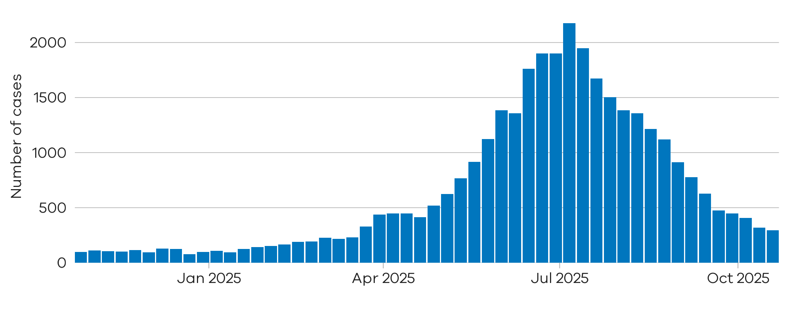
8% decrease
There were 296 notified RSV cases last week
19 Oct 2025 to 25 Oct 2025
There were 320 notified RSV cases two weeks ago

12 Oct 2025 to 18 Oct 2025

Figure 7: RSV trends in notified cases (7-day rolling average), Victoria, 1 January 2023 to 25 October 2025
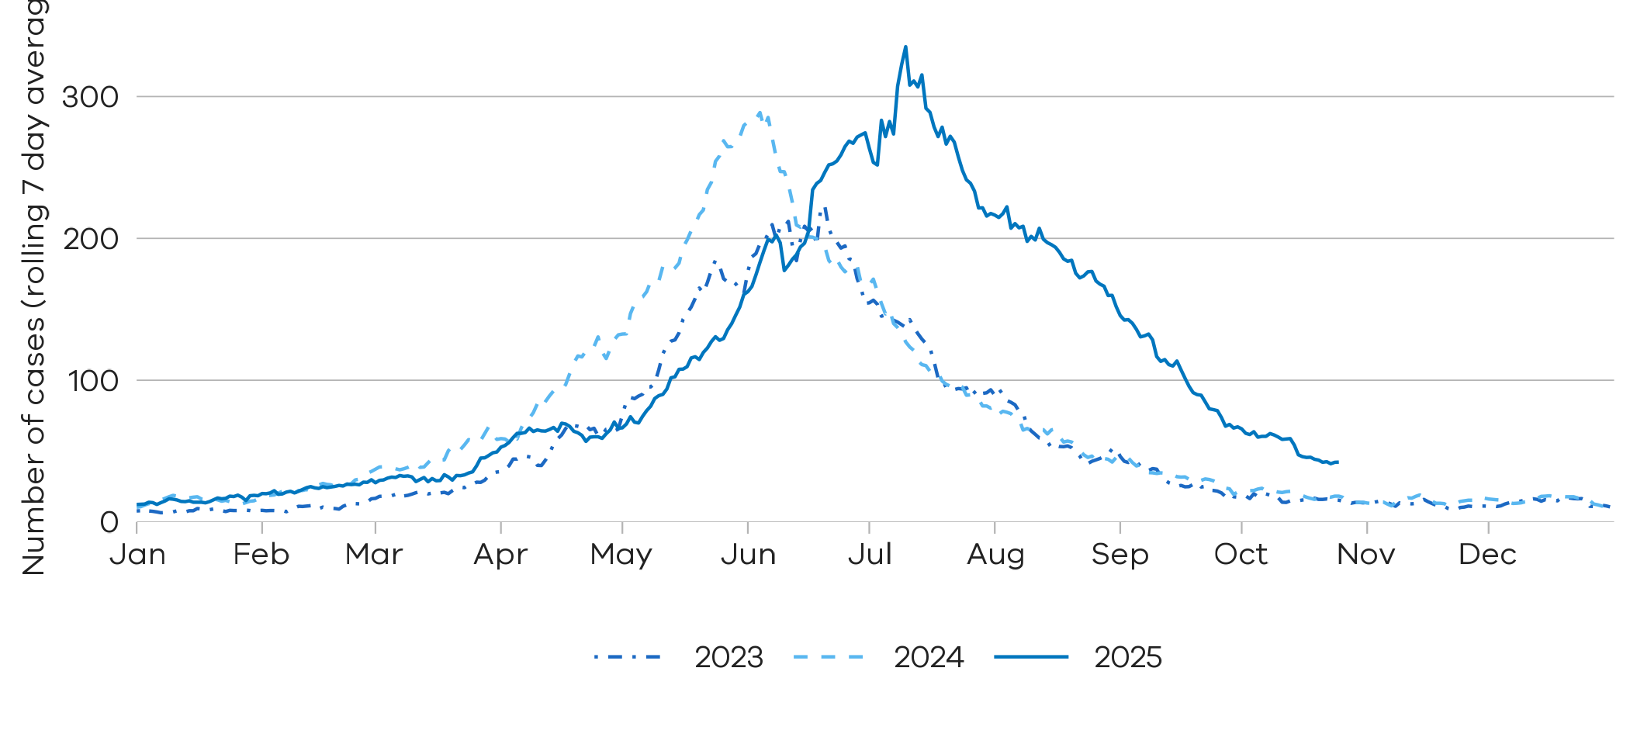
Notified RSV cases are at slightly higher levels compared to the same time in the past two years

Young children and older adults
Young children and older adults are at greater risk of severe disease from RSV.
Figure 8: RSV trends in notified cases by week in young children (under 5 years), Victoria, 27 October 2024 to 25 October 2025
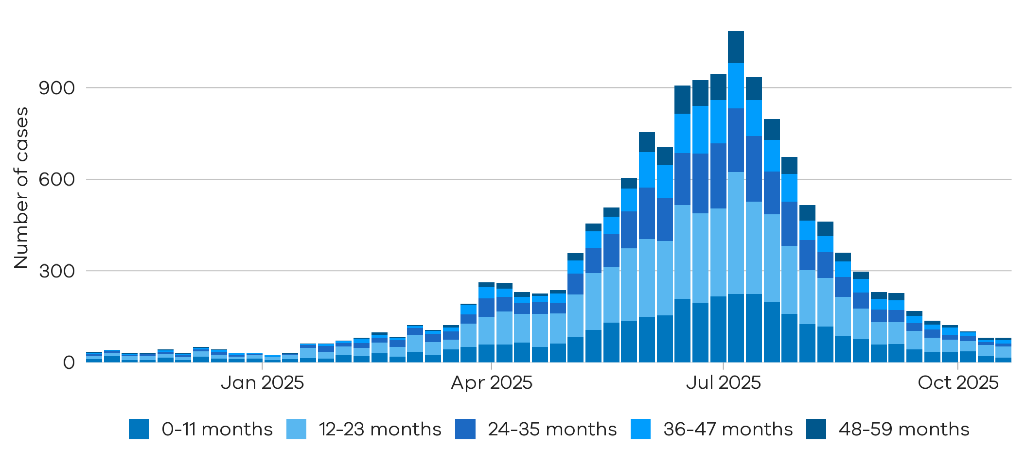
Children under 2 years comprise the majority of notified RSV cases in young children

Figure 9: RSV trends in notified cases by week in older adults (65+ years), Victoria, 27 October 2024 to 25 October 2025
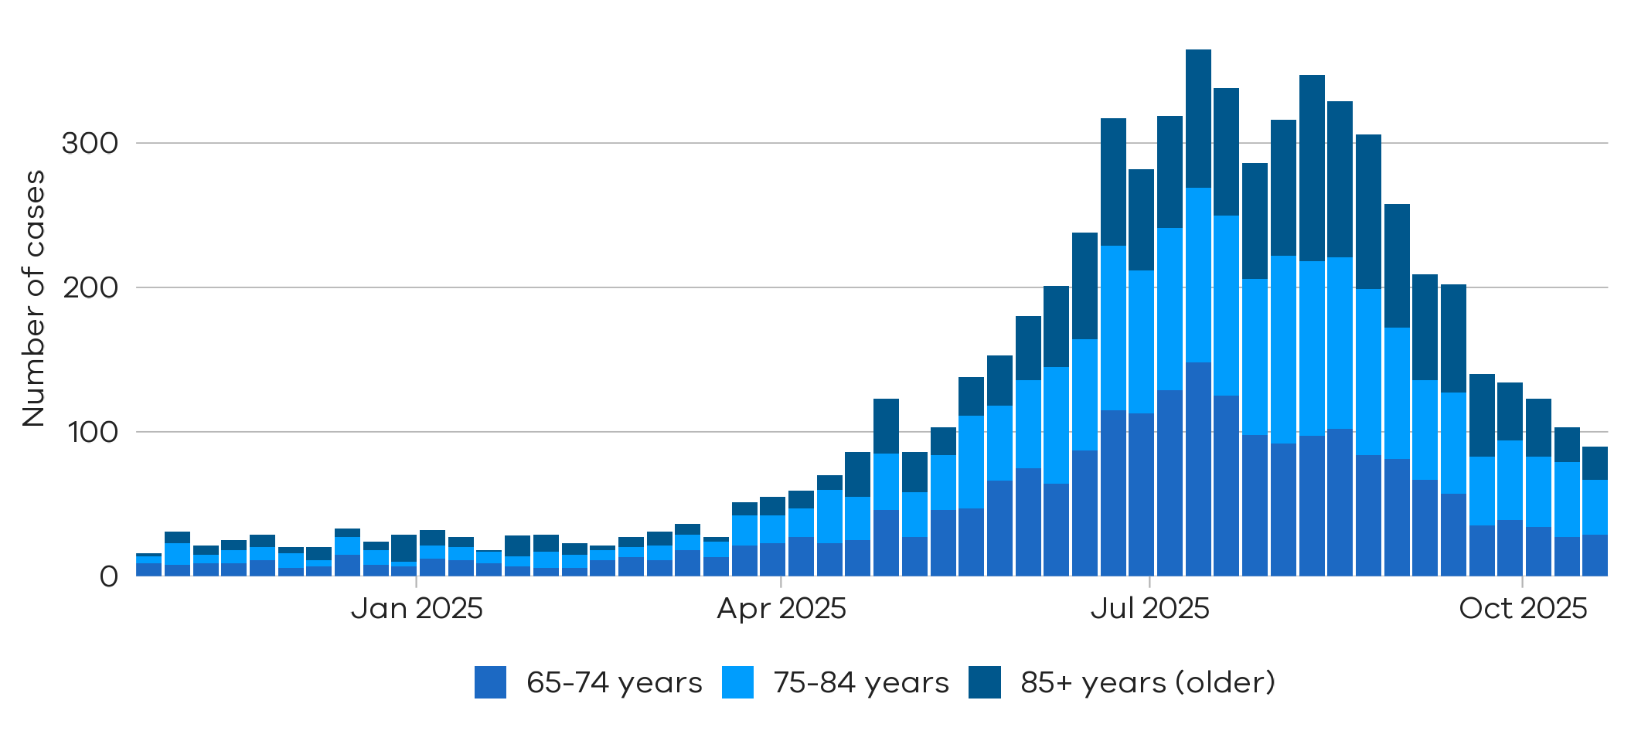
Notified RSV cases in adults aged over 65 years have declined in the recent period

Testing

Laboratory testing for respiratory illnesses changes over time. Tracking the percentage of tests with the notifiable condition detected (i.e. test positivity) is a useful measure to understand trends in disease surveillance over time.
Test results presented in this report are from selected laboratories. These include private and hospital laboratories and represent tests completed across Victoria.

Summary
In the past week, the percentage of COVID-19 tests that were positive have remained stable (2.2% to 2.1%), the percentage of influenza tests that were positive have increased (5.5% to 6.1%) (influenza A: 10.0% to 11.4%; influenza B: 1.1% to 0.8%), and the percentage of RSV tests that were positive were stable (2.5% to 2.3%).

Figure 10: Weekly test positivity for COVID-19, influenza and RSV, Victoria, 27 October 2024 to 25 October 2025
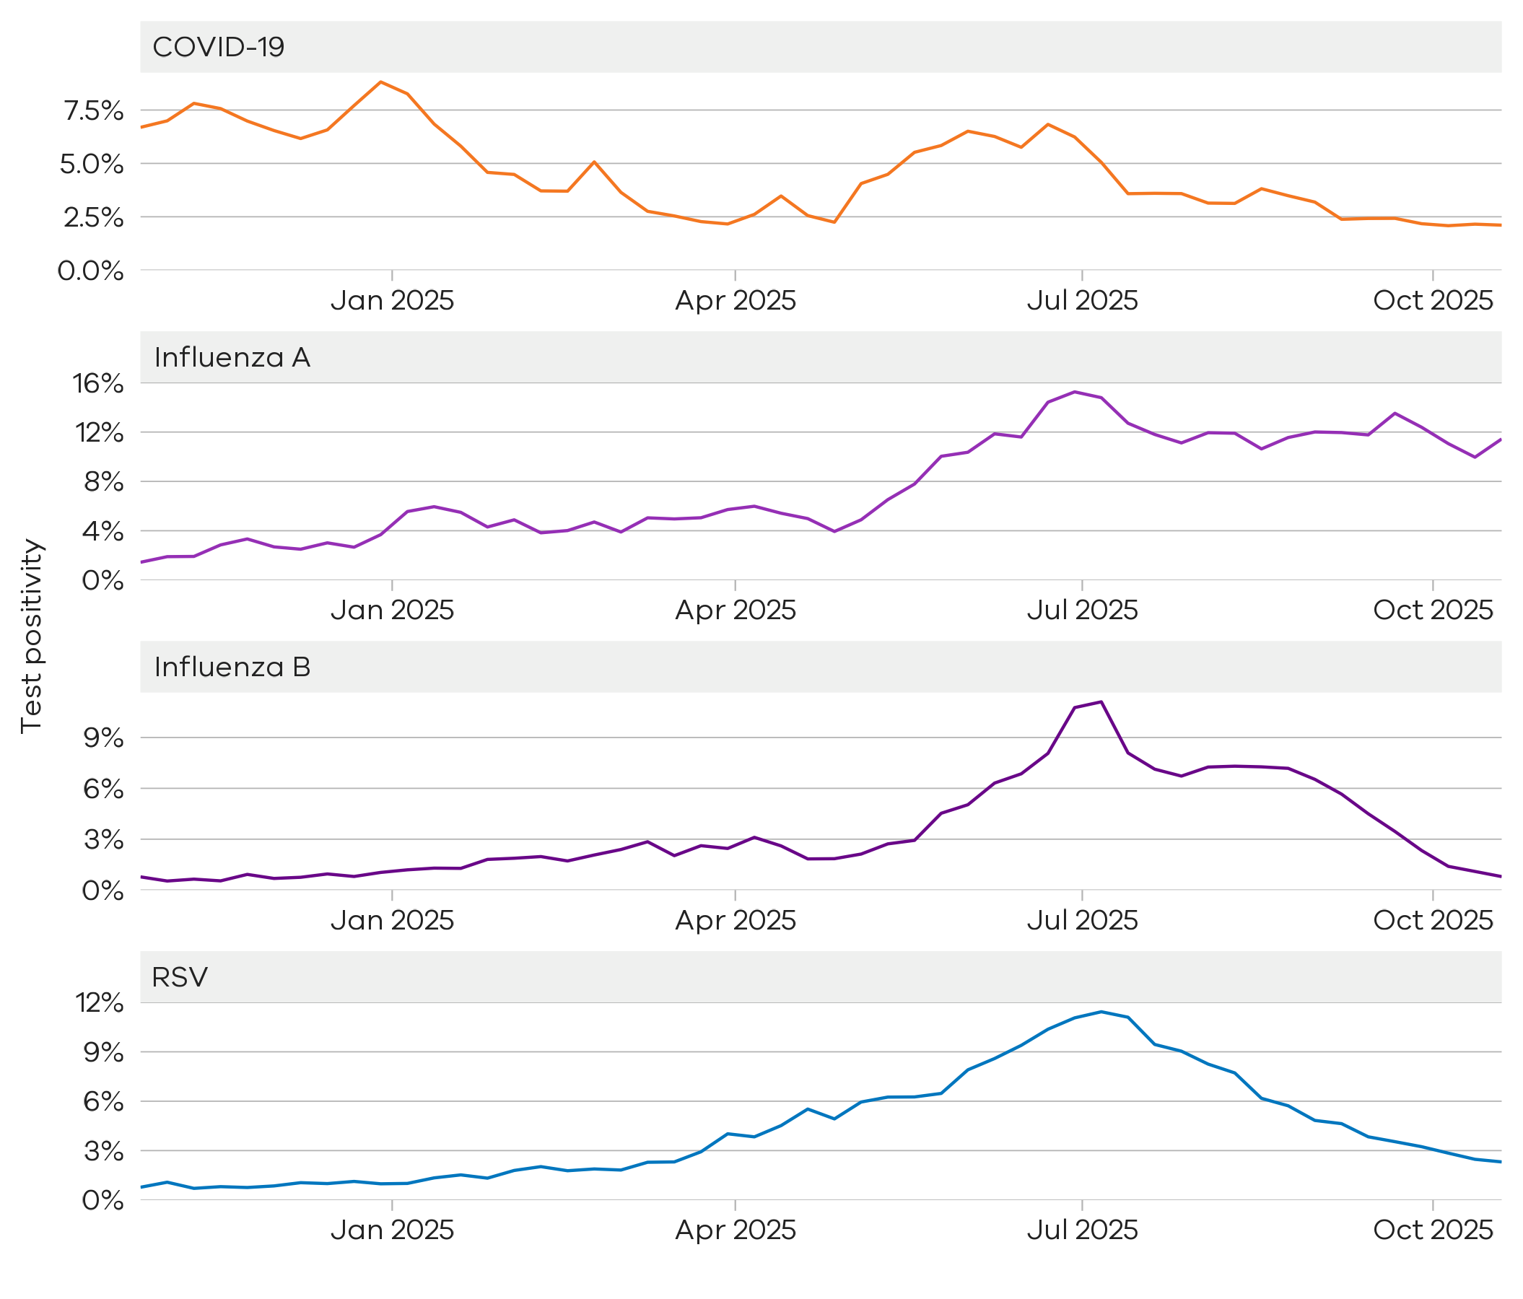

Figure 11: Weekly test positivity by age groups for COVID-19, influenza and RSV, Victoria, 27 October 2024 to 25 October 2025

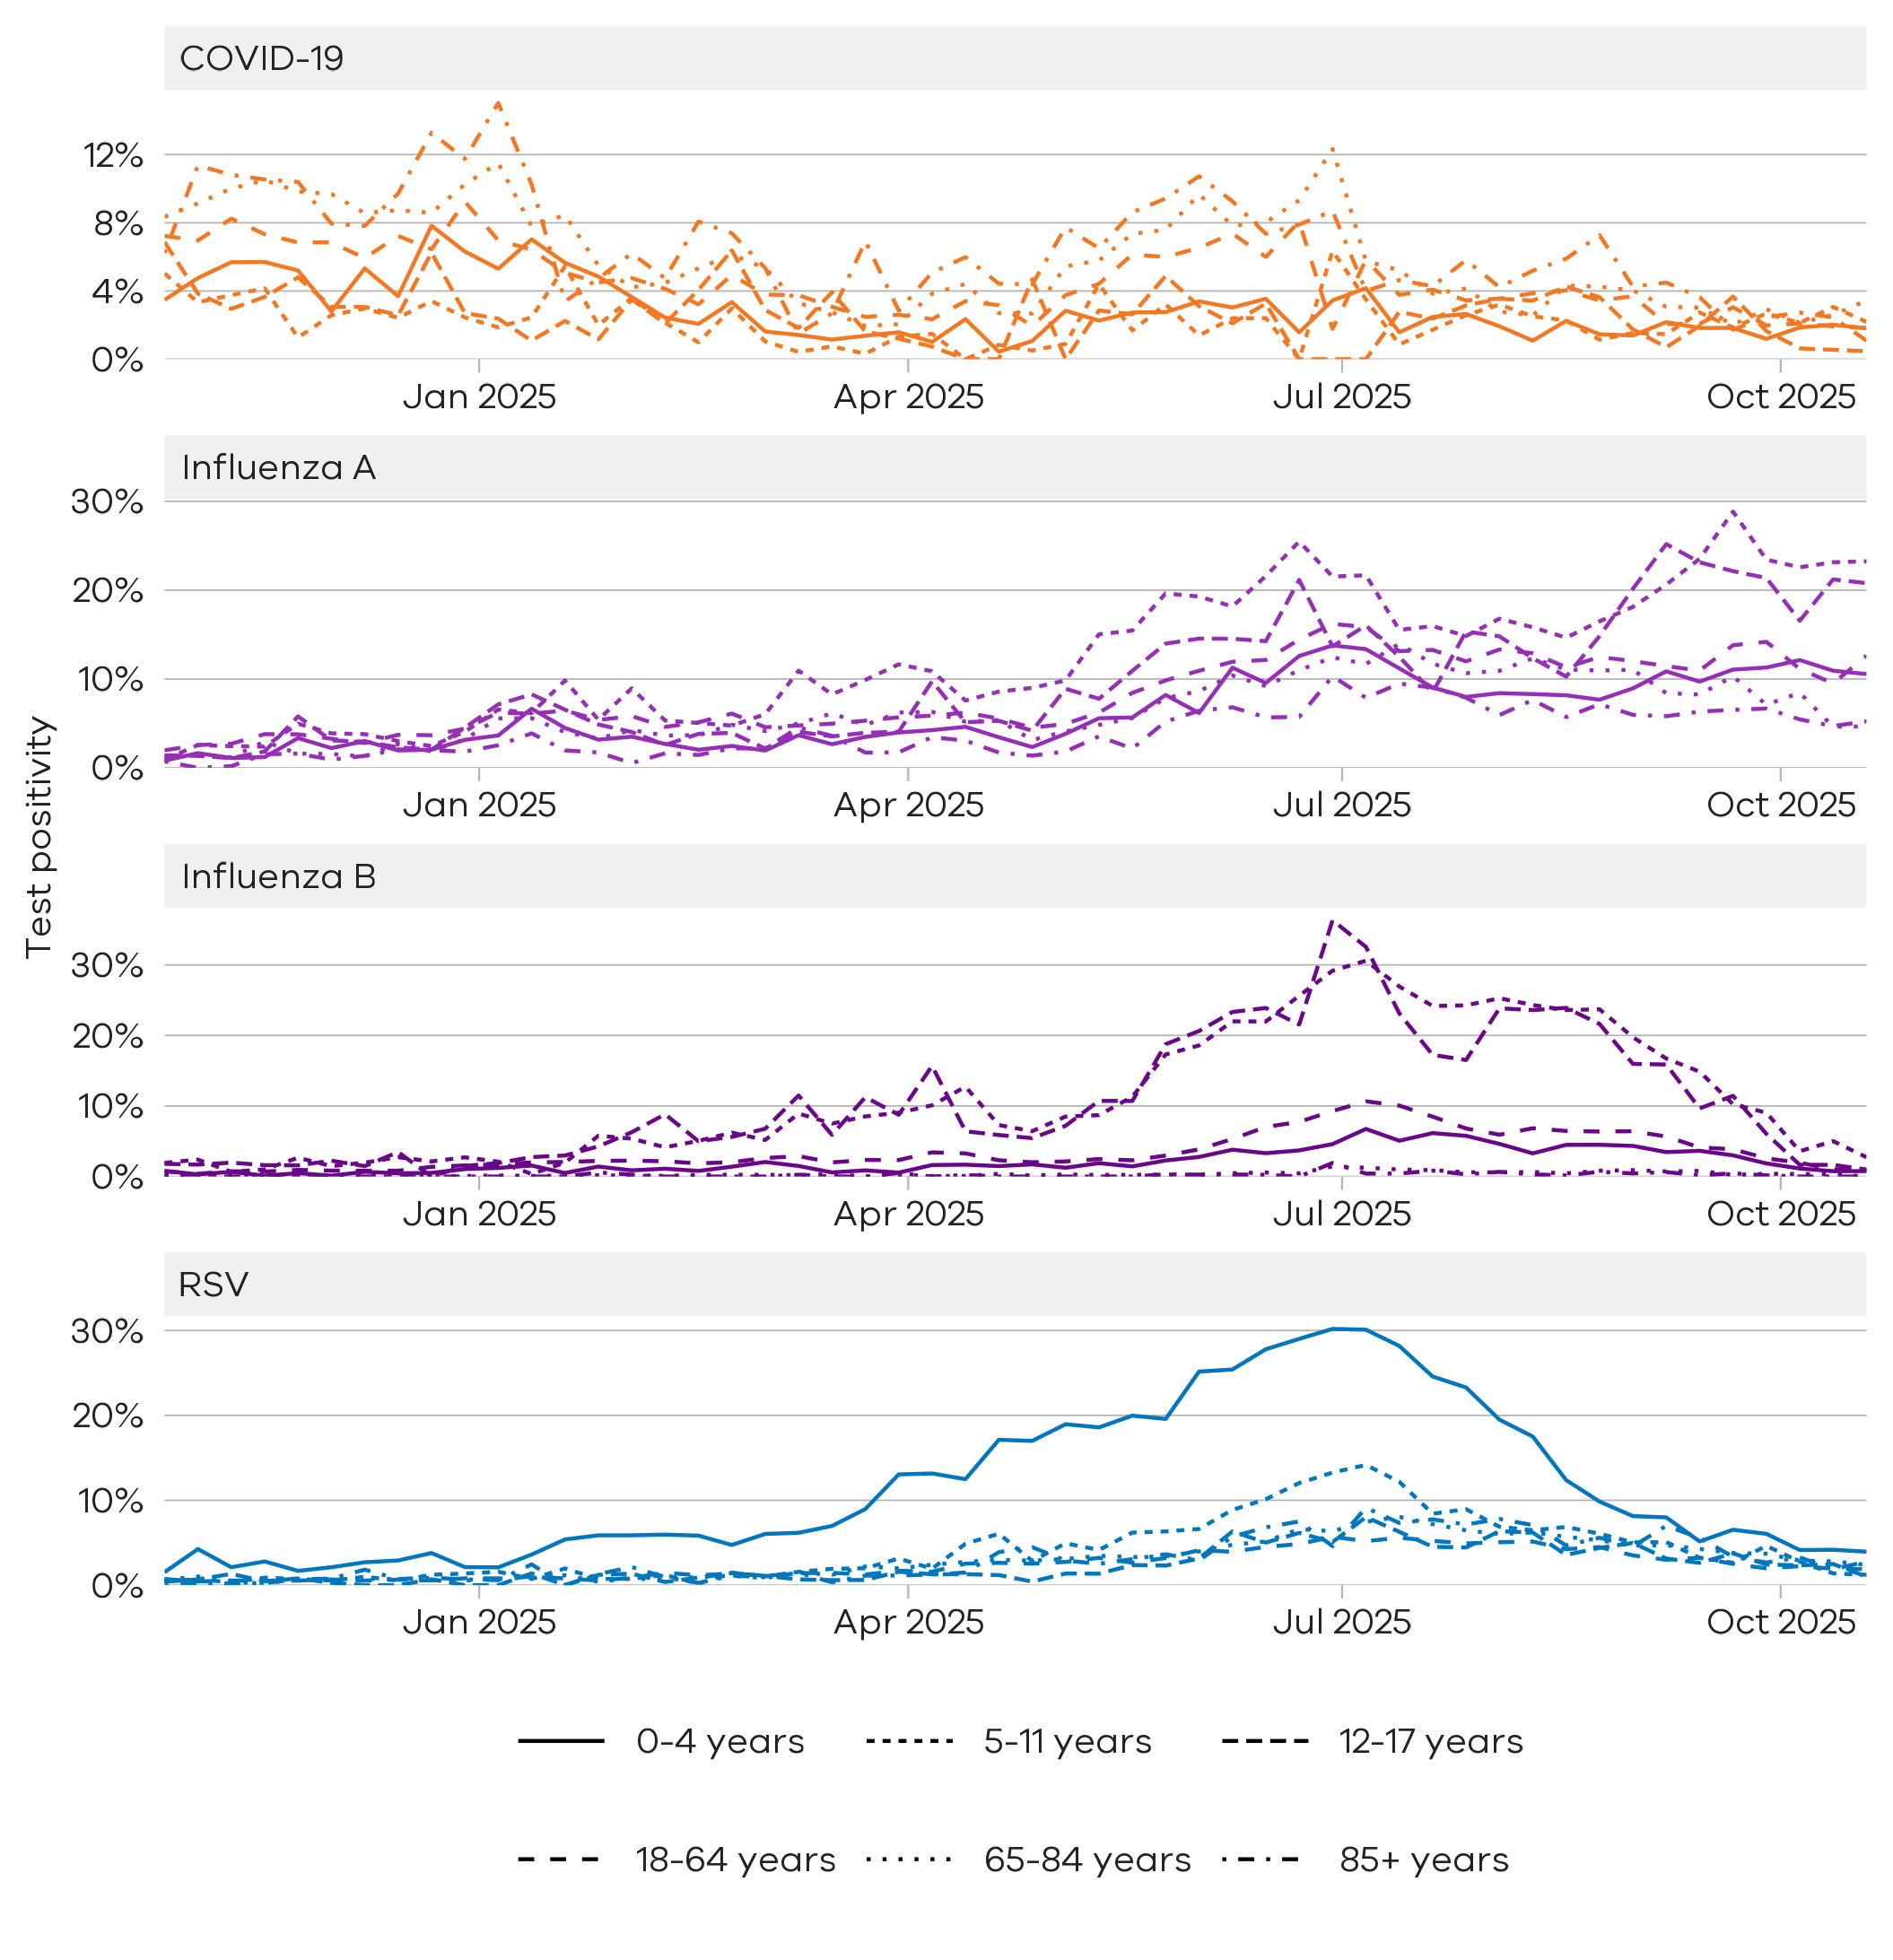

Community surveillance

Respiratory illnesses are not limited to the notifiable conditions presented above. Understanding the overall burden of respiratory illness in the community is useful to understand broader trends in illness over time.
FluTracking
FluTracking is an online surveillance system across Australia, New Zealand, Hong Kong and Fiji. Volunteer participants complete a simple weekly online survey which collects self-reported information on respiratory symptoms. More information about FluTracking and ways to be involved are available here: https://info.flutracking.net/

Summary
In the past week, the percentage of Victorian FluTracking participants reporting respiratory illness (fever and cough) were stable from the previous week.
Figure 12: Proportion of FluTracking participants reporting respiratory illness by week, Victoria, 1 January 2023 to 26 October 2025. Respiratory illness is defined as fever & cough.
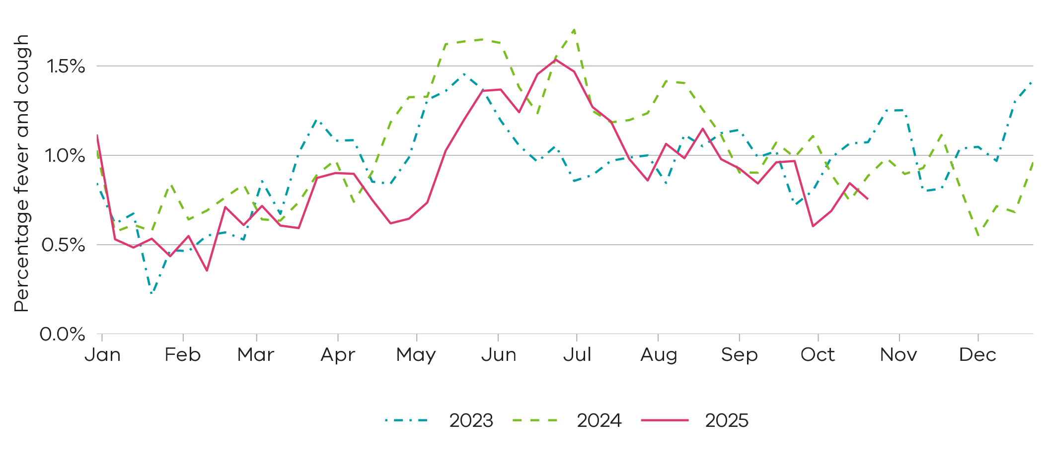
Reported respiratory illness is at slightly lower levels compared to the past two years.

How to use this report

Data sources
All notified cases in Victoria are recorded in the Victorian Public Health Events Surveillance System (PHESS). Under the Public Health and Wellbeing Act 2008 and Public Health and Wellbeing Regulations 2019, the Victorian Department of Health is authorised to collect information from doctors and laboratories about diagnoses of certain health-related conditions in Victoria.
The FluTracking surveillance system collects data from volunteer participants in a weekly survey. FluTracking reports are available here: https://info.flutracking.net/reports/australia-reports/
The Victorian Department of Health continually reviews surveillance methods to monitor respiratory disease in Victoria. Measurements included in this report may be updated or removed accordingly.
Definitions
Notified cases: Laboratory-confirmed cases of COVID-19, influenza, and RSV are reported according to the CDNA case definitions https://www.health.gov.au/resources/collections/cdna-surveillance-case-definitions/ Where multiple positive test results are received for the same person within 30 days of the initial test result they are counted as a single case.
Rapid antigen test results are not collected by the Victorian Department of Health, however, remain an important tool for individuals to access treatment and protect their community.
Case notifications are included in the Victorian dataset if the postcode of residence of the case is in Victoria. This does not necessarily reflect where the infection was acquired.
Test positivity: Test positivity is the percentage of total tests where the notifiable condition was detected. This is reported by the date of specimen collection.
Dates: Case notifications are based on the date the notification was first received by the Victorian Department of Health. Test positivity is based on the date of specimen collection.
Weeks: For the purposes of this report, data are aggregated by week, with the week starting Sunday and ending Saturday unless otherwise specified.

Authorised and published by the Victorian Government, 1 Treasury Place, Melbourne.
© State of Victoria, Australia, Department of Health, October 2025
ISSN 2982-3161 - Online (pdf/word)

