|  |
| --- |
| **Voluntary Assisted Dying Review Board Annual Report** |
| **July 2024 to June 2025** |
|  |



|  |
| --- |
| **Voluntary Assisted Dying Review Board Annual Report**  1 July 2024 to 30 June 2025 |
|  |

|  |
| --- |
|  |
| To receive this publication in an accessible format phone 1300 758 551, using the National Relay Service 13 36 77 if required, or [email Voluntary Assisted Dying](mailto:VADBoard@health.vic.gov.au) <VADBoard@health.vic.gov.au>  Authorised and published by the Victorian Government, 1 Treasury Place, Melbourne.  © State of Victoria, Australia, September 2025 (2505197)  ISSN 2652-1962 – Print  ISSN 2652-1970 – Online (pdf/word)  Available at the [Department of Health website](https://www.health.vic.gov.au/)­ <https://www.health.vic.gov.au> |
|  |

# Acknowledgement of Country

The Voluntary Assisted Dying Review Board acknowledges the Traditional Custodians of the lands, waters, and skies across Victoria.

We recognise that Aboriginal and Torres Strait Islander people in Victoria practice their lore, customs and languages, and nurture Country through their deep spiritual and cultural connections to land and water.

We are committed to a future based on equality, truth and justice. We acknowledge that the entrenched systemic injustices experienced by Aboriginal and Torres Strait Islander people endure, including in our health system, and that Victoria’s ongoing treaty and truth-telling processes provide an opportunity to right these wrongs and ensure Aboriginal and Torres Strait Islander people have the freedom and power to make the decisions that affect their communities.

We express our deepest gratitude and pay our deepest respects to Elders past and present and extend this to all First Nations people.

Contents

Acknowledgement of Country 4

Foreword 6

Introduction 10

Snapshot 11

The request and assessment process 14

Medical practitioner engagement and participation 17

People who applied for voluntary assisted dying 23

Applications and assessments 29

Permit outcome and substance dispensing 36

Timeframes 38

Deaths 45

Reflections 49

Compliance reviews 50

Review of the Operation of Victoria’s Voluntary Assisted Dying Act 2017 52

Continuous improvement and reflections on recommendations of the review 53

Stakeholder engagement and consultation 59

Board reflections on amendments to the Act 61

Research and data 65

Appendices 66

# Foreword

Compassionate end-of-life care recognises and responds to the physical, emotional, and psychological distress that can accompany dying. This involves person-centred care that respects personal autonomy, facilitates informed decision-making, and ensures timely access to end-of-life care options. These principles govern voluntary assisted dying in Victoria and guide the Board’s mandate to promote equitable access and to uphold a system that is both safe and compassionate.

In its sixth year of operation, the *Voluntary Assisted Dying Act 2017* (the Act) continued to afford terminally ill Victorians personal autonomy and choice at end of life. Community approval and support for the provision of voluntary assisted dying continues to grow, as does the expectation for broader eligibility and access to this end-of-life care option.

The Board is satisfied that over the past 12 months the objective to provide safe access to voluntary assisted dying was realised. However, barriers to timely access and concerns around program sustainability remain. Addressing these matters is essential to realising compassionate end-of-life care for more Victorians.

## The year in review

In 2024–25, the Board received an unprecedented 837 requests for voluntary assisted dying (VAD). As community awareness continues to grow, the Board anticipates this will rise significantly. Projections indicate there may be around 1,300 requests each year by 2028. This growth means Victoria will need to adjust the way it supports the system through which VAD requests proceed.

VAD deaths accounted for 0.85% of all deaths in Victoria, consistent with the previous year.

There was a modest 1% increase in self-administration permits issued, alongside a significant 28% rise in practitioner administration permits. In correlation with this, the proportion of VAD deaths involving practitioner administration rose to 23%. This was a 19% increase from the previous year. Under Victorian law, practitioner administration is only permitted when an applicant is unable to self-administer. By contrast, in some other Australian jurisdictions, applicants may choose their preferred mode of administration.

During 2024–25, 171 applicants died before receiving a permit. The majority of these applicants had only completed a first or consulting assessment before their death. Additionally, 28% of applications were withdrawn before the substance was dispensed, and in 40% of these cases, the applicant died within 2 weeks of their first request.

This is consistent with what we have seen over the past 6 years. This pattern suggests that many patients begin the application process very late in the course of their illness. The Board remains concerned about the significant proportion of individuals who request VAD but die before they can access it.

Several factors may contribute to this. Many people may underestimate the complexity and duration of the VAD process. They may expect to receive a prescription shortly after consulting their doctor. Others may delay initiating a request due to the emotional difficulty and time needed to confront a terminal diagnosis.

A coronial finding during the year also drew attention to several instances where a person took their own life after being found ineligible for VAD or believed that they would be.

The current prohibition on health practitioners initiating discussions about VAD also presents a significant barrier. The Board continues to receive reports of patients whose requests were ignored or obstructed by practitioners, or who experienced delays because practitioners were unfamiliar with the legislation or referral pathways.

The Board is also concerned about ongoing disparities in equitable access, particularly for people from regional communities. Although 25% of Victorians live in rural or regional areas, 39% of VAD requests originated from these regions. Despite this over-representation, regional applicants face significant barriers to accessing VAD. These include limited access to practitioners and the prohibition on using telehealth for consultations.

In addition, it can take considerable time to complete the full process from assessment to permit approval and substance dispensing. These delays can be critical for applicants whose condition is rapidly deteriorating. This report further explores the impact of the legislation on these timeframes.

Addressing these barriers is essential to ensuring equitable access for all Victorians and the ongoing sustainability of the program.

## Review of the Operation of the Act

In October 2024, the Board welcomed the findings and recommendations of the *Review of the Operation of the Voluntary Assisted Dying Act 2017* (the Review) and extends its gratitude to all involved, particularly members of the public and health professionals who contributed their voices to the evaluation. The Review affirmed that the Board is achieving its responsibilities to promote and ensure compliance with the Act.

During 2024–25, the Board continued to promote and facilitate ways to meet recommendations made by the Review to better realise the goal of compassionate care. The Board’s ongoing work in continuous improvement and response to the recommendations made are contained within this report.

## Introducing legislation to amend the Act

The Board welcomes the announcement from the Minister for Health, which committed to reviewing and amending the Act. The Minister for Health stated[1]:

While our Australian-first voluntary assisted dying laws are giving Victorians the dignity of making their own decisions about the timing and manner of their death – we know we need to update them to ensure they remain fair. Reforming our VAD laws to bring them in line with other states is critical to maintaining a service that is accessible to all Victorians, no matter where they live.

Amending the Act will advance the goal of delivering safe and compassionate end-of-life care. The Board’s reflections on amendments to the Act are contained within this report.

## Harmonisation with other jurisdictions

VAD is now available in all Australian states and New Zealand, which provides valuable opportunities to harmonise practices and learn from shared experiences. The Trans-Tasman VAD Chairs Forum, which meets quarterly, plays a key role in this collaboration.

Together with the Forum, the Board continues to advocate for the removal of the Commonwealth prohibition on telehealth in VAD. We continue to work towards standardising data collection and reporting across jurisdictions and promoting best practice.

## Compliance and monitoring for continuous improvement

At the heart of the Board’s activity are two primary roles:

* reviewing every case after completion to ensure compliance with the legislation and to monitor safety and quality
* monitoring the system and promoting continuous improvement.

The Board thanks all the contact people, family members and medical practitioners who share their feedback. This helps us continually improve the program. That such feedback often comes from people still impacted by bereavement, and in many cases in need of support for themselves, makes it all the more valued.

### Recognising the contributions of the Board

This year was a significant period of transition for the Board. We farewelled Mr Julian Gardner AM and welcomed the appointment of Professor Euan Wallace AM as Chairperson in August 2025.

With the conclusion of terms for the inaugural members in June 2024, 6 new members were appointed and 3 reappointed. Among them was Dr Mitchell Chipman, who generously extended his service to support continuity during this period of change.

Of the new appointees, 4 are clinicians who have previously provided VAD services as a co-ordinating or consulting practitioner. Their perspectives bring valuable insight to VAD’s practical challenges and benefits.

In May 2025, Julian retired from his role, concluding an extensive and influential involvement with the development of VAD in Victoria. His work began as a member of the Ministerial Advisory Panel (2017–18), which advised on the drafting of the original legislation, and continued through his leadership of the VAD Implementation Taskforce (2018–19).

Julian’s leadership, thoughtful guidance and legal expertise have been pivotal in shaping a program that is safe, compassionate and trusted by the community. His legacy extends beyond Victoria, and his work has influenced VAD programs in other Australian states and international jurisdictions that have drawn on the Victorian model.

On behalf of the Victorian community and fellow board members, we extend our sincere gratitude to Julian for his dedication and service.

The Board is supported by the Secretariat within the Department of Health. I express my appreciation and that of the Board. We could not function effectively without this team’s professionalism.

The successful delivery of VAD relies on the dedication of medical practitioners and a broader network of health professionals, including care navigators, pharmacists and health service coordinators.

The Board acknowledges the vital contributions of the Statewide Care Navigator Service and the Statewide Pharmacy Service, both of which consistently provide timely and compassionate support to applicants and families.

We extend special recognition to Victoria’s medical practitioners. Families and support people often highlight the compassionate care they receive, which is provided in a context of limited remuneration and significant time demands.

The Board also acknowledges the critical role played by family members and loved ones in supporting applicants. We recognise their grief and loss.

Looking ahead, the Board warmly welcomes Professor Euan Wallace AM and looks forwards to his leadership in advancing reforms that remove barriers to timely access and compassionate care.

His guidance will foster greater engagement from Victorian medical practitioners and health services who support patients who have chosen voluntary assisted dying.

**Paula Shelton  
Deputy Chairperson  
Voluntary Assisted Dying Review Board**

# Introduction

In addition to six half-year reports, this is the fourth annual report from the independent Voluntary Assisted Dying Review Board (the Board).

The report sets out:

* activity from 1 July 2024 to 30 June 2025, as well as activity since the commencement of the *Voluntary Assisted Dying Act 2017* (Vic) on 19 June 2019
* the Board’s reflections drawn from case reviews and feedback.

This report contains quotes and feedback from:

* people who have voluntarily chosen to die from taking the assisted dying substance
* those who were with them towards the end of life and at death
* trained medical practitioners involved in voluntary assisted dying requests.

The quotes have been deidentified to protect privacy. This content may be distressing for some readers. Appendix 3 provides contact details for support organisations.

By law, the Board is required to produce an annual report at the end of each financial year. The next report will be submitted by the end of September 2026. It will cover the reporting period 1 July 2025 to 30 June 2026.

## Information on financial reporting

The Board does not operate a budget associated with the delivery of voluntary assisted dying or operations under the *Voluntary Assisted Dying Act 2017*. Therefore, no financial reporting is required or provided within this report.

## More information

Access more information on the:

* [Voluntary Assisted Dying Review Board web page](https://www.health.vic.gov.au/voluntary-assisted-dying/voluntary-assisted-dying-review-board)[2]
* [About voluntary assisted dying web page](https://www.health.vic.gov.au/voluntary-assisted-dying/about).[3]

## Data sources

Data in this report has been obtained from the Voluntary Assisted Dying Portal (the Portal). The Portal is an information management system for reporting and managing required information related to voluntary assisted dying in Victoria. The Board receives approved forms via the Portal at each stage of the voluntary assisted dying process.

Data has also been obtained from the Department of Health, the Victorian Registry of Births, Deaths and Marriages, Statewide Pharmacy Service (Alfred Health), and the Statewide Care Navigator Service (Peter MacCallum Cancer Centre).

# Snapshot

Figure 1: Voluntary assisted dying minimum dataset, 1 July 2024 to 30 June 2025

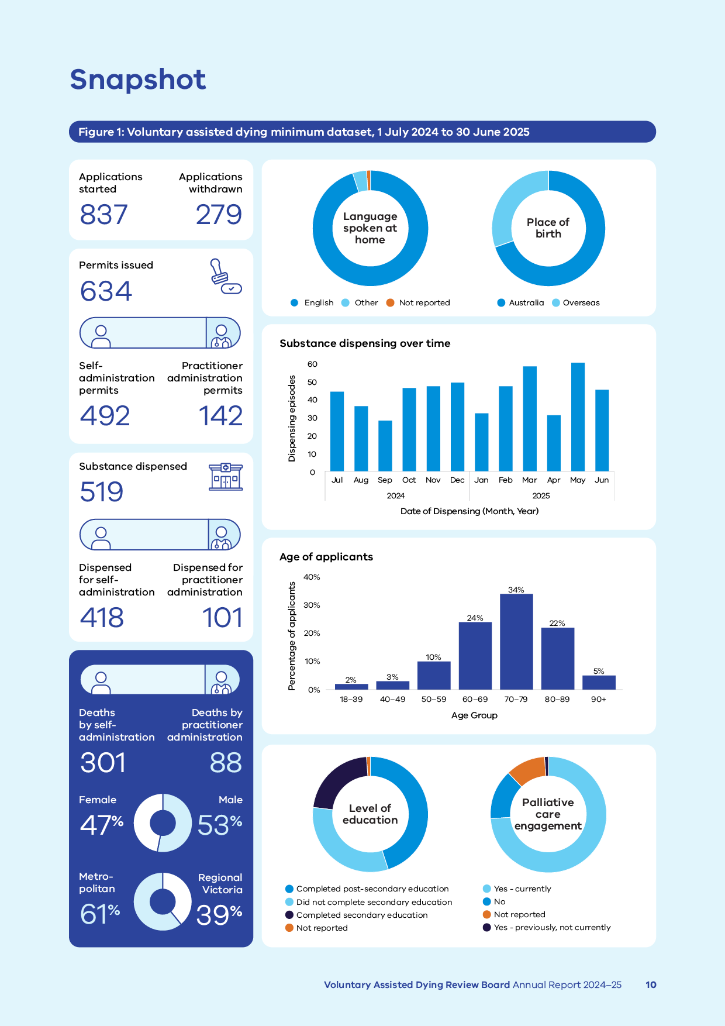

Figure 1 includes the following data:

* number of applications started – 837
* withdrawn applications – 279
* permits issued – 634
* self-administration permits issued – 492
* practitioner administration permits issued – 142
* substance dispensed – 519
* dispensed for self-administration – 418
* dispensed for practitioner administration – 101
* deaths by self‑administration – 301
* deaths by practitioner administration – 88
* female – 47%
* male – 53%
* metropolitan – 61%
* regional Victoria – 39%.

## In the 2024–25 reporting year

* 799 first assessments completed
* 634 permits issued to prescribe self- or practitioner administration of VAD substance
* 389 deaths from administration of VAD substance
* 30% of applicants with a permit died without administration of a VAD substance[4]
* 53% of applicants with a first assessment died from administration of a VAD substance[5]

| 799  First assessments completed | 634  Permits issued to prescribe self- or practitioner administration of VAD substance | 389  Deaths from administration of VAD substance | 30%  of applicants with a permit died without administration of a VAD substance | 53%  of applicants with a first assessment died from administration of VAD substance |
| --- | --- | --- | --- | --- |

## Since commencement of the Act

* 3,568 first assessments completed
* 2,758 permits issued to prescribe self- or practitioner administration of VAD substance
* 1,683 deaths from administration of VAD substance
* 32% of applicants with a permit died without administration of a VAD substance4
* 52% of applicants with a first assessment died from administration of a VAD substance5

| 3,568  first assessments completed | 2,758  permits issued to prescribe self- or practitioner administration of VAD substance | 1,683  deaths from administration of VAD substance | 32%  of applicants with a permit died without administration of a VAD substance | 52%  of applicants with a first assessment died from administration of VAD substance |
| --- | --- | --- | --- | --- |

# The request and assessment process

Access to VAD has strict eligibility requirements and is a highly controlled process. Figure 2 sets out the simplified steps a person and their medical practitioners must take to apply for and obtain a permit. The full process is detailed in the Act.

Figure 2: Request and assessment process

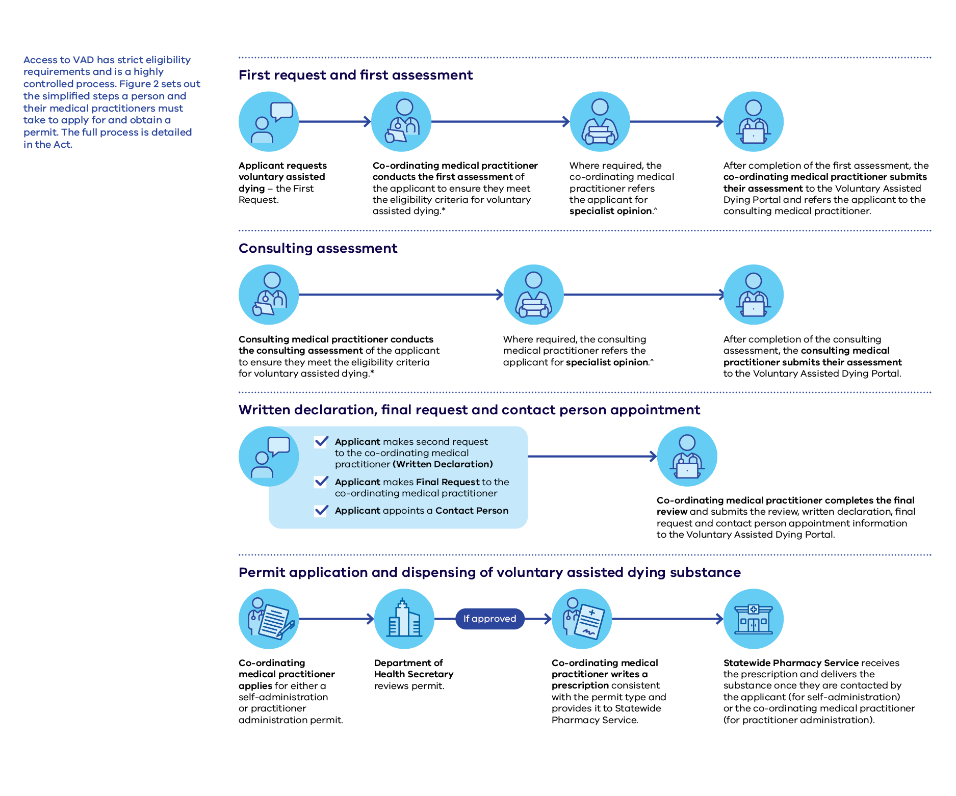

First request and first assessment

* Applicant requests voluntary assisted dying – the first request.
* Co-ordinating medical practitioner conducts the first assessment of the applicant to ensure they meet the eligibility criteria for voluntary assisted dying.[6]
* Where required, the co-ordinating medical practitioner refers the applicant for specialist opinion.[7]
* After completion of the first assessment, the co-ordinating medical practitioner submits their assessment to the Voluntary Assisted Dying Portal and refers the applicant to the consulting medical practitioner.

Consulting assessment

* Consulting medical practitioner conducts the consulting assessment of the applicant to ensure they meet the eligibility criteria for voluntary assisted dying.[8]
* Where required, the consulting medical practitioner refers the applicant for specialist opinion.[9]
* After completion of the consulting assessment, the consulting medical practitioner submits their assessment to the Voluntary Assisted Dying Portal.

Written declaration, final request and contact person appointment

* Applicant makes second request to the co-ordinating medical practitioner (written declaration).
* Applicant makes final request to the co-ordinating medical practitioner.
* Applicant appoints a contact person.
* Co-ordinating medical practitioner completes the final review and submits the review, written declaration, final request and contact person appointment information to the Voluntary Assisted Dying Portal.

Permit application and dispensing of voluntary assisted dying substance

* Co-ordinating medical practitioner applies for either a self-administration or practitioner-administration permit.
* Department of Health Secretary reviews permit.
* If approved:
  + Co-ordinating medical practitioner writes a prescription consistent with the permit type and provides it to Statewide Pharmacy Service.
  + Statewide Pharmacy Service receives the prescription and delivers the substance once they are contacted by the applicant (for self‑administration) or the co-ordinating medical practitioner (for practitioner administration).

# Medical practitioner engagement and participation

Medical practitioners in Victoria provide compassionate care to people who seek VAD. Practitioners play a crucial role in supporting applicants and ensuring access to this end-of-life option. They consistently deliver safe, high-quality care to applicants.

Victoria needs a well-trained and supported group of practitioners to meet the growing number of VAD requests.

## Training and registration

There has been continual growth in the number of medical practitioners registering to complete the online training program since VAD came into operation in Victoria.

On 30 June 2025, there were 423 medical practitioners with active profiles in the VAD Portal. Practitioner profiles may become inactive after registration if a practitioner retires or ceases to be involved in the VAD program.

General practitioners make up 52% of all medical practitioners registered in the Portal.

In regional Victoria, general practitioners make up 68% of all practitioners registered to provide VAD.

Medical practitioners must successfully complete Victoria’s mandated training program before they can undertake VAD eligibility assessments.

Medical practitioners often complete the training to support a patient who has requested their assistance to access VAD. They may also complete the training so they are ready to help a patient in the future.

Practitioners complete the VAD online training in their own time at their preferred pace. They may also complete the training at one of the many training days hosted throughout the year by the Statewide Care Navigator Service at various health service sites across the state.

The [Department of Health web page for VAD medical practitioner training](https://www.health.vic.gov.au/voluntary-assisted-dying/training-for-medical-practitioners)[10] provides more information for practitioners. To find out about in-person and online training, email [vadcarenavigator@petermac.org](mailto:vadcarenavigator@petermac.org) or phone 03 8559 5823.

Table 1: Medical practitioner training and involvement since commencement of training availability

| **Stage** | **Description** | **Total as of 30 June 2021** | **Total as of 30 June 2022** | **Total as of 30 June 2023** | **Total as of 30 June 2024** | **Total as of 30 June 2025** | **Change (%)** |
| --- | --- | --- | --- | --- | --- | --- | --- |
| Online training | Medical practitioners registered for the online training program | 511 | 618 | 734 | 822 | 938 | +14% |
| Portal registration | Trained medical practitioners registered in the Portal | 234 | 326 | 347 | 394 | 423 | +7% |
| Case participation | Participation by the medical practitioner in at least one case as either the co-ordinating or consulting medical practitioner | 154 | 185 | 208 | 318 | 365 | +15% |

Figure 3: Number of medical practitioners newly registered in the voluntary assisted dying Portal, by Portal registration date

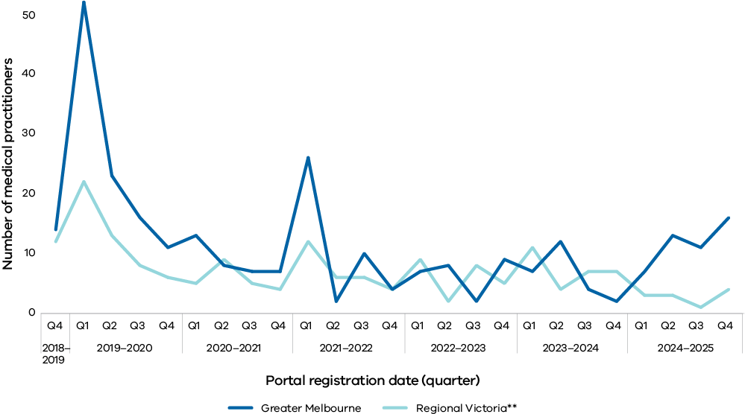

Notes:

Numbers include medical practitioners who have since deactivated.

‘Regional Victoria’ includes 3 trained and registered medical practitioners whose principal place of practice is in New South Wales. They registered in Q3 2023–24, and Q2 and Q4 2024–25.

## Participation

As of 30 June 2025, 423 medical practitioners were registered to provide assessments for applicants seeking VAD.

Of these, 54% were active in this reporting period. This means they participated as a co-ordinating or consulting medical practitioner in at least one VAD request during 2024–25.

The other 46% of registered practitioners did not actively participate during the year.

In addition, in 2024–25 there were:

* 56 new medical practitioners who completed training and registered on the Portal. Of these, 34 submitted their first assessment during 2024–25
* 228 active registered practitioners, which is a 42% increase from the previous year in the number of registered practitioners who submitted at least one assessment during the reporting period. However, 27% of these active practitioners submitted only **one** assessment for the entire reporting period
* 228 registered practitioners who submitted 1,487 first and consulting assessments, averaging 6.5 assessments per medical practitioner. In the previous year, 161 registered practitioners submitted 1,365 first and consulting assessments, averaging 8.5 assessments per medical practitioner.

Despite the increase in the number of practitioners actively participating in a VAD request this year, the average number of assessments remains relatively high for a small number of medical practitioners.

Half of all the assessments in this reporting period were submitted by 32 individual medical practitioners, representing 8% of the trained and registered cohort. On average, each of these 32 medical practitioners submitted 23 assessments.

The 10 medical practitioners with the highest assessment load in this reporting period submitted 26% of all assessments (both co-ordinating and consulting assessments) in 2024–25.

Of these practitioners, each submitted an average of 39 assessments.

Only 2 of these medical practitioners are in regional Victoria. Between them, these 2 medical practitioners submitted 6% of total assessments during this reporting period.

## Geographical distribution

In 2024–25, there were 8 medical practitioners trained to provide VAD per 100,000 adults in Victoria.[11] As of 30 June 2025, 63% of registered VAD practitioners are based in metropolitan Melbourne, while 37% primarily practise in regional Victoria.

Since the program’s commencement, the ratio of medical practitioners to applicants is 1 to 8 in both metropolitan and regional areas.

Practitioners in regional Victoria are concentrated around the larger towns in central Victoria, Geelong and the Bellarine peninsula, and the Hume region. There are very few active practitioners in the Grampians region, and specifically Ovens Murray and Goulburn Valley in the Hume region. These areas account for less than 5% of the registered practitioner cohort.

The geographical distribution of VAD practitioners broadly aligns with the population distribution in Victoria. However, some large geographic areas have few, if any, medical practitioners. The concentration of practitioners in larger towns and metropolitan Melbourne and their scarcity in regional areas exacerbates the challenges for regional Victorians who wish to access VAD services.

Regional patients and practitioners may have to travel significant distances to facilitate the required in-person assessments and discussions about VAD. In some instances, co-ordinating medical practitioners have been unable to progress an applicant’s request because there were no consulting medical practitioners who could practicably travel to the applicant’s location.

Thirty-seven per cent of VAD requests are made by people living in regional Victoria. The rate of death by VAD is consistently higher in regional and rural areas compared with metropolitan areas. The variance between metropolitan and regional Victoria underscores the importance of engaging and supporting practitioners servicing those areas.

Removing the prohibition on telehealth would help bridge this gap and improve access to VAD for people outside metropolitan areas.

Overall, addressing these challenges will help to ensure that all patients, regardless of their location, have equitable and timely access to VAD services.

Figure 4: Clinical specialities of medical practitioners by primary location of practice

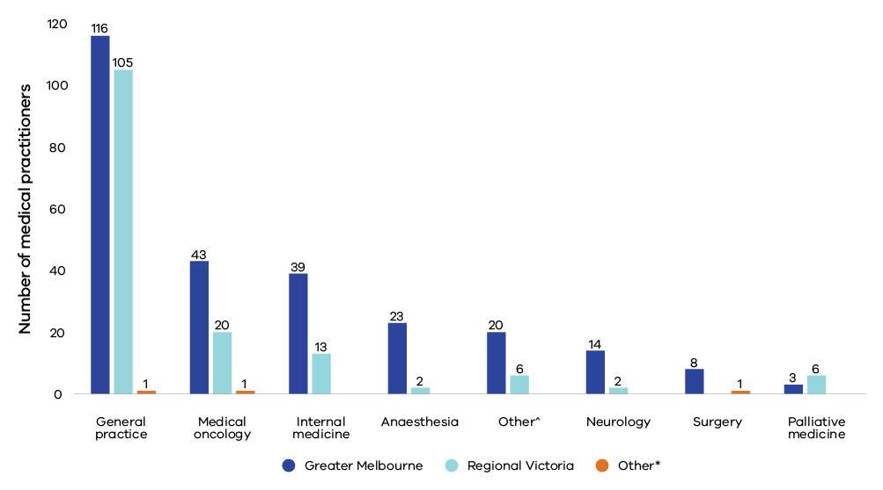

Notes:

A medical practitioner may have more than one medical specialisation.

‘Other’ specialities include haematology, emergency medicine, psychiatry and radiation oncology.

*‘Other’ regions include 3 medical practitioners whose principal place of work is registered in Albury, New South Wales.

**Figure 5: Geographic distribution of medical practitioners**

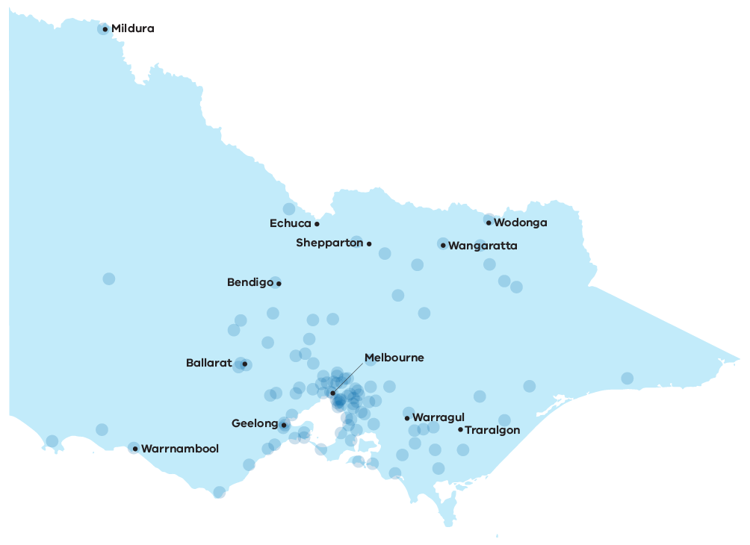

## Engagement and sustainability

Since the commencement of the program in June 2019, a small cohort of practitioners has undertaken the majority of assessments.

The Board recognises that continuing to rely on a small number of practitioners is a significant risk to the sustainable delivery of an equitable VAD program.

Victoria has made progress in training and registering practitioners, but there are still opportunities to expand and further support the workforce to better ensure its sustainability.

In particular, and as highlighted in the *Five Year review of the Operation of the Voluntary Assisted Dying Act 2017*, relying on the existing cohort of practitioners will limit the program’s capacity to meet growing demand.

Somewhat reassuringly, while the number of permits issued in 2024–25 (n = 634) increased by 73% compared with 2020–21 (n = 366), the number of practitioners with an active profile in the program increased by 82% over the same period (423 in 2024–25 compared with 234 in 2020–21).

Nonetheless, loss of active practitioners from the program – whether due to occupational fatigue, psychosocial stress or retirement – risks placing further strain on an already small workforce, particularly in rural and regional areas.

Broadening the practitioner base will alleviate this pressure and increase the diversity of clinical expertise and experience. This will help to ensure the program can meet applicants’ needs, whatever their underlying condition and wherever they reside in Victoria.

There is a paucity of VAD trained doctors able to offer an expert opinion in the applicant’s pathology.  
**Medical practitioner**

There are also a number of measures that may both help sustain practitioners currently registered with the program and encourage others to become registered. For example, introduction of VAD protocols and policies, and improving access to the VAD Portal (the application management system used to submit VAD assessments) across health networks, hospitals, and residential care facilities would likely facilitate practitioner retention and recruitment.

Practitioner data also suggest that the program would benefit from targeted strategies to increase the active involvement of practitioners already registered with the program but not attending to many applicants, especially in areas where demand for VAD exceeds capacity.

Encouraging greater active participation would help distribute cases more evenly and ease the workload on practitioners currently managing high caseloads. Raising awareness among the broader medical practitioner community and health services would also foster wider engagement and participation. In addition, advocating for the use of telehealth in VAD assessments would greatly improve accessibility and practitioner involvement, particularly in remote and underserved areas.

## Community of practice

Medical practitioners who have completed Victoria’s VAD online training program are encouraged to join the community of practice.

This is an online forum and peer support network with 94 members.

The online discussion forum is available as needed and the community of practice meets formally online 4 times a year. The community of practice supports practitioners and specialists in the fields of:

* general practice
* oncology
* haematology
* palliative care
* geriatrics
* anaesthesia
* psychiatry
* nephrology
* rheumatology
* emergency medicine.

Practitioners who wish to join can email [vadcommunity@westvicphn.com.au](mailto:vadcommunity@westvicphn.com.au).

# People who applied for voluntary assisted dying

An applicant is an individual seeking access to VAD. To initiate the application and assessment process, the applicant must make a first request to a VAD medical practitioner. Victorian applicants, along with their families and support networks, receive support from medical practitioners, the Statewide Care Navigator Service and the Statewide Pharmacy Service.

## Overview

Since the commencement of the program, 3,655 people have applied for access to VAD. The median age of applicants was 73 years, and half of all applicants were aged 64–80 years. Consistently over the years, just over half of all applicants were male.

Less than 4% of people spoke a language other than English at home, despite comprising more than 33% of the Victorian population according to Australian Bureau of Statistic (ABS) census data.[12]

Only 2% required an interpreter to facilitate their request and assessment process.

Just under 1% of applicants identified as Aboriginal and Torres Strait Islander, which is slightly lower than the 1% of the Victorian population who identify as Aboriginal and Torres Strait Islander according to ABS census data.12

In this reporting period, 821 people applied for access to VAD. The median age of applicants was 72 years, and half of all applicants were aged 65–80 years. Just over half of all applicants were male, and 4% of people spoke a language other than English at home.

The demographic characteristics of applicants have been consistent since the Act came into effect.

Table 2: Applicant demographics, 1 July 2024 to 30 June 2025 compared with 19 June 2019 to 30 June 2025

| **Characteristics** | **Number (%)**  **1 July 2024 to 30 June  2025** | **Number (%)**  **19 June 2019 to 30 June 2025** |
| --- | --- | --- |
| **Sex** |  |  |
| Female | 385 (47%) | 1680 (46%) |
| Male | 436 (53%) | 1973 (54%) |
| Self-described | 0 (0%) | 2 (0%) |
| **Age** |  |  |
| 18-39 | 16 (2%) | 71 (2%) |
| 40-49 | 22 (3%) | 128 (3%) |
| 50-59 | 80 (10%) | 353 (10%) |
| 60-69 | 200 (24%) | 909 (25%) |
| 70-79 | 280 (34%) | 1221 (33%) |
| 80-89 | 182 (22%) | 761 (21%) |
| 90+ | 41 (5%) | 212 (6%) |
| **Country of birth** |  |  |
| Australia | 540 (66%) | 2430 (66%) |
| Overseas | 281 (34%) | 1225 (34%) |
| **Identification as Aboriginal or Torres Strait Islander** |  |  |
| Yes | 6 (< 1%) | 24 (1%) |
| No | 711 (87%) | 3359 (92%) |
| Not reported | 104 (13%) | 272 (7%) |
| **Language spoken at home** |  |  |
| English | 709 (86%) | 3301 (90%) |
| Not reported | 81 (10%) | 214 (6%) |
| Other | 31 (4%) | 140 (4%) |
| **Interpreter required** |  |  |
| Yes | 26 (3%) | 85 (2%) |
| No | 742 (90%) | 3440 (94%) |
| Not reported | 53 (7%) | 130 (4%) |
| **Highest level of education completed** |  |  |
| Did not complete secondary  education | 174 (21%) | 858 (23%) |
| Completed secondary education | 122 (15%) | 727 (20%) |
| Completed post-secondary education | 251 (31%) | 1263 (35%) |
| Not reported | 274 (33%) | 807 (22%) |
| **Area of residence** |  |  |
| Metropolitan Melbourne | 499 (61%) | 2308 (63%) |
| Regional Victoria | 322 (39%) | 1347 (37%) |
| **Living situation** |  |  |
| Private household | 653 (80%) | 3036 (83%) |
| Longer term care or assisted living  facility | 59 (7%) | 287 (8%) |
| Health service | 70 (8%) | 213 (6%) |
| Not reported | 39 (5%) | 119 (3%) |

Figure 6: Geographic distribution of applicants

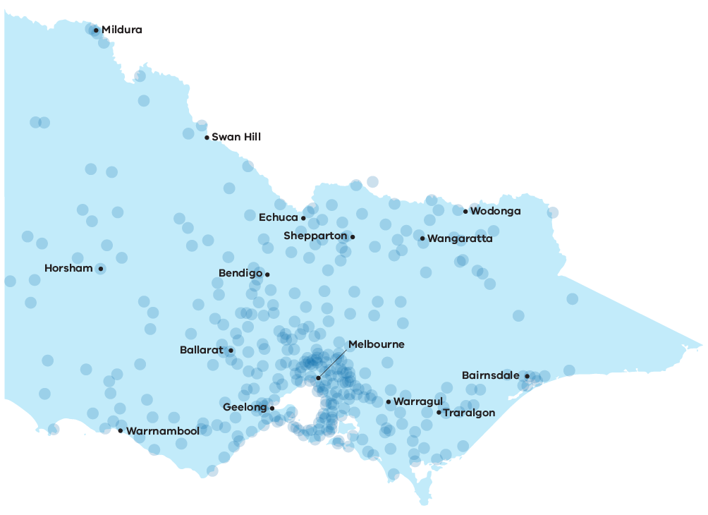

According to the ABS, 75% of the Victorian population lives in metropolitan Victoria and 25% lives in regional Victoria.[13] In this reporting period, 61% of VAD applicants lived in metropolitan Victoria and 39% in regional Victoria.

## Life-limiting conditions

In 2024–25, the majority of people applying for VAD had cancer. The most common cancers were lung, gastrointestinal tract malignancies, pancreatic, colorectal and breast cancers. The next largest group of patients were those with a neurodegenerative condition, most often motor neurone disease.

These proportions of life-limiting conditions remain similar to previous reporting periods.

Table 3: Life-limiting conditions of applicants 1 July 2024 to 30 June 2025 compared   
with 19 June 2019 to 30 June 2025

| **Life-limiting condition** | **Number (%)**  **1 July 2024 to 30 June  2025** | **Number (%)**  **19 June 2019 to 30 June 2025** |
| --- | --- | --- |
| **Cancer** | **671 (82%)** | **2852 (78%)** |
| Lung malignancy | 120 (15%) | 521 (14%) |
| Other gastrointestinal tract  malignancy | 93 (11%) | 344 (9%) |
| Colorectal malignancy | 76 (9%) | 315 (9%) |
| Pancreas malignancy | 62 (8%) | 247 (7%) |
| Breast malignancy | 53 (7%) | 238 (6%) |
| Gynaecological malignancy | 43 (5%) | 173 (5%) |
| Prostate malignancy | 40 (5%) | 199 (5%) |
| Haematological malignancy | 38 (5%) | 153 (4%) |
| Head and neck malignancy | 32 (4%) | 127 (4%) |
| Other urological malignancy | 31 (4%) | 122 (3%) |
| Central nervous system  malignancy | 28 (3%) | 125 (3%) |
| Malignant – not further defined | 22 (3%) | 59 (2%) |
| Skin malignancy | 19 (2%) | 93 (3%) |
| Bone and soft tissue malignancy | 11 (1%) | 64 (2%) |
| Other primary malignancy | 2 (0%) | 50 (1%) |
| Unknown primary malignancy | 1 (0%) | 22 (1%) |
| **Neurological** | **77 (9%)** | **339 (9%)** |
| Motor neurone disease | 57 (7%) | 252 (7%) |
| Other neurological disease | 20 (2%) | 87 (2%) |
| **Respiratory** | **44 (5%)** | **167 (5%)** |
| **Other** | **29 (4%)** | **158 (4%)** |
| **Not reported** | **0 (0%)** | **139 (4%)** |

Notes:

‘Other gastrointestinal tract malignancy’ includes primary liver cancers.

‘Other’ life-limiting conditions includes cardiovascular disease, dementia, diabetes, end-stage kidney disease, end-stage liver disease, HIV/AIDS, multiple organ failure, sepsis, stroke and other rare non-malignant conditions.

A data consolidation exercise is under way, and ‘not reported’ conditions may be captured in future reporting.

Data audits in 2024–25 have resulted in improved reporting. Some figures that appeared in past reports have now been updated to reflect current data.

## Palliative care

Palliative care services are available to all Victorians, depending on individual need. This may include hospital-based care, home-based care, or residential facility-based care. It is important to recognise that VAD is not an alternative to palliative care.

Since the commencement of the Act, 79% of applicants who have applied for VAD also accessed, or were being cared for, by a palliative care service.

Palliative care is an essential provision, and the integration of palliative care options remains an important aspect of the end-of-life care delivery model.

In 2024–25, 75% of applicants were accessing palliative care when they first requested VAD. This suggests that VAD is being appropriately accessed in conjunction with palliative care, rather than as an alternative to it.

Table 4: Use of palliative care by applicants, 1 July 2024 to 30 June 2025 compared with 19 June 2019 to 30 June 2025

| **Palliative care services** | **Number (%)**  **1 July 2024 to 30 June 2025** | **Number (%)**  **19 June 2019 to 30 June 2025** |
| --- | --- | --- |
| **Accessed** | **614 (75%)** | **2879 (79%)** |
| Yes – currently | 607 (74%) | 2840 (78%) |
| Yes – previously, not currently | 7 (1%) | 39 (1%) |
| **No** | **118 (14%)** | **531 (14%)** |
| **Not reported** | **89 (11%)** | **245 (7%)** |
| **Duration of engagement with palliative care** |  |  |
| Less than 12 months | 378 | 1990 |
| Greater than 12 months | 87 | 465 |
| Duration of engagement not reported | 149 | 424 |
| Median months (interquartile range) | 3 (1, 7) | 3 (1, 7) |

Palliative care services provide bereavement services for registered family and carers. Other bereavement services are available, including Grief Australia. Appendix 3 provides contact details for bereavement support.

The Board welcomed the findings of a national survey conducted by Palliative Care Australia,[14] presented at the Trans-Tasman Voluntary Assisted Dying Conference in Brisbane in October 2024.

The survey revealed the introduction of VAD in every state has led to an increase in conversations about end-of-life care choices. It also found that palliative care providers overwhelmingly recognise and respect VAD as a valid end-of-life care option. These findings confirm that palliative care and VAD services can and do work hand in hand.

Notably, almost a fifth of respondents reported an increased demand for palliative care after the introduction of VAD in their respective state.

Additionally, 80% of individuals who chose VAD were also receiving palliative care.

These findings are consistent with trends seen in Victoria. They provide further evidence that the introduction of VAD has not diminished the role of palliative care and may, in fact, be increasing it.

In relation to challenges identified by the survey, the Board notes concerns about whether providers’ responsibilities to facilitate patient choice are being met effectively across jurisdictions.

To address this, the Board encourages closer collaboration between services. This should aim to make end-of-life care pathways easier for people to navigate and ensure patients are well-informed about their end-of-life care options.

# Applications and assessments

To access VAD, an applicant must meet all eligibility criteria, as assessed by their co‑ordinating and consulting medical practitioners. The Statewide Care Navigator Service and the Statewide Pharmacy Service provide support to applicants and their families, medical practitioners and healthcare services throughout the application process. As more Victorians consider VAD, there is increasing demand for both statewide services.

## Statewide Care Navigator Service

The Statewide Care Navigator Service provides information and support to people seeking to access VAD, along with their families and carers.

The service also provides information, support and training to medical and health practitioners, as well as Victoria’s health, aged care and palliative care services. If necessary, it can connect people with medical practitioners who have completed VAD training.

Care navigators are highly skilled and experienced nurses and allied health professionals. They are located at a central metropolitan health service site and 5 regional health service sites.

From 1 July 2024 to 30 June 2025, there were 1,401 contacts made by people to the care navigator service seeking information or support. This is an increase of 30% on the previous year, when 1,074 contacts were made. Of these:

* 34% were from people applying for VAD
* 28% were from a family member or friend
* 15% were from the usual treating doctor
* 9% were from a VAD medical practitioner
* 13% of other sources were from another healthcare professional
* 1% of other sources were from the facility management or administration.

Notably, 42% of total contacts with the care navigator service were from regional or rural Victoria.

Of contacts that occurred from 1 July 2024 to 30 June 2025:

* 20% were for support for people who were planning to apply or were in the process of applying for VAD
* 72% were requests for information from people considering VAD
* 4% were for people seeking assistance in finding a second trained medical practitioner to complete an applicant’s eligibility assessment
* 4% were for other reasons.

The care navigator service provides a variety of education and training sessions across Victoria including:

* training days to support medical practitioners who choose to complete the online training in a group environment. These training days may be attended in person or online. Medical practitioners may find more information on locations and dates of the training days by contacting the Statewide Care Navigator Service via email [vadcarenavigator@petermac.org](mailto:vadcarenavigator@petermac.org)
* a health practitioner community of practice, providing webinars and education sessions to healthcare professionals specific to their clinical context such as aged care or palliative care services. For information or to join, please email [vadcarenavigator@petermac.org](mailto:vadcarenavigator@petermac.org)
* assistance to health, aged care and palliative care services, enabling them to support a person in their care who is seeking VAD.

During 2024–25, the care navigator service provided 172 webinars, education sessions and activities across Victoria.

## Reflections on the Statewide Care Navigator service

Contact persons and medical professionals continue to provide positive feedback about the Statewide Care Navigator Service.

We were well supported through the whole process.  
**Service user**

The care and guidance in understanding the legislation, the process and she enabled us to have realistic expectations. She was also great at gently asking Mum about her needs and wishes – in a way that allowed Mum to feel safe and supported.  
**Service user**

Their knowledge, experience and empathy and personal care were all invaluable. They were so approachable and happy to answer questions.  
**Service user**

Just letting you know that Pa passed away at sunset on Sunday night. I just want to thank you all for your care and your help. And if you can please pass on our many thanks to [the navigator]. Her sincere and caring attitude meant that he felt heard and seen and respected. [She] explained things to Pa in a way that he actually understood his options and felt heard when he chose then, she helped him to speak with the nursing staff better and arranged the treating doctor to come and talk to him some more in a way that he can understand.  
**Service user**

We are all so grateful that our loved one was able to access VAD and that we could all support as kindly as we did. The VAD team were exceptional.  
**Service user**

Contact the Statewide Care Navigator Service:

* phone 03 8559 5823
* [vadcarenavigator@petermac.org](mailto:vadcarenavigator@petermac.org)

## Application stages and forms

A VAD application comprises several key stages and the completion of each is demonstrated by the submission of forms in accordance with the Act and the *Voluntary Assisted Dying Regulations 2018* (the Regulations).

After a person makes a first request to access VAD, the co-ordinating medical practitioner conducts an eligibility assessment of the applicant (the first assessment).

If the applicant is found eligible, a second independent medical practitioner conducts an eligibility assessment (the consulting assessment).

If the applicant is found eligible, the applicant can make a written declaration and a final request to the co-ordinating medical practitioner to access VAD. A contact person is then appointed.

The Act requires that a final request is made at least 9 days after the first request, unless both assessing medical practitioners consider the applicant’s death is likely to occur within 9 days of the first request.

The following graph represents the total number of forms submitted to the Portal as part of the application process, since the commencement of operations in June 2019.

Figure 7: Applications over time (forms submitted by quarter)

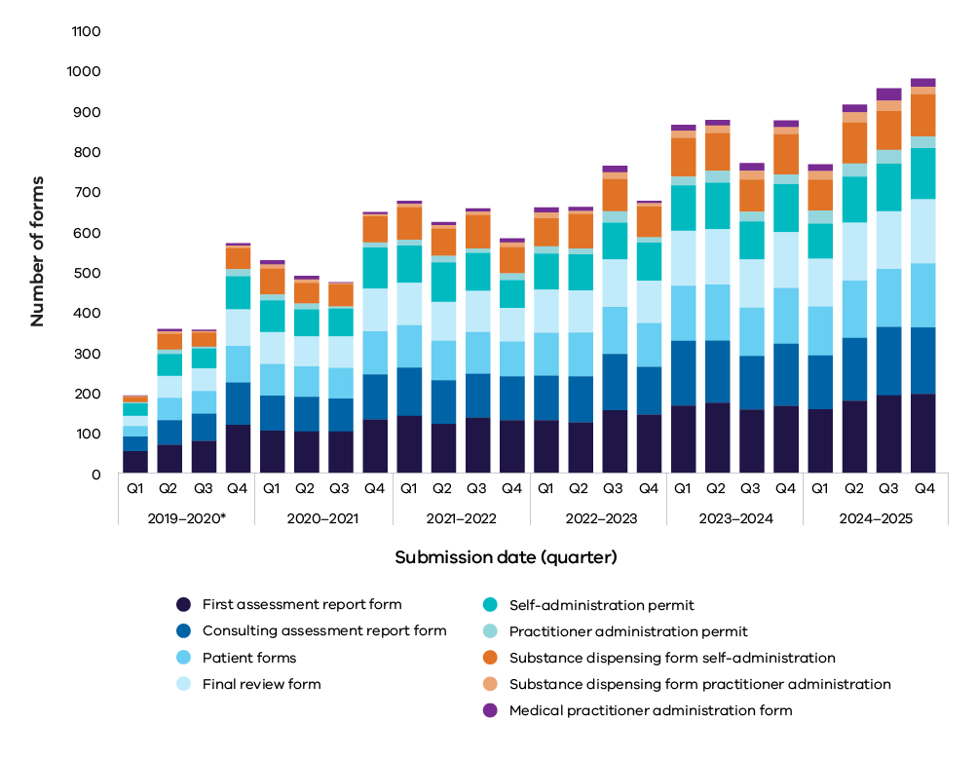

Note:

Q1 2019–2020 includes 12 days of 2018–2019 financial year as the program commenced on 19 June 2019.

In the 2024–25 reporting period, 1,487 assessment forms were submitted. Since the commencement of the Act, a total of 6,647 assessment forms have been submitted to the Board.

Notably, there has been a 9% increase in the number of VAD applications (n = 837) initiated by medical practitioners compared with last year (n = 768). Since the Act began, applications have grown at an average rate of 16% per year.

Table 5: Outcomes of each application stage for voluntary assisted dying

| **Stage** | **2019–20** | | **2020–21** | **2021–22** | **2022–23** | **2023–24** | **2024–25** | **Total to date#** | **Change from previous year** |
| --- | --- | --- | --- | --- | --- | --- | --- | --- | --- |
| **First assessment completed** | | **353** | **487** | **585** | **612** | **732** | **799** | **3568** | **+9%** |
| Eligible | | 346 | 465 | 552 | 601 | 728 | 791 | 3483 | +9% |
| Ineligible | | 7 | 22 | 33 | 11 | 4 | 8 | 85 | +100% |
| **Consulting assessment completed** | | **299** | **404** | **491** | **533** | **664** | **688** | **3079** | **+4%** |
| Eligible | | 297 | 398 | 486 | 528 | 663 | 682 | 3054 | +3% |
| Ineligible | | 2 | 6 | 5 | 5 | 1 | 6 | 25 | +500% |
| **Self-administration permit** | | **239** | **350** | **390** | **403** | **486** | **492** | **2360** | **+1%** |
| Permit issued | | 207 | 323 | 379 | 403 | 486 | 492 | 2290 | +1% |
| Permit not issued | | 32 | 27 | 11 | 0 | 0 | 0 | 70 |  |
| **Substance dispensed for self-administration** | | **155** | **260** | **328** | **343** | **407** | **418** | **1911** | **+3%** |
| **Practitioner administration permit** | | **39** | **52** | **65** | **82** | **111** | **142** | **491** | **+28%** |
| Permit issued | | 30 | 43 | 60 | 82 | 111 | 142 | 468 | +28% |
| Permit not issued | | 9 | 9 | 5 | 0 | 0 | 0 | 23 |  |
| **Substance dispensed for practitioner administration** | | **20** | **29** | **40** | **53** | **84** | **101** | **327** | **+20%** |
| **Medical practitioner administration form** | | **20** | **31** | **38** | **50** | **71** | **97** | **307** | **+37%** |

Notes:

This table counts individual form submissions for applications. A single individual may be linked to more than one application, and some applications may have the same form submitted multiple times.

The 2019–20 column includes 12 days of 2018–19 financial year as the program commenced on 19 June 2019.

The ‘Total to date’ column includes total figures are since the commencement of the Act in June 2019.

‘Ineligible’ may not be an accurate reflection of the true number of ineligible assessments as there are instances where an ineligible assessment form has not been submitted.

For ‘Permit issued’ There are circumstances where one applicant is issued with 2 permits: first, for self-administration and subsequently if there is a changeover to practitioner administration.

‘Substance dispensed for self-administration’ is reported by counting the number of substance dispensing forms for self-administration permit (Form 6) submitted.

There is no obligation for a medical practitioner to submit a substance dispensing form for practitioner administration as this is an optional form.

For ‘Medical practitioner administration form’, the substance dispensing form for practitioner administration is optional. This means the number of medical practitioner administration forms (Form 8), which are mandatory according to the legislation, are also reported.

Data audit and Portal enhancements in 2024–25 have resulted in improved reporting of figures. Some figures that appeared in past reports have now been updated to reflect current data.

## Additional assessments

As part of the assessment process, either the co-ordinating or consulting medical practitioner may seek additional specialist opinion to determine whether a person has decision-making capacity, or to confirm diagnosis or prognosis. If an applicant has a neurodegenerative condition and a prognosis of 6 to 12 months, the Act requires the co-ordinating practitioner to seek a further specialist opinion at the first assessment stage.

Table 6: Referrals for additional assessments, 1 July 2024 to 30 June 2025 compared with 19 June 2019 to 30 June 2025

| **Referrals for additional assessments** | **Number (%)**  **1 July 2024 to 30 June 2025** | **Number (%)**  **19 June 2019 to 30 June 2025** |
| --- | --- | --- |
| Applicants with a neurodegenerative condition and a prognosis of 6-12 months | 45 (5%) | 211 (6%) |
| Decision-making capacity | 0 (0%) | 35 (1%) |

## Appointment of a contact person

The Act requires that a contact person is appointed once a final request is made. Under the Act, a contact person has a duty to return any unused or remaining VAD substance within 15 days after the date of death of the applicant to the Statewide Pharmacy Service. This is also the case if the applicant must change from self-administration to a practitioner administration permit.

The Act requires the Board to, within 7 days of being notified of an applicant’s death, provide the contact person with information to assist them to return unused or remaining substance to the dispensing pharmacy.

As part of this engagement, the Board also seeks feedback on the experience of supporting an applicant through the VAD process. The Board extends its gratitude to all who shared valuable insights on their experience of the voluntary assisted dying journey. Contact person feedback plays a pivotal role in informing the Board’s quality and safety reviews and has been incorporated throughout this report.

## Withdrawal of applications

Since the commencement of the Act, a total of 1,300 applications (34% of all applications) were withdrawn before the substance was dispensed. Of these, 38% were withdrawn because the applicant died less than 2 weeks after making the first request. This represents 13% of all applications started and suggests many patients begin the application process very late in the course of their illness.

Reasons for withdrawal provided by medical practitioners include:

* death of the applicant (prior to the VAD substance being dispensed)
* deterioration in the applicant’s clinical condition and consequently being too unwell to continue the assessment process
* deterioration in the applicant’s clinical condition and consequent loss of decision-making capacity
* duplicate applications created in error for an individual applicant.

Table 7: Reason for withdrawal, 1 July 2024 to 30 June 2025 compared to 19 June 2019 to 30 June 2025

| **Reason for withdrawal** | **Number (%)**  **1 July 2024 to 30 June  2025** | **Number (%)**  **19 June 2019 to 30 June 2025** |
| --- | --- | --- |
| **Applicant died** | 245 (88%) | 1039 (80%) |
| **Other** | 13 (5%) | 53 (4%) |
| **Applicant is too unwell to proceed** | 10 (4%) | 35 (3%) |
| **Applicant is too unwell to proceed AND no longer has decision-making capacity** | 5 (2%) | 32 (2%) |
| **Applicant decided not to proceed** | 4 (1%) | 14 (1%) |
| **Applicant no longer has decision-making capacity** | 2 (<1%) | 32 (2%) |
| **Not reported** | 0 (0%) | 95 (7%) |

Notes:

‘Not reported’ accounts for cases that were withdrawn before the Portal had the option to provide a reason (19 June 2019 to 16 January 2020).

Other reasons for withdrawal include:

* applicants opted for further disease-modifying treatment that favourably altered their prognosis, meaning they no longer met eligibility criteria
* applicants with New Zealand citizenship or formerly of UK citizenship were unable to obtain evidence of Australian citizenship or permanent residency (despite living in Victoria for most of their lives) in a timely enough manner to evidence meeting eligibility criteria
* applicants were unable to access a consulting medical practitioner with appropriate medical specialisation for an assessment (particularly for applicants living in a regional area)
* co-ordinating medical practitioners were unable to find an available consulting medical practitioner to undertake a consulting assessment
* medical practitioners were no longer able to continue as co-ordinating medical practitioner and were unable to find another medical practitioner to undertake the role
* applicants did not return for an assessment, effectively withdrawing their request
* no further progress of an application for more than 12 months
* applicants transferred care to a new local health service area and would no longer be in contact with the co-ordinating medical practitioner. A new co-ordinating medical practitioner initiated a new application.

The data suggests the main reasons for withdrawing a request, sometimes before an assessment outcome is determined, are mostly associated with:

* **unpredictable clinical trajectory** – an applicant’s sudden deterioration leading to death earlier than anticipated
* **challenges in sourcing documentation** –difficulties in sourcing documents to demonstrate eligibility, such as evidence of Australian citizenship or permanent residency
* **short prognosis** – an applicant’s prognosis is too short to allow progression through the application stages within the timeframes required by the process and prescribed by the Act
* **challenges in locating appropriate practitioners** – finding a practitioner to undertake required assessments or provide a third assessment in cases where the applicant has a neurodegenerative condition
* **lack of awareness of VAD** – people not knowing VAD is an end-of-life care option until too late in their illness to complete an application.

# Permit outcome and substance dispensing

Once the assessment process has been finalised and the applicant has made a final request, the co-ordinating medical practitioner must apply for a permit to prescribe the VAD substance.

The Secretary of the Department of Health or their delegate reviews all permit applications.

A permit allows the co-ordinating medical practitioner to write a prescription for dispensing of the VAD substance by the Statewide Pharmacy Service. When a permit is issued, the applicant can decide if, and when, they request access to the VAD substance. The Statewide Pharmacy Service visits applicants anywhere in Victoria to dispense the substance.

## Overview

Between 1 July 2024 and 30 June 2025, the Secretary issued 634 permits, for either self‑administration or practitioner administration.

In this reporting cycle, there were no permit applications with an outcome of ‘permit not issued’. This is a result of the growing experience of medical practitioners in completing the application forms and better understanding of VAD eligibility criteria, as well as ongoing enhancements to the Portal.

## Permit outcomes

The *Voluntary Assisted Dying Regulations 2018* allow the Secretary a maximum of 3 business days to determine the outcome of a permit application. Outcomes for 99.37% of permit applications were determined within this timeframe.

Delays to a permit application may occur when incomplete paperwork is provided as part of the assessment process, or the Secretary seeks further information to assess the application.

The secretariat for the Board conducts an administrative check on all assessment forms as they are lodged. If necessary, the secretariat provides feedback to medical practitioners to promote compliance with the Act. It is entirely a matter for medical practitioners to act on this feedback.

However, the Secretary, in making the final determination to issue or not issue the permit, considers the application when it is complete. This is when all relevant information has been provided and checks for compliance with the Act are completed.

## Statewide Pharmacy Service

The Department of Health funds a VAD Statewide Pharmacy Service based at Alfred Health. The service provides responsive, patient-centred care to Victorians who have sought access to VAD, their families, carers, medical practitioners, health care providers and aged care providers. It works closely with the Statewide Care Navigator Service when a person has chosen to seek support from the service.

After the substance is prescribed, the Statewide Pharmacy Service dispenses it at a time and location of the applicant’s choosing.

The Statewide Pharmacy Service consistently meets its goal of dispensing the substance at, or very close to, the applicant’s chosen time. Pharmacists travel throughout the state to provide education and support to people, their families and medical practitioners. They also safely dispose of any unused substance returned by the applicant, contact person or medical practitioner.

In 2024–25, the Statewide Pharmacy Service saw an increase in visits to applicants and medical practitioners, peaking at 62 visits in May 2025.

During 2024–25, there were 519 occasions where a VAD substance was dispensed (a 6% increase from the previous year). Of these:

* 97% of people had the substance provided on the day they requested it
* 99% of people had the substance provided within 2 business days of their preferred delivery day
* 59% of substance dispenses were to metropolitan people/medical practitioners
* 41% of substance dispenses were to regional people/medical practitioners.

## Feedback and reflections on the Statewide Pharmacy Service

Feedback on the Statewide Pharmacy Service enables continuous performance monitoring and evaluation. It demonstrates:

* 96% reported excellent service from the pharmacist(s)
* 93% said the pharmacist visited at a time that suited the applicant.

Feedback about the service includes the following quotes:

Could not fault the care and service we received. They were patient with us and relayed all the information in a professional manner whilst treating us with respect and empathy. Very impressed with both these lovely humans. We felt we had known them forever and they made us feel very relaxed.  
**Service user**

The pharmacy staff were amazing. Clear, calm, respectful, professional, understanding, supportive, put everyone at ease, demonstrated unconditional positive regard! My family thanks pharmacy staff for your commitment to supporting mum and our family and the broader community with giving people choice and dignity with VAD/end of life choices.  
**Service user**

We were impressed with the flexibility the pharmacy team showed and the clear information with directions that the pharmacy team carried out. This made the whole process for our family smooth.  
**Service user**

The pharmacists that came out to show dad how to use the kit were kind, knowledgeable and very professional but warm. At no stage did it feel like they were giving a speech they had given hundreds of times before. It was perfect.  
**Service user**

Always wonderful help and support from the pharmacist to both doctors and patients. Thank you.  
**Medical practitioner**

Excellent, friendly, professional service as always. Such a pleasure to work with you.   
**Medical practitioner**

# Timeframes

The VAD process involves several stages with specific timeframes mandated by the Act. Timeliness is critical. The Board recognises that during this highly time-sensitive process, those seeking access to VAD are in the final stages of life and are experiencing suffering they find intolerable. Delays – whether in paperwork, appointments or approvals – can cause distress for the applicant, their families and support people, as well as healthcare providers.

Balancing the need for compassion, respect for personal autonomy, and compliance with the legislation is key. Services involved in the process aim to respond efficiently and sensitively, helping applicants move through each stage without delay while adhering to the requirements under the legislation.

## Overview

The table below shows the number of days elapsed from an applicant’s first request for VAD to permit outcome and substance dispensing in this reporting period.

Table 8: Timeframes – first request to key events for applicants, 1 July 2024 to 30 June 2025

| **Timeframes** | **Days elapsed (all applicants)** | **Days elapsed (applicants from Metropolitan Melbourne)** | **Days elapsed (applicants from Regional Victoria)** |
| --- | --- | --- | --- |
| **First request to final request** |  |  |  |
| Median | 14 | 13 | 16 |
| Interquartile range | 11, 24 | 10, 21 | 12, 29.5 |
| **First request to permit issue** |  |  |  |
| Median | 20 | 18 | 23 |
| Interquartile range | 14, 30 | 13, 25 | 17, 37 |
| **First request to dispensing for self-administration** |  |  |  |
| Median | 29 | 26 | 34 |
| Interquartile range | 21, 43 | 19, 37.25 | 24, 50 |
| **First request to dispensing for practitioner administration** |  |  |  |
| Median | 22 | 21 | 30 |
| Interquartile range | 14.25, 41.5 | 11.75, 36.5 | 19, 55.25 |

Notes:

Once issued a permit to dispense the substance, an applicant must make a request to the Statewide Pharmacy Service. Many applicants choose not to make a request immediately or at all. Therefore, the time from first request to dispensing for self-administration may be extended by personal choice.

For ‘First request to dispending for practitioner administration’, There is no obligation for a medical practitioner to submit a substance dispensing form for practitioner administration as this is an optional form, so these timeframe calculations are only for cases where a dispensing form for practitioner administration was submitted.

### First request to final request

The Act requires a final request be made at least 9 days after the first request, unless both assessing medical practitioners consider the applicant’s death is likely to occur less than 9 days from the date of the first request.

In this reporting period, the median timeframe from first to final request was 14 days. Applications in metropolitan areas had a median duration of 13 days, and those in regional areas had a median duration of 16 days.

Since the commencement of the Act, the median timeframe from first to final request was 15 days. For metropolitan applications, the median duration was 14 days, and for regional applications it was 19 days.

### First request to permit issue

In this reporting period, the median timeframe from first request to permit issue was 20 days.

Applications in metropolitan areas had a median duration of 18 days, and those in regional areas had a median duration of 23 days.

Since the commencement of the Act, the median timeframe from first request to permit issue was 21 days. For metropolitan applications, the median duration was 20 days, and for regional applications, 24 days.

Figure 8: Time between first request and permit issue date, median days and interquartile range

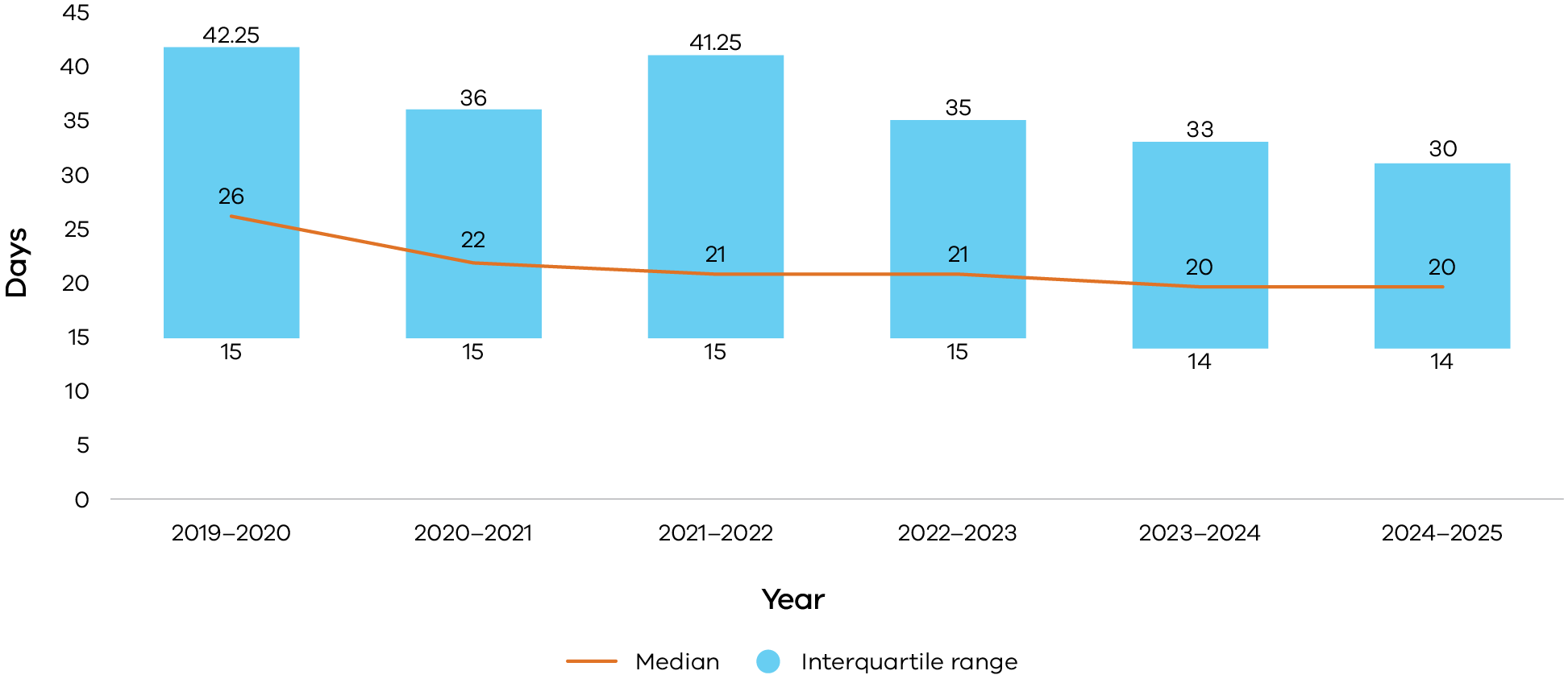

In the inaugural year of the program, the median timeframe between first request to permit issue was 26 days. This has reduced to 20 days in this reporting period, reflecting continuous improvement in efficiency across all application stages preceding permit outcome over time.

Despite these overall gains, regional applications still take approximately 5 days longer than metropolitan applications to reach permit outcome.

### First request to substance dispensing

In this reporting period, the median timeframe from first request to dispensing of substance for self-administration is 29 days and for dispensing of practitioner administration substance is 22 days.

For applications in metropolitan areas, the median duration for self-administration of substance is 26 days and 21 days for practitioner administration. For regional areas, the median duration for self-administration substance is 34 days and 30 days for practitioner administration.

Since commencement of the Act, the median timeframe from first request to dispensing substance for self-administration is 32 days and 25 days for practitioner administration.

This indicates the median time taken for an applicant to obtain a prescription and to access VAD is decreasing over time.

The data also indicates that dispensing substance to applicants in regional Victoria takes 8 days longer for self-administration and 9 days longer for practitioner administration than the median timeframes for applicants in metropolitan Melbourne.

### Permit issue to substance dispensing

Of applicants issued a permit this reporting year, the data includes instances where an applicant was issued a permit but chose not to proceed with contacting the pharmacy to schedule a meeting or to have the substance dispensed.

The table below shows timeframes for interactions with the Statewide Pharmacy Service for cases where a permit was issued and the applicant chose to proceed.

**Table 9: Timeframes – permit issue date to substance dispensing events, 1 July 2024 to 30 June 2025**

| **Timeframes** | **Days elapsed (all applicants)** | **Days elapsed (applicants from metropolitan Melbourne)** | **Days elapsed (applicants from regional Victoria)** |
| --- | --- | --- | --- |
| **Permit issue date to first contact with Statewide Pharmacy Service** |  |  |  |
| Median | 1 | 1 | 2 |
| Interquartile range | 0, 5 | 0, 4 | 1, 5 |
| **Permit issue date to Statewide Pharmacy Service visit to applicant** |  |  |  |
| Median | 6 | 6 | 7 |
| Interquartile range | 3, 11 | 3, 10 | 4, 13 |
| **Permit issue date to substance dispense date by Statewide Pharmacy Service** |  |  |  |
| Median | 6 | 6 | 7 |
| Interquartile range | 3, 11 | 2, 10 | 4, 12 |

Notes:

Data in this table only includes cases where a permit was issued and contact was made to the Statewide Pharmacy Service.

First contact is made either by applicant or co-ordinating medical practitioner to Statewide Pharmacy Service.

Applicants choose the date and time of both the pharmacist visit and delivery of substance. The Statewide Pharmacy Service aims to schedule at the elected time, or within 24 hours of the applicant’s preference. For some applicants, the visit and delivery occur on the same day. For others the visit and delivery occur on different days.

A value of 0 indicates contact occurred on the same day the permit was issued.

In this reporting period, the median timeframe from permit issue to dispensing of substance was 6 days. For metropolitan applicants, the median timeframe from permit issue to contacting the Statewide Pharmacy Service to schedule an appointment was one day. From permit issue to the pharmacist visit was 6 days. For regional applicants, the median timeframe from permit issue to contacting the Statewide Pharmacy Service to schedule an appointment was 2 days, and to the pharmacist visit was 7 days.

## Timeliness

In this reporting period, the Secretary issued 99% of permits within 3 business days per the timeframe mandated by the Regulations. The Statewide Pharmacy Service delivered 98% of requests for substance on the day of request or one day after and delivered 96% of requests on the day chosen by the applicant.

In Victoria, there is no maximum timeframe for completing a VAD application or for dispensing the prescribed substance. From the time of making a first request, an applicant is under no obligation to continue the VAD request or take any further steps in relation to accessing the substance. An applicant can change their mind at any stage and determine when, if at all, the substance is to be dispensed.

As such, the interval between permit issuance and substance dispensing does not serve as a measure of the Statewide Pharmacy Service's performance in dispensing the substance in a timely manner.

Cases where a permit was issued but did not result in a prescription, contact with the Statewide Pharmacy Service for dispensing, or administration of the substance, can be attributed to:

* the applicant decided not to proceed
* the applicant decided to delay proceeding to the next stage
* the applicant died or lost decision-making capacity before proceeding to the next stage.

The principles of personal autonomy and informed choice are fundamental to compassionate end-of-life care.

Applicants, practitioners and contact persons frequently report that reaching key stages – permit approval, prescription or substance dispensing – often brings a profound sense of relief and restored control.

Many applicants gain comfort from the assurance that their request is valid and that the option remains available to them.

The experience was so empowering for my mother, who was often overwhelmed by the possible pain and suffering she would experience. Having that medicine gave her back her sense of control and power. It made a huge difference for her to know it was there if she decided to use it.  
**Contact person**

Although permits and substances are generally provided in a timely manner, legislative barriers to timely access remain. One such barrier is the need for practitioners to obtain an additional permit for practitioner administration when an applicant can no longer self-administer.

This procedural step includes cancelling the self-administration permit and applying for a new permit. It can introduce delays and logistical burdens at a time when an applicant’s clinical condition has often deteriorated significantly. This can lead to further distress and suffering.

Additional legislative constraints include the eligibility criteria of a 6 months or less prognosis (12 months for neurodegenerative conditions) and the mandatory 9-day waiting period between first and final requests.

Moreover, as the data indicates, the overall timeframe from assessment to permit application and substance dispensing is influenced by legislative requirements, with regional applicants particularly affected. In 2024–25, the median timeframe from first request to permit outcome was 20 days. From first request to dispensing of substance, it was 29 days for self-administration and 22 days for practitioner administration. In metropolitan Melbourne, the median timeframe from first request to permit approval was 18 days, and in regional Victoria it was 23 days.

The difference in timeframes between metropolitan and regional Victoria is noteworthy, with the average duration of an application process taking approximately 5 days longer for a regional applicant.

## Permit changeovers

An applicant’s clinical circumstances may change after a self-administration permit has been issued. Medical practitioners and pharmacists play key roles in monitoring the applicant’s capacity to self-administer the prescribed substance. If the co-ordinating medical practitioner assesses an applicant can no longer self-administer, they may determine that practitioner administration is required. In such cases, the co-ordinating medical practitioner must then cancel the existing self-administration permit and apply for a practitioner administration permit.

Since the commencement of the Act, of the 2,651 cases that were issued at least one permit, 94 (3.5%) included a permit changeover. This occurred when a practitioner administration permit was issued after a self-administration permit was cancelled due to the applicant’s loss of ability to self-administer.

In 2024–25, 5% of cases had a permit changeover. Figure 8 shows this is occurring with increasing frequency over time.

Figure 9: Number of cases with a permit changeover, by second permit issue date

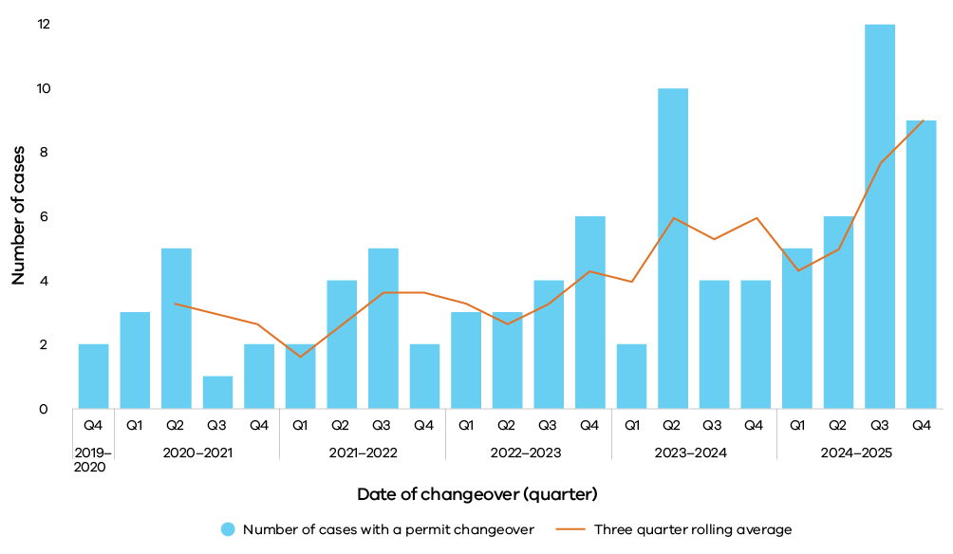

## Cases with multiple permit applications

Since the commencement of operations, 107 cases had a second permit application commenced after the first permit was issued.

Of these, 7% did not receive the second permit because the applicant died before a permit outcome was determined. The remaining 93% were issued a second permit.

Table 10: Cases with multiple permit applications, 19 June 2019 to 30 June 2025

| **Reason for multiple permit applications** | **Number of cases** |
| --- | --- |
| **Multiple permits issued** | **99** |
| Self-administration to practitioner administration permit changeover | 94 |
| Second self-administration permit issued | 3 |
| Second practitioner administration permit issued† | 2 |
| **One permit issued; second application commenced** | **8** |
| Self-administration to practitioner administration permit changeover  commenced | 7 |
| Second practitioner administration permit application commenced | 1 |

Notes:

One case had 3 permits issued: a permit changeover from self-administration to practitioner administration was required, and then a role transfer occurred between the 2 medical practitioners, resulting in a second practitioner administration permit being issued.

‘Second self-administration permit issued’ occurred because the nominated contact person changed in these cases.

‘Second practitioner administration permit issued’ occurred because either the applicant required a different route of administration or there was a transfer of the co-ordinating medical practitioner role.

‘Second practitioner administration permit application commenced’ occurred because the applicant required a different route of administration.

## Deaths that involved a permit changeover

Since the commencement of the Act, 94 cases were issued a practitioner administration permit after cancellation of a self-administration permit. Of these, 61% were then administered the VAD substance by the medical practitioner. Thirty-five per cent choose not to proceed or died of other causes before administration. As of 30 June 2025, 4% remained alive.

## Withdrawal of cases during permit consideration period

Since the commencement of the Act, 68 cases were withdrawn during the permit consideration period (between submission of a permit application and permit outcome).

Of these cases, 72% were self-administration applications and 28% were practitioner administration applications. Of these,18% were withdrawn during the permit consideration period because applicants had a prognosis of less than 9 days.

In this reporting period, 15 cases were withdrawn during the permit consideration period (between permit application and permit outcome).

Of these cases, 67% were self-administration applications and 33% were practitioner administration applications. Thirty-three per cent of cases withdrawn during the permit consideration period involved applicants assessed to have a prognosis of less than 9 days.

Since the commencement of the Act, the majority of cases withdrawn during the permit consideration period were due to the death of the applicant.

# Deaths

Since the commencement of the Act, 2,457 applicants who were issued with a permit for self-administration or practitioner administration of a VAD substance subsequently died.

Over the past 12 months, deaths from the administration of the VAD substance account for approximately 9 per 1,000 deaths in Victoria.

The table below shows the manner of death for these applicants and how this is changing over time.

Table 11: Deaths of applicants issued with permits, 19 June 2019 to 30 June 2025

| **Manner of death** | **2019–20** | **2020–21** | **2021–22** | **2022–23** | **2023–24** | **2024–25** | **Total to date** | **Change from previous year** |
| --- | --- | --- | --- | --- | --- | --- | --- | --- |
| **Deaths from administration of VAD substance** | **129** | **202** | **275** | **307** | **373** | **389** | **1675** | **+4%** |
| Self-administration | 108 | 174 | 237 | 258 | 304 | 301 | 1382 | -1% |
| Practitioner   administration | 21 | 28 | 38 | 49 | 69 | 88 | 293 | +28% |
| **Deaths of permit holder not from VAD substance** | **50** | **113** | **132** | **136** | **181** | **170** | **782** | **-6%** |
| **Total deaths** | **179** | **315** | **407** | **443** | **554** | **559** | **2457** | **+1%** |

Notes:

The 2019-20 column includes 12 days of the 2018-19 financial year as the program commenced on 19 June 2019.

A data audit was performed this year and figures in this table may differ to prior reports.

Figure 10: Percentage of deaths of permit holders by manner of death and reporting year, 19 June 2019 to 30 June 2025

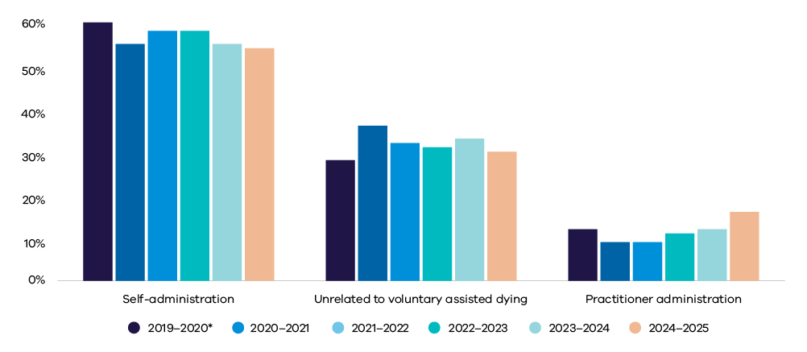

Note:

2019-20 includes 12 days of 2018–19 financial year as the program commenced on 19 June 2019.

In this reporting year, 559 applicants who were issued a permit subsequently died. Of these, 54% died after self-administration, 16% died after practitioner administration and 30% died unrelated to administration of a VAD substance.

There was a notable increase in the proportion of applicants who were subject to a practitioner administration permit and subsequently died using this method of administration compared to previous years: 12% in 2023–24 versus 16% in 2024–25.

For applicants issued with a self-administration permit, 56% died from self-administration of the substance and 44% did not (22% remained alive).

For applicants issued a practitioner-administration permit, 61% died from practitioner administration of the substance and 39% did not (17% remained alive).

## Deaths during the application process

Since the commencement of the Act, 831 applicants died before being issued a permit.

Most of these applicants died after the first or consulting assessment (refer to Figure 11). This trend has remained stable over time. This suggests that many applicants are commencing VAD applications late in the course of their illness.

For all applicants who died unrelated to VAD and had a permit application submitted for consideration, 22% intended to have practitioner administration and 78% intended to self-administer.

Figure 11: Applicants who died prior to receiving a permit and application stage reached, by date of death

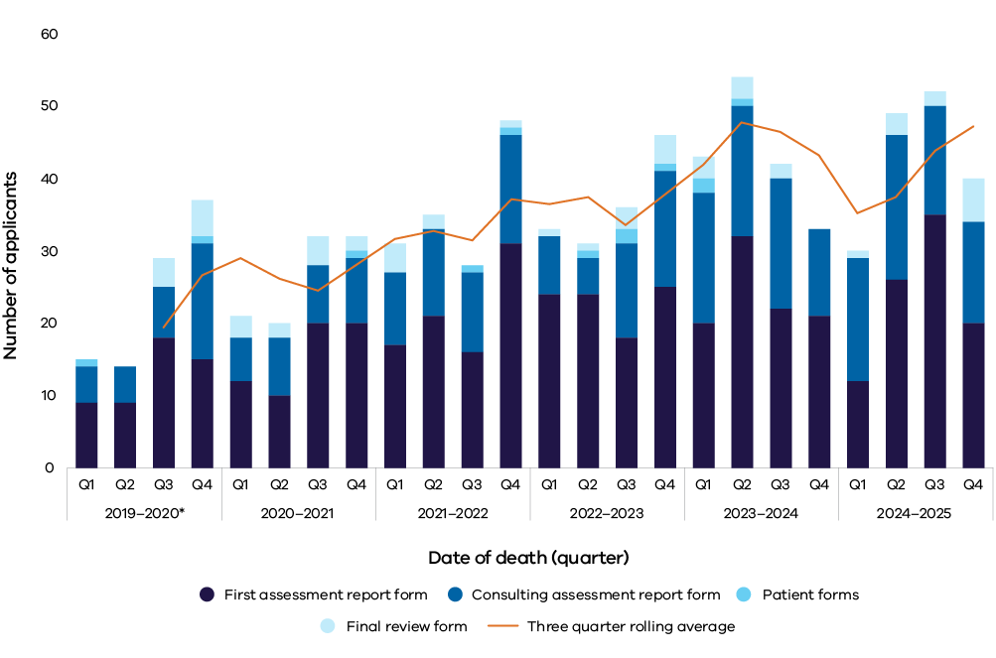

Note:

2019–20 includes 12 days of 2018–19 financial year as the program commenced on 19 June 2019.

## Place and cause of death

VAD provides applicants with not only a choice about when and how they die, but also, where medically appropriate, the location of their death.

According to place of death information recorded in Medical Certificate Cause of Death (MCCD) fromthe *Registry of Births, Deaths and Marriages,* in this reporting year, regardless of manner of death:

* 45% of applicants died at home
* 49% of applicants died in hospital
* 6% of applicants died in a residential care facility.[15]

For applicants who died via administration of VAD substance, 48% died at home. Of these, 82% died via self-administration and 18% died via practitioner administration. Figure 12 shows manner of death by place of death.

**Figure 12: Manner of death by place of death per Medical Certificates Cause of Death, 1 July 2024 to 30 June 2025**

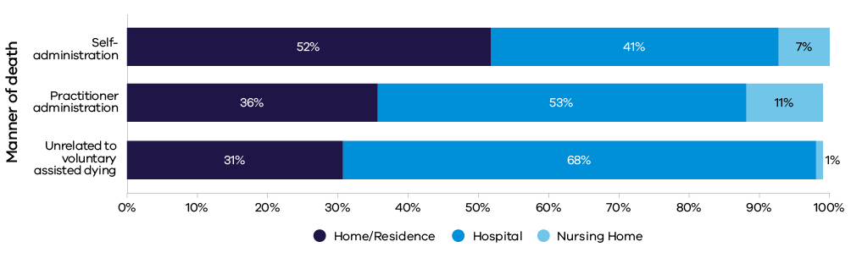

Note:

Medical Certificates Cause of Death does not specifically report deaths occurring in palliative care and these deaths are likely to be grouped into *Hospital* or *Nursing Home*.

Contact persons also voluntarily report place of death information. In 2024–25, contact persons for 22% of applicants who died provided this information. Of these, 53% died at home, 30% died in hospital, 11% died in palliative care and 6% died in a residential care facility.

# Reflections

Applicants can provide a personal statement when they submit *Form 3: Written declaration*. The Board also invites contact persons and medical practitioners to provide feedback on the program after the death of an applicant.

My intention is to go down the path of VAD. The people involved in that have been outstanding and I feel most confident in their ability to execute this programme as I await the outcome. Their excellent work has offered me the choice of going ahead or not.  
**Applicant**

She passed away with her cat on her lap, looking across our backyard to the dam with me holding her. It doesn’t get better than that.  
**Contact person**

This was a surprisingly smooth and positive process for me. It felt like a very valuable service to be able to be a part of, and the applicant was very grateful.  
**Medical practitioner**

Thank you so much for the opportunity to ease my dad's pain and suffering – to die with dignity on his terms, at his chosen time, surrounded by his family. He felt very happy, calm, and grateful to have this choice.  
**Contact person**

I would like to thank those who instituted and implemented access to Victorian VAD. Given my condition, where the disease has basically a fatal conclusion with potentially debilitating and painful outcomes along this inevitable path, this program gives peace of mind for myself in that I have control over the unknown and the possibility of a distressing death.  
**Applicant**

The whole process was done with care, dignity, and professionalism. At no time did either of us feel judged or pressed. The staff were all excellent and supportive.  
**Contact person**

I am very grateful to be able to access VAD. When I was 17, I saw my brother die a painful death from a brain tumour. My disease has taken so much from me, but it is great comfort to know that if my application is approved, I will have control over when I die. I thank all those who actively advocated for these laws. It significantly bolstered human rights in Victoria. Finally, I support further improvements to the laws, including allowing appropriate medical professionals to raise the option of assisted dying with terminally ill patients.   
**Applicant**

We found all the medical professionals involved to be caring and dedicated individuals.  
**Contact person**

# Compliance reviews

The *Voluntary Assisted Dying Act 2017* (Vic) has 71 safeguards and a diligent oversight scheme in place.

The Act is interpreted strictly, consistent with maintaining public safety and confidence.

The Board conducts retrospective compliance reviews of completed applications for the purpose of monitoring the program and to promote compliance with the legislation.

## Case compliance

Between 1 July 2024 and 30 June 2025, the Board found 9 cases that were non-compliant with the Act.

Three of these cases were deemed non-compliant due to a delay in the return of the unadministered substance to the Statewide Pharmacy Service. The contact person is required by s. 39(2)(a) of the Act to return any outstanding substance within 15 days of the death of an applicant, or when a substance has been dispensed for self-administration and then a practitioner-administration permit request commences (s. 55).

One case was deemed non-compliant due to an error in witnessing *Form 3: Written declaration form*.

Five cases were deemed non‑compliant due to late submission of *Form 1: First assessment report form*, *Form 2: Consulting assessment report form*, *Form 6: Voluntary assisted dying substance dispensing form*, and *Form 8: Co-ordinating medical practitioner administration form* (and ss. 21(2), 30(2), 60(2) and 66(2) of the Act respectively).

None of these late form submissions gave rise to an issue regarding the applicant’s eligibility or risk to the applicant or any other person.

## Return of substance

Occasional delays in the notification of VAD deaths to the Board can affect timely follow-up with the appointed contact person, as required under s. 106 of the Act.

This follow-up serves to remind contact persons of their obligation to return unused substance to the dispensing pharmacy, as required by s. 39(2) of the Act.

In the 3 instances where the substance was returned soon after the legislated period, a reason for the delay was provided and no further action was taken.

While these instances were resolved appropriately, it is important to note that the penalty associated with this oversight can be severe. Applicants and contact persons should be given information and support to ensure they comply with the Act.

Practitioners involved in the assessment process should ensure that the appointed contact person understands their legal responsibility to return unused substance to the Statewide Pharmacy Service within 15 days of the applicant’s death, as required by law.

Additionally, if the substance is returned to the Statewide Pharmacy Service prior to the applicant’s death for any reason, it will be disposed of by the pharmacy and cannot be re-dispensed.

## Late submissions of forms

Section 90 of the Act creates an offence for failing to give copies of forms to the Board in accordance with the Act. A fine may apply for non-compliance. However, medical practitioners who do not comply with this requirement have an opportunity to explain the reason for the late submission and are reminded of the requirements of the Act, usually without being further penalised.

## Referral to other agencies

During this reporting period, no deaths were considered to require further investigation by the State Coroner and no referrals were made to the Chief Commissioner of Police or the Australian Health Practitioner Regulation Agency.

# Review of the Operation of Victoria’s Voluntary Assisted Dying Act 2017

The *Review of the Operation of Victoria’s Voluntary Assisted Dying Act 2017* was tabled in both Houses of Parliament on Thursday 20 February 2025. The review was required by s. 116 of the *Voluntary Assisted Dying Act 2017*. It evaluated the systems, processes and practices that underpin the operation of the Act.

Extensive community and stakeholder consultations informed the review. This included consultation with the families and carers of people who had accessed VAD, medical practitioners who provide VAD, along with health services, special interest groups, the Board and officials involved in the day-to-day operation of VAD. In total, 303 surveys were completed, 257 submissions provided and 119 people were interviewed for the review.

An independent review was also conducted by a specialist Indigenous-owned consulting firm, Karabena Consulting, to ensure culturally sensitive consultations took place with Aboriginal Elders and community members.

Overall, the review found that VAD in Victoria is operating as intended, providing a safe and compassionate end-of-life choice for eligible Victorians. The review found:

* access to VAD is safe and compliance with the Act is very high
* performance monitoring, oversight and accountability mechanisms are working well
* systems and supports for health practitioners and people seeking access to VAD are operating effectively.

The review also found areas where improvements to the operation of VAD will improve access and experience. These include clearer guidance for health services and health practitioners, improved community awareness of VAD as an end-of-life choice, and better support and resources for the health practitioner workforce.

The review made 5 recommendations:

* Recommendation 1: Improve the provision of sector guidance and build on approaches to continuous improvement
* Recommendation 2: Enhance community awareness of VAD and grief and bereavement supports
* Recommendation 3: Support the workforce to ensure VAD is accessible, viable and sustainable
* Recommendation 4: Consider enhancement to the statewide service models to meet anticipated future demand
* Recommendation 5: Advocate to the Commonwealth Government for greater federal support for VAD.

The Victorian Government has accepted all recommendations.

While the review focused on the operation of the Act, consultation feedback also highlighted the need for legislative reform in some areas.

# Continuous improvement and reflections on recommendations of the review

One of the Board's key functions is to promote continuous improvement in the quality and safety of VAD.

As part of the compliance review process, the Board reviews individual cases to identify areas for development to reduce barriers to equitable and timely access to VAD.

The Board identified barriers including lack of community awareness about VAD, underestimation of the length of time required to access it and difficulties in accessing qualified medical practitioners.

This year, the review of the first 4 years of the operation of Victoria’s *Voluntary Assisted Dying Act 2017* observed that access to VAD is safe and the program is working as intended.

The review found that compliance with the Act has been very high, and the time in which people can access VAD is progressively shortening. However, it also identified that some processes and safeguards impede access, undermine patient-centred care and would benefit from improvement.

The review presented 5 key recommendations. This section sets out the Board’s commentary on each of these recommendations.

## Recommendation 1: Increase the provision of sector guidance and build on approaches to continuous improvement

### Obstruction by services to accessing voluntary assisted dying

While VAD legislation recognises the right of medical practitioners to conscientiously object, the Act is generally silent on the rights of services to support an applicant to access VAD.

While a facility at which a patient may be residing (either temporarily or permanently) has no legislated role in VAD, it can refuse access in various ways.

The Board is unable to accurately determine the magnitude and impact of obstructive practices. This is because instances are not routinely reported, and health services are not obligated to provide information to the Board. The confidential nature of VAD requests between a patient and medical practitioner further compounds difficulty in pinpointing specific services where obstructive practices are occurring.

The Board considers that health services and residential aged care facilities should:

* consult stakeholders and have a VAD request protocol or policy in place, with a view to creating a safe environment for patients, residents and staff – for both those who want access to VAD or who wish to support it, and for those who do not
* communicate their VAD policy openly so patients or residents can consider this when deciding which health or aged care facility they attend
* provide safeguards including the ability for individuals to be referred in sufficient time to another service, or to access VAD services within the facility without involvement of objecting staff
* enable on-site access for support staff (including medical practitioners, pharmacists and care navigators) to a patient or resident, for the purpose of facilitating a VAD request. This may include conducting assessments, substance delivery, and administration of the substance – as requested by the applicant.

### Voluntary assisted dying Portal improvements

The Portal is the information management system through which registered practitioners complete, submit, view and download forms required under the *Voluntary Assisted Dying Act 2017* and the *Voluntary Assisted Dying Regulations 2018*.

A significant project to improve the Portal commenced in January 2024 and was completed in October 2024. Based on stakeholder feedback, including from medical practitioners, 92 improvements were made to the Portal. These improvements optimise usability and performance, improve cohesiveness of system elements that comprise a VAD application, streamline administrative processes to improve timeliness and support compliance with the Act. Overall, the changes improved the Portal’s quality and safety.

The project reflects the Board’s commitment to reducing the administrative burden of the application process and improving timeliness where possible. The Board continues to gather feedback on improving the Portal. It supports consultations with local e-health services to improve compatibility of local networks and medical practitioner access to the Portal.

### Recommendation 2: Enhance community awareness of voluntary assisted dying and grief and bereavement supports

### Enhancement of information provided to the public on VAD

In collaboration with the Department of Health, the Board is developing further guidance on eligibility criteria. The guidance will support patients who request more information as they explore end-of-life care options.

The Board continues to engage with the Department of Health and other stakeholders to ensure information about VAD reaches the community effectively via available means, including through the department’s dedicated website.

The Board continues to improve presentation and provision of information on VAD.

### Lifting the ban on medical practitioners from raising VAD during end-of-life care discussions

As demand for VAD increases, medical practitioners should anticipate, and be better prepared for, questions about VAD during end-of-life care discussions with their patients.

We need to ensure patients, health professionals and health services are equipped for these conversations.

Finding out how to start the VAD process was my biggest barrier, as no one mentioned it and I didn’t know who to ask. Knowing someone who had taken his own life because VAD wasn’t legislated at the time made me more aware of the value of VAD now that I am in a similar situation.  
***Applicant***

A pragmatic reason is that some patients will inevitably ask about VAD as part of their end-of-life planning. Attempts to exclude VAD from these discussions are impractical. This is because patients tend to see end-of-life choices holistically, and they are unlikely to separate palliative options and VAD in an end-of-life care discussion.[16]

An ethical reason to prepare for VAD discussions is that it is necessary to inform patients about their potential or future eligibility for VAD. This will allow them to make a fully informed decision about their preferred treatment.

Some patients, as with end-of-life care discussions generally, may be waiting for health practitioners to initiate VAD discussions. Other patients may not be aware that VAD is an end-of-life care option or whether they may be eligible.

I think there should be the ability for specialists to talk to patients or at least give them a handout with their options. It’s still considered taboo, and I suspect many people wouldn’t be brave enough to have the conversation.  
**Contact person**

The Board has previously recommended legislating to allow health practitioners to initiate discussion of all end-of-life care options including VAD with their patients. This would bring Victoria into line with other states.

### Grief and bereavement support

Grief and bereavement associated with a VAD death can be a complex and challenging experience. Practitioners report that grief following VAD often feels ‘different’.[17]

It is widely reported there are unique factors in grief and bereavement associated with VAD deaths, and the bereaved can experience feelings of isolation because of limited understanding or acceptance of VAD within their network or community, and a lack of counselling services specific to VAD.

Grief and bereavement support services dedicated to VAD remain a recognised gap in the community.

The Board continues to monitor contact person feedback and find ways to improve referral to support services.

Contact persons, family members and support people are advised to seek support from their local GP. Other support services can be found in Appendix 3.

### Recommendation 3: Support the workforce to ensure VAD is accessible, viable and sustainable

### Increase engagement and participation of medical practitioners

The Board continues to monitor workforce capacity trends to ensure the sustainability of the program and its ability to meet anticipated future demand.

Increased support, such as better peer support and opportunities for collaboration, will help to retain and engage practitioners. It will also help to offset the demands of the workload and the challenging nature of the work.

The Board has been collaborating with stakeholders to improve the current training program and expand educational initiatives. In 2024–25, the Board invited medical colleges to share insights on how they prepare and support members training to become VAD practitioners. Looking ahead to 2025-26, the Board aims to broaden this dialogue and explore further strategies to ensure sustainability of the program and increase specialty diversity within the practitioner cohort.

### Improve education for medical practitioners

The Board seeks to educate participating medical practitioners about their obligations under the Act and to enhance the delivery of VAD services across Victoria. It does this by:

* **promoting compliance** – notifying individual practitioners about minor instances of non-compliance (that do not require referral) to promote compliance with the Act
* **educational outreach** – providing education about compliance matters and other issues of concern through a quarterly newsletter and ongoing dialogue with medical practitioners
* **training and community engagement** – presenting at medical practitioner training sessions and attending Community of Practice meetings
* **improving current education initiatives** – supporting the delivery and improvement of the education program provided by the Department of Health
* **feedback mechanism** – collecting feedback and suggestions from medical practitioners on the improvement of training and education initiatives
* **curriculum development** – supporting medical colleges to integrate VAD into end-of-life care teaching curriculums.

There needs to be more education given to health services on their role, especially for non-faith-based organisations and what their ethical obligations are to facilitate patients wanting VAD.  
***Medical practitioner***

### Non-participating medical practitioners

Medical practitioners may choose not to participate in VAD for various reasons, including time constraints, institutional policies that govern their employment or conscientious objection.

While practitioners have the right to decline involvement, the Board encourages the broader medical profession to respond respectfully and promptly to patients seeking information – either by providing guidance or referring them to a trained practitioner or the Care Navigator Service.

Obstruction, inaction or discouragement by medical practitioners in response to a person’s request for more information about VAD is inconsistent with patient-centred treatment. It also undermines the provision of compassionate end-of-life care that respects personal autonomy.

The Board notes such behaviour is inconsistent with the Australian Medical Association’s position on conscientious objection, which states that medical practitioners ‘have an ethical obligation to minimise disruption to patient care and must never use a conscientious objection to intentionally impede patients’ access to care’.[18]

### First requests and ineligible assessments

The Act requires a practitioner to respond to a person’s request for VAD within 7 days, by either accepting or refusing it. If accepted, a practitioner can then assess the applicant for eligibility and submit assessment outcome of eligible or ineligible to the Board.

This year, the Board reviewed public findings from the State Coroner involving deceased individuals who had sought access to VAD but were found ineligible. These cases highlight the challenges medical practitioners may face in providing accurate prognoses. In some instances, difficulties may have been alleviated if the eligibility criteria for prognosis had been 12 months instead of 6. Several cases revealed that individuals died within days of being found ineligible.

A recurring theme identified by the coroner in these cases was the impact that VAD refusal or denial of information or referral had on the deceased. Family members reported that when individuals believed they would have access to VAD, they maintained hope that they would be able to exercise control over how they died. When their access to VAD was refused or a request for more information was rebuffed, their consequent despair and frustration contributed to their decision to take their own life.

These findings underscore the importance for medical practitioners to be mindful of the potential consequences of assessing an applicant as ineligible for VAD or withholding referrals. Practitioners should offer their patients connection to appropriate support services.

### Recommendation 4: Consider enhancements to the statewide service models to meet anticipated future demand

The Board supports the expansion and additional resourcing of statewide services to meet growth in demand for VAD. It continues to provide feedback and observations to the Department of Health and statewide services about matters related to service performance and anticipated growth of the program.

The Board also supports greater collaboration between services. The Statewide Care Navigator Service would benefit from a formal relationship with the Medical Practitioner Community of Practice. The Board supports the Statewide Care Navigator Service working with the Department of Health to strengthen this relationship, noting the role the Statewide Care Navigator Service plays in the community of practice in other states.

### Recommendation 5: Advocate to the Commonwealth for greater federal support for VAD

### Commonwealth Criminal Code

As the Board has highlighted since the commencement of the Act, the existing Commonwealth law that bans the use of telehealth for VAD discussions and assessments creates barriers to accessing care. In some cases, this creates situations that result in unreasonable travel demands on medical practitioners and people suffering from life-limiting medical conditions.

The Commonwealth Criminal Code provides that it is an offence to use an electronic carriage service such as a telephone or the internet to access, transmit, publish or make available material that counsels or incites suicide. A Federal Court judgement in 2023 determined health practitioners who use electronic communications for VAD activities under the Act will be at risk of breaching the Code.

Very difficult to coordinate a rural patient who lived hours from our service without being able to utilise telecommunications. This caused delays in being able to assess and manage this case.  
**Medical practitioner**

The Board recognises the logistical issues this decision causes. It continues to advocate, alongside other Australian jurisdictions with VAD legislation, for a change to the Commonwealth law. Access to VAD should be available for all Victorians, regardless of their geographical location or mobility.

Living regionally, I found it hard to get to appointments. It would have been nice to at least have the oncologist appointment by zoom.  
**Applicant**

The Board has made approaches at state and Commonwealth level to advocate for repeal of the ban on the use of telehealth.

### Medicare Benefits Schedule (MBS) and VAD

Medical practitioners who support applicants through a VAD request have considerable demands on them. This is particularly so for practitioners assuming the role of co-ordinating medical practitioner.

The VAD process can be protracted over weeks and months. It involves the dedication of intensive hours to support an applicant, coordinate the application and, in some instances, be present at the time of administration.

There are no MBS item numbers specifically for VAD services in the federal funding model. This means that much of the work medical practitioners undertake to provide VAD is unpaid. Some medical practitioners may opt to privately invoice applicants. However, many medical practitioners are reluctant to do so, and they provide services without sufficient remuneration.

Inadequate remuneration for medical practitioners is thought to be a significant barrier to equitable access. It can deter practitioners from participating in the program. This limits the availability of care across Victoria. Furthermore, it can serve as a disincentive for both new and existing practitioners to register or remain engaged.

On 1 July 2024, Western Australia introduced the *Voluntary assisted dying practitioner fee for service payment guidelines*. The guidelines advance equity of access by supporting Western Australia practitioner participation in the process. They provide dedicated payments for VAD services.

The Board recognises the compassion and commitment of medical practitioners who support applicants seeking VAD. It continues to advocate, alongside other Australian jurisdictions with VAD legislation, for re-evaluation of the current federal funding model.

# Stakeholder engagement and consultation

The Board continued to engage and consult with the Victorian community, special interest groups and organisations, government departments and agencies, and medical practitioners in relation to VAD.

The Board also welcomed correspondence from medical practitioners, public and private entities, and members of the public.

Ongoing stakeholder engagement ensures the program remains safe, trusted and responsive to the needs of patients, medical practitioners and the community. This helps to ensure the Board’s role is well understood.

## Overview

Engagement activities conducted over the past 12 months included:

* participating in the Trans-Tasman Voluntary Assisted Dying Chairs Forum
* presenting at conferences and symposiums
* attending community of practice meetings and presenting at practitioner training
* maintaining a dialogue with the State Coroner’s office, Dying with Dignity Victoria, Go Gentle Australia, Voluntary Assisted Dying Australia and New Zealand, Aged Care peak bodies, Commonwealth Department of Health, Victorian Department of Health, statewide services and medical practitioners.

## AMA position statement update

The Board was pleased to see the Australian Medical Association (AMA) release an updated position statement on voluntary assisted dying in 2025.[19]

The new statement is a significant departure from the peak medical body’s previous position. The AMA now recognises that end-of-life care encompasses a variety of health services, including palliative care services and voluntary assisted dying services (in jurisdictions where it is lawful).

Notably, the position statement supports both medical practitioners and patients who choose to participate, as well as those who choose not to participate in VAD.

It emphasises that medical practitioners ‘have an ethical duty to provide their patients with quality end-of-life care that strives to alleviate pain and suffering, supports individuals’ values and preferences for care and allows them to achieve the best quality of life possible’.

That is, medical practitioners should continue to support patients as they explore their options, including VAD, as they make end-of-life care decisions.

The AMA’s statement signals an important message to its membership, the broader medical profession, and health services.

It affirms that VAD is a health service and option at end of life. It highlights that patients and medical practitioners who choose to participate in VAD should not be impeded or discouraged from doing so.

It also calls for greater support and facilitation from the broader health sector and governments to enable practitioners to support patients who are considering VAD at end of life.

This support is crucial to ensure patients and medical practitioners can participate without obstruction.

# Board reflections on amendments to the Act

The Board reviews each case to identify opportunities to improve efficiency and reduce unnecessary barriers to equitable and timely access to VAD. It regularly provides advice on these matters.

However, the Act will need to be amended if we are to achieve the goal of providing optimal compassionate care and to bring the legislation in line with other jurisdictions.

The Act has now been in operation in Victoria for 6 years, enabling a substantive review of performance against its goals.

With legislation now operating in all other states and passed in the Australian Capital Territory, there are opportunities for harmonisation and sharing knowledge.

## Overview

This year, the Board welcomed the Minister’s announcement to review and amend the Act.

Subject to consultation, the Victorian Government is considering legislative changes that include:

* allowing health practitioners to initiate discussions about VAD with their patients
* requiring health practitioners who conscientiously object to VAD to provide minimum information to patients
* removing the third assessment requirement for applicants with neurodegenerative conditions.

The Board advocated for legislative change in its 2023–24 annual report. It also made subsequent submissions to the Minister in 2024–25 as part of a consultation process informing the amendments.

In making its recommendations, the Board focused on promoting compassionate care and enhancing access, drawing on key themes that have emerged through its review of operational experience and stakeholder engagement.

## Compassion and safety

The then Minister for Health, when introducing the Victorian legislation into Parliament, identified the principal goals of the VAD program to be safety (for both those accessing VAD and for the public) and the delivery of compassionate, patient-centred care.

The Board is satisfied the first goal of safety is being achieved. There have been no issues concerning the dispensing, storage or use of the VAD substance. There have been instances of the late return of unused medication, but no harm was caused. There have been no instances of alleged offences under the Act (other than the administratively late return of forms). Other than instances of persons being pressured not to access voluntary assisted dying, there have been no reports of coercion or undue influence to access it.

The Board received numerous instances of feedback that illustrate the achievement of the second goal of providing compassionate end-of-life care. These are cases in which the physical and psychological distress that can be associated with dying is minimised, the treatment is person-centred, personal autonomy is promoted, and there is an absence of unreasonable or preventable barriers to timely access.

For example, in one case, the applicant had the substance for 18 weeks before using it. This example illustrates how having control and a sense of autonomy can provide relief from greater suffering.

The applicant’s husband reported:

I believe it offered [my wife] a more dignified option than hospital. She passed away with her cat on her lap, looking across our backyard to the dam with me holding her. It doesn’t get better than that, it’s a wonderful option, thank you for making that possible for us.

However, other feedback indicates there are opportunities to improve compassionate care. Data in this annual report shows the uptake of VAD in Victoria is significantly lower than in most other states. This cannot be explained by differences in morbidity between states. Other data shows a significant proportion of people who initiate a VAD request die before the application process can be finalised, or the VAD substance is dispensed.

There are several opportunities to reduce unnecessary or unreasonable barriers to accessing VAD.

## Awareness of VAD

This is frequently cited as a substantial barrier and is exacerbated by health practitioners being prevented from initiating a discussion about VAD.

A survey in Victoria in 2023 identified a lack of awareness of VAD as a barrier to access.[20]

It identified 4 specific barriers:

* not knowing VAD exists as a legal option
* not recognising a person is potentially eligible for VAD
* not knowing the next steps or not being able to achieve them in practice
* challenges with patients being required to raise the topic of VAD because doctors are legally prohibited from doing so.

## Access to medical practitioners

Accessing medical services can be challenging across a range of health needs.

While reforms to the Act will not increase the number of specialists practising outside the Melbourne metropolitan area, they may increase the potential pool of VAD practitioners.

This can be achieved by addressing the restrictions on who may qualify as a VAD practitioner, reducing disincentives to work in this area and, where possible, reducing the work demands on practitioners.

## Restrictions on choice and autonomy

The data cited earlier in this report comparing the proportion of deaths from VAD in Victoria with other states is, to an extent, mirrored in the data on the use of practitioner administration of the VAD substance.

In this reporting year, practitioner administration accounted for 23% of VAD deaths in Victoria, compared with more than 65% in Western Australia, New South Wales and Queensland. While correlation does not establish causation, the data does invite the inference there is an unreasonable limitation on the degree to which Victorians can exercise their autonomy.

The only barrier I had as the physician was not knowing that towards the end of life, [the patient] would have preferred practitioner administration.  
**Medical practitioner**

## Length of the process

The length of time it takes to process an application does operate to deny access for some people. This is the case even if, as the data in this report shows, some people leave it too late to apply.

## Institutional obstruction

There is currently no data to determine whether institutional obstruction leads to a denial of access to VAD. However, the Board has received numerous reports of the negative impact that institutional obstruction has on the provision of compassionate, patient-centred care.

## Harmonisation with other jurisdictions

In most other Australian states, VAD has been an option for end-of-life care for long enough to allow for comparisons between jurisdictions.

Bringing Victorian legislation more in line with that of other states would promote greater consistency and equity in applicant experience across Australia, thereby improving access and quality of end-of-life care.

In line with its role under s. 93 (1)(f) of the Act, the Board recommends the following amendments:

1. Redefine eligibility criteria in relation to Australian citizenship and permanent residency to be more inclusive of individuals who may not have either of these but are ordinarily resident in Australia.
2. Extend eligibility criteria to be ‘ordinarily resident’ in Victoria for 12 months or more, to ‘ordinarily resident’ in Australia for 12 months or more.
3. Standardise the time within which the requirement for ‘the disease, illness, or medical condition is expected to cause death’ to 12 months for all conditions, rather than the current distinction of 6 months for most conditions and 12 months for neurodegenerative conditions.
4. Remove requirement of a third medical opinion in some cases involving neurodegenerative conditions.
5. Lift the restriction on health practitioners to initiate discussions of VAD with their patients.
6. Reduce the 9-day consideration period between first request and final request.
7. Provide for applicant choice (made in consultation with medical practitioners) about the mode of administration of the VAD substance.
8. Create the role of administering practitioner and extend this to include nurse practitioners.
9. Remove administration-distinctive permits (self-administration and practitioner administration) and introduce a generic permit that allows the medical practitioner to prescribe the substance for either method.
10. Ease the qualification requirement of practicing at least 5 years post fellowship or vocational registration for co-ordinating and consulting practitioners.
11. Require health services and residential care facilities to make public their policies in relation to VAD.
12. Require health services and residential care facilities to facilitate access to VAD, making it possible for residents to access information, be assessed for eligibility and to administer the substance.
13. Remove the penalty for non-compliance with the requirement to submit particular forms to the Board within 7 days.

# Research and data

The *Voluntary Assisted Dying Act 2017* grants the Board the function to conduct analysis and carry out research in relation to information given to the Board in accordance with the Act.

The introduction of VAD in most jurisdictions across Australia represents a major change in sociomedical policy and end-of-life care discussion.

The Board collaborates with researchers to find out about the experiences of applicants’ family members and carers, health professionals, community members and others.

This year, the Board laid foundations to expand the research agenda and looks forward to facilitating research opportunities and collaborating with more researchers in the coming year.

## Publications

The Board did not author any publications in 2024–25. However, it completed several smaller analysis projects. These include work relating to medical practitioner workload and sustainability and trends and influences affecting the changing rate of practitioner administration permit applications and deaths.

The Board received 6 external requests for data this year. The Board approved the sharing of data for requests relating to service improvement and planning. It also approved release of data and analysis to support the completion *Review of the Operation of the Voluntary Assisted Dying Act 2017*.

## Data audits

An audit completed in March 2025 identified inconsistencies in historical data. The aim of the project was to strengthen data integrity, reporting and the research framework.

An audit completed in April 2025 identified VAD requests that remained active after an applicant died for reasons other than taking the substance. The aim of the project was to better support data integrity, reporting and to close outstanding requests.

## Data governance

The Board approved several requests for data under the framework for approval of data sharing.

Under the Act, the Board is authorised to undertake research with data and to share deidentified data for research purposes.

Board members contributed to a number of research collaborations and articles over the past year and will continue to expand the research environment.

## Voluntary assisted dying minimum dataset

The Board continued to liaise with other Australian jurisdictions and New Zealand to maintain the minimum dataset requirements established in the previous reporting period. This dataset is important for the harmonisation of data recording and reporting practices. It will facilitate comparison of VAD data across the jurisdictions in the future.

There have been no major changes to the agreed set of key data items, which are included in the ‘Snapshot’ section of this report.

# Appendices

## Appendix 1: Minimum dataset since commencement of the legislation

Figure 13: Voluntary assisted dying minimum dataset, 19 June 2019 to 30 June 2025

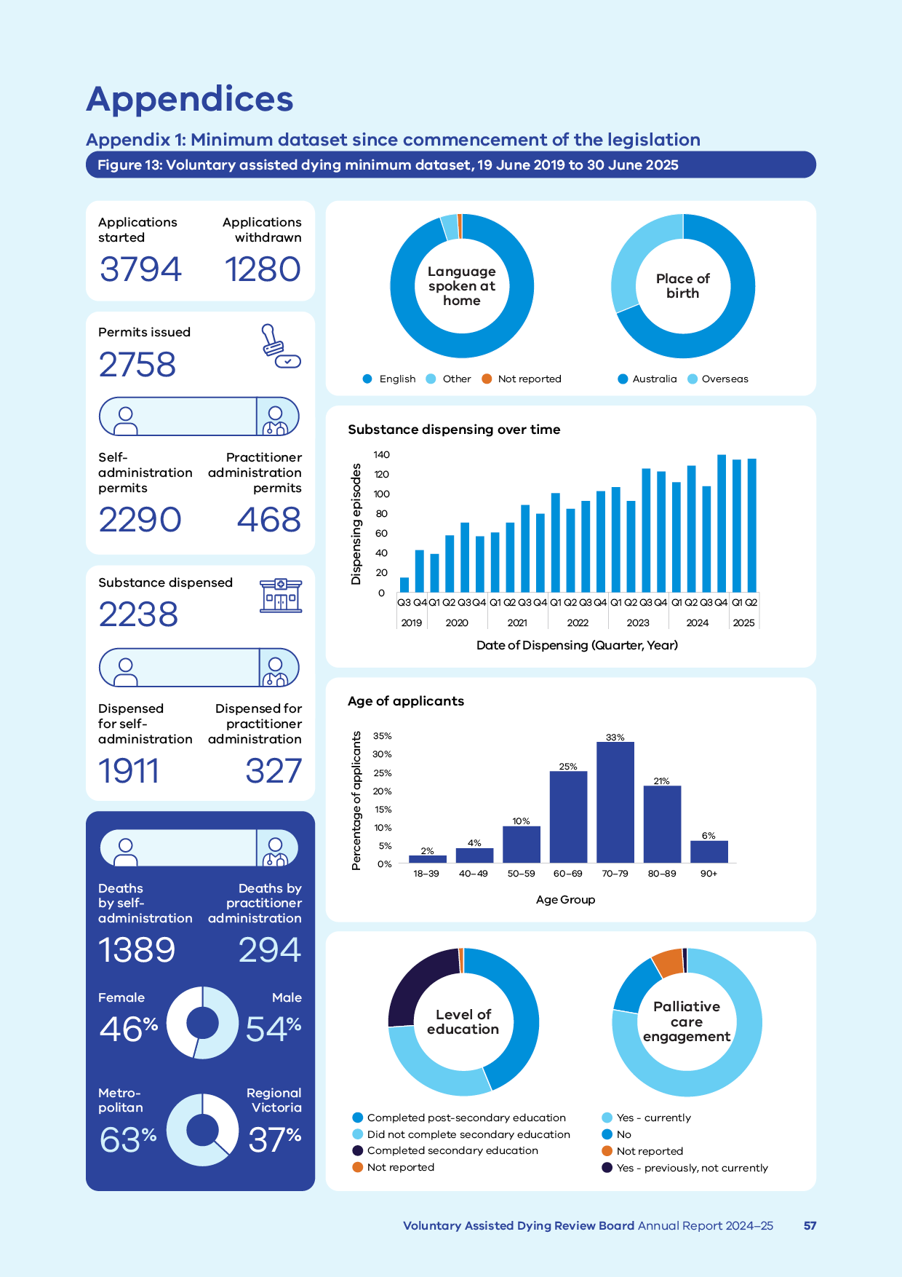

Figure 13 includes the following data:

* number of applications started – 3,794
* withdrawn applications – 1,280
* permits issued – 2,758
* self-administration permits issued – 2,290
* practitioner administration permits issued – 468
* substance dispensed – 2,238
* dispensed for self-administration – 1,911
* dispensed for practitioner administration – 327
* deaths by self‑administration – 1,389
* deaths by practitioner administration – 294
* female – 46%
* male – 54%
* metropolitan – 63%
* regional Victoria – 37%

## Appendix 2: Applying for VAD

The experience of people who have accessed, supported or provided care to applicants throughout the process provides insight on key considerations related to the process.

Previous applicants have told us the following information is helpful.

### How to access VAD

A person interested in VAD can ask their doctor to help them to access VAD.

The Statewide Care Navigator Service can provide information and support to find a trained medical practitioner to discuss the process with you.

Email the service on [vadcarenavigator@petermac.org](http://vadcarenavigator@petermac.org) or call 03 8559 5823.

A potential applicant must ask a medical practitioner directly about VAD to commence a conversation on the subject. Medical practitioners, by law, are unable to start a conversation about the process without a direct request from a person who wishes to make an application.

You can ask for support from an interpreter or speech pathologist. They can help you with your application.

### Who can access VAD

The Act outlines the eligibility criteria. A medical practitioner who has completed VAD training will conduct an assessment to determine eligibility to proceed with a request.

The medical practitioner will assess both demographic and medical information. They must determine that an applicant is:

* over 18
* an Australian citizen or permanent resident
* has ordinarily been a resident of Victoria for at least 12 months at the time of the first request.

The applicant must have decision-making capacity. They must be diagnosed with a disease, illness or medical condition that is:

* incurable
* advanced, progressive and will cause death within 6 months (or 12 months for a neurodegenerative condition)
* is causing suffering to the person that cannot be relieved in a manner that the person considers tolerable.

### What you need before you make a first request

You should prepare you identity documentation. Applicants need to show that they are over 18 years of age, that they are an Australian citizen or permanent resident, and that they have resided in Victoria for 12 months or more prior to the first request date.

Medical practitioners need to see this documentation and keep a copy of it as part of the process.

### What medical practitioners assess

The Act requires that co-ordinating and consulting medical practitioners must assess that the applicant meets the eligibility criteria outlined in the Act.

They must also assess that a person is acting voluntarily and without coercion, and that their request is enduring.

### How long the process will take

VAD is not an emergency medical procedure. It requires time and thoughtful planning. On average, once a first request is made, it takes about 20 days to receive a permit.

The VAD assessments can take time to complete, even if all the documentation and information is available at the initial appointment.

There is provision in the Act to shorten the process. However, this is only for a patient unlikely to survive more than 9 days after their first request.

Once the application process is complete, the permit can take up to 3 business days to be approved, after which a booking with the Statewide Pharmacy Service for delivery of the substance can be made.

### Why you need to provide a contact person

Applicants must appoint a contact person. The person is responsible for returning any unused substance to the Statewide Pharmacy Service.

Applicants may wish to have the contact person support them in preparing the substance before it is administered.

The Board invites contact people to provide feedback on the application process and their experience.

### Access to VAD in aged care or palliative care

VAD is a legislated process in Victoria. However, individual medical practitioners have the right to conscientiously object to involvement in the process.

If you are unable to access information or support for progressing an application, contact the Statewide Care Navigator Service to discuss your options. In some cases, you may need to move to another hospital or palliative care setting to complete the process.

The Board supports the right of practitioners to conscientiously object to the process. However, it encourages practitioners who do not wish to be involved to provide information about the Statewide Care Navigator Service to people who ask about accessing VAD.

### Why applicants need to see more than 2 medical practitioners

Applicants with a neurodegenerative disease, illness or medical condition with a prognosis of 6–12 months will be referred by the co-ordinating medical practitioner for a third specialist opinion as part of the assessment process.

A specialist medical opinion may be sought by either medical practitioner to ascertain decision‑making capacity. This may be necessary due to the applicant’s medical condition or history.

If an applicant has a disease, illness or medical condition that is rare, or that the assessing medical practitioner does not have the relevant experience or expertise to assess in relation to eligibility to access VAD, the medical practitioner may refer the person for a specialist opinion to inform their assessment process.

### Why applicants need to see medical practitioners in person

Commonwealth law prohibits the use of a carriage service (such as telephone or telehealth) for suicide-related material. This definition may include VAD. This means that in states where VAD is legal, medical practitioners must see an applicant in person to complete the assessment process.

The Board, alongside our peers in other Australian jurisdictions, understands that this affects regional and rural patients and those unable to travel due to limited mobility or other reasons.

The Board has raised this issue with the Attorney-General and discussed the impact with other jurisdictions.

Although we are confident a resolution to this restriction will be reached, we empathise that this currently has an adverse impact on applicants.

People unable to travel to see a medical practitioner in person are encouraged to contact the Statewide Care Navigator Service to see if there are other options to complete an assessment.

## Appendix 3: Statewide services and support organisations

### Voluntary Assisted Dying Review Board Secretariat

[VADBoard@health.vic.gov.au](mailto:VADboard@health.vic.gov.au)

### Statewide Care Navigator Service

[vadcarenavigator@petermac.org](mailto:vadcarenavigator@petermac.org)

03 8559 5823

### Statewide Pharmacy Service

[statewidepharmacy@alfred.org.au](mailto:statewidepharmacy@alfred.org.au)

### Policy, Engagement and Projects team, Department of Health

[EndofLifecare@health.vic.gov.au](mailto:EndofLifecare@health.vic.gov.au)

### Join a community of practice

For healthcare professionals who support people to access voluntary assisted dying.

[vadcarenavigator@petermac.org](mailto:vadcarenavigator@petermac.org)

For medical practitioners who have completed the voluntary assisted dying training.

[vadcommunity@westvicphn.com.au](mailto:vadcommunity@westvicphn.com.au)

### Grief and bereavement services

**Lifeline** (call 13 11 14) provides telephone or online support and counselling 24 hours a day, 7 days a week.

**13YARN** (www.13yarn.org.au) offer a one-on-one yarning opportunity with Lifeline-trained Aboriginal & Torres Strait Islander Crisis Supporters 24 hours a day, 7 days a week.

**Grief Australia** (call 1800 642 066) provides a statewide specialist bereavement service (including counselling and support groups) for individuals, children, and families.

**Beyond Blue** (call 1300 224 636) provides support 24 hours a day, 7 days a week, with options including telephone, online, email and forums.

**Palliative Care Victoria** (www.pallcarevic.asn.au) provides information and resources about grief and loss, including details for grief and bereavement services.

## Appendix 4: Voluntary Assisted Dying Review Board membership

### Board members

At the end of the 2024–25 reporting year, the Board had 9 members representing a wide range of expertise and skills to help perform the functions and duties of the Board.

The Board farewelled Julian Gardner AM who was appointed Chairperson from 3 March 2022 and retired 26 May 2025; and Charlie Corke AM who was appointed Deputy Chairperson from 4 June 2018 and resigned 30 June 2024.

The Board welcomed Euan Wallace AM who was appointed Chairperson as of 1 August 2025; and new members who were appointed 4 July 2024.

Paula Shelton was appointed Deputy Chairperson on 24 December 2024.

#### Chairperson

**Euan Wallace AM**  
Distinguished Professor and clinical academic

#### Deputy Chairperson

**Paula Shelton**  
Lawyer

#### Retirements

**Julian Gardner AM***Chairperson*  
retired 26 May 2025  
Lawyer

#### Resignations

**Charlie Corke AM***Deputy Chairperson*resigned 30 June 2024  
Intensivist

**Mitchell Chipman**resigned 15 January 2025  
Medical oncologist and palliative care physician

#### Members

**John Clements**  
Consumer representative and IT consultant

#### Members from 4 July 2024

**Emma Felman**  
Lawyer and teaching fellow

**Donna Goldsmith**  
Registered nurse, researcher and consumer representative

**Geraldine Goss**  
Medical oncologist and palliative care physician

**Nerina Harley AM**  
Intensivist and nephrologist

**Peter Lange**  
Geriatrician and general medicine physician

**Greg Mewett**Palliative care physician

Table 12: Record of 2024–25 attendance for Board membership on 30 June 2025

|  |  |  |  |  |  |  |  |  |  |
| --- | --- | --- | --- | --- | --- | --- | --- | --- | --- |
| **Board Member** | **Julian Gardner** | **Paula Shelton** | **John Clements** | **Emma Felman** | **Donna Goldsmith** | **Geraldine Goss** | **Nerina Harley** | **Peter Lange** | **Greg Mewett** |
| **Attendance record** | 90% | 100% | 100% | 71% | 82% | 73% | 71% | 73% | 73% |

1. State Government Victoria. (2025, February 20) *Voluntary assisted dying laws still the compassionate choice* [Media release]. Retrieved from <https://www.premier.vic.gov.au/voluntary-assisted-dying-laws-still-compassionate-choice>
2. Department of Health. (2025). *Voluntary Assisted Dying Review Board.* Retrieved from <https://www.health.vic.gov.au/voluntary-assisted-dying/voluntary-assisted-dying-review-board>
3. Department of Health. (2024). *About voluntary assisted dying.* Retrieved from <https://www.health.vic.gov.au/voluntary-assisted-dying/about>
4. Based on the number of applicants who were issued a permit, not the number of permits issued.
5. Based on the number of applicants who had a first assessment, not the total number of first assessments completed.
6. Conditions for accessing voluntary assisted dying in Victoria:

   People can ask for voluntary assisted dying if they meet all the following conditions:

   * They must have an advanced, progressive disease that will cause their death and that is:
     + likely to cause their death within six months (or within 12 months for neurodegenerative conditions like motor neurone disease)
     + causing the person suffering that is unacceptable to them.
   * They must have the ability to make and communicate a decision about voluntary assisted dying throughout the formal request process.
   * They must also:
     + be an adult 18 years or over
     + have been living in Victoria for at least 12 months
     + be an Australian citizen or permanent resident.

   For more information, refer to s. 9 of the *Voluntary Assisted Dying Act 2017.*
7. Referrals for specialist opinion are required:

   * If the co-ordinating medical practitioner determines that the person has a disease, illness or medical condition that is neurodegenerative and is expected to cause death between 6 and 12 months.
   * If either medical practitioner is unable to determine whether the person has decision making capacity in relation to voluntary assisted dying as required by the eligibility criteria.
   * If either medical practitioner is unable to determine whether the person’s disease, illness or medical condition meets the requirements of the eligibility criteria.

   For more information, see ss. 18 and 27 of the Voluntary Assisted Dying Act 2017.
8. As per footnote 5.
9. As per footnote 6.
10. Department of Health. (2024). *Voluntary assisted dying training for medical practitioners.* Retrieved from <https://www.health.vic.gov.au/voluntary-assisted-dying/training-for-medical-practitioners>
11. Australian Bureau of Statistics (2021) *Age (AGEP) by state (UR)* [Census TableBuilder], accessed 8 July 2025.
12. Australian Bureau of Statistics. (2022). *Snapshot of Victoria.* Retrieved from <https://www.abs.gov.au/articles/snapshot-vic-2021>
13. Australian Bureau of Statistics (2021) 'Table 1: Estimated resident population, local government areas (ASGS2021), Australia’, *Regional population*. [https://www.abs.gov.au/statistics/people/population/regional-population/2021#data-downloads](https://www.abs.gov.au/statistics/people/population/regional-population/2021%23data-downloads), accessed 08 July 2025
14. Palliative Care Australia (2025) Palliative care and voluntary assisted dying: survey finds a growing connection. <https://palliativecare.org.au/mediarelease/palliative-care-and-voluntary-assisted-dying-survey-finds-a-growing-connection/>
15. The *Registry of Births, Deaths and Marriages* uses the term *Nursing Home* for a residential care facility. 
16. White B et al. (2023) ‘Implications of voluntary assisted dying for advance care planning’, *The Medical Journal of Australia,* 220(3):129–133.
17. Department of Health. (2025, February 20). *Voluntary assisted dying five-year review.* Retrieved from  
    <https://www.health.vic.gov.au/voluntary-assisted-dying/five-year-review>
18. Australian Medical Association. (2019). *Conscientious objection*. Retrieved from <https://www.ama.com.au/position-statement/conscientious-objection-2019>
19. Australian Medical Association (AMA). (2025). *AMA position statement on Voluntary Assisted Dying 2025.* Retrieved from <https://www.ama.com.au/articles/ama-position-statement-voluntary-assisted-dying-2025>
20. White B et al. (2023) ‘Barriers to connecting with the voluntary assisted dying system in Victoria, Australia: a qualitative mixed method study’, *Health Expectations*, 1–14.