


Contents

Victorian Respiratory Surveillance Report
19 September 2025
About this report 1
Summary 2
Laboratory surveillance 3
Case notifications 3
Testing 8
Community surveillance 9
FluTracking 9
How to use this report 12
Data sources 12
Interpretation of data 12
Definitions 12

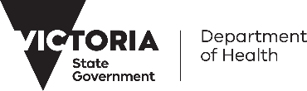
About this report
The Victorian Respiratory Surveillance Report summarises the latest surveillance information on COVID-19, influenza and respiratory syncytial virus (RSV) in Victoria. This report provides an overview of the current levels and trends of acute respiratory illness from these conditions in the community. Please see the section on How to use this report for more information.
Measurements of the greatest value for summarising respiratory illness in Victoria are presented in this report. Other systems are also reviewed by the Department of Health to understand patterns of respiratory disease in Victoria which inform the overall summaries presented.
Data are presented as at 17 September 2025 for the week ending 13 September 2025.
Each report reflects the data available at the time the report was prepared. Information may differ from previous reports as new data is received or updated.

Victorian Respiratory Surveillance Report | Summary | 19 September 2025 2

Summary

In Victoria, activity of COVID-19, influenza and RSV has decreased from winter peaks. RSV and COVID-19 trends continue to decrease whilst influenza activity remains at elevated levels.
Increases in respiratory disease activity are typical during the winter period in Victoria. COVID-19 activity increased in May, peaked in June, and then started to decline. Trends stabilised throughout August, remaining above baseline levels, before continuing to decrease into September. Influenza activity increased in May and peaked in early July. This was followed by a brief decline, with activity stabilising from mid-July onwards at elevated levels. Marginal decreases in activity have been observed in recent weeks. RSV activity also increased in May and peaked in early July, and has continued to decline since the peak.

COVID-19
NOTIFICATIONS LAST 12 WEEKS
TEST POSITIVITY
The percentage of tests that were positive continued to decrease

CASE TREND
Notifications have continued to decrease
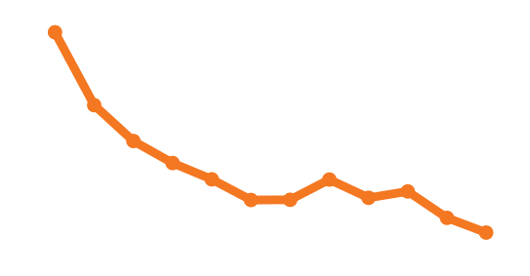
Influenza
NOTIFICATIONS LAST 12 WEEKS
TEST POSITIVITY
The percentage of tests that were positive decreased

CASE TREND
Notifications have continued to decrease
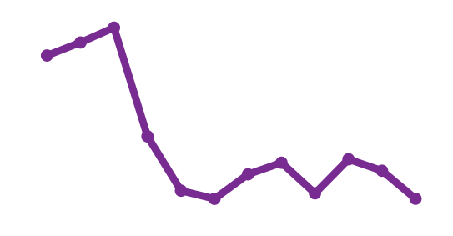
RSV
NOTIFICATIONS LAST 12 WEEKS
TEST POSITIVITY
The percentage of tests that were positive continued to decrease

CASE TREND
Notifications have continued to decrease
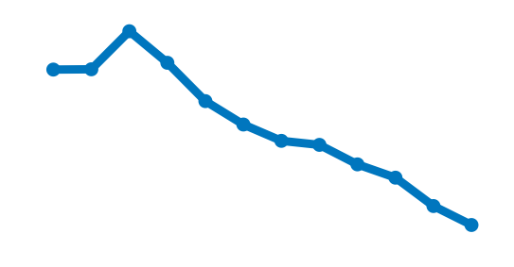

Laboratory surveillance

Case notifications
Laboratory-confirmed cases of COVID-19, influenza and respiratory syncytial virus are notified to the Victorian Department of Health. Notified infections that are diagnosed through laboratory testing are only a subset of the total number of infections in the community. Trends in notifications may be impacted by changes in testing.

Summary
In the past week, COVID-19 notifications decreased (-10%), influenza notifications decreased (-8%) and RSV notifications decreased (-15%).
COVID-19
10% decrease

RSV
15% decrease
8% decrease
Influenza

COVID-19

Figure 1: COVID-19 notified cases by week, Victoria, 15 September 2024 to 13 September 2025
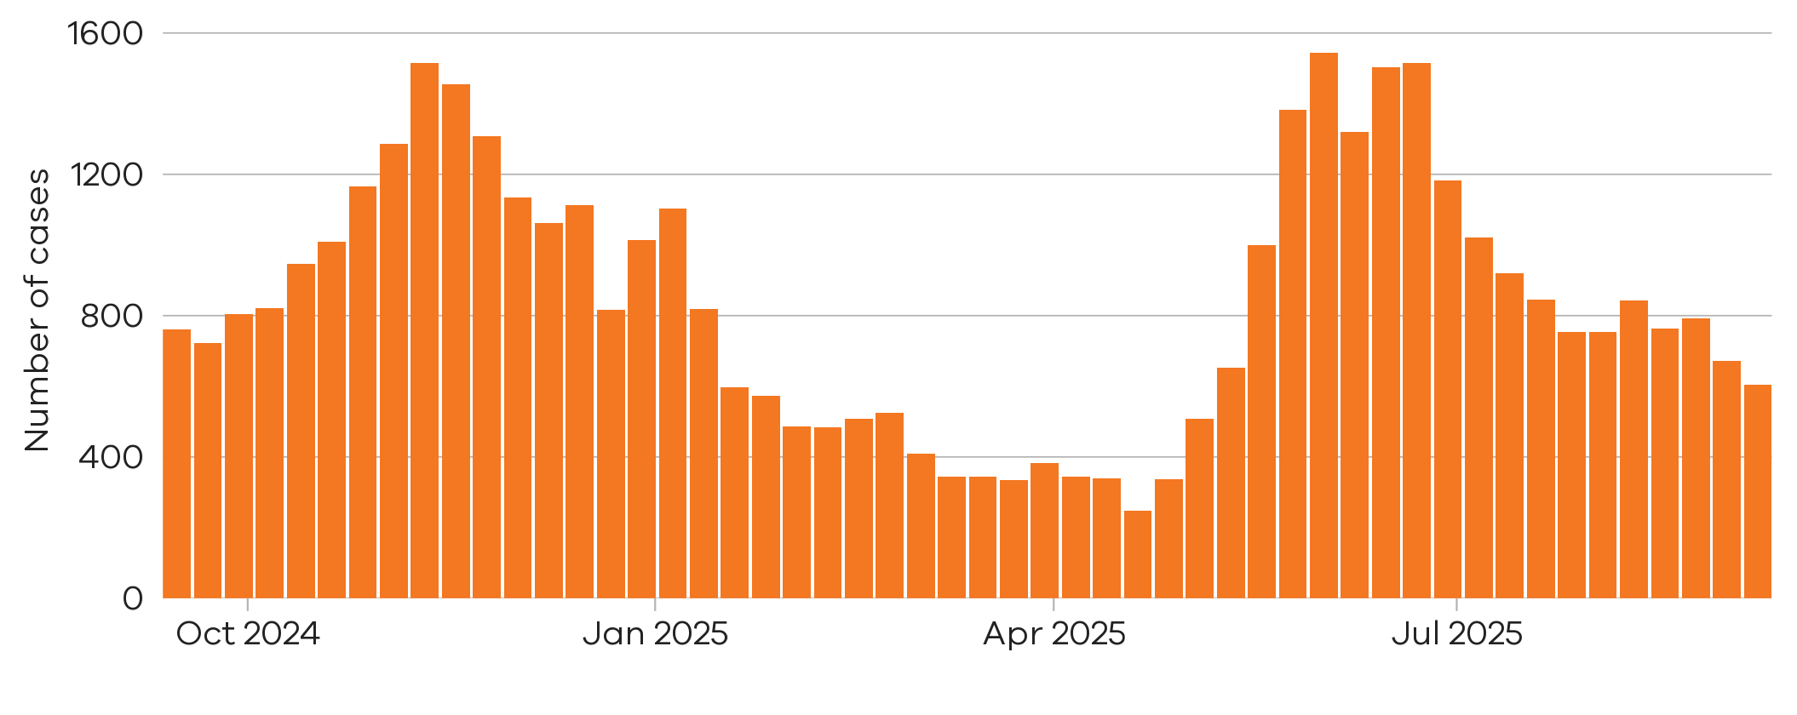
10% decrease
There were 605 notified COVID-19 cases last week
7 Sep 2025 to 13 Sep 2025
There were 672 notified COVID-19 cases two weeks ago

31 Aug 2025 to 6 Sep 2025

Figure 2: COVID-19 trends in notified cases (7-day rolling average), Victoria, 1 January 2023 to 13 September 2025
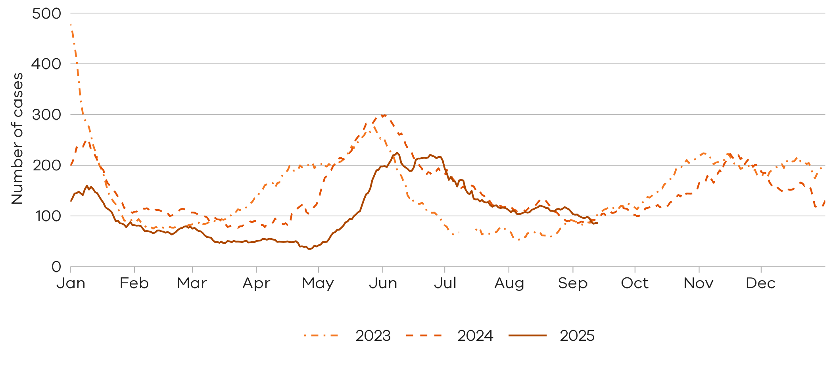

Notified COVID-19 cases are at similar levels compared to the same time in the past two years

Influenza

Influenza notifications presented in this report are reported from a subset of laboratories in Victoria, generally comprising around 85% of total influenza notifications.
Figure 3: Influenza notified cases by week, Victoria, 15 September 2024 to 13 September 2025
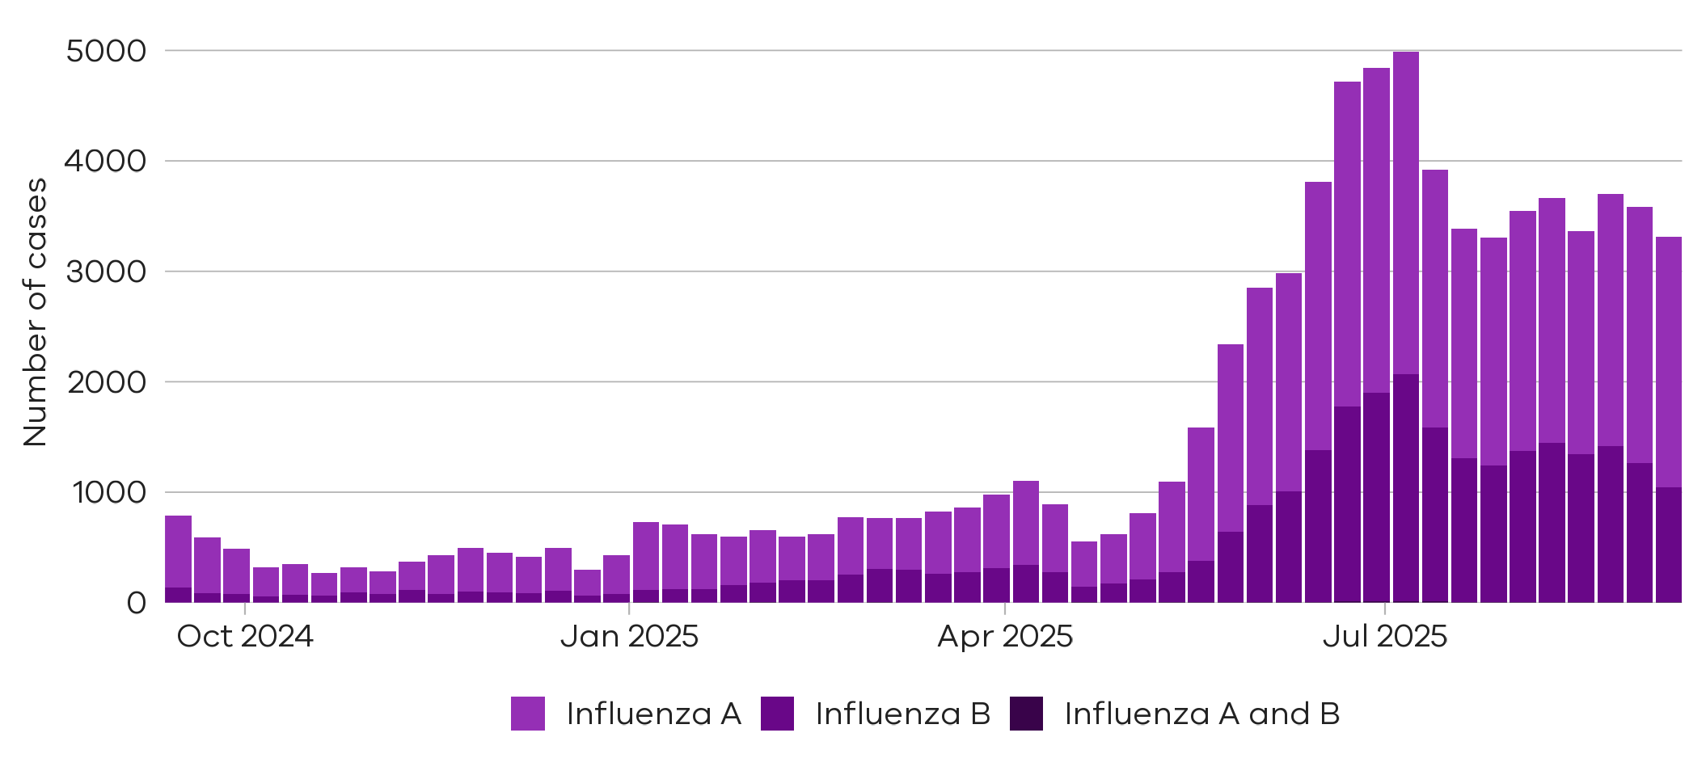
There were 1254 cases of influenza B notified two weeks ago

31 Aug 2025 to 6 Sep 2025
There were 2323 cases of influenza A notified two weeks ago
31 Aug 2025 to 6 Sep 2025
There were 2264 cases of
influenza A notified last week
7 Sep 2025 to 13 Sep 2025
There were 1043 cases of
influenza B notified last week

7 Sep 2025 to 13 Sep 2025
3% decrease
17% decrease

Figure 4: Influenza A trends in notified cases (7-day rolling average), Victoria, 1 January 2023 to 13 September 2025
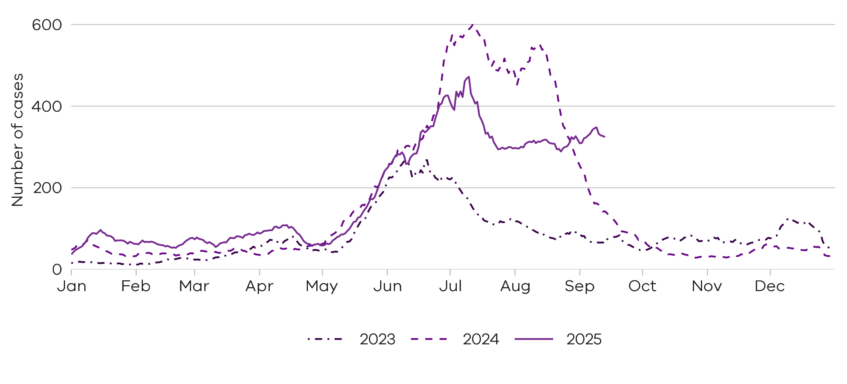

Notified influenza A cases are at higher levels compared to the same time in the past two years

Figure 5: Influenza B trends in notified cases (7-day rolling average), Victoria, 1 January 2023 to 13 September 2025
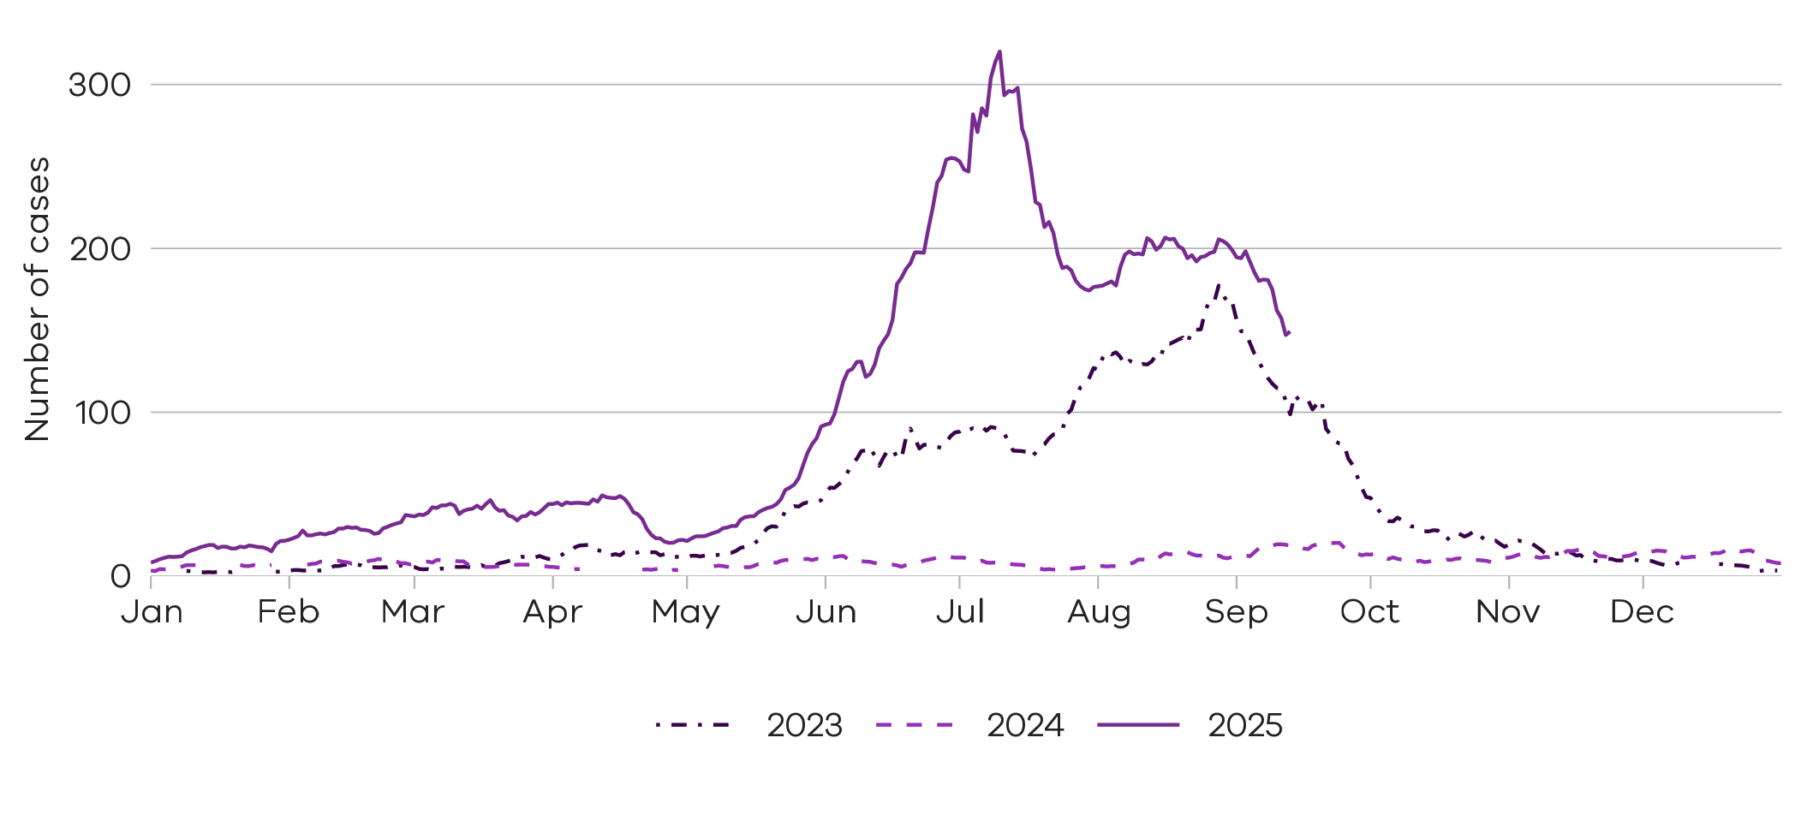
Notified influenza B cases are at similar levels to the same time two years ago

Respiratory Syncytial virus (RSV)

RSV notifications presented in this report are reported from a subset of laboratories in Victoria, generally comprising around 85% of total RSV notifications.
Figure 6: RSV notified cases by week, Victoria, 15 September 2024 to 13 September 2025
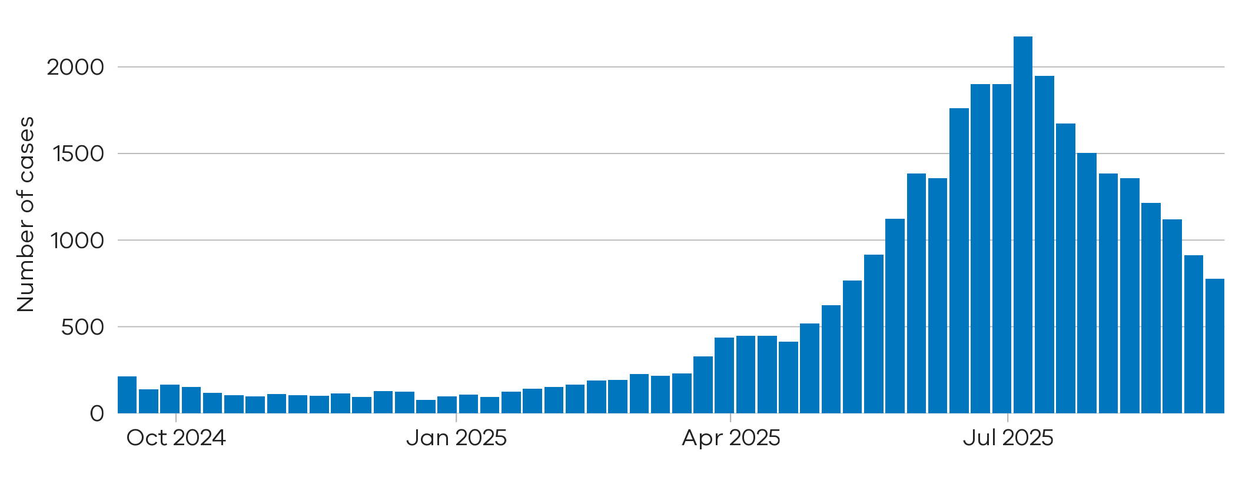
15% decrease
There were 777 notified RSV cases last week
7 Sep 2025 to 13 Sep 2025
There were 914 notified RSV cases two weeks ago

31 Aug 2025 to 6 Sep 2025

Figure 7: RSV trends in notified cases (7-day rolling average), Victoria, 1 January 2023 to 13 September 2025
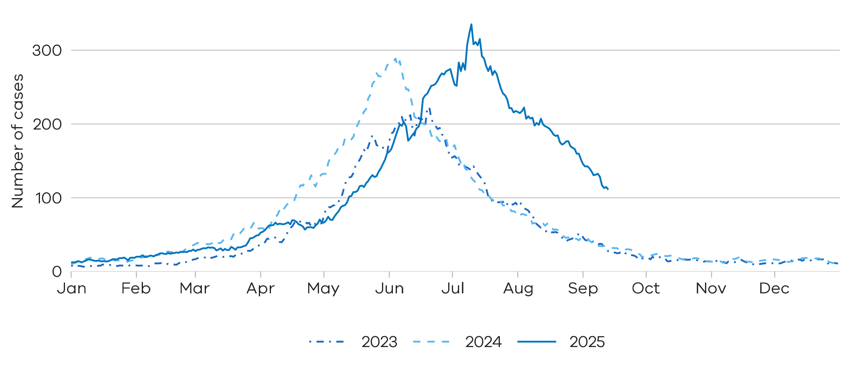
Notified RSV cases are at higher levels compared to the same time in the past two years

Young children and older adults
Young children and older adults are at greater risk of severe disease from RSV.
Figure 8: RSV trends in notified cases by week in young children (under 5 years), Victoria, 15 September 2024 to 13 September 2025
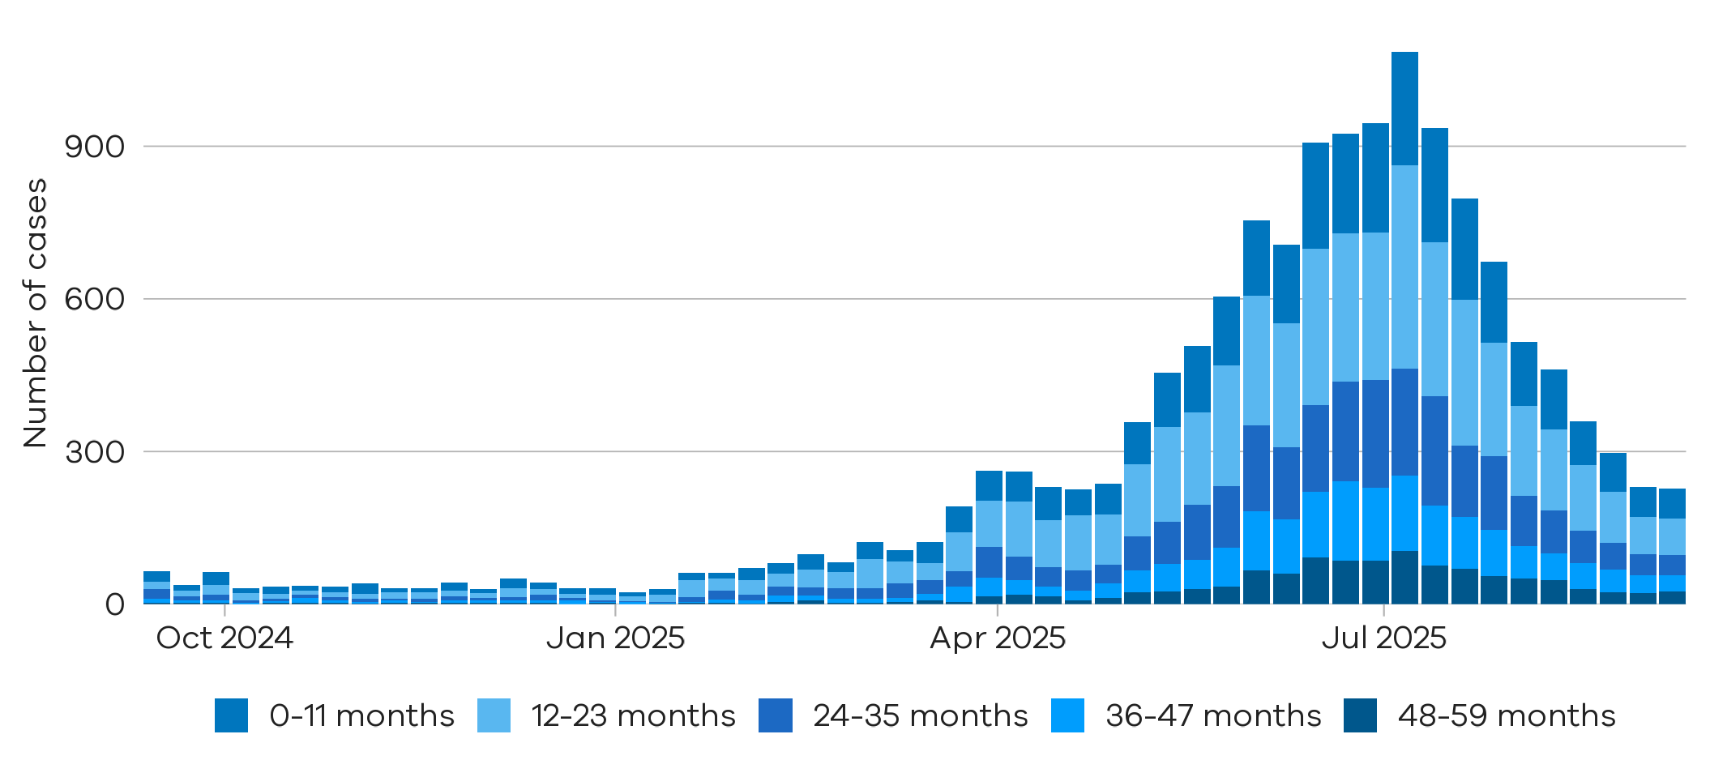
Children under 2 years comprise the majority of notified RSV cases

Figure 9: RSV trends in notified cases by week in older adults (65+ years), Victoria, 15 September 2024 to 13 September 2025
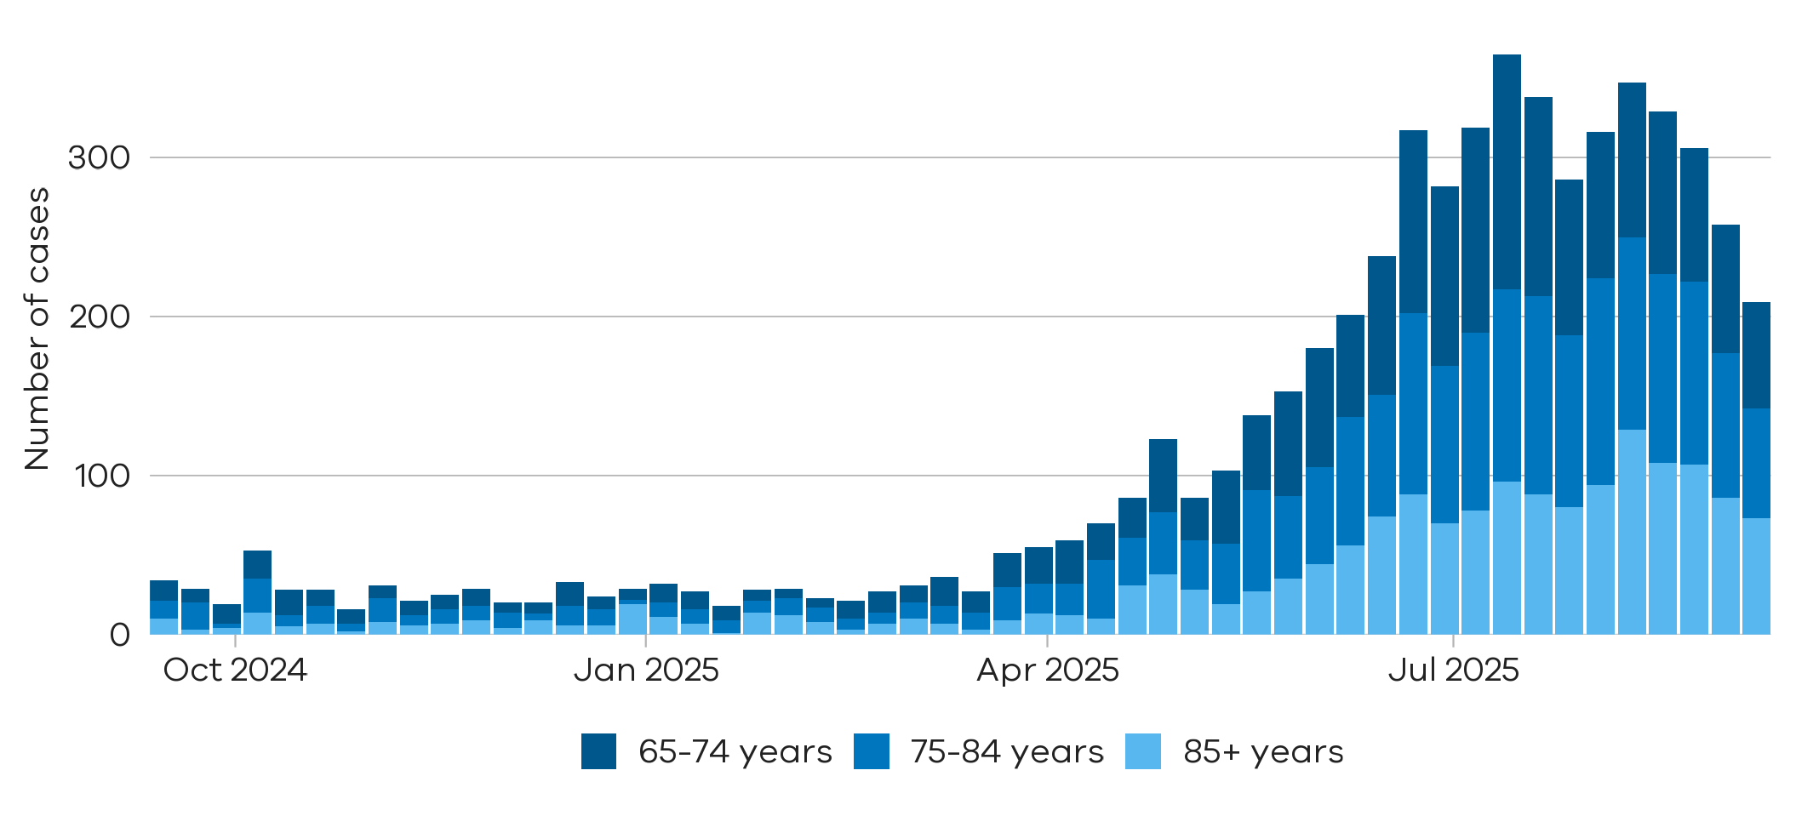
Notified RSV cases in adults aged over 65 years have declined in the recent period

Testing

Laboratory testing for respiratory illnesses changes over time. Tracking the percentage of tests with the notifiable condition detected (i.e. test positivity) is a useful measure to understand trends in disease surveillance over time.
Test results presented in this report are from selected laboratories. These include private and hospital laboratories and represent tests completed across Victoria.

Summary
In the past week, the percentage of COVID-19 tests that were positive decreased (3.17% to 2.38%), the percentage of influenza tests that were positive decreased (9.27% to 8.76%) and the percentage of RSV tests that were positive decreased (4.83% to 4.61%).

Figure 10: Weekly test positivity for COVID-19, Influenza and RSV, Victoria, 15 September 2024 to 13 September 2025
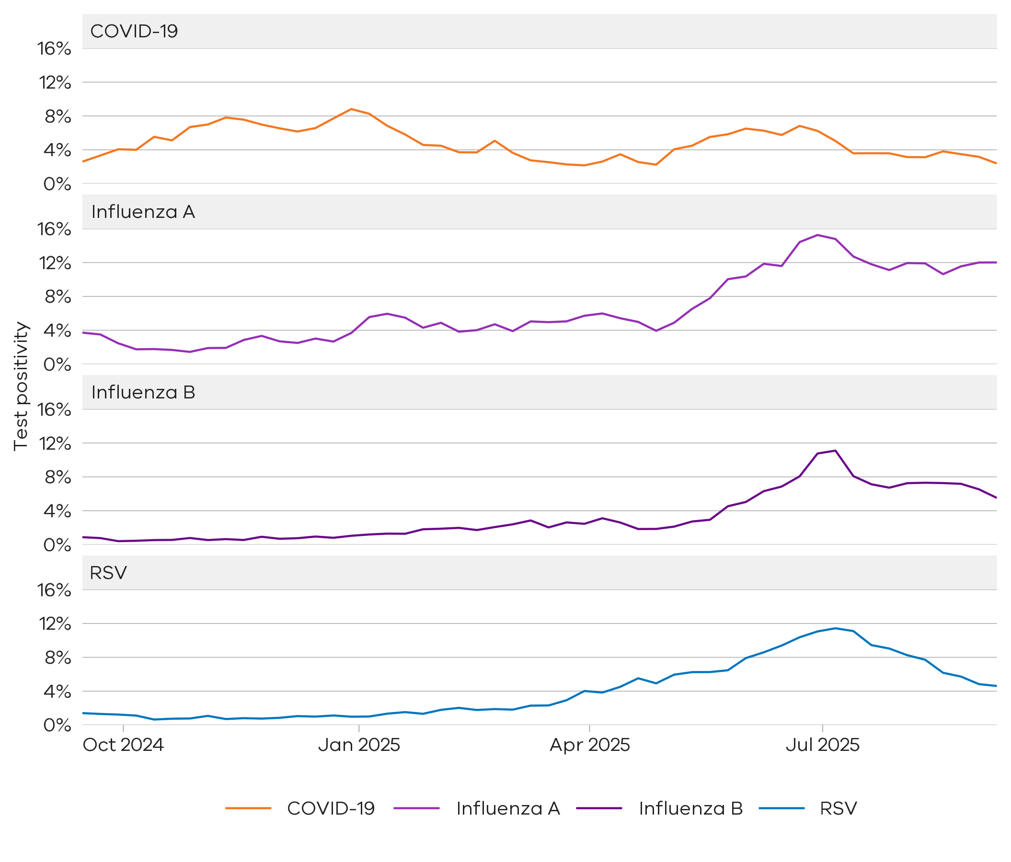

Figure 11: Weekly test positivity by age groups for COVID-19, Influenza and RSV, Victoria, 15 September 2024 to 13 September 2025

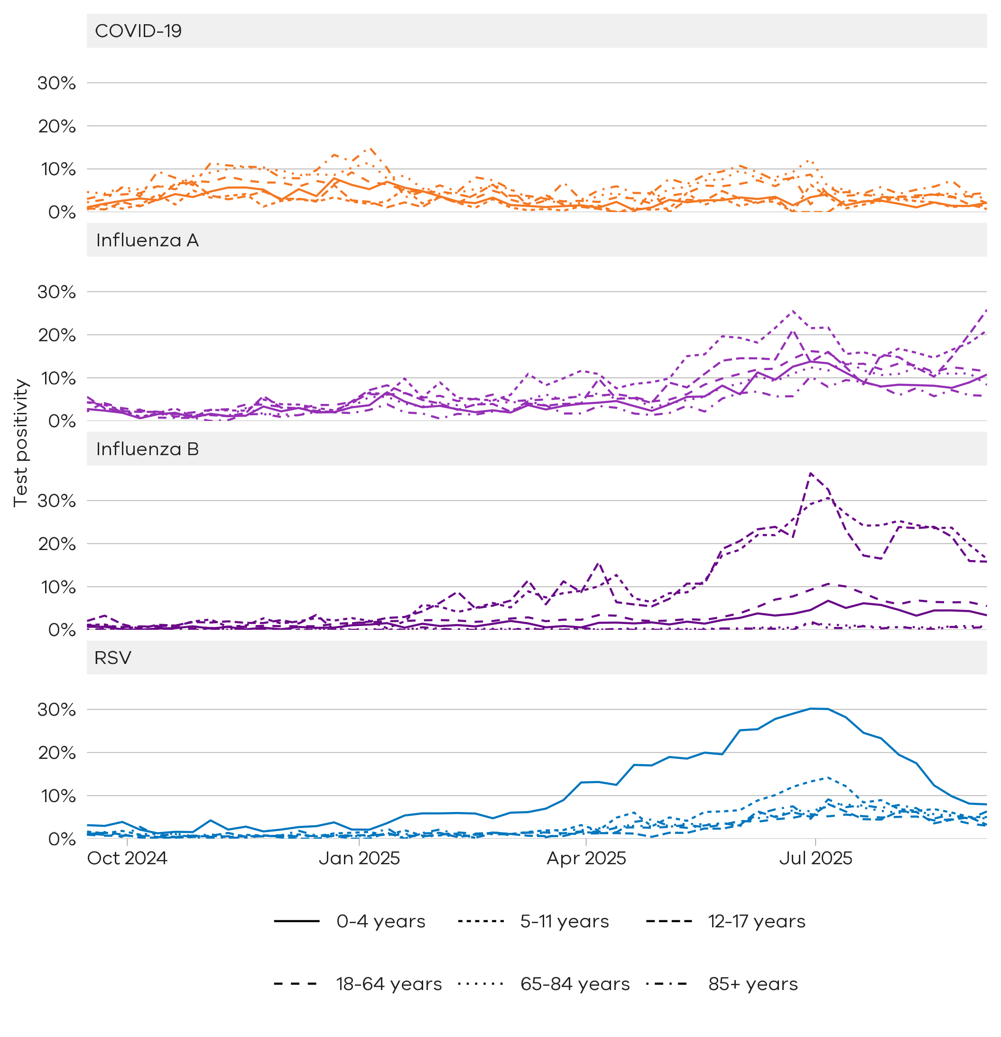

Community surveillance

Respiratory illnesses are not limited to the notifiable conditions presented above. Understanding the overall burden of respiratory illness in the community is useful to understand broader trends in illness over time.
FluTracking
FluTracking is an online surveillance system across Australia, New Zealand, Hong Kong and Fiji. Volunteer participants complete a simple weekly online survey which collects self-reported information on respiratory symptoms. More information about FluTracking and ways to be involved are available here: www.flutracking.net/

Summary
In the past week, the percentage of Victorian FluTracking participants reporting respiratory illness (fever and cough) was stable from the previous week.
Figure 12: Proportion of FluTracking participants reporting respiratory illness by week, Victoria, 1 January 2023 to 13 September 2025. Respiratory illness is defined as fever & cough.
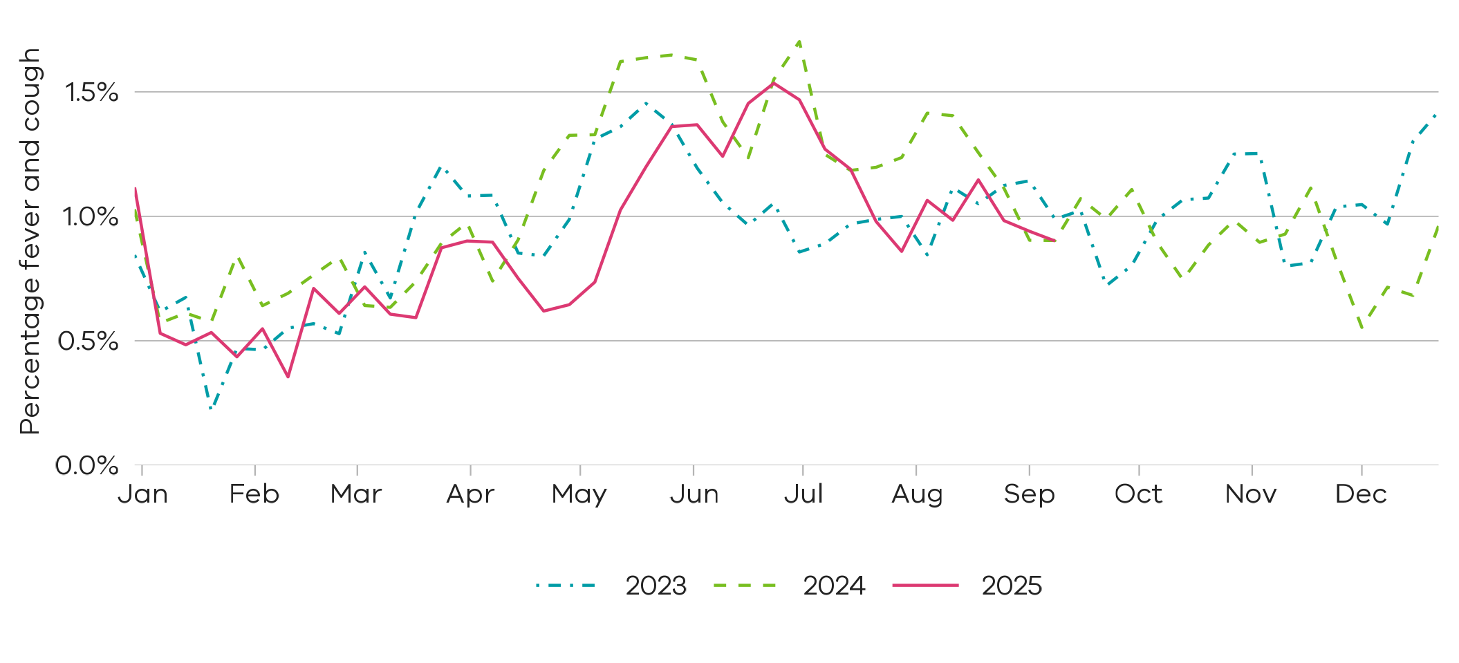
Reported respiratory illness from FluTracking is at similar levels in the past two years

How to use this report

Data sources
All notified cases in Victoria are recorded in the Victorian Public Health Events Surveillance System (PHESS). Under the Public Health and Wellbeing Act 2008 and Public Health and Wellbeing Regulations 2019, the Victorian Department of Health is authorised to collect information from doctors and laboratories about diagnoses of certain health-related conditions in Victoria.
The FluTracking surveillance system collects data from volunteer participants in a weekly survey. FluTracking reports are available here: https://info.flutracking.net/reports/australia-reports/
The Victorian Department of Health continually reviews surveillance methods to monitor respiratory disease in Victoria. Measurements included in this report may be updated or removed accordingly.
Definitions
Notified cases: Laboratory-confirmed cases of COVID-19, Influenza, and respiratory syncytial virus are reported according to the CDNA case definitions https://www.health.gov.au/resources/collections/cdna-surveillance-case-definitions Where multiple positive test results are received for the same person within 30 days of the initial test result they are counted as a single case.
Rapid antigen test results are not collected by the Victorian Department of Health, however, remain an important tool for individuals to access treatment and protect their community.
Notified cases represent a subset of the total number of infections for these conditions in the community. The number of notified cases is indicative of trends rather than absolute numbers of cases.
Test positivity: Test positivity is the percentage of total tests where the notifiable condition was detected.
Dates: Case notifications are based on the date the notification was first received by the Victorian Department of Health. Test positivity is based on the date of specimen collection.
Weeks: For the purposes of this report, data are aggregated by week, with the week starting Sunday and ending Saturday.

Authorised and published by the Victorian Government, 1 Treasury Place, Melbourne.
© State of Victoria, Australia, Department of Health, September 2025
ISSN 2982-3161 - Online (pdf/word)

