

|  |
| --- |
| Office of the Chief Psychiatrist: Role and core activities |
|  |
|  |

The Office of the Chief Psychiatrist (OCP) has a legislative role to monitor services to ensure compliance with the *Mental Health and Wellbeing Act 2022*. The OCP provides clinical governance and leadership to the Victorian mental health sector and is part of a governance architecture that oversees and improves quality and safety in mental health treatment and care. The OCP’s main activities are outlined below.

# Clinical governance

As part of its clinical governance role, the OCP provides rigorous oversight of quality and safety in Victoria’s clinical mental health and wellbeing services. It does this through monitoring and responding to quantitative and qualitative information reported by services on:

* restrictive practices
* electroconvulsive treatment
* deaths of people in the care of a mental health service
* sexual incidents in mental health and wellbeing services.

The OCP’s approach to clinical governance is both top-down and bottom-up. It involves regulation and compliance with the Mental Health and Wellbeing Act and supporting services to continuously improve delivery of clinical treatment and care.

In addition to system wide governance, the OCP provides targeted, case based governance through support of clinical escalation via individual clinical discussions, case conferences or via the Statewide Complex Needs Panel to support shared clinical decision making across teams. The OCP may seek clinical information from services about the delivery of treatment and care to enable it to carry out its oversight duties.

The OCP does not take a role in direct clinical care. While the Chief Psychiatrist can provide directions, this is only when all collaborative approaches have been exhausted and where there is a clear course of action required legally or ethically. The intent of good governance is to support expert local decision making and this approach will be prioritised. Many dilemmas escalated to the OCP have no single correct outcome and thus shared decision making is the most protective way to guide future decision making.

It is the role of the OCP to understand and support local clinical governance thinking to ensure each designated mental health service has a good clinical governance architecture. Although there may differences across the sector, some commonalities should exist on all sites: a modern clinical governance approach, a focus on systems issues, support for staff and regular local quality and safety meetings which monitor the quality of local work, identify risks, actively manage incidents and identify targets for continuous improvements.

Services should have well documented internal clinical governance policies and adopt a supported decision-making approach, in which a consumer’s preferences guide decisions about their treatment, and families and carers are also involved in care decisions.

Escalation to the OCP from services should involve the Authorised Psychiatrist to support local governance approaches.

# Leadership and engagement

The OCP undertakes a variety of leadership and engagement activities to promote clinical best practice, including:

* conducting **service visits** to strengthen connection with mental health and wellbeing services, to better understand the challenges they face and the support they require to address them, and to promote the rights of people receiving mental health and wellbeing services
* designing and delivering **quality and safety forums** to foster collaboration with and between mental health service providers to address contemporary quality and safety issues in mental health care
* publishing **quality and safety bulletins** to provide specialist advice on clinical issues raised by mental health and wellbeing services, and feedback to the sector important information to support good clinical governance and continuous improvement
* publishing Chief Psychiatrist **newsletters** to disseminate contemporary information about statutory functions, OCP activities and upcoming opportunities for sector engagement.

# Portfolios

The OCP carries out its clinical governance and leadership role through a matrix portfolio approach. Each portfolio is made up of an interdisciplinary team that has members with psychiatric and clinical expertise and project, policy and administration skills. Through this approach, the OCP delivers legislated functions through a diversity of input and thinking. The diagram below underpins OCP clinical governance and leadership and represents the interactions of portfolios with key stakeholders.

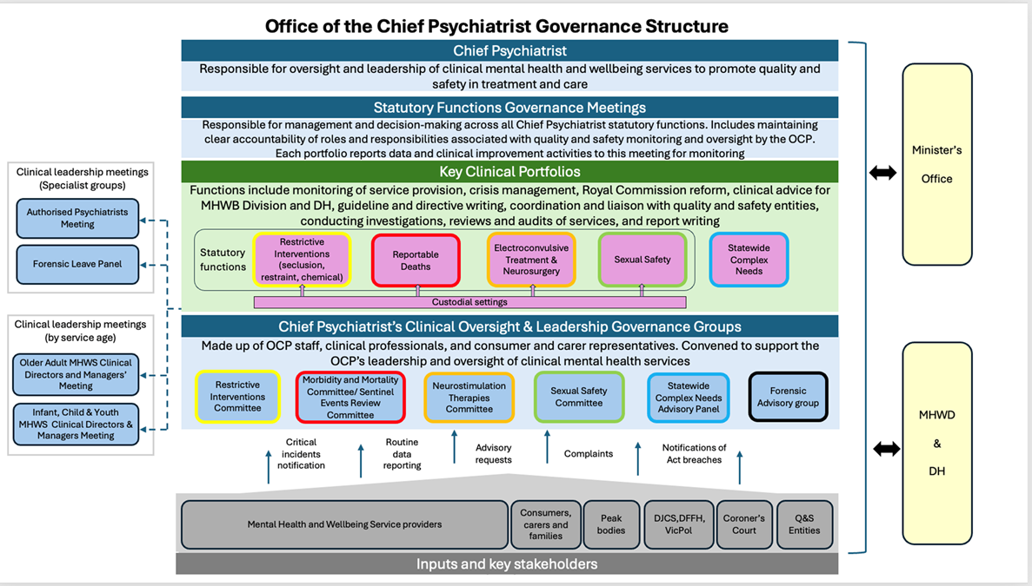

# Advisory functions to Mental Health and Wellbeing Division and transformational reform

The OCP provides an advisory function in the Mental Health and Wellbeing Division, Department of Health, and can provide a clinical perspective to assist governmental decision making. In addition, the OCP undertakes transformational reform stemming from the recommendations of the Royal Commission into Victoria’s Mental Health System.

The Royal Commission reforms that the OCP has been specifically involved in include:

* introducing oversight of:
  + chemical restraint in all of Victoria’s designated mental health services
  + restrictive interventions in emergency departments and urgent care centres
  + forensic mental health and wellbeing services
  + Adult and Older Adults Local Mental Health and Wellbeing Services
* contributing to Children Health and Wellbeing Locals development
* contributing to Locals Governance Framework.

# Contacting the OCP

Mental health and wellbeing services are advised to copy the OCP inbox at [ocp@health.vic.gov.au](mailto:ocp@health.vic.gov.au) when emailing the Chief Psychiatrist and Deputy Chief Psychiatrists.

All other inquiries to the OCP can be made by telephone on 1300 767 299 or email at [ocp@health.vic.gov.au](mailto:ocp@health.vic.gov.au).

|  |
| --- |
| To receive this document in another format, phone 1300 767 299, using the National Relay Service 13 36 77 if required, or email the Office of the Chief Psychiatrist <ocp@health.vic.gov.au>.  Authorised and published by the Victorian Government, 1 Treasury Place, Melbourne.  © State of Victoria, Australia, Department of Health, April 2025.  ISBN 978-1-76131-770-5 (pdf/word/online)  Available at [About the Chief Psychiatrist](https://www.health.vic.gov.au/chief-psychiatrist/about-the-chief-psychiatrist) <https://www.health.vic.gov.au/chief-psychiatrist/about-the-chief-psychiatrist> |