

|  |
| --- |
| VADC: Managed File Transfer (MFT) |
| June 2022 |
|  |

**Contents**

Information about MFT portal 2

**How do I get an MFT account? 2**

**How to connect to the Managed File Transfer (MFT)? 3**

**How to upload a VADC file to The Managed File Transfer (MFT)? 7**

**How to collect your reports. 9**

**MFT Frequently Asked Questions (FAQ’s): 10**

Can I change the way I receive the MFA Security Code? 10

What should I do if I haven’t received the emailed MFA Security Code after 15 minutes? 10

Can I use another person’s MFT account to obtain the MFA Security Code? 10

What should I do after I’ve entered the MFA Security Code provided but I still cannot connect to the MFT portal? 11

Can we have a generic login to the MFT? 11

Can I upload multiple files to the same site at the same time? 11

Can one person send a file and another person download the data validation Feedback Report? 11

Are files archived on MFT? 11

Are there file naming conventions for VADC submission files using MFT? 12

Can TEST files be submitted to VADC? 12

Can I remove an XML extract file that has been uploaded in error? 12

What are the system requirements? 12

What do I do if I can’t log in OR I’ve forgotten my password? 12

Is there support available? 13

## Information about MFT portal

The Managed File Transfer (MFT) web portal is used to submit VADC XML extract files and retrieve VADC ‘Feedback Validation’ reports and the VADC ‘Service Event Statement’ (SES).

To access the MFT portal, account holders are required to obtain and enter a single-use MFA Security Code as well as enter their MFT login name and password. The MFA Security Code is valid for one login session only, therefore MFT users will be required to obtain and enter a new MFA Security Code at each new login session.

By default, all MFT account holders are setup to receive the single-use MFA Security Code via email using the email address linked to their MFT account profile.

MFT account holders can choose to receive their MFA Security Code via SMS (text) to their mobile phone number. If a MFT account holder would prefer to access this option, please email [vadc_data@health.vic.gov.au](mailto:vadc_data@health.vic.gov.au) providing their mobile phone number. Their MFT account profile will be updated, and they will receive email confirmation from the VADC team.

Individuals using MFT accounts that are not their own or using an account with an email address they cannot access will not be able to obtain the single-use MFA Security Code. **These users will not be able to access the MFT portal.**

**MFT account holders who have not supplied their mobile telephone number cannot receive the single use MFA Security Code via SMS (text).**

**It is strongly recommended that users access the MFT portal via Google CHROME or Microsoft Edge, Internet Explorer is being phased out and will no longer be supported in the coming months.**

**The WEB Browser must be started in “Incognito or Private Mode” which eliminates any problems arising from cached content. MFT users should contact their IT support if they need assistance with this.**

## How do I get an MFT account?

Send an email to [vadc_data@health.vic.gov.au](mailto:vadc_data@health.vic.gov.au) providing the following details. Please put ‘VADC MFT’ in the Subject line:

* First name:
* Surname:
* Day and month of birth (only):
* Email address:
* Service provider folder ID/s (e.g., VADC_123) which you require access to:
* Manager approval:

Please note individual email addresses are required to register and create user accounts. No shared email addresses can be used in the registration process.

Once these details are received your user account will be created, and your login details will be emailed back to you.

## 

## How to connect to the Managed File Transfer (MFT)?

1. To access the MFT logon page we recommend you use Google CHROME or Microsoft EDGE.

a) If using Google CHROME, it must be opened in Incognito mode – you can do this by right clicking on the CHROME icon and selecting New Incognito window. Once opened the window will be darker coloured than a standard CHROME window and you’ll see a page explaining how incognito mode works.

b) If using Microsoft EDGE this must be opened in Privacy Mode by right clicking on the EDGE icon and selecting New InPrivate window

1. To open the MFT portal logon page, copy and paste the following URL into your web browser: [**https://prs2-mft.prod.services**](https://prs2-mft.prod.services)

If you have a problem accessing the website refer to the FAQ’s at the end of this document.

1. **DO NOT enter any details into the login ID or Password fields prior to clicking on the GET MFA Code button – these fields must be left blank.**

Select Get MFA Code (as highlighted below) which re-directs you to the MFA login page.

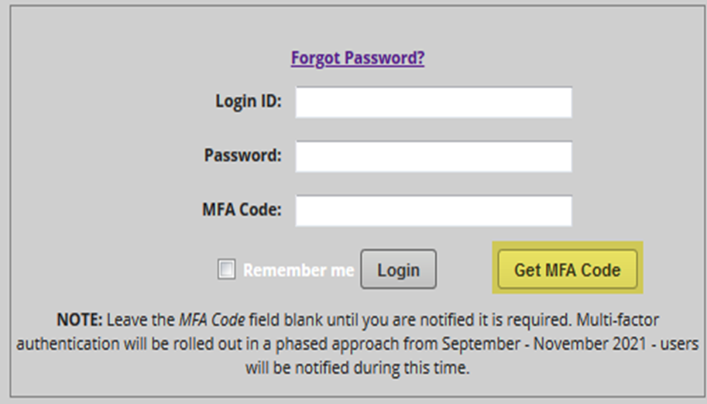

1. At the MFT Login page, click on either **SMS** OR **Email** (whichever is your registered option). You **MUST** manually enter your MFT login ID in the User Identifier field and your email address OR registered mobile number in the required field (even if your WEB Browser has already listed these details).

**If you do not manually enter these details your attempt to connect to the MFT portal will fail**.

Note: **Soft Token** option is **NOT** available to MFT users.

Once you have manually entered the required information, click **Continue (**there is a bug in the process), and you will need to re-enter your MFT account/login ID again in the User Identifier field. Then select **Continue** again.

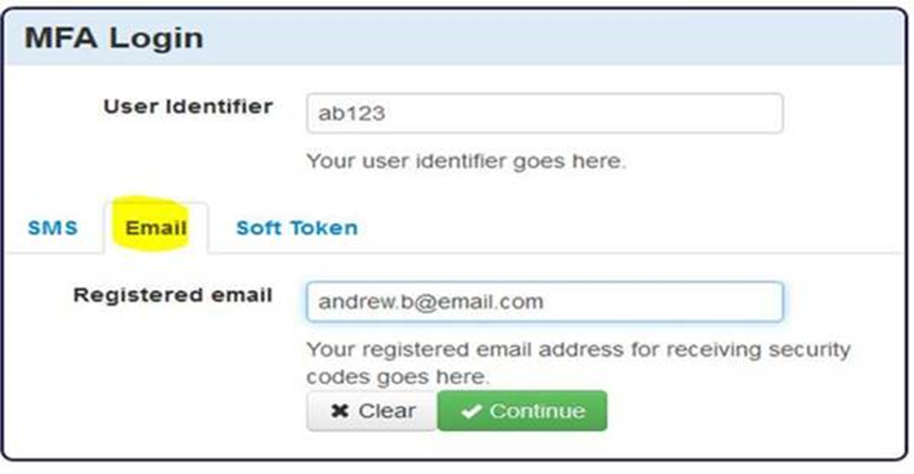

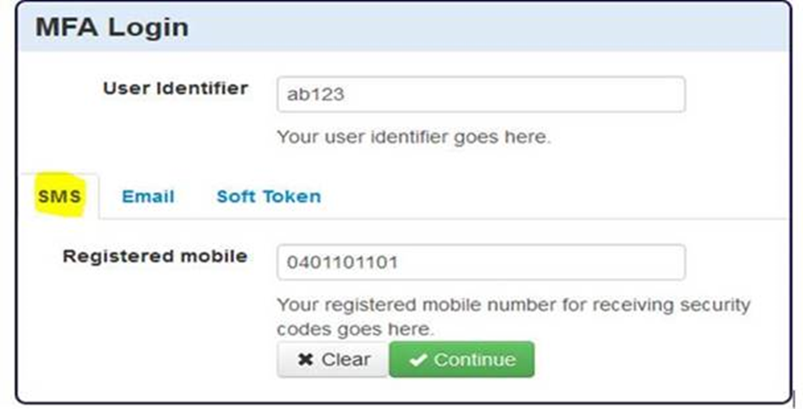

Selecting **Clear** will remove any details entered so you can re-start the process at the MFA login page

1. A Security Code Request Confirmed window appears (as shown below). Click **Continue** to be

re-directed to the MFT login page.

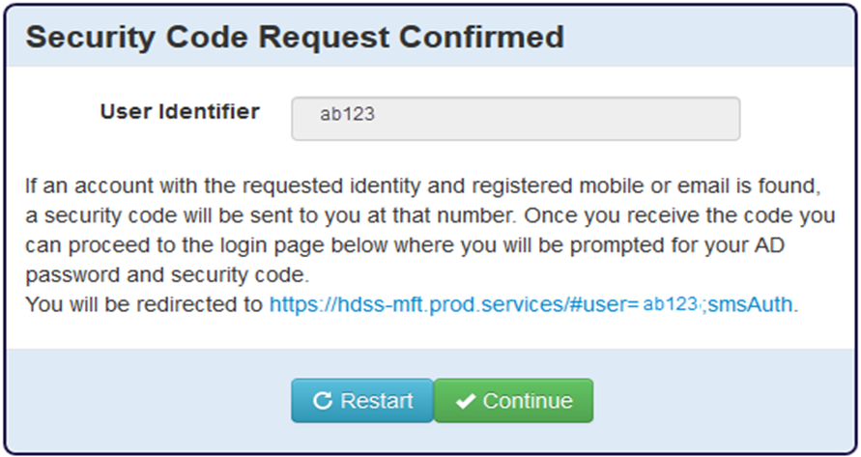

Please Note:

The following message is received if a problem occurs with your request for an MFA Security Code.

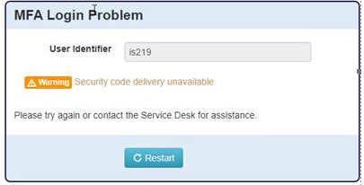

Try again, by selecting **Restart** which will take you back to the blank MFA login page to restart the process. Do not select this option unless you want to restart the process.

If you experience a problem, please send an email to [vadc_data@health.vic.gov.au](mailto:vadc_data@health.vic.gov.au) for assistance.

1. You will receive your MFA Security Code via email or SMS (as shown below)

|  |  |  |
| --- | --- | --- |
| **Mobile MFA Security Code** |  | **Email MFA Security Code** |
| MFT security code via mobile |  | MFT security code via email |

1. **IF LOGGING ONTO MFT FOR THE VERY FIRST TIME,** please use the login details emailed to you, when your account was created. At the MFT login page you will need to set your password using the ‘Forgot Password?’ option on the login screen. Click on ‘Forgot Password?’ and follow the prompts to set your password for the first time.
2. Once you are redirected back to the MFT login page, if you are not logging onto MFT for the very first time your User ID will be prefilled with the user identifier on the MFA login page (as shown below). If logging into MFT for the very first time you will need to type in your User ID.

The final step is to enter your MFT account password, then enter your MFA Security Code received via email or SMS (text) in the MFA Code field. When these details have been entered and verified, you will have successfully connected to the MFT portal.

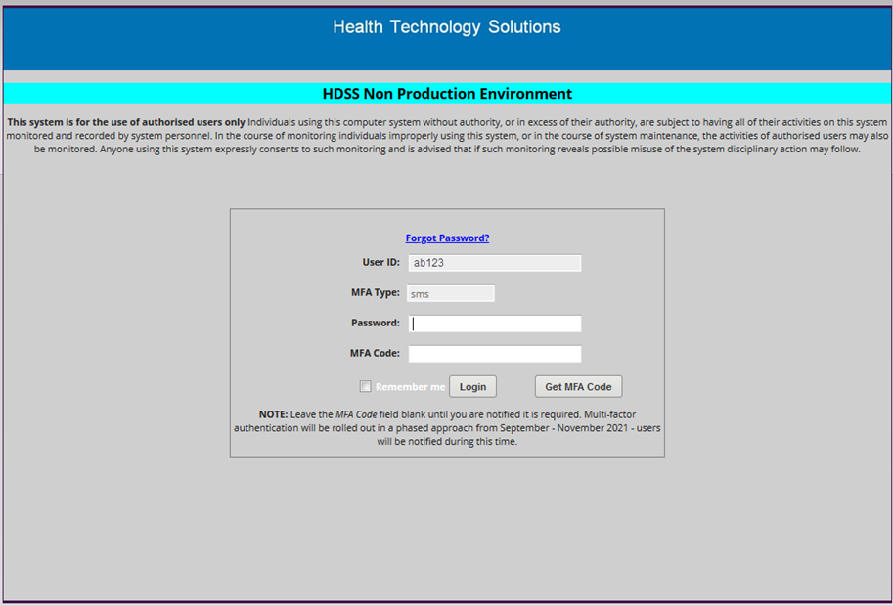

**IMPORTANT:**

**If you have 3 unsuccessful attempts logging into MFT you will be locked out for 24 hours.** If you fail to connect to the MFT portal in your first two attempts, **BEFORE** attempting a third time, try changing your MFT account password using the FORGOT PASSWORD link on the MFT login page.

If you succeed in updating your MFT account password, a message confirming this appears at the end which includes a green tick, you can then try connecting to the MFT portal again.

If the password update process fails, the message received will include a red cross and your MFT account is locked for 24 hours. Once 24 hours has passed, use the FORGOT PASSWORD link to set a new password again. If this is successful you can proceed to the MFT login page.

If unsuccessful, send an email to [vadc_data@health.vic.gov.au](mailto:vadc_data@health.vic.gov.au) requesting assistance.

## How to upload a VADC file to The Managed File Transfer (MFT)?

Upon initial connection you will see a folder called VADC_### where ‘###’ represents your service provider ID – which is the first 3 digits of your outlet code.

To access your Parent directory/folder double click the folder labelled with your service provider ID, ‘VADC_###’.

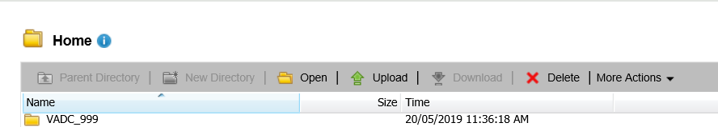

Your Parent Directory will look like this.

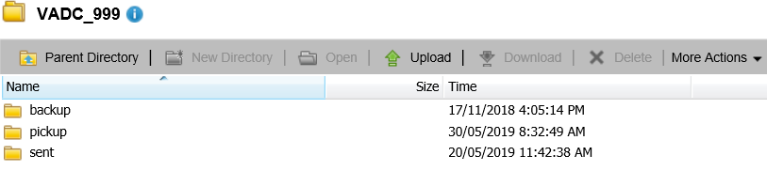

1. To upload an XML file, click on the ‘Upload’ button and follow the prompts.



1. You will need to browse your local network drive for the XML extract file to be uploaded.

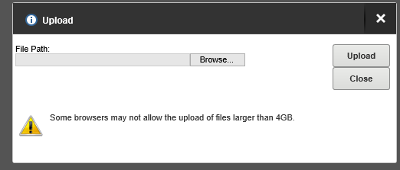

Select your XML extract file then click the upload button again and the file will be uploaded into your agency’s ‘Parent’ Directory’ folder, below the three folders labelled **backup**, **pickup** and **sent**. Please see example below.

**IMPORTANT: The first 3 numbers of the VADC XML extract file being uploaded MUST match the 3-digit number of the MFT folder.**

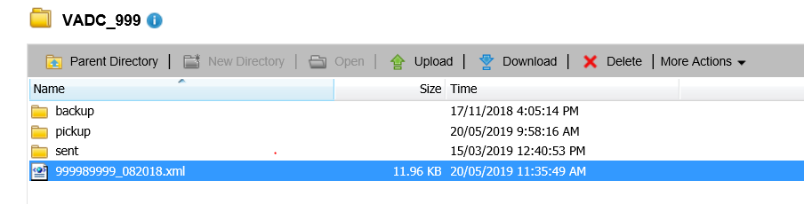

1. Your file/s will be automatically collected for processing and validation.

**IMPORTANT: If you upload your file into the wrong location or your file is incorrectly named, it will NOT be transferred by the MFT. If this occurs please send an email to** [vadc_data@health.vic.gov.au](mailto:vadc_data@health.vic.gov.au) **requesting the file to be deleted, please include a screenshot of the file requiring deletion.**

1. Once your XML extract file has been transferred a copy gets moved into the ‘sent’ folder where it remains for 7 days and a timestamp is added to the file name.

## How to collect your reports.

Go to the ‘Home Directory’ folder and double click the correct service provider folder.



__________________________________________________________________________________

1. Double click the ‘pickup’ folder to retrieve your ‘Feedback Validation’ report after your file has been processed or to pick up your monthly Service Event Statement (SES).

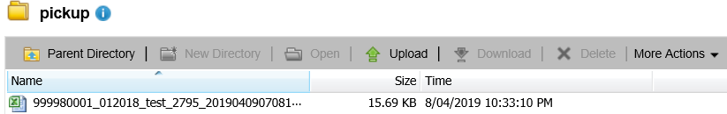

1. Please ensure you download the report.

Click the download button then click the drop-down arrow on the ‘Save’ button and select ‘Save as. Save you’re the downloaded reports to your preferred location (e.g desktop).

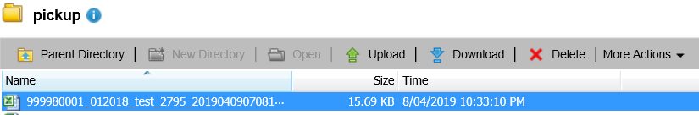

__________________________________________________________________________________

1. **Once you have opened or downloaded your report, the report moves into the ‘Backup folder’**. The report can be downloaded from the backup folder. **Please note the report is only available in this folder for 7 days.**

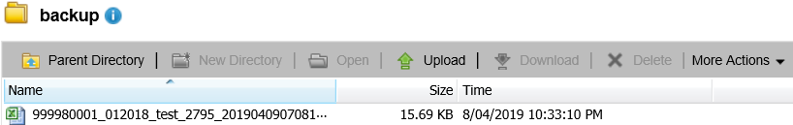

## MFT Frequently Asked Questions (FAQ’s):

### Can I change the way I receive the MFA Security Code?

Yes. To receive the MFA Security Code via SMS (text) instead of email, send an email to [vadc_data@health.vic.gov.au](mailto:vadc_data@health.vic.gov.au) providing your MFT account name and mobile phone number. Users can only select SMS if they have already provided their mobile phone number to the VADC data team and have been notified that their account has been updated to receive the MFA Security Code via SMS.

**NOTE:** The MFA Security Code supplied will expire if not used within 10 minutes of the code being sent (both emails and SMS messages are time stamped). The code cannot be used once expired. If this happens, MFT users will need to return to the MFA Login page to restart the process of generating a new single use MFA Security Code.

### What should I do if I haven’t received the emailed MFA Security Code after 15 minutes?

If you haven’t received your emailed MFA Security Code after 15 minutes check your SPAM folder, if not there, email [vadc_data@health.vic.gov.au](mailto:vadc_data@health.vic.gov.au) to confirm the email account details listed in your MFT account profile. If the email account listed is correct, you will need to liaise with your internal IT support to confirm that your internal email server is releasing this email (and all future emails), and/or there are no firewall constraints in place preventing the delivery of these emails.

### Can I use another person’s MFT account to obtain the MFA Security Code?

No. To successfully connect to the MFT portal, users must have access to the email account listed in the MFT account profile. MFT users attempting to access the portal using an account that is not theirs or use an account where they cannot access the email, will fail in their attempt to connect to the MFT portal.

### What should I do after I’ve entered the MFA Security Code provided but I still cannot connect to the MFT portal?

If you have received your MFA Security Code and used this within the 10 minute specified timeframe to connect to the MFT portal and are still unsuccessful, you may need to reset your individual MFT account password first. Use the **FORGOT PASSWORD** link at the MFT portal login screen to complete this process.

### Can we have a generic login to the MFT?

No. Shared or generic logins are not permitted. All registrations must be linked to an individual person’s email address.

### Can I upload multiple files to the same site at the same time?

Yes, if each file name is unique. As the file name includes both an Outlet Code and the reporting

period (mmyyyy), more than one file for the same agency can be submitted. It is advisable, however, to submit one file at a time for the same agency and await processing to determine if corrections need to be included in the subsequent file. NOTE: If you have uploaded multiple files into the same folder, MFT will only pick up one file at a time for processing (each file pickup is approx. every 10 minutes). Therefore, if you upload 5 files MFT will take 50 minutes to clear your folder.

### Can one person send a file and another person download the data validation Feedback Report?

Yes. Multiple registered users can access the same folder. Example: one user can submit the XML extract file and another user can login and collect the ‘Feedback Validation’ report.

### Are files archived on MFT?

Yes,

• Data validation ’Feedback Reports’ reports in the pickup folder will be archived after 35 days. We recommend that all files be downloaded and saved locally within this timeframe.

• Reports located in the backup folder after initial download, will be archived after 7 days. If copies of these reports are required for the current financial year, please email [vadc_data@health.vic.gov.au](mailto:vadc_data@health.vic.gov.au).

• Copies of submitted XML extract files in the sent folder will be archived after 7 days.

pickup folder: cleared every 35 days

backup folder: cleared every 7 days

sent folder: cleared every 7 days

### Are there file naming conventions for VADC submission files using MFT?

Yes,

* The naming convention to submit VADC XML files to the production environment is *outlet code_monthyear* (e.g. 99998999_052019.xml).
* The naming convention for **testing** a VADC XML extract file is *outlet code_monthyear_test*

*(e.g.* 99998999_052019_test.xml)

Please refer to the file naming convention outlined in the VADC Compilation and Submission specification for more information located here: [VADC documentation - health.vic](https://www2.health.vic.gov.au/alcohol-and-drugs/funding-and-reporting-aod-services/reporting-for-aod-services/data-collection/VADC%20documentation)

### Can TEST files be submitted to VADC?

Yes, to submit a TEST file add **_test** to the end of the file name *(e.g.* 99998999_052019_test.xml).

It is recommended that TEST files be submitted until there are no errors present in the file. Once there are no errors present remove **_test** from the file name and upload the file to MFT. Note there are different arrangements for testing the annual changes – these will be communicated via VADC Bulletin

### Can I remove an XML extract file that has been uploaded in error?

No, you must send an email to [vadc-data@health.vic.gov.au](mailto:vadc-data@health.vic.gov.au) identifying the XML extract file that you would like to be removed. Files already transferred for processing cannot be removed.

If you have uploaded into the incorrect folder, you will need to identify the folder and XML extract file that you would like to be removed.

### What are the system requirements?

The following minimum system requirements must be met:

One of the following browsers must be used:

* Chrome - latest version
* Microsoft Edge - latest version

Cookies and JavaScript must be enabled in the browser

### What do I do if I can’t log in OR I’ve forgotten my password?

Unfortunately, MFT doesn’t notify you when your password requires a change, it just locks you out. If you cannot login to MFT please select ‘Forgot Password’ & follow the prompts to re-set a new password. The same process applies if you have forgotten your password.

### Is there support available?

The VADC data team is available to assist anyone experiencing difficulties setting up their accounts.

However, any queries relating to your service’s internal network and firewall configuration must be directed to IT support within your organisation. The VADC data team can be contacted at:

[vadc-data@health.vic.gov.au](mailto:vadc-data@health.vic.gov.au). Please ensure you **start the email subject line with ‘VADC MFT’** for all queries related to submitting VADC data files via the Managed File Transfer.

|  |
| --- |
| To receive this publication in an another format [email VADC Data](mailto:vadc_data@health.vic.gov.au) VADC_data@health.vic.gov.au  Authorised and published by the Victorian Government, 1 Treasury Place, Melbourne.  © State of Victoria, Australia, Department of Health, June 2022  Available from the Victorian Alcohol and Drug Collection (VADC) on [Health.vic website](https://www.health.vic.gov.au/funding-and-reporting-aod-services/victorian-alcohol-and-drug-collection-vadc)  <https://www.health.vic.gov.au/funding-and-reporting-aod-services/victorian-alcohol-and-drug-collection-vadc>  **ISBN** 978-1-76096-861-8 **(pdf/online/MS word)** |