

|  |
| --- |
| Non-Admitted Clinic Management System (NACMS) |
| User Manual for Victorian Public Hospitals |
|  |

|  |
| --- |
| Non-Admitted Clinic Management System (NACMS)  User Manual for Victorian Public Hospitals |
|  |

|  |
| --- |
|  |
| To receive this document in another format, phone ng the National Relay Service 13 36 77 if required or email the Funding Policy and Accountability unit via the following email address [Non-Admitted Clinic Management System](mailto:nacms@health.vic.gov.au) <nacms@health.vic.gov.au>.  Authorised and published by the Victorian Government, 1 Treasury Place, Melbourne.  © State of Victoria, Australia, Department of Health, February 2025. |
|  |

Contents

Introduction 6

Background 6

Revision History 6

Scope 7

Inclusions 7

Exclusions 7

Non-Admitted Patient Service Event 8

How to get access to NACMS 9

Viewing registered clinics 9

Data Entry Instructions 11

Before commencing registration 11

Register a new clinic 11

Draft clinic registration 16

Copy clinic registration 17

Editing clinic registration details 19

Closing a clinic registration 20

Re-open a closed clinic 22

Change a clinic status to Inactive 22

Change a clinic ID 22

Requesting new clinic deletion 22

Clinic Approval Process 23

Tier 2 Classification Review 23

Non-Admitted data reporting 24

Clinic Registration Reports 24

Glossary 26

Queries 28

Additional Resources 28

# Introduction

The Non-Admitted Clinic Management System (NACMS) user manual has been developed to assist Victorian public hospitals with the registration and management of non-admitted clinics. Registration enables public hospitals to report non-admitted activity data via the Agency Information Management System (AIMS) and Victorian Integrated Non-Admitted Health (VINAH) data collections.

## Background

The National Health Reform Agreement (NHRA) between the Commonwealth and all state and territory governments, commits signatories to work in partnership to improve health outcomes for all Australians and ensure the sustainability of the Australian health system. Under the NHRA, the Commonwealth and the States and Territories are jointly responsible for funding public hospital services, using activity-based funding (ABF) where appropriate.

ABF links funding to the quantity and kind of services provided with the efficient cost of delivering those services.

Non-admitted services are classified using the Tier 2 Non-Admitted Services Classification (Tier 2), a broad clinic-based classification system that supports ABF in the Australian public hospital system.

Victorian public hospitals must classify in-scope, acute non-admitted clinics to the most appropriate Tier 2 classification and report the agreed national non-admitted service activity data items in line with agreed timelines.

The mechanism for registering non-admitted clinics (or requesting changes to existing registered clinics) is via the Healthcollect portal.

## Revision History

Table 1. Document Version

| **Version** | **Date** | **Comments** |
| --- | --- | --- |
| 1. | June 2023 | This version consolidates previous versions and incorporate changes made to NACMS. The purpose of this document is to assist public hospital users to register Non-Admitted clinics in NACMS. |
| 2. | February 2025 | This version has been reviewed to incorporate NACMS clinic automation |

# Scope

All public health services in Victoria (ABF or block funded) must register acute non-admitted clinics. Clinics should be registered against the health service campus where the activity occurs.

For MBS funded clinics, refer to the [MBS Billing Interpretative Guidelines](mailto:https://www.health.vic.gov.au/funding-performance-accountability/mbs-billing-policy-framework-victorian-public-hospitals) <https://www.health.vic.gov.au/funding-performance-accountability/mbs-billing-policy-framework-victorian-public-hospitals> to make an initial assessment as to whether the MBS billed clinic is included or excluded from clinic registration.

## Inclusions

There are two broad categories of in-scope, public hospital acute non-admitted services:

### Specialist Outpatient Clinic Services

This comprises all clinics in the Tier 2 Non-Admitted Services classification in the following series:

* 10 – Procedure
* 20 – Medical Consultation
* 40 – Allied Health and/or clinical nurse specialist intervention

### Other Non-Admitted Patient Service, Tier 2 – 40 Classification

To be eligible for ABF funding in the Tier 2 – 40 classification, the non-admitted service must meet the following criteria:

* related to an inpatient admission or an emergency department attendance, or
* intended to substitute directly for an inpatient admission or an emergency department attendance, or
* expected to improve the health or better manage the symptoms of persons with health conditions who have a history of frequent hospital attendance or admission.

Where a hub and spoke arrangement is in place, contact the department to discuss which health service should register the non-admitted clinic.

## Exclusions

The following services are excluded from non-admitted clinic registration:

* Diagnostic (Tier 2 – 30 Series) and ancillary services, including pathology, radiology, pharmacy, and clinical photography, should not be registered as clinics in NACMS.
* Private clinics operated by medical practitioners or other healthcare providers on a completely private basis where the medical record is not held by the health service.
* Health practitioners who have a Rental Agreement with the health service.
* Dental services funded by Dental Health Services Victoria.
* Non-admitted services that are funded by Home and Community Care Program (HACC).
* Primary Health Care (e.g., Immunisation/vaccination clinics).
* Aged Care Assessments.
* Health Independence Program (HIP) and other non-admitted subacute services.
* Mental Health non-admitted.
* Community Health.
* Stand-alone Advanced Care Planning Clinics.
* Services funded by external agencies or foundations such as the Jane McGrath Foundation.
* Non-admitted services where the patient is charged a fee to attend e.g., childbirth/parenting classes.
* Clinical Trials not funded by the Department of Health.
* COVID-19 Immunisation Clinics. This activity should be reported via the COVID Vaccine Management System (CVMS).
* Clinics with an ineligible status. An ineligible clinic is one that undertakes activity which is either not clinically directed at hospital patients, is undertaken purely by the private sector, or is funded from another source.

## Non-Admitted Patient Service Event

In addition to the non-admitted service meeting scope for clinic registration, all elements of the non-admitted patient service event must be met to count the public hospital services delivered to patients for ABF purposes.

A non-admitted patient service event is defined as an interaction between one or more healthcare provider(s) with one non-admitted patient, which must contain therapeutic/clinical content and result in a dated entry in the patient’s medical record.

The interaction may be for assessment, examination, consultation, treatment, and/or education.

The non-admitted patient service event and further information on non-admitted services can be found in the IHACPA publication page <www.ihacpa.gov.au/health-care/classification/non-admitted-care/tier-2-non-admitted-services-classification>

# How to get access to NACMS

Public hospitals should ensure that appropriate staff are authorised to access NACMS for registration purposes. Public hospitals can arrange access for new or additional staff by contacting the HDSS Helpdesk <hdss.helpdesk@health.vic.gov.au>

Public hospitals must have appropriate mechanisms in place to ensure that all new clinic registrations, or changes to existing clinics, submitted via the registration system are appropriately authorised by the health service.

## Viewing registered clinics

Log on to the Healthcollect portal <www.healthcollect.vic.gov.au> using your authorised username and password.

1. Click **AIMS** from the Healthcollect home page. (Figure 1)

Figure 1

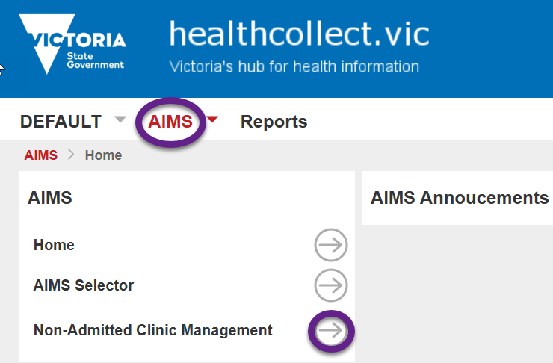

1. Click **Non-Admitted Clinic Management** – this will open the Non-Admitted Clinic Registration screen. (Figure 2)
2. Select **health service** or campus name from the drop-down box.

You will only have access to view information for your health service. A list of all clinics submitted by your health service campus will display, including Clinic ID, Clinic name, Status and Tier 2 code.

Figure 2

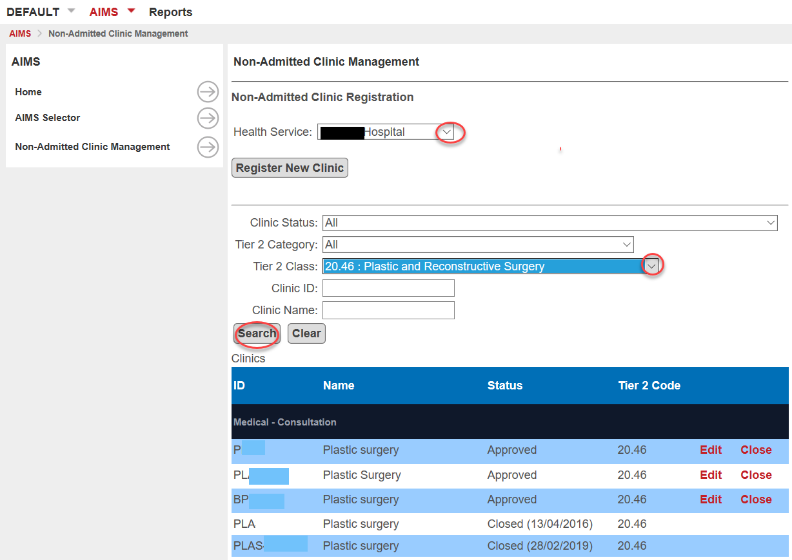

To search for specific clinics, enter data into any of the search criteria fields, and click the Search button. For example, selecting all clinic status and the Tier 2 20.26 (Plastic & Reconstructive Surgery) classification will display all clinics that Tier 2 class.

# Data Entry Instructions

## Before commencing registration

Before registering a new clinic, it is recommended that the user familiarise themselves with the Independent Health and Aged Care Pricing Authority (IHACPA) Tier 2 Non-admitted services resources, available via <www. https://www.ihacpa.gov.au/health-care/classification/non-admitted-care/tier-2-non-admitted-services-classification>:

* IHACPA Tier 2 Non-admitted Services Definitions Manual
* IHACPA Tier 2 Non-admitted Services Compendium
* IHACPA Tier 2 Non-admitted services National Index.

Health service users must ensure they have adequate clinic details before commencing the clinic registration process. All data fields within the registration form must be accurate at the time of clinic registration. Clinic details must be unique and specific and not be copied from the Tier 2 Non-admitted Services Definitions Manual.

## Register a new clinic

Log on to the Healthcollect portal <www.healthcollect.vic.gov.au> using your authorised username and password.

1. Click the **AIMS** tab from the Healthcollect home page.
2. Click **Non-Admitted Clinic Management** from left hand tab – this will open the Non-Admitted Clinic Registration screen.
3. Select your health service and/or **campus** from the drop-down box. You will only have access to view your health service options. A list of all clinics submitted by your health service/campus will display, including Clinic ID, Clinic name, Status and Tier 2 code.
4. Click **Register New Clinic** tab to proceed with clinic registration. (Figure 3)

**Figure 3**

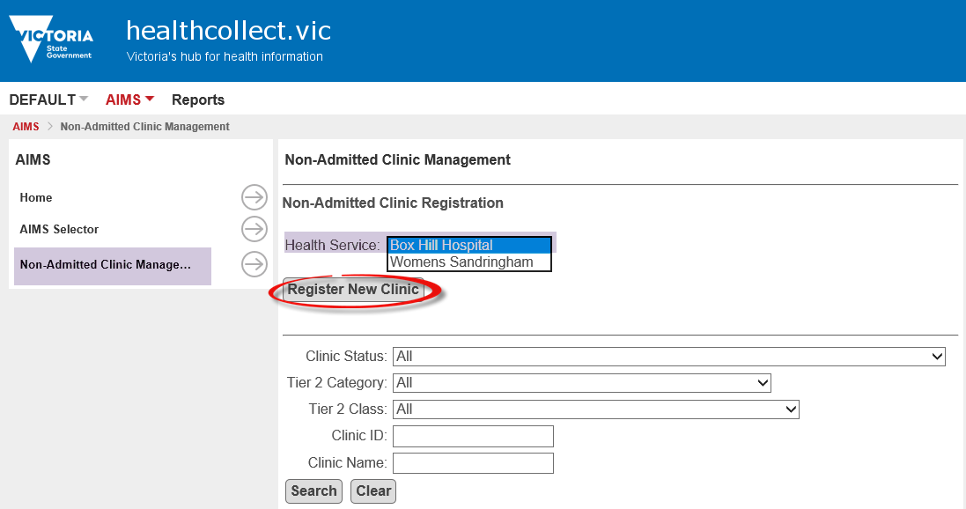

1. The new clinic notification form will open. The campus and Agency code will be visible in the pre-populated form (Figure 4).

Figure 4

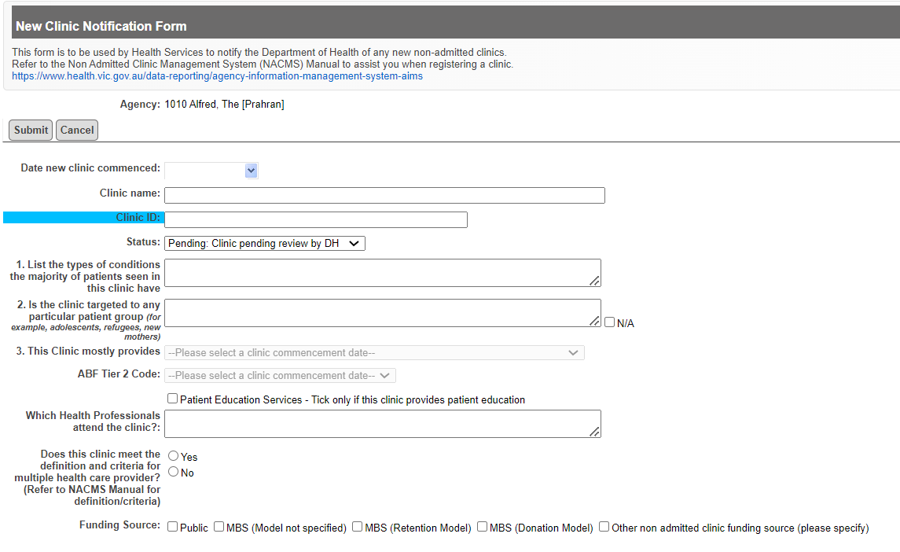

1. Commence data entry into the blank fields provided. Start from **the Date new clinic commenced** field to ensure the correct Tier 2 options are provided in the clinic registration form:

**Date new clinic commenced** – enter clinic start date in the format DD/MM/YYYY. If registering an existing clinic, enter the approximate date that the clinic first commenced. A retrospective date can be entered. A prospective start date can also be entered when a clinic has not yet commenced.

**Clinic Name** – enter the name of the clinic. The name should be meaningful or as advised by the department (when applicable).

**Clinic ID** – code used to identify the clinic. The clinic ID must be unique within the health service, not just the campus. (If reporting through VINAH, the clinic ID reported through VINAH must be the same as the clinic ID in NACMS).

**Status** – select Draft if not ready to submit to the department. Select Pending when submitting to the department.

**Q1. List the types of conditions most patients seen in this clinic have.** List the broad type of health conditions most patients in the clinic have. For example, arthritis, asthma, diabetes, fracture, etc.

**Q2. Is the clinic targeted to any patient group.** Specify if applicable, examples include adolescents, refugees, new mothers, paediatrics.

**Q3. This clinic mostly provides.** Select the purpose of the clinic from one of the options provided (Figure 5):

* + Consultation services provided by a medical specialist or nurse practitioner.
  + Consultation services provided by a clinical nurse specialist or allied health professional.
  + Procedural and/or intervention services.

Figure 5

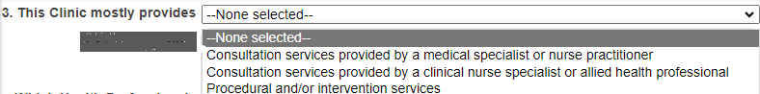

**ABF Tier 2 code** Health Service users should refer to the Tier 2 Non-admitted Services Definitions Manual to assist in selecting the most appropriate Tier 2 class when registering a clinic <www.ihacpa.gov.au/health-care/classification/non-admitted-care/tier-2-non-admitted-services-classification>

The drop list will be customised to display Tier 2 codes that are active as at the clinic commencement date and based on your selection in **Question 3** in the registration form.

For example, if ‘Consultation services provided by a medical specialist or nurse practitioner’ is selected, the 20.xx series will display, see image below (Figure 6):

Figure 6

Example: Question 3 cont... 
Consultation services provided by medical specialist or nurse practitioner, followed by
List of Tier 2 Code

When the Procedure and/or intervention services is selected, an additional text box will appear (Figure 7):

Figure 7

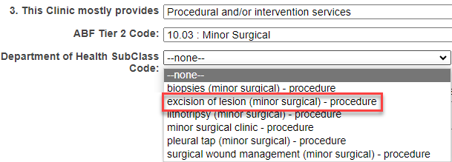

**Department of Health Sub Class**: This additional information in NACMS will only apply to procedure clinics Tier 2 10. xx. From the drop-down list provided select the type of procedure or intervention that will be provided in the clinic, see example below: Only one option can be selected.

The list of Procedures and interventions will be based on the most current IHACPA Tier 2 Index List published annually.

**Patient Education Services:** If a clinic provides patient education services, please tick the box. If no education services are being provided leave the tick box empty.

**Health Professionals** – list all the healthcare providers that see patients in the clinic. For example, colorectal surgeon, social worker, nurse. Be as specific as possible - instead of ‘Consultant’ specify ‘Colorectal surgeon,’ ‘Gastroenterologist’ etc. instead of ‘Allied Health clinician,’ specify ‘Social Worker,’ ‘Physiotherapist,’ ‘Occupational Therapist’ etc.

**Multiple Healthcare Providers** – Will most of the activity reported under this clinic meet the definition and criteria for multiple healthcare provider? Select Yes or No (Refer to the definition/criteria below).

Please note that the multiple health care provider activity loading only applies to service events, which may consist of one or more contacts, if three or more health care providers of different specialities are reported to VINAH under the *Contact Professional Group* data element regardless of a clinic being registered as a Multiple Healthcare Provider Clinic.

**Multiple Healthcare Provider – Definition/Criteria**

‘…in the context of reporting non-admitted data for activity-based funding ‘Multiple health care provider’ means three or more health care providers who deliver care either individually or jointly within a non-admitted patient service event. The health care providers may be of the same profession (medical, nursing, or allied health). However, they must each have a different speciality so that the care provided by each provider is unique and meets the definition of a non-admitted patient service event.’ The link to the Meteor data element is on the [Meteor website](http://meteor.aihw.gov.au/content/index.phtml/itemId/584616) <http://meteor.aihw.gov.au/content/index.phtml/itemId/584616>

Further information and examples on non-admitted patient service events involving multiple healthcare providers can be found in the IHACPA Tier 2 Non-admitted services compendium <www.ihacpa.gov.au/health-care/classification/non-admitted-care/tier-2-non-admitted-services-classification>

**Funding source**

This is the general or usual funding source for the patients attending the clinic. More than one funding source can be selected.

* + Public – National Health Reform Agreement funded clinic
  + Public MBS-Billed clinic
  + Other (e.g., TAC, Research grant).

Where a clinic has been registered and the MBS funding source is selected, the remuneration model must be specified for clinics treating private patients.

Acute MBS-Billed public specialist clinics are run by practitioners exercising rights of private practice and has a private practice arrangement with the health service. These services can only be provided if the same service is provided on a public basis. The aim of this policy is to prevent professional services from being claimed under Medicare that are already obtaining public funding. This change was implemented in April 2018 to NACMS. Public hospitals are required to review their registered clinics regularly and ensure the MBS remuneration model has been correctly identified for each registered clinic treating private non-admitted patients.

Private clinics operated by medical practitioners or other healthcare providers on a completely private basis. Health services should refer to the [MBS Billing Interprative Guidelines](MBS%20Billing%20Interprative%20Guidelines) < https://www.health.vic.gov.au/funding-performance-accountability/mbs-billing-policy-framework-victorian-public-hospitals> to make an initial assessment as to whether a MBS billed clinic is for inclusion or exclusion from clinic registration.

**Additional Clinic Details:**

**Does doctor/nurse practitioner see every patient?** The user must select one of the three options provided. If No is selected, estimate the percentage of patients the doctor would usually see and give a reason the doctor does not see every patient.

**Note:** From 1 July 2023, Endorsed Midwife Practitioner that is qualified to prescribe schedule 2, 3, 4 and 8 medicines and to provide associated services for midwifery practice in accordance with relevant state and territory legislation can be classified to the Medical Obstetrics Classification.

**Are Notes documented in the Agency medical Record?** Select Yes or No.

If notes are not documented in the Agency medical record, specify where the clinical notes are written and kept.

**Other comments.** Document details that might be helpful in classifying the clinic.

**Clinic contact details.** Record details of the most appropriate person for the department to contact for follow-up.

**Comments.** Document additional clinic information that might be useful (Figure 8)

Figure 8

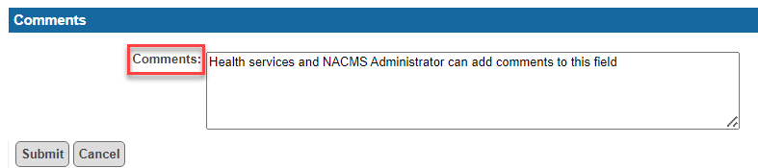

Once all mandatory fields are complete, click **Submit**. The form cannot be submitted if any mandatory fields have been left uncompleted. Mandatory fields requiring data entry will be highlighted in red at the top of the clinic registration form and the user will be prompted to enter the missing data.

Once the form is submitted, the system will return to the Non-Admitted Clinic Registration screen and the newly registered clinic will appear in the health service’s list of clinics.

The person who submits the clinic registration details is the person who will receive automatic email notifications.

## Draft clinic registration

During the clinic registration process, a health service may select ‘**Draft clinic awaiting submission to DH’** as a temporary clinic status. The draft status will allow the user the option of adding and changing information as necessary prior to submitting clinic registration details to the department. All fields in the registration screen must be complete prior to the clinic being saved as a draft clinic. Draft clinics will not appear on the AIMS S10 form until the clinic status has been amended to ‘Pending’ by the health service.

No data is to be reported to the VINAH MDS while a clinic has a status of ‘Draft.’

The following is an example of a clinic with a Draft status.

Figure 9

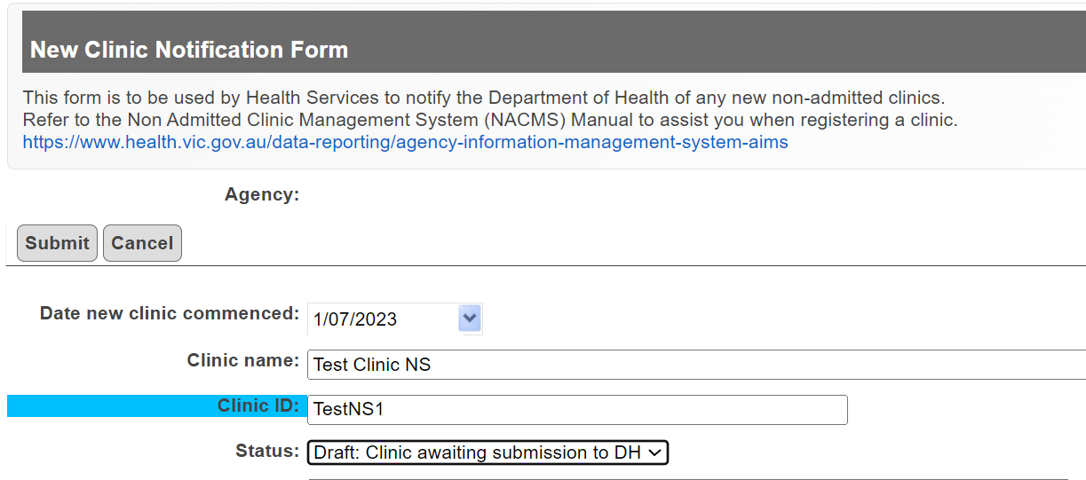

### Editing a draft clinic registration

1. From the Non-Admitted Clinic Registration screen, select your health service from the drop-down box. Then select **Draft** from the Clinic Status and press the **search** button.

2. The list of draft clinics will appear. Then select **Edit** on the clinic you wish to open.

Figure 10

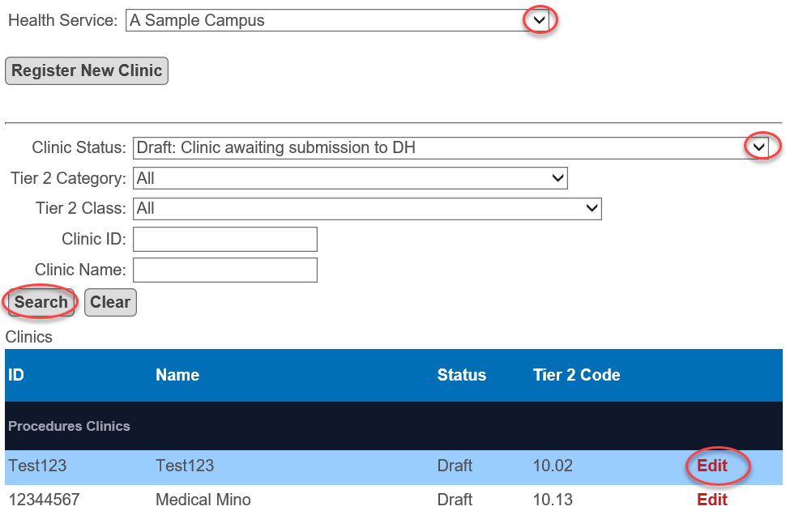

Once final edits have been made the clinic status will need to be changed to ‘Pending’ for the clinic to be submitted to the department.

## Copy clinic registration

It is possible to copy the registration details from an existing clinic to create a new clinic registration. Use this function if the new clinic is identical to an existing clinic e.g., setting up a second General Surgery clinic – users can copy registration details from the original General Surgery clinic and edit fields where applicable. Users must ensure that the new clinic registration has sufficient clinic details to support assignment of a Tier 2 class. This function will only work if the original clinic has an approved status.

1. From the Non-Admitted Clinic Registration screen, select your health service from the drop-down box.
2. Search for the existing clinic you wish to make a copy then select Edit.

Figure 11

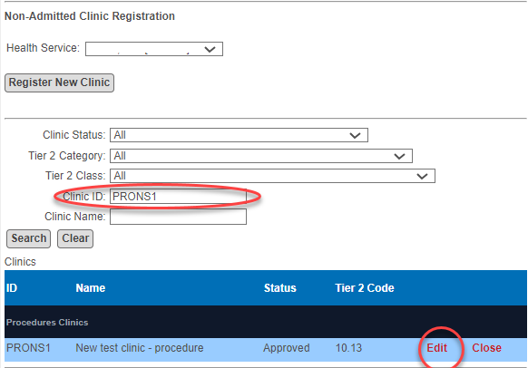

The clinic edit form will open.

Figure 12

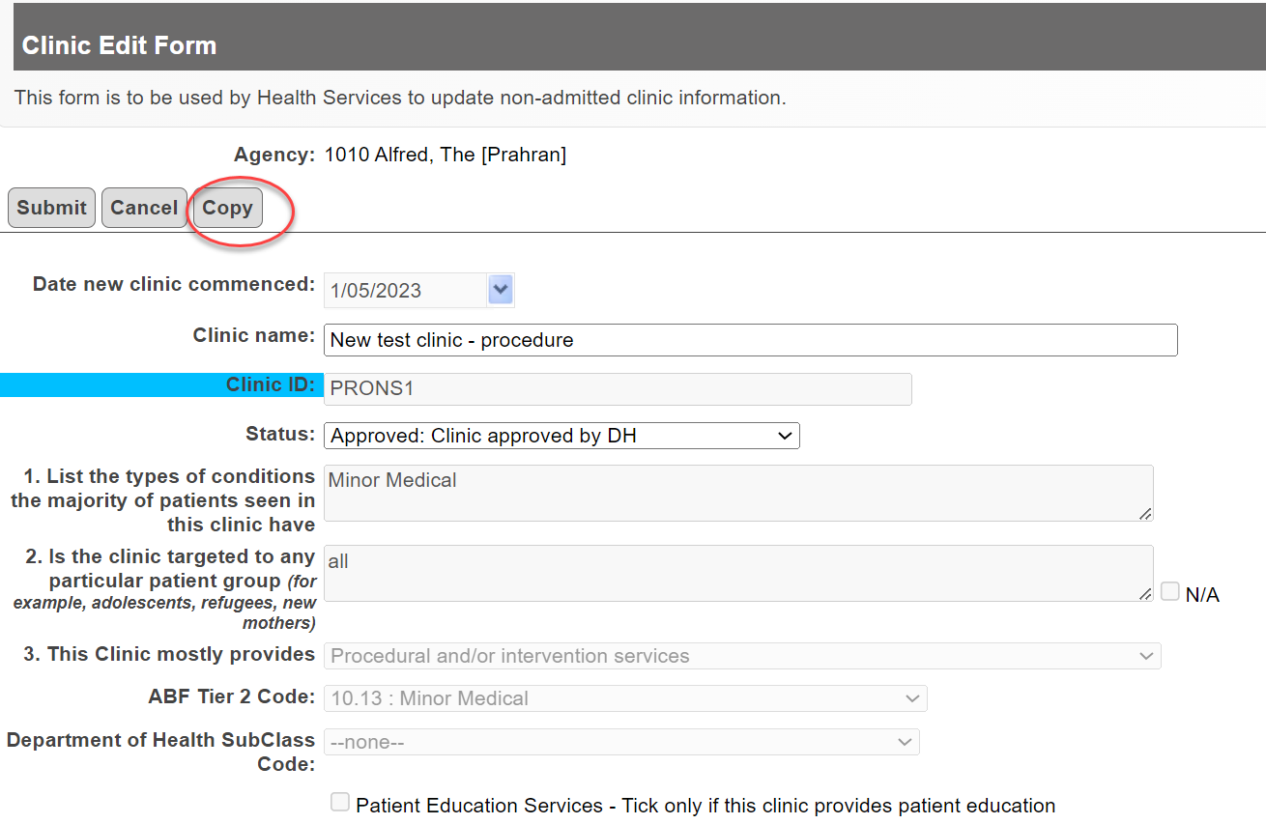

1. Select **Copy** and a new Clinic Notification Form will open populated with data from the previous form (Figure 13).

Figure 13

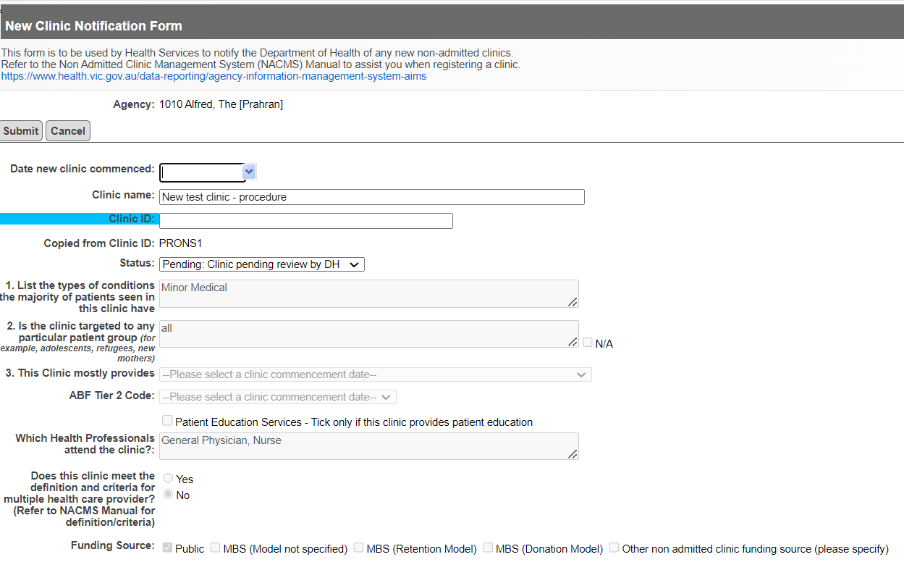

The following fields will be made available for you to edit from the copied registration:

**Date new clinic commenced** – enter clinic start date in the format DD/MM/YYYY. Date entered must be on or after 1 January 2011. A retrospective date can be entered. A prospective start date can also be entered which is useful when registering a clinic that has not yet commenced.

**Clinic Name** – enter the name of the clinic. The name should be meaningful.

ABF Tier 2 code – once a clinic date is entered, users will be able to select an ABF Tier 2 code from the drop-down list. The drop-down list is customised to display Tier 2 codes that are active as at the clinic commencement date.

**Clinic ID** – must be changed as no two clinics can have the same clinic ID. A clinic ID must be unique within the health service, not just the campus. If reporting through VINAH, the clinic ID reported through VINAH must be the same as the clinic ID on the Non-Admitted Clinic Management System.

**Status** – select Draft if not ready to submit to the department. Select Pending when submitting to the department.

**Comments** – document additional clinic information that might be useful.

1. Ensure all mandatory fields are complete, and then click Submit. The form will not be submitted if any mandatory fields have not been completed. Instructions for entering data into vacant mandatory fields will be highlighted in red.
2. Once the form has been submitted, you will be returned to the Non-Admitted Clinic Registration screen, and the newly registered clinic will appear in the clinic list.

## Editing clinic registration details

Health services are responsible for the accuracy of the information entered into the clinic registration. Errors or inaccuracies in registration details previously submitted to the department must be corrected. Health services will have limited access to edit registration details and can only edit/amend the following fields once a clinic has been approved:

* Clinic Name
* Status (users can change a clinic status from Approved to Inactive and vice versa)
* Funding source
* Clinic contact details
* Comments

To Edit any of the above fields:

1. From the Non-Admitted Clinic Registration screen, select your health service from the drop-down box.
2. Search for the clinic and then select Edit - the Clinic Edit form will open.
3. Proceed to update the clinic registration.

If a health service requires a change to any other details after a clinic has been approved, the health service must submit the request in writing to [Non-Admitted Clinic Management System](mailto:nacms@health.vic.gov.au)<nacms@health.vic.gov.au>.

## Closing a clinic registration

When a clinic permanently ceases to operate the clinic should be closed and date of closure recorded. Activity data cannot be reported after the clinic closure date.

Users can only close clinics that have a status of **Approved** or **Inactive**. Clinics with any other status including, pending, reviewed, draft or ineligible cannot be closed.

To close a clinic:

1. From the Non-Admitted Clinic Registration screen, select your health service/campus from the drop-down box.
2. Enter the Tier 2 code to limit the search and then select the clinic to Close.

Figure 14

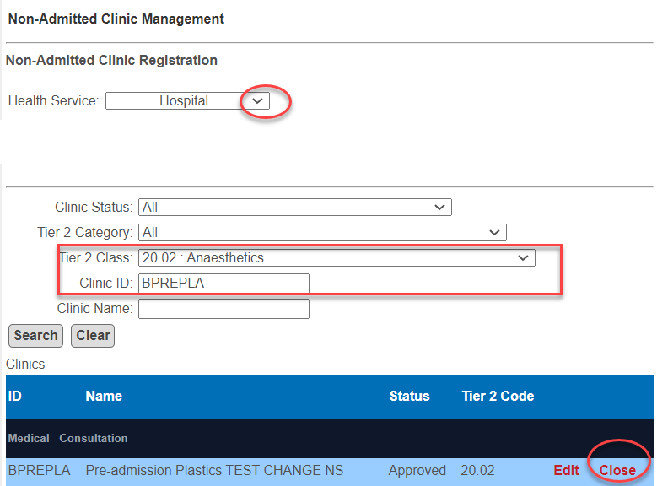

The clinic closure form will open.

1. To close a clinic effective immediately, click **Close**.
2. To close a clinic either prior to, or after, the current date, enter the clinic closure date in the ‘Date of closure’ field, then click **Close**.
3. A message confirming you want to close the clinic will appear, click **OK** to close the clinic.

Figure 15

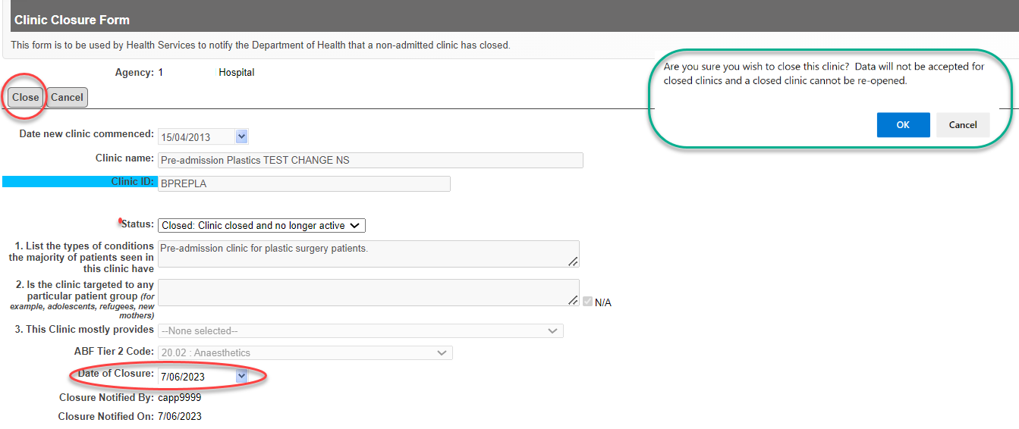

1. Once OK has been selected, you will be returned to the Non-Admitted Clinic Registration screen and the newly closed clinic will have a status of closed. You can check the status by selecting the Closed status and the ClinicID and the closed date will display.

Figure 16

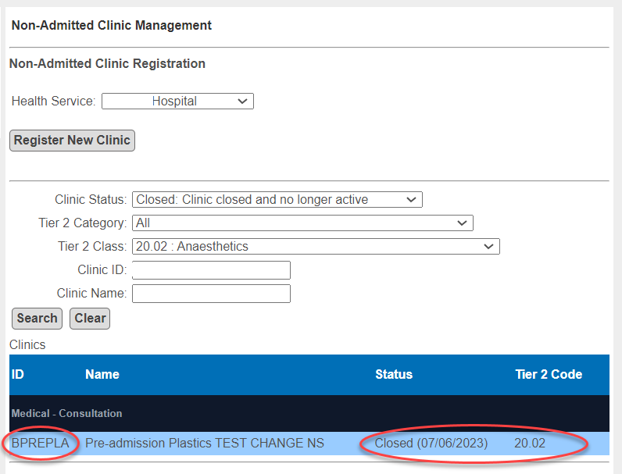

## Re-open a closed clinic

If a clinic is inadvertently closed and needs to be re-opened the department can re-open the clinic. The health service must submit a request in writing to [Non-Admitted Clinic Management System](mailto:nacms@health.vic.gov.au) <nacms@health.vic.gov.au>

## Change a clinic status to Inactive

When a clinic temporarily ceases to operate, the status should be changed to Inactive. Users can change the status from approved to inactive (and vice versa).

If a clinic has a status of anything other than approved, the health service will not be able to change the status to inactive. The health service can submit a request for change in status (to inactive) in writing to [Non-Admitted Clinic Management System](mailto:nacms@health.vic.gov.au) <nacms@health.vic.gov.au>

## Change a clinic ID

If a health service requires a change to a clinic ID, the department will make this change. The health service must submit the request in writing to [Non-Admitted Clinic Management System](mailto:nacms@health.vic.gov.au) <nacms@health.vic.gov.au>

## Requesting new clinic deletion

A health service cannot delete a clinic that has been registered.

If a clinic has been registered by mistake the health service must submit a request in writing to the [Non-Admitted Clinic Management System](mailto:nacms@health.vic.gov.au) <nacms@health.vic.gov.au> and explain why the clinic needs to be deleted.

The department will check if AIMS or VINAH data has been submitted. A clinic which has activity data reported will not be deleted. Clinics that do not have activity data submitted will be considered for deletion.

# Clinic Approval Process

The clinic approval process is automated to provide timely clinic approval and response outcomes for health services.

The automated process includes a system generated approval process. Automation includes a number of data validation checks on the registration form and will then provide health services with an outcome whether the clinic has been approved or not. A clinic that has not been approved will remain with a pending status until further review by the NACMS Administrator. Communication will be made with health service where clinics have not been approved through automation.

All clinics submitted to the department will have a final clinic status outcome.

## Tier 2 Classification Review

The department will consider a Tier 2 classification review in exceptional circumstances. Please contact the NACMS Administrator if you wish to submit a clinic for a Tier 2 classification review <nacms@health.vic.gov.au>

If the nature of an existing clinic has changed i.e. different model of care, health services should close the existing clinic registration and submit a new clinic registration.

# Non-Admitted data reporting

Registration of non-admitted specialist clinics will enable public hospitals to report all in-scope non-admitted activity data via the AIMS and or VINAH data collections.

Once a clinic is registered on the Non-Admitted Clinic Management System and has a status of Pending, Reviewed or Approved, public hospitals will be able to report service event activity.

Where a clinic has been registered and the department have assessed the clinic as **‘Ineligible’** for ABF funding, activity reported against this clinic will be excluded from NWAU reporting by the department.

For further information on Non-Admitted data reporting please refer to the [Health Data Standards and Systems website](https://www.health.vic.gov.au/data-reporting/health-data-standards-and-systems) <www.health.vic.gov.au/data-reporting/health-data-standards-and-systems> Alternatively, for specific non-admitted reporting queries please contact the [HDSS Helpdesk](mailto:hdss.helpdesk@health.vic.gov.au) <[hdss.helpdesk@health.vic.gov.au](mailto:hdss.helpdesk@health.vic.gov.au)>.

# Clinic Registration Reports

Public hospitals have access to clinic registration reports in the Healthcollect portal which lists clinics registered in NACMS. Reports may be accessed as follows.

1. Click **Reports** from the Healthcollect home page

Figure 17

Example of how to access Non-admitted Reports on the Healthcollect portal.

Select Reports from Healthcollect portal.

1. Click **AIMS**

Figure 18

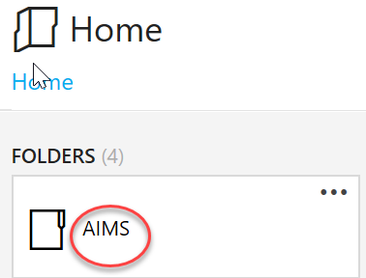

1. Select **Non-Admitted Clinics** from the listed options

Figure 19

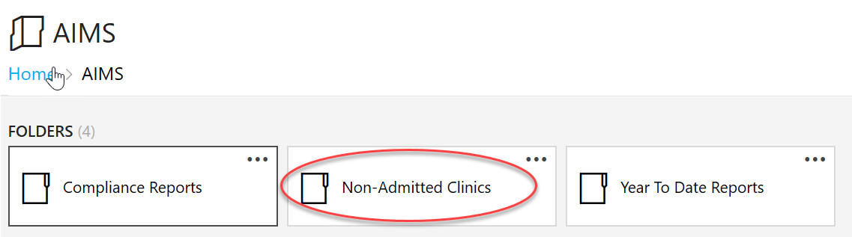

There will be two reports available in the menu: **Non-admitted clinic details** and **Non-admitted clinic summary.**

Figure 20

Two reports available in the menu:  
Non-admitted clinic details and 
Non-admitted clinic summary.  
Select preferred report by clicking on the tab you want to open.

1. Select your preferred report by clicking on the tab.
2. Select **Agency** from the drop list

Figure 21

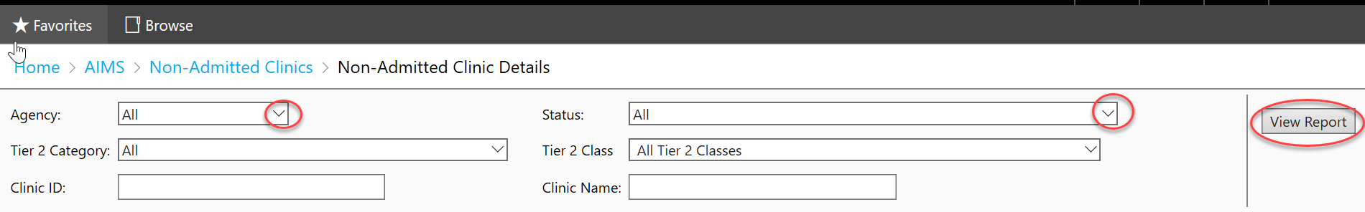

1. The reports can be filtered to customise:

* Select **Status** from the drop list and/or
* Select **Tier 2 Category** from the drop list and/or
* Select **Tier 2 Class** and/or
* Enter a **Clinic ID** if looking for a specific clinic and/or
* Enter **Clinic name** if looking for a specific clinic

1. Click on **View Report**
2. Reports can be exported. To export a report, click the **export button** as indicated in Figure 22 below.

Figure 22

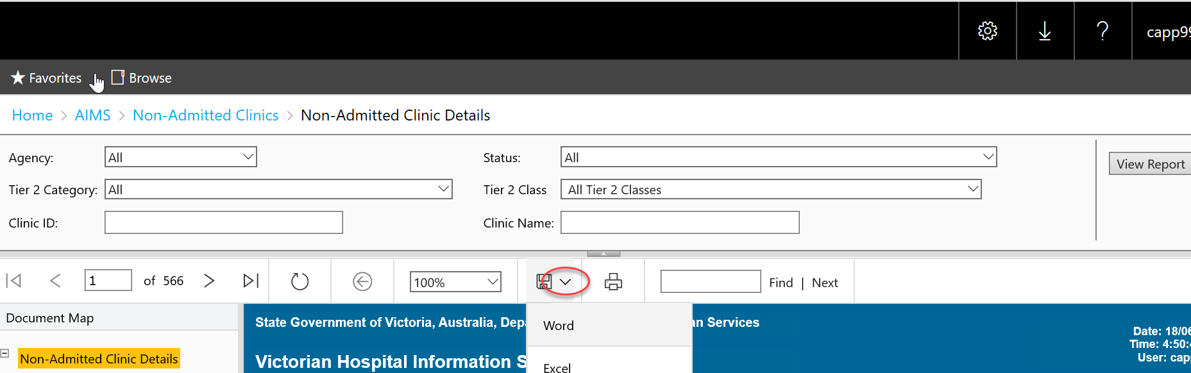

1. Select the format for the file to be exported into, for example Word, Excel.
2. Save the file to your folder.

# Glossary

### Clinically relevant service

Clinically relevant services are defined as one which is accepted by the relevant profession as necessary for the appropriate treatment of the patient. (MBS, section GN. 1.2 and subsection 3(1) of the Health Insurance Act 1973).

### Clinic Identifier (Clinic ID)

A code used to identify the clinic. The clinic ID must be unique within the health service (not just the campus) and should be short and meaningful. The clinic ID can be alphanumeric. Do not include spaces or backslashes or any other character in the clinic identifier code. This same clinic ID must be used to when reporting patient level activity and cost data associated with the clinic.

### Eligible non-admitted clinic

Clinics that provide clinically relevant services to eligible persons free of charge as public patients. This excludes activity undertaken purely by the private sector.

### Funding source

This is the general or usual funding source for the patients attending the clinic. Some patients in the clinic will differ from the general funding source for the clinic. For example, a TAC patient in a public clinic. Not every patient in the clinic must have the same funding source.

### Public hospitals

Public hospitals mean public health services, denominational hospitals, and public hospitals (as defined by the *Health Services Act 1988*)

### Multiple healthcare provider

The national definition that has been developed by the IHPA for this data element is as follows “…in the context of reporting non-admitted data for activity-based funding ‘Multiple health care provider’ means three or more health care providers who deliver care either individually or jointly within a non-admitted patient service event. The health care providers may be of the same profession (medical, nursing, or allied health). However, they must each have a different speciality so that the care provided by each provider is unique and meets the definition of a non-admitted patient service event.” The link to the Meteor data element can be found on the [Meteor website](http://meteor.aihw.gov.au/content/index.phtml/itemId/584616) <http://meteor.aihw.gov.au/content/index.phtml/itemId/584616>

### Tier 2 clinic classification

The Tier 2 Non-admitted Services Definitions Manual provides a national framework for classifying non-admitted service events <https://www.ihacpa.gov.au/resources/tier-2-non-admitted-services-2024-25>.

### Clinic Status

The most up to date clinic status will display in the Non-Admitted Clinic Management System and can be one of the following:

Pending: the clinic registration has been received by the department. It will remain pending until reviewed by the department. Activity data can be submitted.

Reviewed: the clinic has been reviewed by the department and awaiting the approval of the Tier 2 classification. Activity data can be submitted.

Approved**:** The Tier 2 classification for this clinic has been approved by the department. Activity data can be submitted.

Ineligible**:** Clinic ineligible for ABF reporting. An ineligible clinic is one that undertakes activity which is either not clinically directed at hospital patients, is undertaken purely by the private sector, or is funded from another source. A clinic will be deemed ineligible if:

* It does not meet the scope of a non-admitted service under the National Health Reform Agreement.
* It does not meet the definition of a non-admitted service event.
* It is not funded by the Department of Health, for example, services funded by Department of Education and Early Childhood Development.
* It is a private practice where the patient pays for the service and the medical record is not kept by the health service.
* It is funded by an external funding source, for example the Jane McGrath foundation.
* It is a standalone diagnostic clinic.
* The patient pays for the service, for example, education classes
* It is not led by a healthcare provider
* It is funded by Dental Health Services Victoria, Home, and Community Care (HACC) or Primary Care.

Health services who have reported data during a pending or reviewed status will be advised to remove any AIMS S10 data prior to a clinic status is changed to ineligible.

Inactive**:** Clinic and Tier 2 classification has been approved but the clinic is not currently active. Activity data cannot be submitted. The clinic identifier cannot be re-issued.

Closed**:** The clinic is closed and no longer active. Activity data cannot be submitted past the clinic closed date.

Draft: Draft clinic registration. The health service’s submission is still in draft stage and has not been lodged with the department. Non admitted activity data cannot be submitted.

# Queries

For all Tier 2 clinic registration queries please email the department via <nacms@health.vic.gov.au>.

## Additional Resources

[Independent Health and Aged Care Pricing Authority (HACPA) Non Admitted Publications](https://www.ihacpa.gov.au/health-care/classification/non-admitted-care)

<https://www.ihacpa.gov.au/health-care/classification/non-admitted-care>

[MBS Billing Interpretative Guidelines](https://www.health.vic.gov.au/funding-performance-accountability/mbs-billing-policy-framework-victorian-public-hospitals) <https://www.health.vic.gov.au/funding-performance-accountability/mbs-billing-policy-framework-victorian-public-hospitals>