

|  |
| --- |
| Addendum to Specifications for revisions to the Agency Information Management System (AIMS) for 2024-25 |
| July 2024 |
| OFFICIAL |

|  |
| --- |
| To receive this document in another format, [email HDSS help desk](mailto:HDSS.Helpdesk@health.vic.gov.au) <HDSS.helpdesk@health.vic.gov.au>.  Authorised and published by the Victorian Government, 1 Treasury Place, Melbourne.  © State of Victoria, Australia, Department of Health, July 2024.  Available at [HDSS annual changes](https://www.health.vic.gov.au/data-reporting/annual-changes) < https://www.health.vic.gov.au/data-reporting/annual-changes> |
|  |

Contents

Introduction 3

Orientation to this document 3

Subcutaneous immunoglobulin (SCIg) infusion therapy – home delivered (new program stream) 4

# Introduction

The Specifications for revisions to the Agency Information Management System (AIMS) for 2024-25 released in December 2023 were complete at that time. Since then, a new program stream has been identified which requires amendment to the AIMS S12 data collection.

An updated AIMS manual will be published shortly. Until then, the current AIMS manual, the Specifications for revisions to the Agency Information Management System (AIMS) for 2024-25, subsequent HDSS Bulletins, and this document, form the AIMS data submission specifications for 2024-25.

Victorian health services must ensure their systems allow capture and reporting of all data collections for their health service, and each campus, in accordance with the revised specifications and ensure reporting capability is achieved to maintain compliance with reporting timeframes set out in the relevant Department of Health policy and funding guidelines or the *Health Services (Health Service Establishments) Regulations 2013.*

## Orientation to this document

* New data elements are marked as (new).
* Changes to existing data elements are highlighted in green
* Redundant values and definitions relating to existing elements are ~~struck through~~.
* Comments relating only to the proposal document appear in *[square brackets and italics].*
* Validations to be changed are marked * when listed as part of a data element or below a validation table.
* Changes are shown under the appropriate manual section headings: the impact of the change is highlighted rather than reproducing the entire entry for the data collection from Section 3 of the AIMS manual.

## Subcutaneous immunoglobulin (SCIg) infusion therapy – home delivered (new program stream)

Subcutaneous immunoglobulin (SCIg) infusion therapy is the administration of immunoglobulin via subcutaneous injection, usually administered one or more times per week.

Subcutaneous immunoglobulin (SCIg) infusion therapy may be counted as a non-admitted patient service event when it is performed:

* by the patient without a healthcare provider present;
* by the patient’s carer without a healthcare provider present;
* with the assistance of a healthcare provider in the patient’s own home;
* provided there is documentation in the patient’s medical record of each administration.

Health services funded to provide consumables to support approved patients who self-administer SCIg infusion therapy must report aggregate data on SCIg activity from 1 July 2024, using the AIMS S12: Self-delivered Non-admitted Services form, via the HealthCollect platform.

Health services dispensing via their pharmacy but providing no other consumables do not receive funding for, nor do they report, that activity.

The SCIg program will be assigned to the AIMS S12 form of the main acute campus of multi-campus participating health services or to specific campuses if more than one site is involved.

Health services that wish to report SCIg activity must contact the [HDSS HelpDesk](mailto:hdss.helpdesk@health.vic.gov.au) <hdss.helpdesk@health.vic.gov.au> to request set up of reporting capacity.

Health services funded to provide consumables to support approved patients who self-administer SCIg infusion therapy must report ‘service events’ for SCIg on the AIMS S12. This differs from other self-administered services reported on the AIMS S12, which report ‘active episodes’.

* A ‘service event’ is the equivalent of an infusion, limited to a count of one per day. For SCIg infusion therapy, each service event, regardless of frequency, is counted as a non-admitted patient service event on the day it is administered, provided there is documentation of the procedure in the patient’s medical record.
* Examples of counting ‘service events’ for SCIg:
  + A patient self-administers SCIg infusion therapy in their own home 3 times a week. There were no disruptions or changes to this routine for the month and each procedure was documented in the patient’s medical record.   
    Count: one non-admitted patient service event for each procedure on the day it was delivered.
  + A patient performs SCIg infusion therapy every day in their own home. Within the month, the patient becomes unable to perform this independently, and requires assistance to perform the SCIg infusion therapy. A nurse from the hospital makes a home visit to assist the patient with SCIg infusion therapy administration and the procedure is documented in the patient's medical record.  
    Count: one non-admitted patient service event for the SCIg infusion therapy, which includes the nurse’s visit (ie one service event, not two).

Subcutaneous immunoglobulin products are funded under the national blood arrangement under specific conditions. For each patient being treated with home delivered SCIg therapy in 2024-25, the department will provide participating hospitals with quarterly funding to cover the cost of consumables to support self-administration, and training and support to patients and their carers. Funding does not cover IV immunoglobulin therapy or inpatient administration of SCIg, nor should those services be included in aggregate reporting of SCIg service events on the AIMS S12 form.

The department’s funding arrangements for SCIg infusion therapy are consistent with the Independent Health and Aged Care Pricing Authority (IHACPA) funding model. The Tier 2 class designated by the IHACPA for SCIg is 10.22 Subcutaneous immunoglobulin (SCIg) infusion therapy – home delivered.

As SCIg infusion therapy will be funded by the department for 2024-25, no funding source is required to be reported on the AIMS S12 form.

**Image of AIMS S12 highlighting changes to accommodate SCIg reporting:**

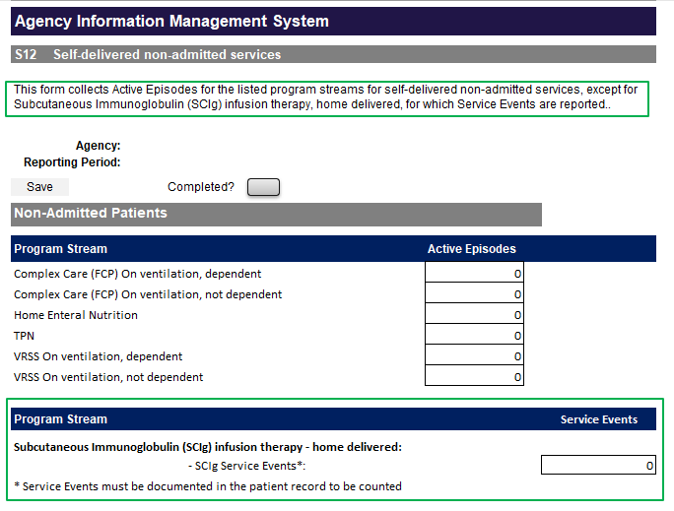

A separate document outlining funding and reporting arrangements for SCIg will be released shortly. Release will be notified via the [HDSS Bulletin](https://www.health.vic.gov.au/data-reporting/health-data-standards-and-systems-communications) < https://www.health.vic.gov.au/data-reporting/health-data-standards-and-systems-communications > .

Advice about reporting patient-level SCIg activity to the VINAH MDS was released in July 2024, and notified via the HDSS Bulletin.

All documents will be available at the [HDSS Annual Changes webpage](https://www.health.vic.gov.au/data-reporting/annual-changes) < https://www.health.vic.gov.au/data-reporting/annual-changes> .

Further information on the SCIg access program is available at [SCIg access program](https://www.health.vic.gov.au/patient-care/subcutaneous-immunoglobulin-scig-access-program) <https://www.health.vic.gov.au/patient-care/subcutaneous-immunoglobulin-scig-access-program> and [Policy and Funding Guidelines](https://www.health.vic.gov.au/policy-and-funding-guidelines-for-health-services) <https://www.health.vic.gov.au/policy-and-funding-guidelines-for-health-services>.