

|  |
| --- |
| Mental Health Bulletin 83 Recording Bodily Restraint on CMI/ODS |
|  |
|  |

# Key Message

This Bulletin is intended to address specific questions around the recording of restraint via the CMI/ODS. This document covers the process for recording restraint occurring in emergency departments which then continues in an inpatient unit as well as covering the recording of combinations of mechanical and physical restraint.

# Purpose

To clarify data entry of bodily restraint where a combination of restraints are used during the same restraint episode.

Note: This document does not include instructions on recording details of chemical restraint.

# Background

CMI/ODS is the Victorian public mental health client information management system and comprises:

* Client Management Interface (CMI) – the CMI is the local client information system used by each public mental health service
* Operational Data Store (ODS) – the ODS manages a set of select data items from each CMI and is used to:
  + allocate a unique (mental health) registration number for each client, known as the statewide unit record (UR) number
  + share select client-level data between Victorian public area mental health and wellbeing services (AMHWS) to support continuity of treatment and care
  + ensure the legal basis for providing treatment is evident to all public mental health service providers where a client may be unable or unwilling to consent to treatment
  + meet the various reporting requirements of the Department of Health
  + support the statutory functions of the Chief Psychiatrist, and the Mental Health Tribunal and the functions of IMHA

# MHWA Forms

Recording bodily restraint on the CMI/ODS is underpinned by information contained on forms MHWA140, MHWA141 and MHWA142. When recording bodily restraint, care should be taken to ensure there is alignment between how this is recorded on the paper/electronic forms and the data entered into the CMI/ODS.

### MHWA140 – Authority for use of restrictive interventions

This form must be completed to authorise the use of restrictive interventions on a person receiving mental health and wellbeing services in a Designated Mental Health Service. This form must be completed as soon as practicable after authorising the restrictive intervention.

#### Part A:

* A restrictive intervention must be authorised by:
  + An authorised psychiatrist or delegate; or
  + If an authorised psychiatrist or delegate is not reasonably available, a Registered Medical Practitioner or the Nurse in Charge
* An Authorised Psychiatrist or Delegate must be notified as soon as practicable if the restrictive intervention is authorised by a Registered Medical Practitioner or a Nurse in Charge (complete point 6, in Part A).

#### Part B:

* The Authorised Psychiatrist or Delegate must then examine the person as soon as practicable to decide whether continued use of the restrictive intervention is necessary unless the person has been released in the meantime.
* If the Authorised Psychiatrist or Delegate is not available to examine the person, they must arrange for a Registered Medical Practitioner to examine the person as soon as practicable to decide whether continued use of the restrictive intervention is necessary, unless the person has been released in the meantime.
* Place cross x in relevant check boxes in each part.

### MHWA141 – Approval for urgent physical restraint

This form is completed by a Registered Nurse to authorise the use of urgent physical restraint on a person receiving mental health services in a Designated Mental Health Service and must be completed as soon as practicable after authorising the use of urgent physical restraint.

A Registered Nurse may only authorise the use of physical restraint if an Authorised Psychiatrist, Registered Medical Practitioner or Nurse in Charge is not immediately available to authorise the use of physical restraint.

A cross x should be placed in relevant check boxes in each part.

### MHWA142 – Restrictive Interventions Observations

This form must be completed by a Registered Nurse or Registered Medical Practitioner.

A Registered Nurse or Registered Medical Practitioner must:

* Continuously observe a person subject to bodily restraint for the entire period of the restraint
* Continuously observe a person subject to chemical restraint for at least one hour after administration
* Clinically review a person subject to a restrictive intervention as often as is appropriate and at least every 15 minutes.

An Authorised Psychiatrist must examine the person as often as is appropriate and at least every 4 hours. If it is not practical for the Authorised Psychiatrist to complete the examination, the Authorised Psychiatrist may direct a Registered Medical Practitioner to do so.

A person who may authorise the use of a restrictive intervention must immediately take steps to release the person from the restrictive intervention as soon as its use is no longer necessary.

# Combinations of Mechanical and Physical Restraint

Cases where there are multiple types of restraint used present a particular risk for incorrect data entry.

Section 1 of MHWA142 (shown below) details the type of restrictive intervention used, the date, start time, end time, signature and designation of clinician.

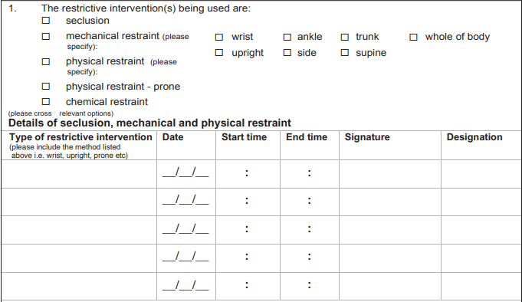

This section should assist with data entry into CMI/ODS. When entering data, it is important to record separate events for each occurrence where the type, method or combination of these changes.

While these rules are intended to record as accurately as possible each variation in type and method of restraint, it is acknowledged that physical restraint may be required to apply mechanical restraint. In this situation: If the purpose of the physical restraint is to facilitate mechanical restraint or seclusion of the consumer, then the period of physical restraint should be recorded as a separate type followed immediately by the other type/s of restrictive intervention as it is occurring contiguously.

For ease of data entry into CMI/ODS, identify each change in the form of restraint by using the ‘Form of Restraint Change’ status which is shown below in Scenario 1.

#### Scenario 1 – Combination of mechanical and physical restraint

A consumer is physically restrained initially and then the restraint changes to mechanical restraint. The consumer is restrained in the prone position from 10:00 to 10:02 and then the form of restraint changes from prone to supine with concurrent wrist restraint from 10:02 to 10:05. Then there is another change to mechanical restraints on wrist and ankle from 10:05 to 10:30.

* Event one from 10:00 until 10:02 reporting the consumer was restrained in prone position
* Event two from 10:02 until 10:05 reporting the consumer was changed from prone to supine position and mechanically restrained by the wrist
* Event three from 10:05 until 10:30 reporting the consumer was mechanically restrained by wrist and ankle

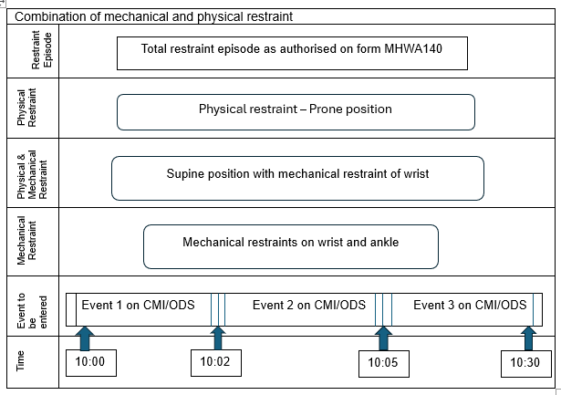

Note: To enter this information into the CMI/ODS requires a single bodily restraint episode containing *three* separate events. When entering a combination of restraints into CMI/ODS select ‘Form of Restraint Change’ as the reason for adding a new line. When all entries have been entered select ‘Complete’ (as shown below).

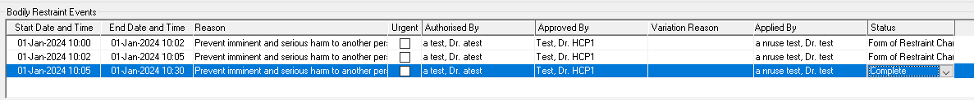

Please ensure that you identify each type of restraint against the correct data entry line as shown below:

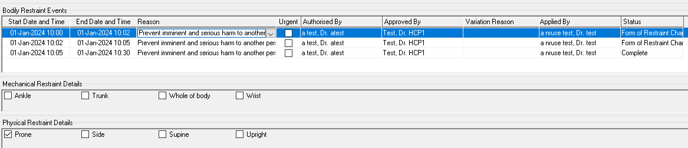

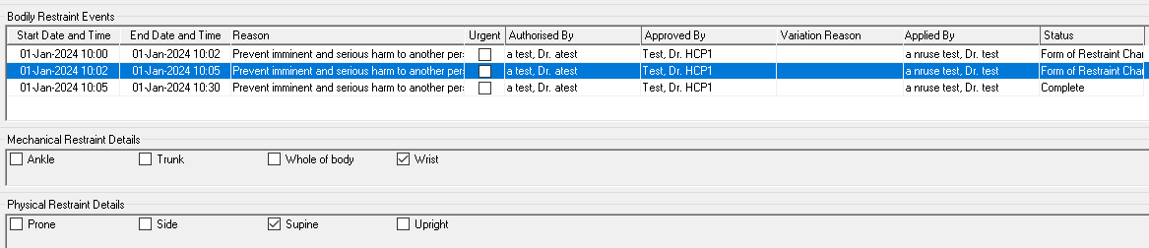

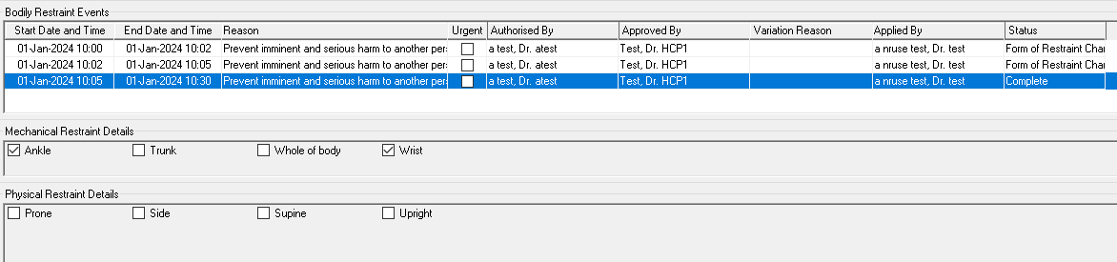

#### Scenario 2 – Combination of bodily restraint types

A patient is restrained for a total period of thirty minutes. The patient is physically restrained from 02:30 until 02:50. They are mechanically restrained from 02:40 until 03:00. A single MHA140 form authorises the use of both mechanical and physical restraint.

* Event one from 02:30 until 02:40 reporting the patient was physically restrained.
* Event two from 02:40 until 02:50 reporting the patient was both physically and mechanically restrained.
* Event three from 02:50 until 03:00 reporting the patient was mechanically restrained.

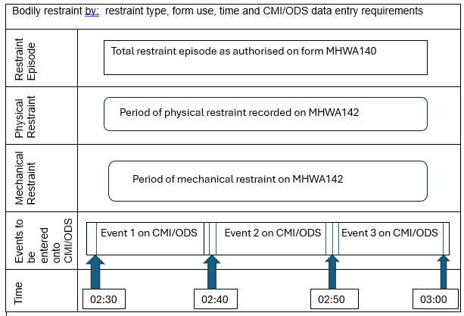

Note: To enter this information into the CMI/ODS requires a single bodily restraint episode containing *three* separate events. When entering a combination of restraints into CMI/ODS select ‘Form of Restraint Change’ as the reason for adding a new line. When all entries have been entered select ‘Complete’.

#### Scenario 3 – Combination of bodily restraint methods

A patient is mechanically restrained for a period of thirty minutes. The patient is restrained by the wrist from 12:30 until 12:40 they are then restrained by both the wrist and ankle from 12:40 until 12:50. The patient is then released from the ankle restraint and the wrist restraint is maintained until 13:00.  
  
To enter this information into the CMI/ODS requires a single bodily restraint episode containing three separate events. When entering a combination of restraints into CMI/ODS select ‘Form of Restraint Change’ as the reason for adding a new line. When all entries have been entered select ‘Complete’.

* Event one from 12:30 until 12:40 reporting the patient was restrained by the wrist
* Event two from 12:40 until 12:50 reporting the patient was physically restrained by both wrist and ankle
* Event three from 12:50 until 13:00 reporting the patient was restrained by wrist



Note: To enter this information into the CMI/ODS requires a single bodily restraint episode containing *three* separate events. When entering a combination of restraints into CMI/ODS select ‘Form of Restraint Change’ as the reason for adding a new line. When all entries have been entered select ‘Complete’.

# Recording Bodily Restraint

The CMI/ODS has the ability to record episodes of bodily restraint which occur in an emergency department, urgent care centre or inpatient unit. While it is possible to record instances which begin in an emergency department and continue as an inpatient as a single episode, the resulting data does not accurately capture this sequence of events. Currently in CMI/ODS this scenario would attribute the entire restraint episode against the emergency department which is an inaccurate representation of what took place.

To resolve this issue, any instances where this scenario occurs should be recorded as two (2) separate restraint episodes. The first episode is to be recorded against the emergency department up until the time of admission with the second episode to be recorded against the inpatient subcentre.

While it is acknowledged that this may not represent the exact nature of the restraint, it is a compromise that permits the accurate recording of the location where the restraint took place.

#### Recording restraint where consumer is in the Emergency Department or Urgent Care Centre

If the consumer has bodily restraint interventions applied in the Emergency Department of an AMHS under the Mental Health & Wellbeing Act then this should be recorded in CMI/ODS against the location of Emergency Department or Urgent Care Centre as below:

* In the Functions menu, select ‘Bodily Restraint’.
* Perform a ‘Client Search’ to find the consumer who is being restrained.
* Click ‘Ok’ to continue to the Bodily Restraint screen.
* Select ADD to commence a new Bodily Restraint Episode.
* Complete all details required in the Bodily Restraint Event section, including the mechanical or physical method
* Select ‘Save’.
* Select emergency department or urgent care centre from the drop-down box to identify the Location
* Select ‘Ok’ and you will be prompted to confirm the details with a warning that the data entry cannot be modified/deleted once saved.
* Select ‘Yes’ to finalise the process.

#### Recording restraint where a consumer is currently admitted

If the consumer is admitted to a mental health inpatient unit, then the Bodily Restraint function can be accessed either by the ‘Functions’ menu or the ‘Options’ menu of the Admission screen/function.

If you are in the admission screen there is no need to search for the consumer as you would have done that already, however, if choosing to use the ‘Function’, ‘Bodily Restraint’ way of entering data then you will need to search for your consumer.

Follow the steps above except that the subcentre will default to the subcentre where the consumer is admitted if the dates of the restraint are within the admitted episode.

#### Recording restraint where a consumer begins in ED and is admitted while restrained

To ensure the location where a consumer is restrained is accurate, this scenario will require two separate episodes of restraint to be recorded.

* To capture the period where the consumer is in ED/UCC, follow the steps under the heading “Recording restraint where consumer is only in the Emergency Department”.
* To capture the period where a consumer is admitted to a mental health inpatient unit, follow the steps under the heading “Recording Restraint where a consumer is currently admitted”.

The Bodily Restraint Summary screen in CMI/ODS should be as shown below:



# For More Information

Further information about the correct use of CMI/ODS can be found on the Victorian Government’s website. Refer to the sections on; Registration of Clients, CMI/ODS Service Contacts and Subcentre/Program Maintenance.

<https://www.health.vic.gov.au/research-and-reporting/bulletins-and-program-management-circulars-pmc>

For any queries relating to data reporting or program setup please email: [MHDReporting@health.vic.gov.au](mailto:MHDReporting@health.vic.gov.au)

|  |
| --- |
| To receive this publication in an accessible format email [MHD Reporting](mailto:MHDReporting@health.vic.gov.au) <MHDReporting@health.vic.gov.au>  Authorised and published by the Victorian Government, 1 Treasury Place, Melbourne.  **ISSN 2653-620X - Online (pdf/word)**  © State of Victoria, Department of Health, September 2024  Available at [Bulletins and Program Management Circulars (PMC)](https://www.health.vic.gov.au/research-and-reporting/bulletins-and-program-management-circulars-pmc) <https://www.health.vic.gov.au/research-and-reporting/bulletins-and-program-management-circulars-pmc>. |