

|  |
| --- |
| Voluntary Assisted Dying  Review Board Annual Report |
| July 2023 to June 2024 |
|  |

|  |
| --- |
| **Voluntary Assisted Dying Review Board Annual Report**  July 2023 to June 2024 |
|  |

|  |
| --- |
|  |
| To receive this publication in an accessible format phone 1300 758 551, using the National Relay Service 13 36 77 if required, or [email Voluntary Assisted Dying](mailto:VADBoard@health.vic.gov.au) <VADBoard@health.vic.gov.au>  Authorised and published by the Victorian Government, 1 Treasury Place, Melbourne.  © State of Victoria, Australia, Department of Health, September 2024 (2407795)  ISSN 2652-1962 – Print  ISSN 2652-1970 – Online (pdf/word)  Available at the [Department of Health website](https://www.health.vic.gov.au/)­ <https://www.health.vic.gov.au> |
|  |

Contents

Introduction 7

Information on financial reporting 7

More information 7

Foreword 8

Reflections on the reporting year 8

The sustainability of voluntary assisted dying in Victoria 9

Recognising the contributions of the inaugural Board 9

Welcome to new Board members 9

Snapshot 11

In the 2023–24 reporting year 13

The request and assessment process 15

Medical practitioner involvement 18

Community of practice 20

Applications and assessments 21

Statewide Care Navigator Service 21

Reflections on the Statewide Care Navigator service 22

Voluntary assisted dying applications 22

Timeframes during the application process 23

People who applied for voluntary assisted dying 24

Life limiting conditions 26

Palliative care 27

Additional assessments 28

Appointment of a contact person 28

Withdrawal of cases 29

Permit approvals and substance dispensing 30

Timeliness 30

Statewide Pharmacy Service 30

Feedback and reflections on the Statewide Pharmacy Service 31

Deaths 32

Deaths during the application process 32

Reflections 34

Compliance reviews 35

Case compliance 35

Return of substance 35

Late submissions of forms 35

Referral to other agencies 36

Compliance Audit 36

Areas for improvement 37

Commonwealth Criminal Code 37

Obstruction by services to accessing voluntary assisted dying 37

Enhancement of information provided to the public on voluntary assisted dying 38

Organ donation and voluntary assisted dying 38

Research and data 39

Publications 39

Data audit 39

Data governance 39

National Minimum Dataset 39

Voluntary assisted dying portal enhancements 40

Board reflections on amendments to the Act 41

Enable medical practitioners to include discussions on voluntary assisted dying when discussing end‑of-life care 41

Extend the circumstances in which a permit for practitioner administration may be granted 41

Definition of an Australian ‘permanent resident’ 42

Requirement to be ‘ordinarily resident’ in Victoria for 12 months before making a request 42

Seeking a third medical opinion in neurodegenerative conditions with a prognosis of between six and 12 months 42

Requirement for health services and residential aged care facilities to publish their voluntary assisted dying policy 42

Simplify the process for transferring the role of co‑ordinating medical practitioner 43

Revise the qualification requirements for the co-ordinating and consulting practitioners 43

Appendices 44

Appendix 1: Minimum dataset since commencement of the legislation 44

Appendix 2: Applying for voluntary assisted dying 46

Appendix 3: Statewide services and support organisations 49

Appendix 4: Voluntary Assisted Dying Review Board membership 50

# Introduction

In addition to four half year reports, this is the third annual report from the independent Voluntary Assisted Dying Review Board.

The report details:

1. Activity from 1 July 2023 to 30 June 2024 in addition to activity since the commencement of the *Voluntary Assisted Dying Act 2017* (Vic) on 19 June 2019

2. Board reflections drawn from case reviews and feedback.

This report contains quotes and feedback from people who have chosen to die from taking the voluntary assisted dying substance, those who were with them when they died, and trained medical practitioners involved in voluntary assisted dying cases. The quotes have been de-identified to protect the privacy of individuals. This content may be upsetting for some. Contact details for support organisations can be found on page 40.

By law, the Board is required to produce an Annual Report at the end of each financial year. The next report will be submitted by the end of September 2025 and will cover the reporting period 1 July 2024 to 30 June 2025.

## Information on financial reporting

It should be noted that the Board does not operate a budget associated with the delivery or operation of the Act. Therefore, no financial reporting is required or provided within this report.

## More information

[https://www.health.vic.gov.au](https://www.health.vic.gov.au/)

# Foreword

In introducing the *Voluntary Assisted Dying Bill* in 2017, the then Minister for Health stated that the Bill ‘balances a compassionate outcome for people at the end of their lives who are suffering and providing community protection’ and that the Bill was designed to provide a ‘safe and compassionate legislative framework’. Based on the experience of the first five years, the Board is satisfied that the objective of safety has been achieved through the *Voluntary Assisted Dying Act 2017.* However, there are opportunities to enhance the extent to which the goal of providing compassionate care is realised.

The provision of compassionate end of life care, through which the physical and psychological distress that can be associated with dying is minimised, involves person-centred treatment, the promotion of personal autonomy, and an absence of unreasonable or preventable barriers to timely access. The Board considers that these elements can be advanced by adopting some procedural changes in the administration of the *Voluntary Assisted Dying Act 2017* – without diminishing the provisions that have ensured the safe operation of the voluntary assisted dying program to date.

The Board welcomed the Minister’s commencement of the *Five Year Review of the Operation of the Voluntary Assisted Dying Act 2017* in 2023. Board members provided their experience and expertise, alongside qualitative and quantitative data collected over the program’s operation to support the review process. We extend our thanks to all involved over the past five years, and members of the public who contributed to the review. The Board looks forward to the outcome of the review. Further to this, our deliberations on the potential for reviewing the legislation are provided within this report.

## Reflections on the reporting year

This reporting period has seen a 22% increase in self-administration permits issued, and a 35% increase in practitioner administration permits. Voluntary assisted dying deaths represented 0.84% of all deaths in Victoria. This compares with 0.65% in the previous reporting year. This is significantly lower than the percentage of voluntary assisted dying deaths in most other States.

The proportion of voluntary assisted dying deaths that involve practitioner administration of the voluntary assisted dying substance in Victoria is 19%. While this an increase on 16% compared to the previous year, it is also significantly lower than in most other States. This reflects the Victorian legislation which requires an applicant be unable to self-administer a substance to be eligible for practitioner administration, versus the right for an applicant to have an element of administration preference in some other jurisdictions.

During the 2023–24 period, 180 applicants died before being issued a permit, the majority having only completed a First or Consulting assessment before their death. This highlights the ongoing pattern that many patients begin the application process very late in the course of their illness.

Supporting this, just over a quarter (26% of all applications were withdrawn before substance was dispensed (noting that a case can be withdrawn for reasons other than the death of an applicant). Sixty per cent of withdrawn cases were withdrawn because the applicant died less than two weeks after making the first request, representing 15% of all applications.

While those living in rural and regional Victoria can face greater difficulty in accessing voluntary assisted dying, especially given the ban on the use of telehealth, it is notable that while comprising 22% of the Victoria population, rural applicants make up 36% of voluntary assisted dying applicants.

## The sustainability of voluntary assisted dying in Victoria

As the offering of voluntary assisted dying as an option for end-of-life care matures in Victoria and we have an opportunity to consolidate the findings of the review, the Board recognises the contributions of medical practitioners to the care and support of Victorians who wish to access voluntary assisted dying.

The Board recognises the ongoing impact of this role. We are concerned about the ongoing sustainability of the program given that the data shows there are only seven medical practitioners trained to provide voluntary assisted dying per 100,000 adults in Victoria.

In 2023–24, 161 trained medical practitioners coordinated or consulted in at least one application for voluntary assisted dying. Twenty-five per cent of these medical practitioners have only been involved in one case over this reporting year.

Ten doctors with the highest case load over this period either co-ordinated or consulted on 55% of all cases in this 12-month period. Four of these practitioners have been involved in over 50 applications each (of a total 768 applications started) this reporting year.

Of these ten medical practitioners, only 3 are located in rural and regional Victoria. These 3 practitioners have been involved in 14% of all cases over this period. This level of practitioner engagement has remained consistent since the commencement of the program in June 2019.

The above information highlights that not only does access to voluntary assisted dying rely on a small number of medical practitioners to perform vital duties as co-ordinating or consulting Medical Practitioner, but that this small number of medical practitioners has remained consistent since the commencement of the program.

This is an issue facing all jurisdictions. While the number of medical practitioners registered to provide voluntary assisted dying rose by 14%, a continued focus on widening the training and support for medical practitioners and those who support the process of voluntary assisted dying is important.

The Board extends its thanks to those practitioners, to other health practitioners, to the Statewide Pharmacy Service and the Care Navigator Service, to contact persons and family members for the support and care provided to those who wish to access voluntary assisted dying.

## Recognising the contributions of the inaugural Board

The role of the Board continues to be an important one. The inaugural Board was appointed before the commencement of the legislation to provide independent monitoring of the operation and system in Victoria. I would like to extend my thanks to Nirasha Parsotam and Jim Howe, who resigned during the year. I would also like to extend my thanks to Mitchell Chipman, John Clements, Sally Cockburn, Charlie Corke, Margaret O’Connor and Paula Shelton for their significant contributions to the program during the six years of their inaugural tenure on the Board.

I also thank the Board Secretariat for its ongoing professional support of the program and the administration of the process. The team has seen a significant change this year with their restructure into the Department of Health and continues to facilitate the effective operation of the Act and Board activities.

## Welcome to new Board members

As a more recent appointment, I will continue as Board Chair over a time of transition in the membership of the Board. I would like to welcome the new and returning appointed Board members listed on page 41. New Board members commenced their tenure on 4 July 2024 and will continue the strong work of quality and safety overseeing the program in Victoria.

**Julian Gardner AM  
Chairperson  
Voluntary Assisted Dying Review Board**

# Snapshot

Figure 1: Voluntary assisted dying minimum dataset 1 July 2023 – 30 June 2024

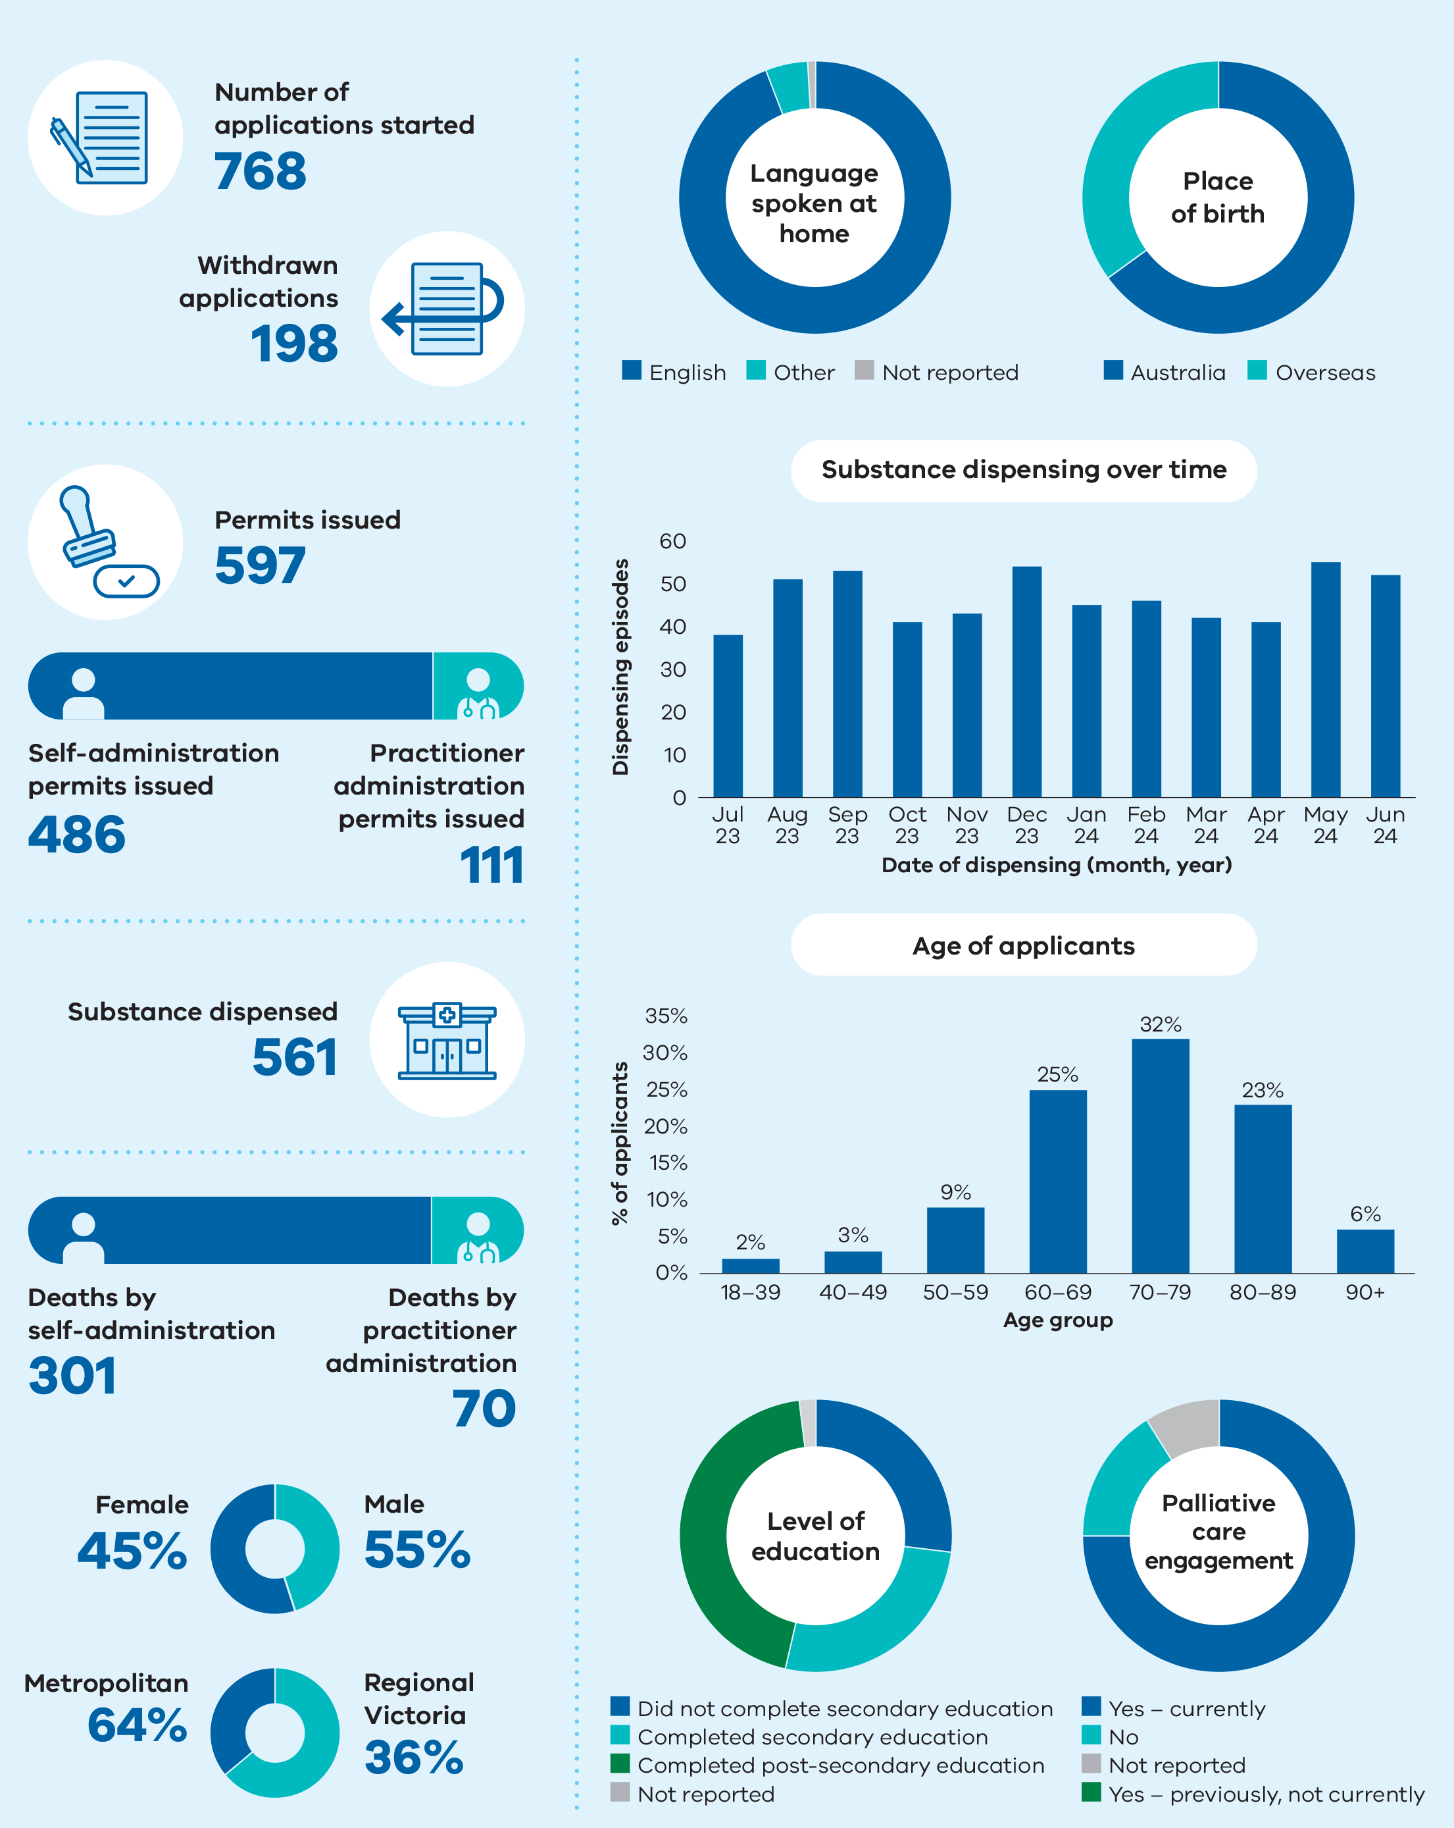

Figure 1 includes the following data:

* Number of applications started – 768
* Withdrawn applications – 198
* Permits issued – 597
* Self-administration permits issued – 486
* Practitioner administration permits issued – 111
* Substance dispensed – 561
* Deaths by self‑administration – 301
* Deaths by practitioner administration – 70
* Female – 45%
* Male – 55%
* Metropolitan – 64%
* Regional Victoria – 36%

Table 1: Outcomes of each application stage for voluntary assisted dying*

|  |  |  |  |  |  |  |  |
| --- | --- | --- | --- | --- | --- | --- | --- |
| **Stage** | **2019–20\*\*** | **2020–21** | **2021–22** | **2022–23** | **2023–24** | **Total to date#** | **Change from previous year** |
| **First assessment completed** | **353** | **487** | **586** | **613** | **730** | **2769** | **+19%** |
| Eligible | 346 | 465 | 553 | 602 | 726 | 2692 | +21% |
| Ineligible## | 7 | 22 | 33 | 11 | 4 | 77 | -64% |
| **Consulting assessment completed** | **299** | **404** | **491** | **532** | **659** | **2385** | **+24%** |
| Eligible | 297 | 398 | 486 | 527 | 658 | 2366 | +25% |
| Ineligible## | 2 | 6 | 5 | 5 | 1 | 19 | -80% |
| **Self-administration permit processed** | **239** | **350** | **390** | **403** | **486** | **1868** | **+21%** |
| Permit issued^ | 207 | 323 | 379 | 403 | 486 | 1798 | +21% |
| Permit not issued | 32 | 27 | 11 |  |  | 70 |  |
| **Substance dispensed for self-administration†** | **155** | **260** | **356** | **401** | **490** | **1662** | **+22%** |
| **Practitioner administration permit processed** | **39** | **52** | **65** | **82** | **111** | **349** | **+35%** |
| Permit issued^ | 30 | 43 | 60 | 82 | 111 | 326 | +35% |
| Permit not issued | 9 | 9 | 5 |  |  | 23 |  |
| **Substance dispensed for practitioner administration^^** | **20** | **31** | **38** | **51** | **71** | **211** | **+39%** |

* This table counts unique applications. A single individual may be linked to more than one application, and some applications may have the same form submitted multiple times.

** This column includes 12 days of 2018–19 financial year as the program commenced on 19 June 2019.

# Total figures are since the commencement of the Act in June 2019.

## There is no requirement in the Act for a medical practitioner to record a case that is considered ineligible. Therefore, this number is not considered an accurate reflection of true ineligible assessments conducted over this reporting period.

^ There are circumstances where one applicant is issued with two permits; firstly, for self-administration and subsequently if there is a change to practitioner administration.

† Substance dispensing for self-administration is reported by counting the number of substance dispensing forms for self‑administration permit (Form 6) submitted.

^^ There is no obligation for a medical practitioner to submit a substance dispensing form for practitioner administration as this is an optional form. Substance dispensing for practitioner-administration is reported by counting the number of medical practitioner administration forms (Form 8) that are submitted, which are mandatory according to the legislation.

Table 2: Deaths of applicants issued with permits

|  |  |  |  |  |  |  |  |
| --- | --- | --- | --- | --- | --- | --- | --- |
| **Manner of death** | **2019–20\*** | **2020–21** | **2021–22** | **2022–23** | **2023–24** | **Total to date** | **Change from previous year** |
| **Deaths from administration of voluntary assisted dying substance** | **129** | **202** | **275** | **305** | **371** | **1282** | **+22%** |
| Self-administration of the voluntary assisted dying substance | 108 | 174 | 237 | 257 | 301 | 1076 | +17% |
| Practitioner administration of the voluntary assisted dying substance | 21 | 28 | 39 | 48 | 70 | 206 | +46% |
| **Deaths of permit holder not from administration of voluntary assisted dying substance** | **50** | **113** | **131** | **138** | **180** | **611** | **+30%** |
| **Total deaths\*\*** | **179** | **315** | **407** | **443** | **554** | **1898** | **+25%** |

* This column includes 12 days of 2018–19 financial year as the program commenced on 19 June 2019.

** 3 applicants who died near 30 June 2024 did not have their manner of death reported to the Board at the time of analysis. This means that the totals for 2023/24 and to date equal three more than the sum of the columns presented.

## In the 2023–24 reporting year

* 730 first assessments completed
* 597 permits issued to prescribe self‑ or practitioner administration of voluntary assisted dying substance
* 371 deaths from administration of voluntary assisted dying substance
* 39% of applicants with a permit died without administration of a voluntary assisted dying substance[1]
* 39% of applicants with a first assessment died from administration of a voluntary assisted dying substance[2]

# The request and assessment process

Access to voluntary assisted dying has strict eligibility requirements and is a highly controlled process. The below diagram explains the simplified steps a person and their medical practitioners must take to apply for and obtain a permit. The full process is detailed in the Act.

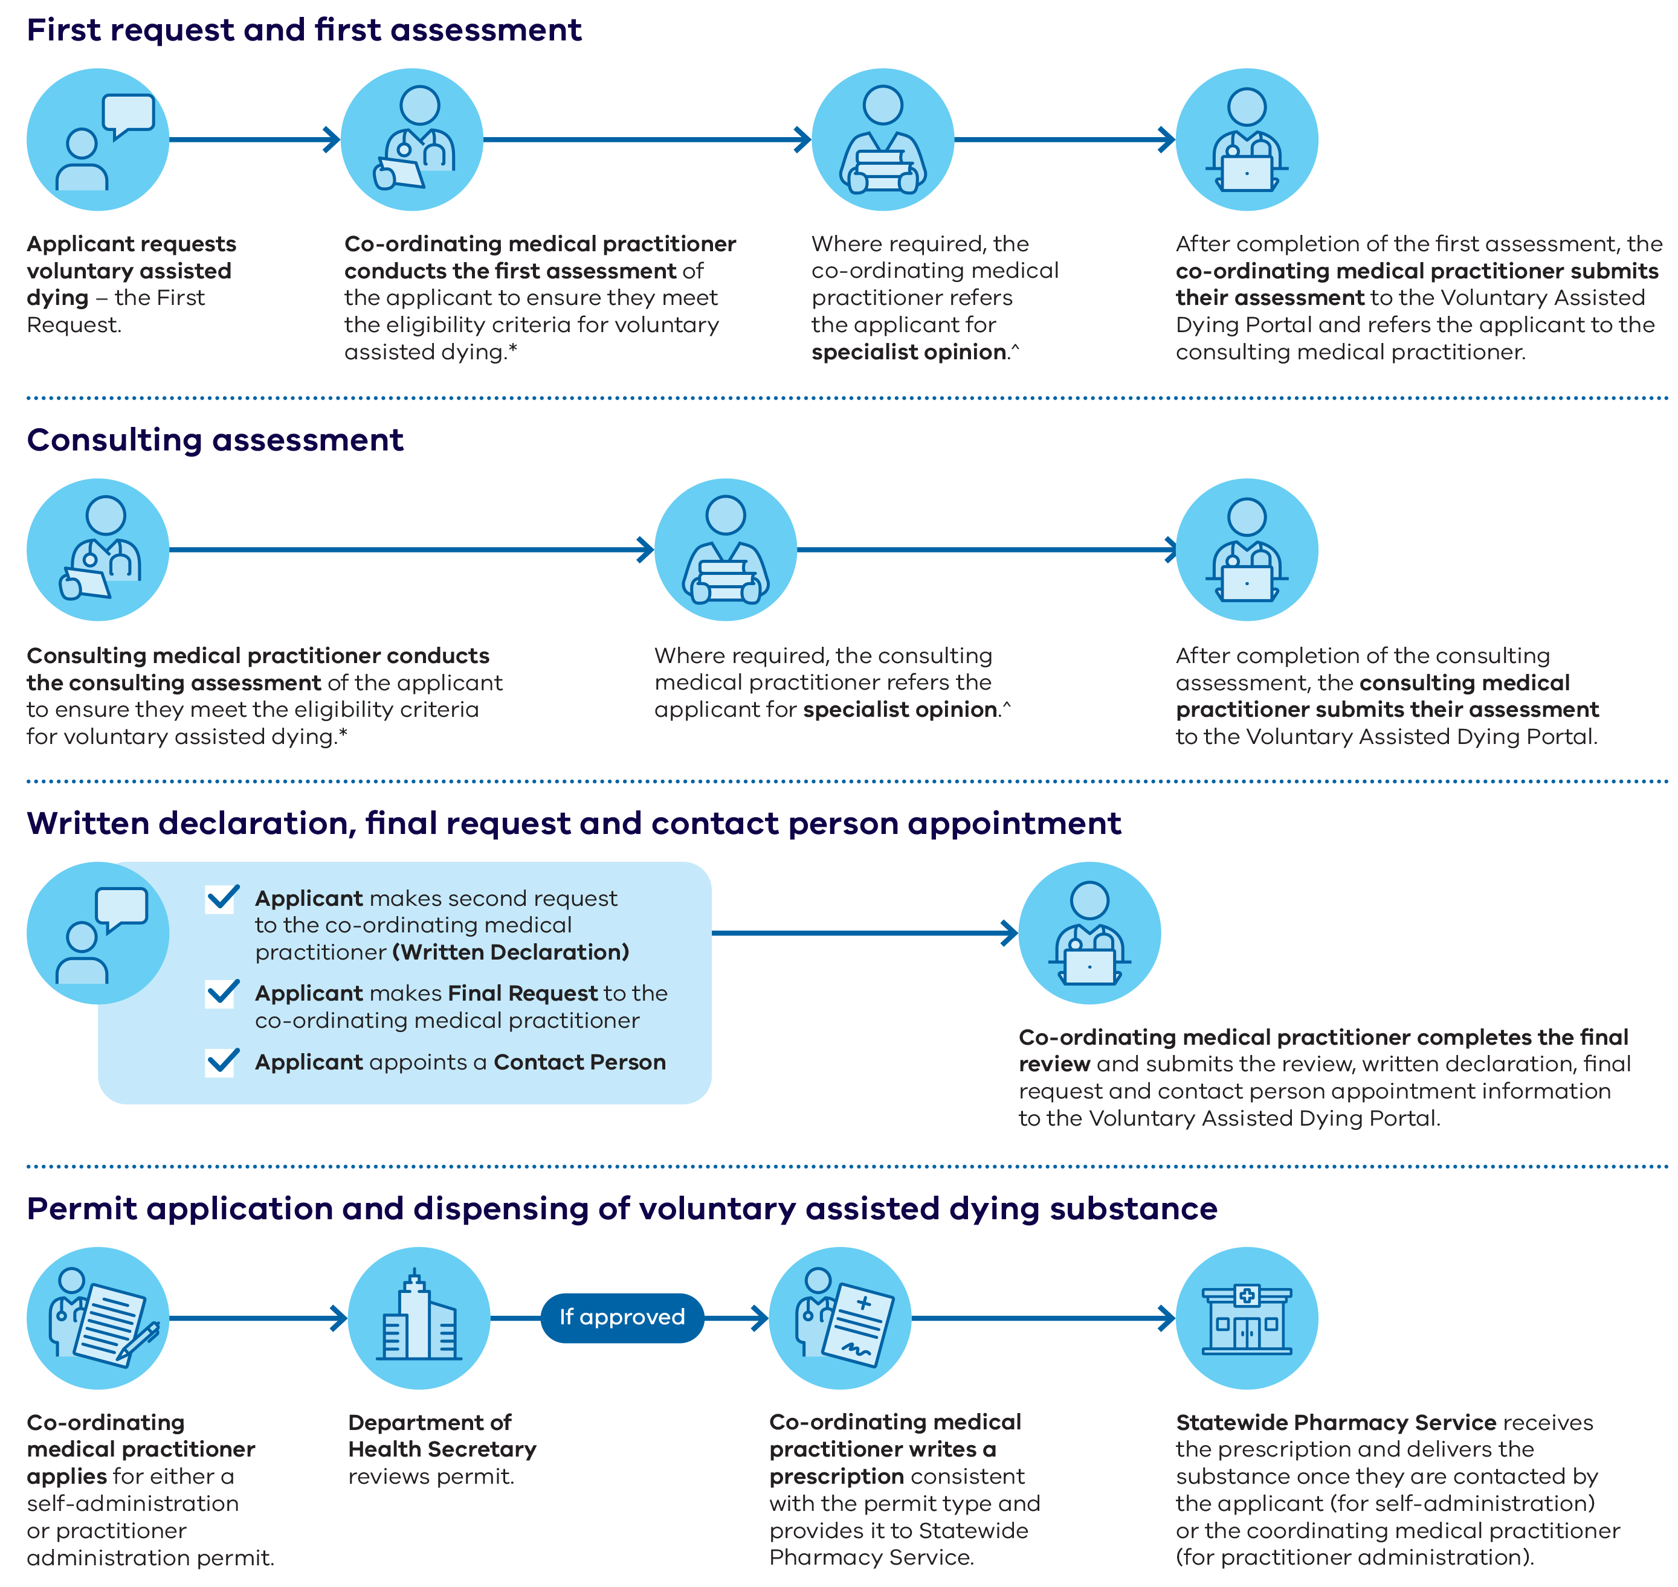

First request and first assessment

* Applicant requests voluntary assisted dying – the First Request.
* Co-ordinating medical practitioner conducts the first assessment of the applicant to ensure they meet the eligibility criteria for voluntary assisted dying.*
* Where required, the co-ordinating medical practitioner refers the applicant for specialist opinion.^
* After completion of the first assessment, the co-ordinating medical practitioner submits their assessment to the Voluntary Assisted Dying Portal and refers the applicant to the consulting medical practitioner.

Consulting assessment

* Consulting medical practitioner conducts the consulting assessment of the applicant to ensure they meet the eligibility criteria for voluntary assisted dying.*
* Where required, the consulting medical practitioner refers the applicant for specialist opinion.^
* After completion of the consulting assessment, the consulting medical practitioner submits their assessment to the Voluntary Assisted Dying Portal.

Written declaration, final request and contact person appointment

* Applicant makes second request to the co-ordinating medical practitioner (Written Declaration)
* Applicant makes Final Request to the co‑ordinating medical practitioner
* Applicant appoints a Contact Person
* Co-ordinating medical practitioner completes the final review and submits the review, written declaration, final request and contact person appointment information to the Voluntary Assisted Dying Portal.

Permit application and dispensing of voluntary assisted dying substance

* Co-ordinating medical practitioner applies for either a self-administration or practitioner administration permit.
* Department of Health Secretary reviews permit.
* If approved
* Co-ordinating medical practitioner writes a prescription consistent with the permit type and provides it to Statewide Pharmacy Service.
* Statewide Pharmacy Service receives the prescription and delivers the substance once they are contacted by the applicant (for self‑administration) or the coordinating medical practitioner (for practitioner administration).

* Conditions for accessing voluntary assisted dying in Victoria:

People can ask for voluntary assisted dying if they meet all the following conditions:

• They must have an advanced disease that will cause their death and that is:

– likely to cause their death within six months (or within 12 months for neurodegenerative diseases like motor neurone disease)

– causing the person suffering that is unacceptable to them.

• They must have the ability to make and communicate a decision about voluntary assisted dying throughout the formal request process.

• They must also:

– be an adult 18 years or over

– have been living in Victoria for at least 12 months

– be an Australian citizen or permanent resident.

For more information, see section 9 of the Voluntary Assisted Dying Act 2017.

^ Referrals for specialist opinion are required:

• If the co-ordinating medical practitioner determines that the person has a disease, illness or medical condition that is neurodegenerative and is expected to cause death between 6 and 12 months.

• If either medical practitioner is unable to determine whether the person has decision making capacity in relation to voluntary assisted dying as required by the eligibility criteria.

• If either medical practitioner is unable to determine whether the person’s disease, illness or medical condition meets the requirements of the eligibility criteria.

For more information, see sections 18 and 27 of the *Voluntary Assisted Dying Act 2017.*

# Medical practitioner involvement

A growing number of medical practitioners are supporting Victorians to exercise their choice to access voluntary assisted dying. The medical practitioners who provide voluntary assisted dying are key to ensuring equity of access to this end-of-life care option and they consistently provide high‑quality, safe and compassionate care to applicants.

Since voluntary assisted dying became a legal end‑of-life option five years ago, medical practitioners across metropolitan, regional, and rural Victoria have continued to register for the online training program. Medical practitioners often complete the training to support a patient who has asked for their assistance to access voluntary assisted dying, or to be ready to help a patient in the future.

There were 394 medical practitioners with active profiles in the portal on 30 June 2024. Medical practitioner profiles may become inactive after registration if a practitioner retires or ceases to be involved in the voluntary assisted dying program.

Table 3: Medical practitioner training and involvement since commencements of training availability

|  |  |  |  |  |  |  |
| --- | --- | --- | --- | --- | --- | --- |
| **Stage** | **Description** | **Total as of 30 June 2021** | **Total as of 30 June 2022** | **Total as of 30 June 2023** | **Total as of 30 June 2024** | **Change from previous year (%)** |
| Online training | Medical practitioners registered for the online training program | 511 | 618 | 734 | 822 | +12% |
| Portal registration | Trained medical practitioner registration within the Voluntary Assisted Dying portal | 234 | 326 | 347 | 394 | +14% |
| Case involvement | Participation by the medical practitioner in at least one case as either the co‑ordinating or consulting medical practitioner | 154 | 185 | 208 | 318 | +53% |

Figure 2: Clinical specialities of medical practitioners by primary location of practice

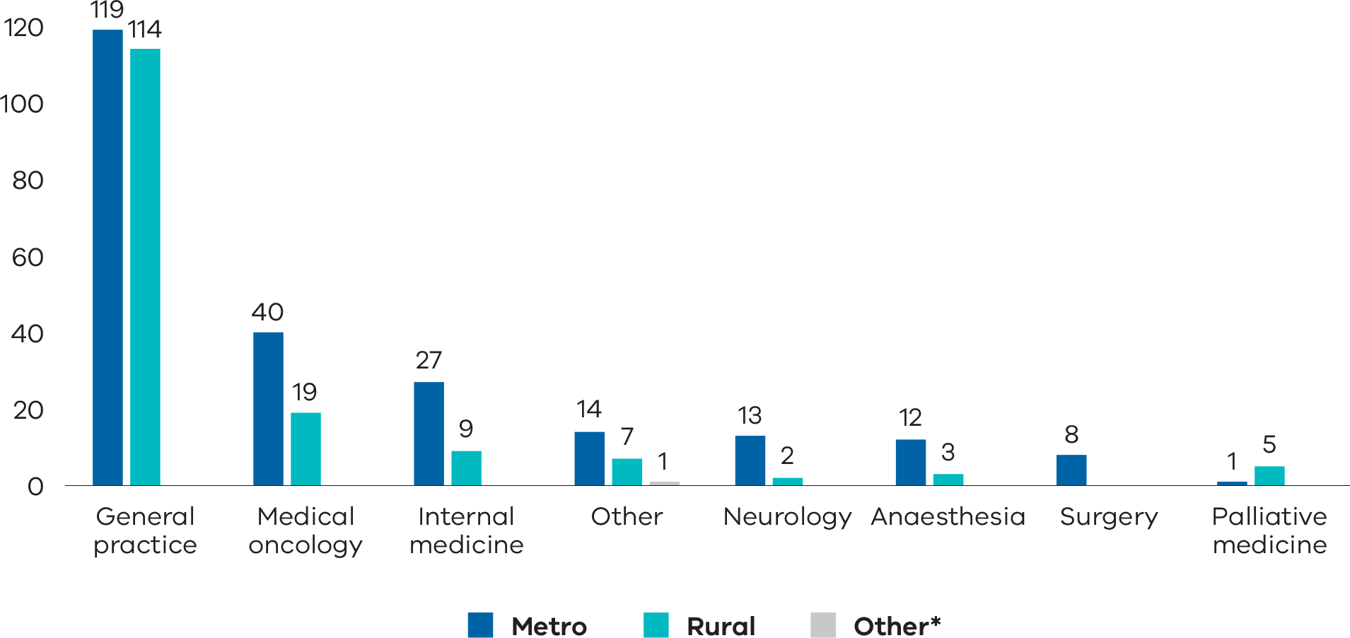

* There is one medical practitioner whose principal place of work is registered in Albury, NSW.

Figure 3: Number of medical practitioners newly registered in the voluntary assisted dying portal*

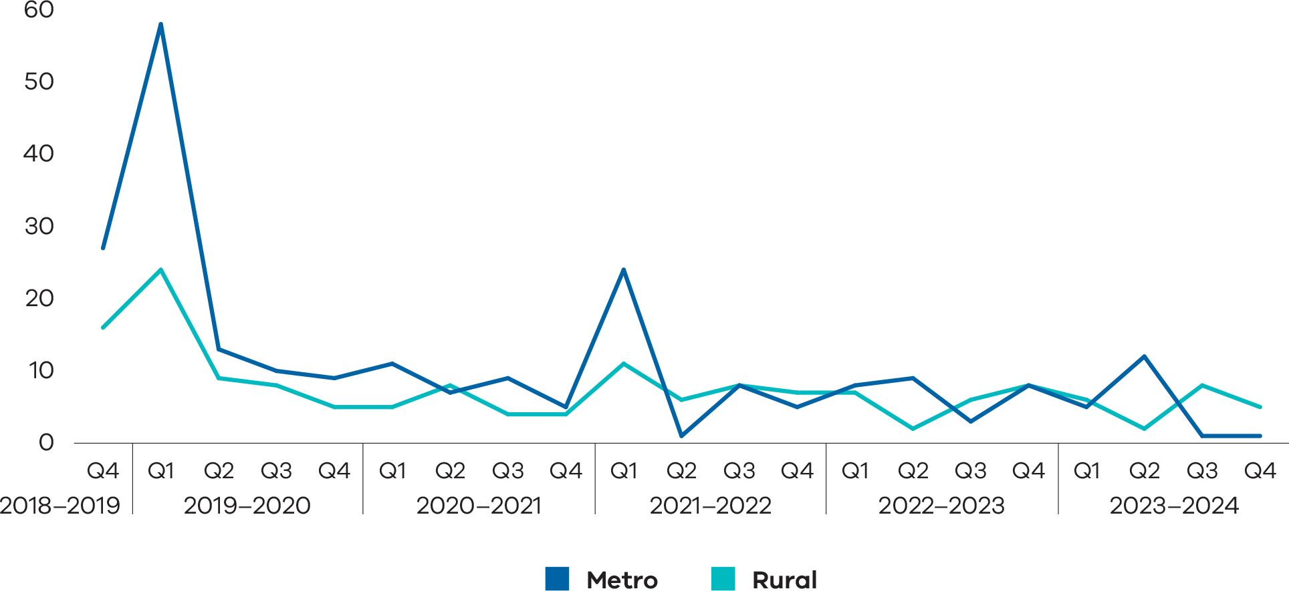

* Excludes practitioners who have since deactivated their profiles

In total, 59% of active medical practitioners are in metropolitan Melbourne, and 41% practice in rural and regional Victoria. Practitioners in regional Victoria are concentrated around the larger towns in central Victoria, Geelong and the Bellarine peninsula, and the Hume region. There are very few practitioners in Western Victoria.

The distribution of practitioners is broadly consistent with the distribution of the population in Victoria. Although there are some large geographic areas with few, if any, medical practitioners. This means regional patients and medical practitioners may have to travel significant distances to facilitate the required in-person assessments and discussions about voluntary assisted dying.

Figure 4: Geographic distribution of medical practitioners

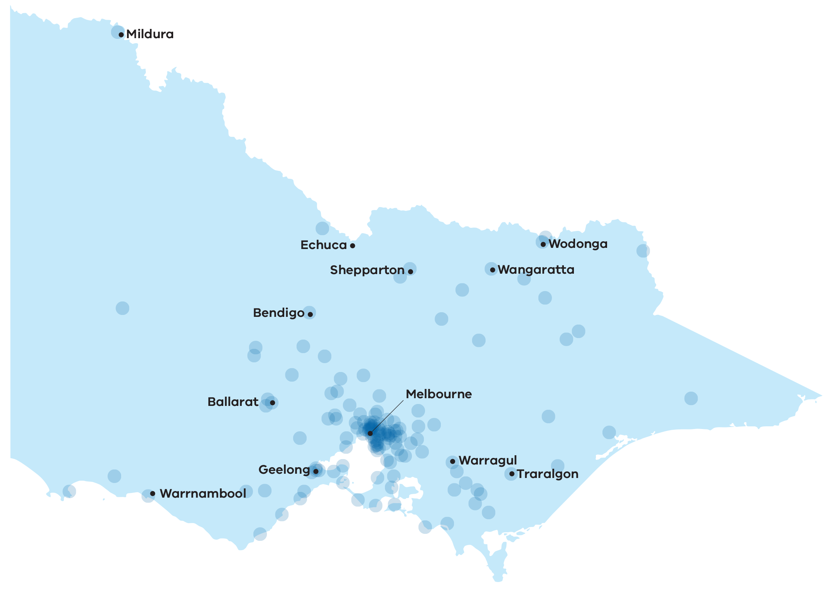

## Community of practice

Medical practitioners who have completed Victoria’s voluntary assisted dying training program can join the voluntary assisted dying medical practitioner community of practice. This is an online forum and peer support network with 78 members. The online forum is available as needed and meets formally online four times per year.

Membership includes specialists in the fields of:

* Oncology
* Haematology
* Palliative Care
* Geriatrics
* Anaesthetics
* General Practice.

Those wishing to join the Community of Practice should contact   
[vadcommunity@westvicphn.com.au](mailto:vadcommunity@westvicphn.com.au)

# Applications and assessments

An applicant is a person seeking to access voluntary assisted dying. They must meet all eligibility criteria, as assessed by their co‑ordinating and consulting medical practitioners. For the last five years, the Statewide Care Navigator Service and the Statewide Pharmacy Service have provided support to applicants and their families, medical practitioners, and health care settings throughout the application process. As more Victorians choose voluntary assisted dying there is growing demand for both statewide services. Additional resourcing continues to be dedicated to ensuring Victorians considering accessing voluntary assisted dying have their needs met when they need it most.

## Statewide Care Navigator Service

The Statewide Care Navigator Service provides information and support to people seeking to access voluntary assisted dying, along with their families and carers. Additionally, it provides information, support and training to medical and health practitioners, as well as Victoria’s health, aged care and palliative care services. If necessary, the service can also connect people with medical practitioners who have completed voluntary assisted dying training.

The care navigators are highly skilled and experienced nurses and allied health professionals. Nine care navigators are located at health services across metropolitan and regional Victoria.

From 1 July 2023 to 30 June 2024, there were 1074 contacts made to the care navigator service seeking information or support. This is an increase of 12% compared to 957 contacts made from the previous year. Of these:

* 27% were from applicants
* 24% were from a family member or friend
* 17% were from the usual treating doctor
* 10% were from a voluntary assisted dying clinician (medical practitioner or coordinator)
* 22% were from other sources:
  + 20% of other sources were from another healthcare professional
  + 1% of other sources was from the facility management or administration
  + 1% of other sources was from another source.

39% of contacts to the care navigator service were from regional or rural Victoria.

Of the contacts made to the Statewide Care Navigator Service from 1 July 2023 – 30 June 2024:

* 24% were for support for applicants who were planning or were in the process of applying for voluntary assisted dying
* 63% were requests for information from those who were considering voluntary assisted dying
* 5% were for assistance in finding a second trained medical practitioner to complete the applicant’s eligibility assessment
* 8% were for other reasons.

The care navigator service provides a variety of education and training sessions across Victoria including:

* training days to support medical practitioners who choose to complete the online training in a group environment
* webinars and education sessions to healthcare professionals specific to their clinical context such as aged care or palliative care services
* assistance to health, aged care and palliative care services, enabling them to support a person in their care seeking voluntary assisted dying.

During 2023–24, the care navigator service provided 145 webinars, education sessions and activities across Victoria.

## Reflections on the Statewide Care Navigator service

Contact persons and medical professionals continue to provide positive feedback about the Statewide Care Navigator Service.

Quotes:

* ‘We would have been unable to successfully navigate the process without the full and complete service offered by the State-wide navigator service and are very thankful for their support over the journey…. (Barwon region) The care and support you showed us as a family and in particular Dad was so wonderful and heartfelt.’ – Contact person
* ‘I have been on the phone with [the applicant]’s daughter who absolutely could not speak more highly of your selflessness, efficiency, kindness and hard work. The whole family feel that they have hit “the jackpot” with meeting you and they were in tears at how overwhelmed they feel by your willingness to go the extra mile.’ – Voluntary assisted dying trained medical practitioner
* ‘Thank you so much for helping [the applicant] and his family – you are incredible, and they wanted you to know that.’ – Voluntary assisted dying trained medical practitioner
* ‘The support, comradery and humour in the voluntary assisted dying team makes the challenging days easier to manage.’ – Statewide Care Navigator team member
* ‘My role as Navigator although challenging has given me the opportunity to work alongside some amazing clinicians who are dedicated to supporting those wishing to undertake voluntary assisted dying as an end-of-life option. Working with the Statewide Team, Pharmacy, Palliative Care Services, the Board, Health Services, aged care facility and assessors in regional Gippsland has been a privilege and honour.’ – Statewide Care Navigator team member

The Statewide Care Navigator Service can be contacted on:

* (03) 8559 5823 or 0436 848 344
* [vadcarenavigator@petermac.org](mailto:vadcarenavigator@petermac.org)

## Voluntary assisted dying applications

After a person makes a first request to access voluntary assisted dying, the co-ordinating medical practitioner lodges an application through the voluntary assisted dying Portal. The following graph represents the total number of forms submitted to the Portal as part of the application process, since the commencement of the legislation.

Figure 5: Applications over time (forms submitted by quarter)

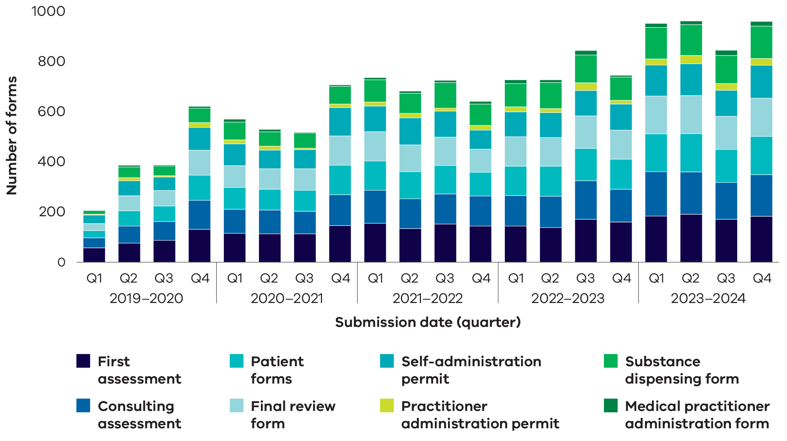

## Timeframes during the application process

The Act requires that a final request is made at least nine days after the first request, unless both assessing medical practitioners consider that the applicant’s death is likely to occur within the nine-day timeframe.

The median timeframe from first to last request is 14 days, and from first request to dispensing of the substance is 28 days.

Table 4: Timeframes – key events for applicants 1 July 2023 – 30 June 2024

|  |  |
| --- | --- |
| **Timeframes** | **Days elapsed** |
| **First to final request** |  |
| Median | 14 |
| Interquartile range | 11, 24 |
| **First request to issue of permit** |  |
| Median | 19 |
| Interquartile range | 14, 30 |
| **First request to dispensing for self-administration\*** |  |
| Median | 28 |
| Interquartile range | 20, 43.5 |

* Once granted a permit to dispense the substance, an applicant must make a request to the pharmacy. Many applicants choose not to make a request immediately or at all. Therefore, the figures for the time from first request to the dispensing of substance for self‑administration are extended by personal choice. Dispensing dates for practitioner administration are not routinely collected

## People who applied for voluntary assisted dying

Since the commencement of the Act, 2853 people have applied for access to voluntary assisted dying. The median age of applicants was 74 years, and half of all applicants were aged 66–82 years. Just over half of the applicants were male (54% male, 46% female).

Over one third (36%) of applicants lived in regional or rural Victoria, while 64% of the Victorian population live in Greater Melbourne.

The demographic characteristics of applicants have been consistent over the time period of the operation of the Act.

Table 5: Applicant demographics 1 July 2023 – 30 June 2024 (n=758) compared to 19 June 2019 – 30 June 2024 (n=2853)

| **Characteristics** | **Number (%)  1 July 2023 – 30 June 2024** | **Number (%)  19 June 2019 – 30 June 2024** |
| --- | --- | --- |
| **Sex** |  |  |
| Female | 339 (45%) | 1305 (46%) |
| Male | 418 (55%) | 1546 (54%) |
| Self-described | 1 (0%) | 2 (0%) |
| **Age\*** |  |  |
| 18–39 | 12 (2%) | 45 (2%) |
| 40–49 | 25 (3%) | 85 (3%) |
| 50–59 | 68 (9%) | 230 (8%) |
| 60–69 | 192 (25%) | 648 (23%) |
| 70–79 | 245 (32%) | 928 (33%) |
| 80–89 | 173 (23%) | 672 (24%) |
| 90+ | 43 (6%) | 245 (9%) |
| Median age (IQR) | 73 (65, 81) | 74 (66, 82) |
| **Country of birth** |  |  |
| Australia | 468 (62%) | 1900 (67%) |
| Overseas | 290 (38%) | 953 (33%) |
| **Identification as Aboriginal or Torres Strait Islander** |  |  |
| Yes | 7 (1%) | 18 (1%) |
| No | 681 (90%) | 2665 (93%) |
| Not reported | 70 (9%) | 170 (6%) |
| **Language spoken at home** |  |  |
| English | 669 (88%) | 2605 (91%) |
| Other | 58 (8%) | 110 (4%) |
| Not reported | 31 (4%) | 138 (5%) |
| **Interpreter required** |  |  |
| Yes | 14 (2%) | 61 (2%) |
| No | 713 (94%) | 2713 (95%) |
| Not reported | 31 (4%) | 79 (3%) |
| **Highest level of education completed** |  |  |
| Did not complete secondary education | 149 (20%) | 685 (24%) |
| Completed secondary education | 148 (19%) | 610 (20%) |
| Completed post-secondary education | 249 (33%) | 1019 (36%) |
| Not reported | 212 (28%) | 572 (20%) |
| **Area of residence** |  |  |
| Greater Melbourne | 488 (64%) | 1822 (64%) |
| Regional Victoria | 270 (36%) | 1031 (36%) |
| **Living situation** |  |  |
| Private household | 607 (80%) | 2398 (84%) |
| Long term care or assisted living facility | 64 (8%) | 229 (8%) |
| Health service | 50 (7%) | 143 (5%) |
| Not reported | 37 (5%) | 83 (3%) |

* The age of the applicant is that noted at the time of patient registration

Figure 6: Geographic distribution of applicants (19 June 2019 – 30 June 2024)*

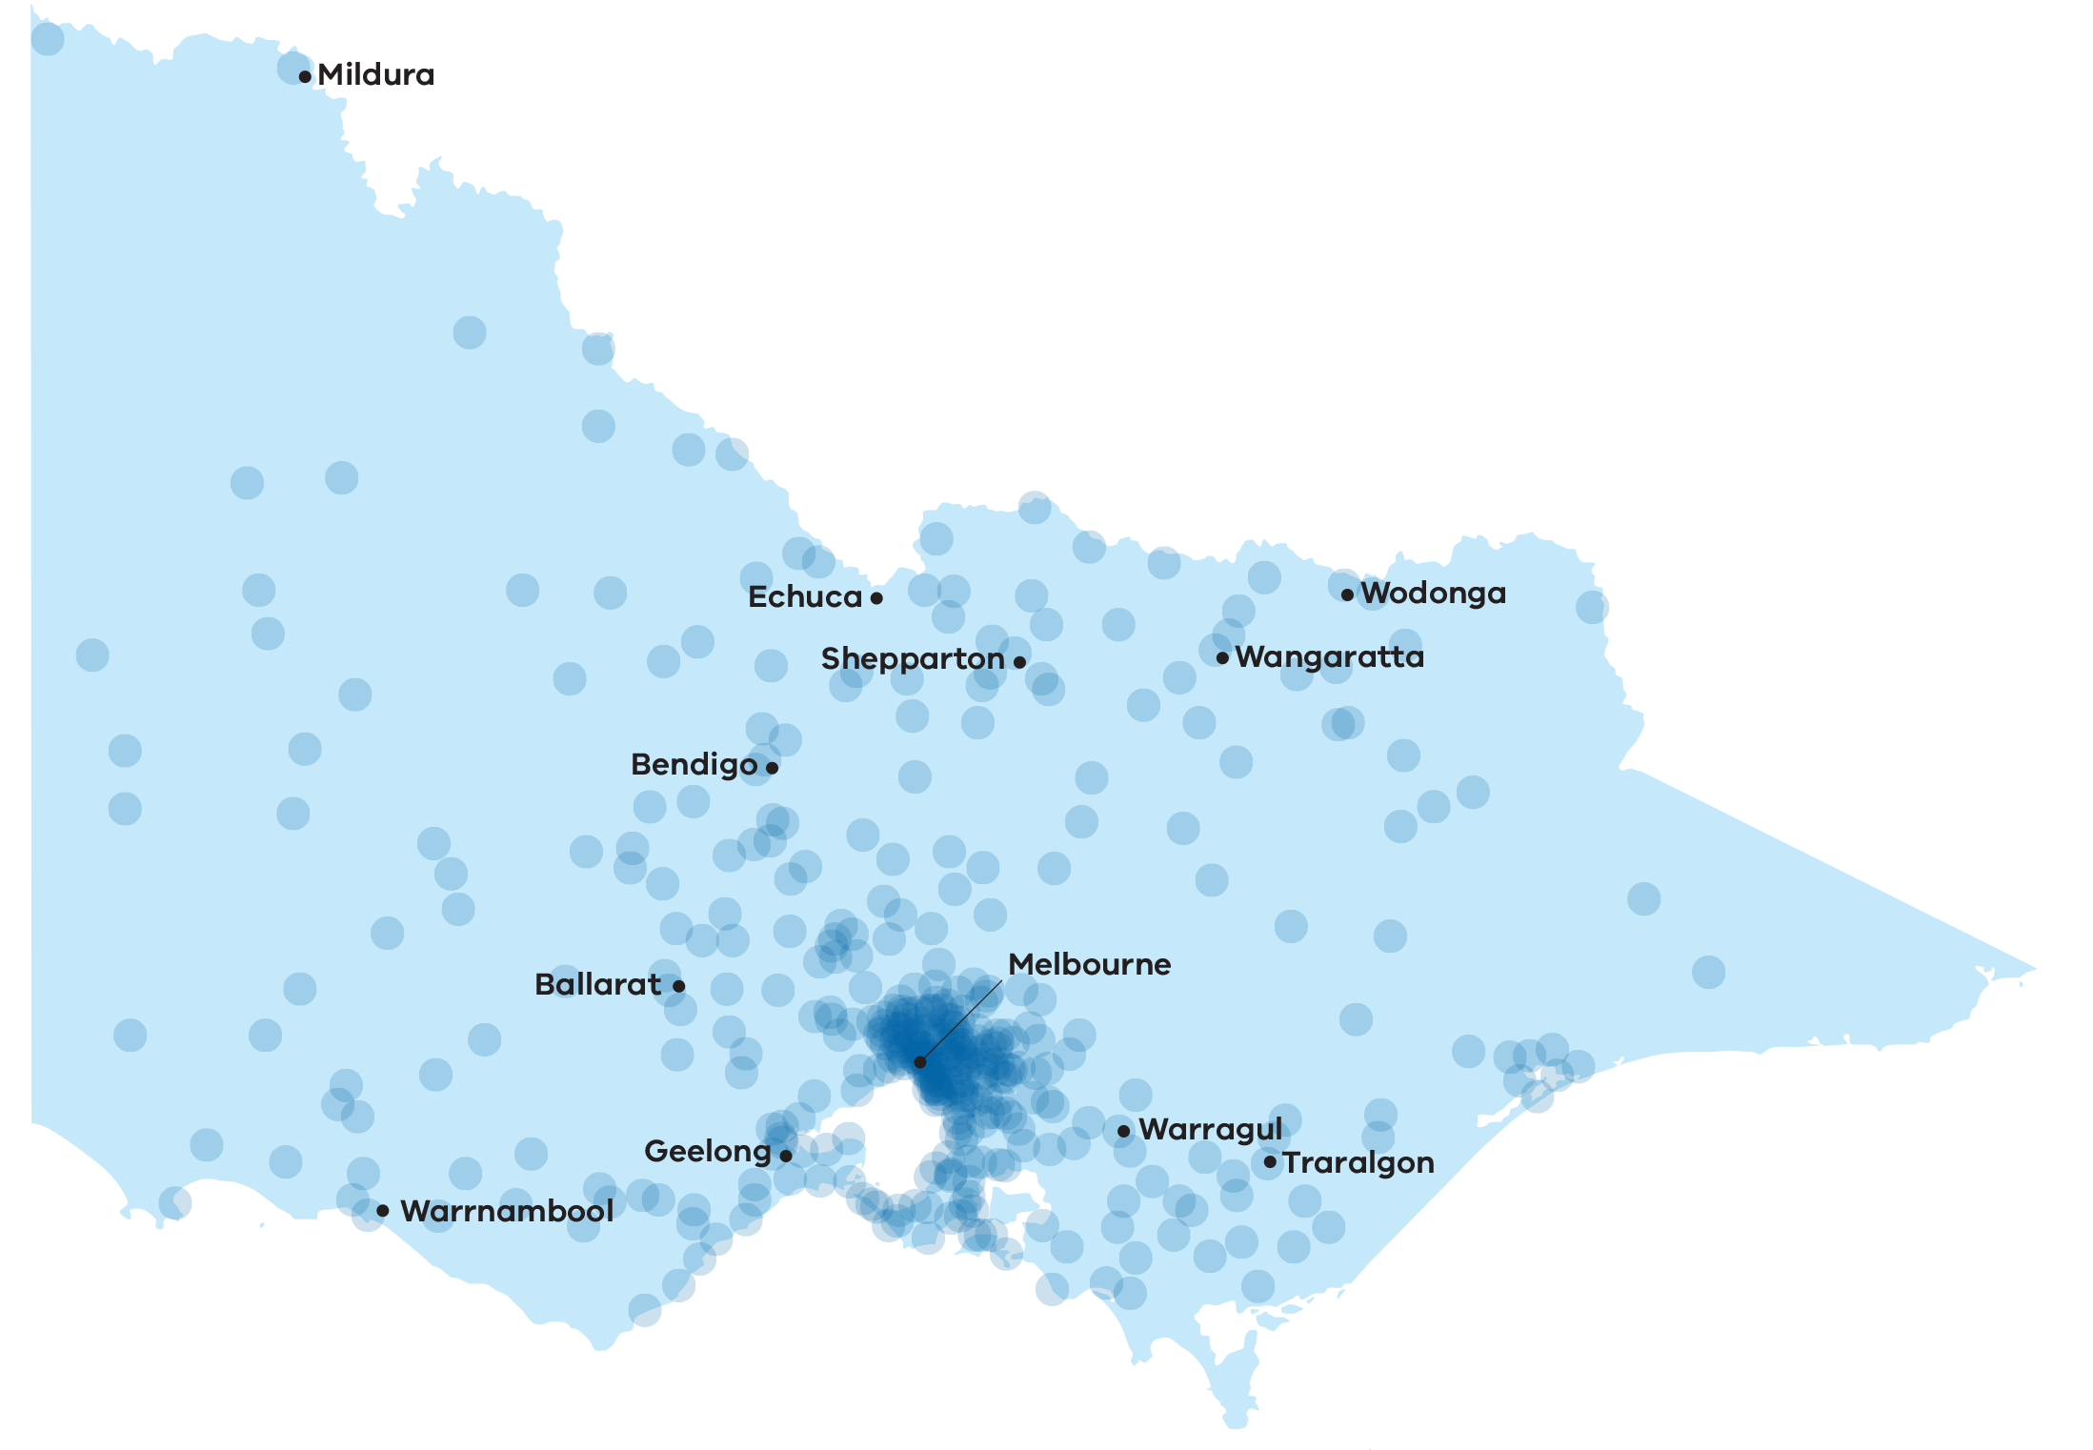

* Locations are approximate, based on the centroid of postcodes.

## Life limiting conditions

A large majority (77%) of people applying for voluntary assisted dying have cancer, with lung, other gastrointestinal malignancies, colorectal and breast cancers being the most common. The next largest group of patients are those with a neurological condition, most often motor neurone disease.

Table 6: Life limiting conditions of applicants 1 July 2023 – 30 June 2024 (n=758) compared   
to 19 June 2019 – 30 June 2024 (n=2853)

| **Characteristics** | **Number (%)  1 July 2023 – 30 June 2024** | **Number (%)  19 June 2019 – 30 June 2024** |
| --- | --- | --- |
| **Cancer** | **609 (80%)** | **2183 (77%)** |
| Lung malignancy | 100 (13%) | 403 (14%) |
| Other gastrointestinal tract malignancy* | 83 (11%) | 252 (9%) |
| Colorectal malignancy | 67 (9%) | 241 (8%) |
| Breast malignancy | 54 (7%) | 187 (7%) |
| Pancreas malignancy | 46 (6%) | 185 (6%) |
| Prostate malignancy | 37 (5%) | 159 (6%) |
| Gynaecological malignancy | 34 (4%) | 131 (5%) |
| Haematological malignancy | 44 (6%) | 114 (4%) |
| Central Nervous System malignancy | 25 (3%) | 96 (3%) |
| Head and neck malignancy | 36 (5%) | 92 (3%) |
| Other urological malignancy | 26 (3%) | 89 (3%) |
| Skin malignancy | 20 (3%) | 75 (3%) |
| Bone and soft tissue malignancy | 9 (1%) | 53 (2%) |
| Other primary malignancy | 4 (1%) | 48 (2%) |
| Malignant – not further defined | 21 (3%) | 37 (1%) |
| Unknown primary malignancy | 3 (0%) | 21 (1%) |
| **Neurological** | **70 (9%)** | **267 (9%)** |
| Motor Neurone Disease | 50 (6%) | 197 (7%) |
| Other neurological disease | 20 (3%) | 70 (2%) |
| **Respiratory** | **43 (6%)** | **115 (4%)** |
| **Other\*\*** | **36 (5%)** | **147 (5%)** |
| **Not yet assigned#** | **0 (0%)** | **141 (5%)** |

* “Other gastrointestinal tract malignancies” includes primary liver cancers.

** “Other” causes include HIV/AIDS, diabetes, chronic cardiovascular disease, advanced liver disease (excluding liver cancer), end-stage kidney disease, and other rare conditions.

# A data consolidation exercise is underway, and these may be captured in future reporting

## Palliative care

Palliative care services are available to all Victorians, with care available dependent on individual need. This may include hospital-based care or care delivered in a person’s home or residential facility. It is important to recognise that voluntary assisted dying is not an alternative to palliative care. This is underscored by the fact that 80% of applicants applying for voluntary assisted dying have accessed or are being cared for by a palliative care service. Palliative care is an essential service, and the integration of palliative care options remains an important aspect of the end-of-life care delivery model.

Palliative care services provide bereavement services for their registered family and carers. Other bereavement services are available including Grief Australia. Further contact details for bereavement support are available on page 40.

Table 7: Use of palliative care by applicants 1 July 2023 – 30 June 2024 (n=758) compared   
to 19 June 2019 – 30 June 2024 (n=2853)

| **Palliative care services** | **Number (%)  1 July 2023 – 30 June 2024** | **Number (%)  19 June 2019 – 30 June 2024** |
| --- | --- | --- |
| **Accessed** | **570 (75%)** | **2278 (80%)** |
| Yes – currently | 567 (75%) | 2245 (79%) |
| Yes – previously, not currently | 3 (0%) | 33 (1%) |
| **No** | **118 (16%)** | **415 (15%)** |
| **Not reported** | **70 (9%)** | **160 (6%)** |
| ***Duration of engagement with palliative care*** |  |  |
| Less than 12 months | 371 (49%) | 1618 (57%) |
| Greater than 12 months | 84 (11%) | 381 (13%) |
| Duration of engagement not reported | 115 (15%) | 279 (10%) |
| Median months (interquartile range) | 3 (1, 6.5) | 3 (1, 7.5) |

## Additional assessments

Additional specialist opinion may be sought by a co-ordinating or consulting medical practitioner as part of the assessment process to determine whether a person has decision making capacity.

Specialist opinion may also be sought by either medical practitioner to confirm a diagnosis or prognosis as part of the assessment process.

It is a requirement for applicants with neurodegenerative conditions with a prognosis of six to 12 months to seek a further specialist opinion at the co-ordinating assessment stage.

Table 8: Referrals for additional assessments 1 July 2023 – 30 June 2024 (n=768*) compared   
to 19 June 2019 – 30 June 2024 (n=2959**)

| **Referrals for additional assessments** | **Number (%)  1 July 2023 – 30 June 2024** | **Number (%)  19 June 2019 – 30 June 2024** |
| --- | --- | --- |
| Neurodegenerative assessment  if prognosis is 6–12 months | 40 (5%) | 166 (6%) |
| Decision making capacity | 3 (0.4%) | 34 (1%) |

* Applications commenced in the 1 July 2023 – 30 June 2024 period.

** Applications commenced the 19 June 2019 – 30 June 2024 period.

## Appointment of a contact person

The Act requires that a contact person is appointed once a final request is made. A contact person has a duty under the Act to return any unused or remaining voluntary assisted dying substance within 15 days after the date of death of the applicant, or if the applicant finds it necessary to change from self-administration to request a practitioner administration permit.

The Act requires the Board to provide information on the requirement to return the substance and outline support information available to assist the contact person within seven days of being notified of the death of an applicant. As part of this, the Board requests feedback on the experience of the process. The Board thanks all those who provided valuable insights on their experience of voluntary assisted dying. Feedback has been incorporated throughout this report and informs the quality and safety reviews conducted by the Board.

## Withdrawal of cases

Since the commencement of the Act, a total of 1003 applications (34% of all applications) have been withdrawn before the substance was dispensed. Of these, 48% were withdrawn because the applicant died less than two weeks after making the first request. This represents 16% of all applications and signifies that many patients begin the application process very late in the course of their illness.

Reasons for withdrawal provided by medical practitioners include:

* the death of applicant prior to the voluntary assisted dying substance being dispensed
* deterioration in condition resulting in loss of decision-making capacity
* being too unwell to continue the assessment process
* duplicate applications created in error for a single applicant.

Table 9: Reason for withdrawal 1 July 2023 – 30 June 2024 (n=198) compared   
to 19 June 2019 – 30 June 2024 (n=1003)

| **Reason for withdrawal** | **Number (%)  1 July 2023 – 30 June 2024** | **Number (%)  19 June 2019 – 30 June 2024** |
| --- | --- | --- |
| Applicant died | 169 (85%) | 785 (78%) |
| Applicant too unwell to proceed | 11 (6%) | 23 (2%) |
| Applicant no longer has decision-making capacity | 4 (2%) | 29 (3%) |
| Applicant is too unwell to proceed AND no longer has decision making capacity | 9 (5%) | 27 (3%) |
| Other | 5 (2%) | 36 (4%) |
| Applicant decided not to proceed | 0 | 9 (1%) |
| Not reported | 0 | 94 (9%) |

# Permit approvals and substance dispensing

Once the assessment process has been finalised and the applicant is found to be eligible, the co-ordinating medical practitioner must apply for a permit to dispense the substance. The Secretary of the Department of Health (the Secretary), or their delegate, reviews all voluntary assisted dying permit applications. If a permit is issued, the applicant can decide if and when they access the voluntary assisted dying substance. The Statewide Pharmacy Service visit applicants anywhere in Victoria to dispense the substance.

Between 1 July 2023 and 30 June 2024, the Secretary issued 597 permits, for either self‑administration or practitioner-administration.

In this reporting cycle there were no permit applications with an outcome of ‘permit not issued’. This is a result of the growing experience of medical practitioners in completing the application forms, as well as the ongoing enhancements to the Voluntary Assisted Dying Portal.

## Timeliness

The *Voluntary Assisted Dying Regulations 2018* allow the Secretary three business days to determine the outcome of a permit application. Outcomes for 99.66% of permit applications were determined within this timeframe, with 98.66% issued within 2 business days.

Delays to a permit application may occur when incomplete paperwork is provided as part of the assessment process, or the Secretary seeks further information to assess the application.

The Secretariat for the Board conducts an administrative check on all assessment forms as they are lodged. If necessary, the Secretariat provides feedback to medical practitioners to promote compliance with the Act. It is entirely a matter for the medical practitioners to act on this feedback. However, the Secretary, in making the final determination to issue or not issue the permit considers the application when it is complete. This is when all relevant information has been provided and checks for compliance with the Act are completed.

Once all required application steps have been completed, and the application has been considered by the Secretary of the Department of Health, a voluntary assisted dying permit may be issued. Then the applicant decides if, and when, they want to access the voluntary assisted dying substance.

## Statewide Pharmacy Service

The Department of Health funded Statewide Pharmacy Service is based at Alfred Health. It continues to provide responsive, patient centred care to Victorians.

The pharmacy service dispenses the voluntary assisted dying substance to each applicant at the time and location of the applicant’s choosing. The pharmacy service continues to meet applicant needs by consistently dispensing the substance at, or very close to, the time the applicant chooses. The pharmacists travel throughout the state to provide education and support to applicants, their families, and medical practitioners. They also safely dispose of any unused substance returned by the contact person or medical practitioner.

During 2023–24:

* 88% of applicants had the substance provided on the day they requested it.
* 99% of applicants had the substance provided within two business days of their preferred delivery day.
* 62% of substance were dispensed to metropolitan applicants.
* 38% of substance were dispensed to regional applicants.

## Feedback and reflections on the Statewide Pharmacy Service

Feedback provided by applicants about the pharmacy service, sought to enable continuous performance monitoring and evaluation, showed:

* 95% reported excellent service from the pharmacist(s).
* 92% said the pharmacist visited at a time that suited them.

Quotes:

* ‘The two people who came to my mum’s house were amazing. They seemed to really understand the gravity of what they were providing; it had not become “just another day’s work” to them. They were polite, kind, respectful, gentle, careful, not patronizing, and acknowledged each person.’ ­– Service user
* ‘My dad, despite having no medical background, had different questions which they encouraged. They were also honest. Although they hadn’t seen someone take it before, they filled us with confidence and comfort. Thank you. And yes, mum used it.’ – Service user
* ‘The pharmacists who attended our home were professional and polite. They ensured they introduced themselves and were very accommodating to my partner’s needs and comfort.’ – Service user
* ‘They were both lovely people and a pleasure to have in our home. They made the whole process easy to understand and were compassionate in their manner. 10/10.’ – Service user

The Statewide Pharmacy can be contacted on:

* 03 9076 5270
* [statewidepharmacy@alfred.org.au](mailto:statewidepharmacy@alfred.org.au)

# Deaths

Since the commencement of the Act, 1898 applicants who were issued with a permit for self-administration or practitioner administration of a voluntary assisted dying substance subsequently died. The figure below shows the manner of death for these applicants and how this is changing over time. In this reporting year, 554 applicants who were issued with a permit subsequently died (noting that 3 applicants who died near 30 June 2024 did not have their manner of death reported to the Board at the time of analysis). Of these, 301 died after self-administration, 70 after practitioner administration and 180 unrelated to administration of the substance.

Practitioner administration permits may be applied for when an applicant is physically incapable of self-administration or digestion of the substance.

These proportions have been stable over time, although the number of people granted permits and taking the substance has increased each year since the Act commenced.

Figure 7: Percentage of deaths of permit holders (n=1898) by manner of death and reporting year

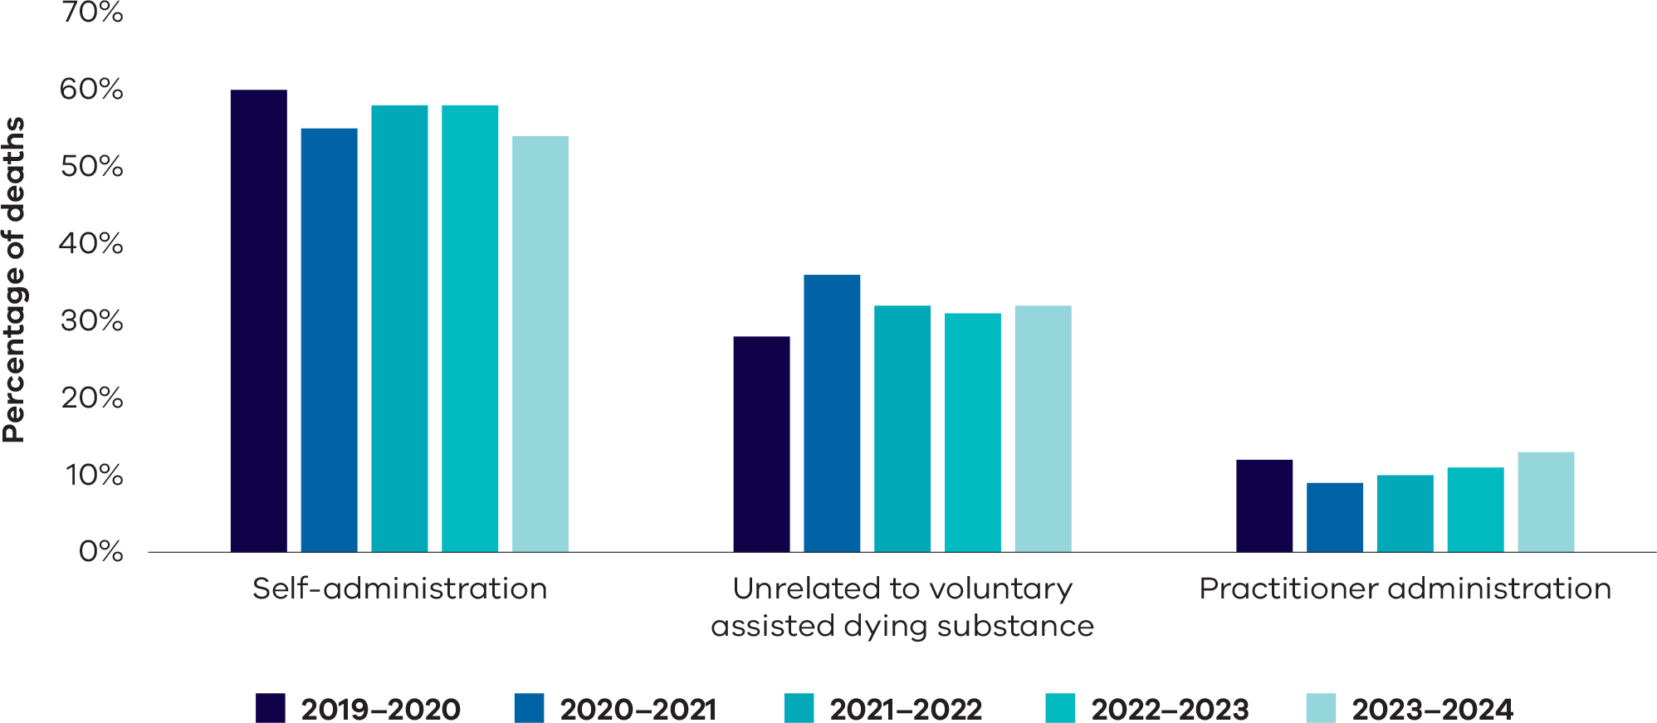

## Deaths during the application process

Since the commencement of the Act, 657 applicants died before being issued a permit. The majority of these applicants died after either the first or consulting assessment. This trend has remained stable over time. This highlights that many applicants are commencing their applications for voluntary assisted dying permits late in the course of their illness.

Figure 8: Applicants who died prior to receiving a permit and their furthest form reached (n=657)*

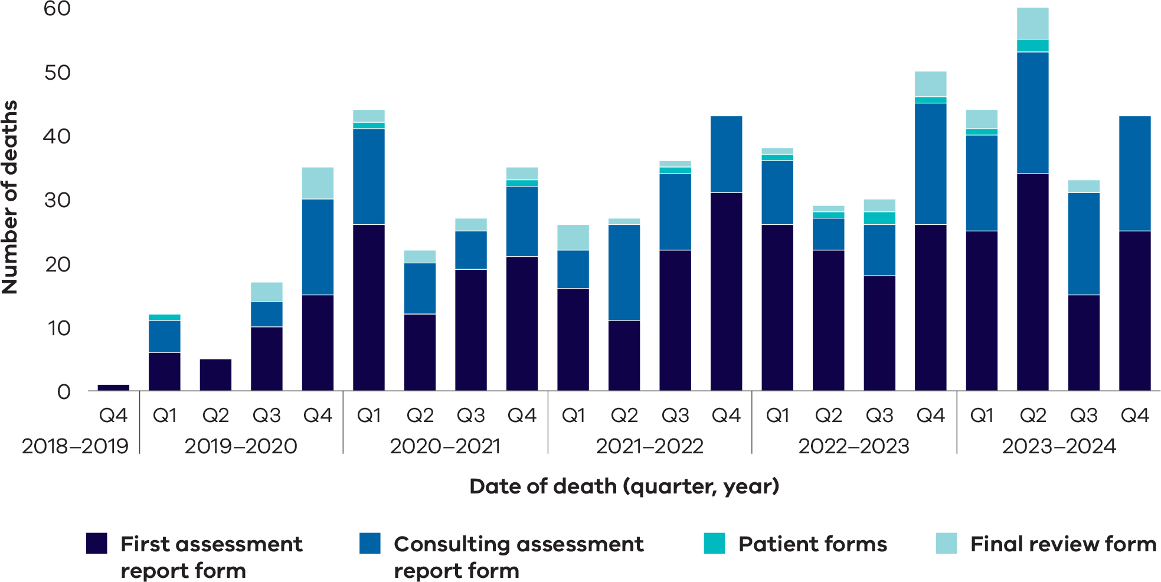

# Reflections

Applicants can provide a personal statement as part of the submission of the Written Declaration (Form 3). The Voluntary Assisted Dying team invite contact people and medical practitioners to provide feedback on the program after the death of an applicant.

Quotes:

* ‘This gives me the opportunity to choose the time and location to pass. I get to pass on my terms with dignity and respect. Voluntary assisted dying lets me control an otherwise uncontrollable situation.’ – Applicant
* ‘I am a strong believer that people diagnosed with a terminal illness should have the option to utilise voluntary assisted dying. I feel this option should be made available to all people before their illness renders them unable to care for themselves. Unfortunately, I have been diagnosed as terminal and am appreciative of the option for voluntary assisted dying, but [I am] yet to be decided.’ – Applicant
* ‘As someone with a terminal cancer diagnosis, I requested access to voluntary assisted dying to provide myself with the option of exercising a choice about the time and place and manner of my passing. I was a great supporter of the legislation since I think it offers individuals the opportunity to exercise an important area of choice about one of life’s most challenging pieces of work: the business of dying.’ - Applicant
* ‘Without [the voluntary assisted dying substance], the applicant would have suffered in pain. This is something that she never wanted to happen to her, but having access to voluntary assisted dying made her last days bearable.’ – Contact person
* ‘We are grateful for the ability to access voluntary assisted dying – it was what our mother had wanted from the beginning. The nurses at the facility were lovely to her, the doctors who helped with the process were lovely. Our mother died exactly how she wanted to, she had the freedom to choose her death and last days.’ – Contact person
* ‘We are just so grateful so many people were willing to help mum and that she had a choice even if she didn’t use it in the end. She was a brilliant and kind person.’ – Contact person
* ‘I would hope that anyone with a terminal illness could have access to voluntary assisted dying. My husband stayed with us for nearly eight months because he had peace of mind knowing he could decide for himself when the time was right to decide to die with dignity. For us it was the best outcome, and I am forever grateful.’ – Contact person
* ‘The whole process was very simple, efficient, and professionally handled. Seeing him depart this world peacefully and on his terms helped make a sad experience that much easier to go through.’ – Contact person
* ‘The whole process was exemplary. From the first contact with the navigator, to the death of my mother, the people and process was fantastic. I can’t thank the Board, the navigator, the doctors, pharmacists and volunteers enough for helping to make mum’s wish a reality. It was a great balance between safeguards and necessary bureaucracy and humanity.’ – Contact person

# Compliance reviews

The *Voluntary Assisted Dying Act 2017* (Vic) has 68 safeguards and a scrupulous oversight scheme in place. The Act is interpreted strictly, consistent with maintaining public safety and confidence. The Board is vigilant that errors do not impact on compliance with the legislation.

## Case compliance

Between 1 July 2023 and 30 June 2024, the Board found 10 cases to be non-compliant with the Act.

Three cases were deemed non-compliant due to a delay in the return of the unadministered substance to the Statewide Pharmacy Service. The contact person is required by Section 39(2)(a) of the Act to return any outstanding substance within 15 days of the death of an applicant, or when a substance has been dispensed for self-administration and then a practitioner permit request commences (Section 55).

One case was deemed non-compliant due to an error in witnessing *Form 4 – Contact Appointment Form.*

The six remaining cases were determined as non‑compliant due to late submission of *Form 1 – First Assessment Report Form, Form 2 – Consulting Assessment Report Form and Form 8 – Co‑ordinating Medical Practitioner Administration Form (*sections 21(2), 30(2) and 66(2) of the Act respectively). None of these late submissions of forms gave rise to an issue regarding the applicant’s eligibility or risk to the applicant or any other person.

## Return of substance

There are sometimes delays to in the notification of voluntary assisted dying deaths to the Board. As a result, it is not always possible for follow up with a contact person within the initial 15-day period post death, as required by Section 106 of the Act. In the three instances where the substance was returned soon after the required period, a reason for the delay was provided and no further action was taken. It is clear in the legislation that the penalty associated with this oversight can be severe. Therefore, a focus on the provision of appropriate information and support for appointed contact persons is paramount.

For those involved in the assessment process, it is important to ensure the contact person is aware of this obligation when they are appointed.

## Late submissions of forms

Section 90 of the Act details that it is an offence to fail to give copies of forms to the Board in accordance with the Act. A penalty in the form of a fine may apply for non-compliance. The Board is appreciative of the dedication and compassion shown by registered medical practitioners in the completion of voluntary assisted dying assessments. Medical practitioners who do not comply with this requirement are provided an opportunity to provide evidence as to the reason for the late submission of forms and are reminded of the requirements of the Act.

## Referral to other agencies

During this reporting period, no deaths were considered to require further investigation by the State Coroner. There were no referrals made to the Chief Commissioner of Police or the Australian Health Practitioner Regulation Agency.

## Compliance Audit

As part of the data review and collation process for the *Five Year Review of the Operation of the Voluntary Assisted Dying Act 2017,* two non‑compliant cases were identified that should have been included in previous reports. These two cases were deemed non-compliant due to late return of substance in the 2022–2023 period. Appropriate follow-up for these cases was performed at the time. Enhancements to the data reporting functions from the Voluntary Assisted Dying Portal since this time allow for greater data integrity and reporting capacity, mitigating for this reporting issue in the future.

# Areas for improvement

As part of the compliance review process, the Board reflects on individual cases. Issues that impede access to voluntary assisted dying are identified and discussed. These reviews allow the Board to perform one of its key functions in supporting continuous improvement of the program.

## Commonwealth Criminal Code

The Commonwealth Criminal Code provides that it is an offence to use an electronic carriage service such as a telephone or the internet to access, transmit, publish or make available material that counsels or incites suicide. The offences do not differentiate voluntary assisted dying from suicide.

As the Board has highlighted since the commencement of the Act, the existing Commonwealth law creates barriers to accessing care and, in some cases, creates situations resulting in unreasonable travel demands on medical practitioners and people suffering from life-limiting medical conditions. The law currently precludes the use of telehealth for conducting voluntary assisted dying assessments.

There was previously some uncertainty about whether the Code applied to voluntary assisted dying, but it is clear from a Federal Court judgement in 2023 that health practitioners who use electronic communications for voluntary assisted dying activities under the Act will be at risk of breaching the Code.

The Board recognises the logistical issues this decision may cause. The Board will continue to advocate, alongside other Australian jurisdictions with voluntary assisted dying legislation, for a change in the Commonwealth law to promote access to voluntary assisted dying for all Victorians, regardless of their location or mobility.

Quotes:

* ‘The applicant travelled twice (350km round trip) for the initial and consulting visits with end stage chronic obstructive pulmonary disease. He required transport support to achieve this. Despite his efforts, he died the day before the medication could be delivered to his home.’ – Medical practitioner
* ‘The incredible cruelty of forcing the applicant to be driven such long distances for appointments – the journeys were torture and pure hell. The applicant was in extreme pain and nauseated/vomiting constantly during the trips. The legal restriction on telehealth appointments meant that the voluntary assisted dying process failed to meet the basic human rights [of the applicant].’ – Contact person

## Obstruction by services to accessing voluntary assisted dying

While voluntary assisted dying legislation recognises the right of medical practitioners to conscientiously object to it, the Act is generally silent on the rights of services to support an applicant to access voluntary assisted dying. While a facility at which a patient may be residing (either temporarily or permanently) has no legislated role in voluntary assisted dying, it can refuse access in various ways, including:

* restricting staff responses to a discussion raised by an individual, about voluntary assisted dying;
* refusing access to medical practitioners to facilitate it;
* requiring people who wish to pursue the option to leave the facility; and
* implementing a blanket policy to refuse individual access to voluntary assisted dying.

It should be noted that the Board is unable to accurately determine the magnitude and impact of obstructive practices as instances are not routinely reported and health services are not obligated to provide information to the Board. The confidential nature of voluntary assisted dying requests between a patient and medical practitioner also compounds the difficulty in pinpointing specific services where obstructive practices are occurring.

The Board considers that health and aged care services should:

* Consult stakeholders and have a voluntary assisted dying request protocol or policy in place, with a view to creating a safe environment for residents and staff – for those who want access to voluntary assisted dying or who wish to support it, and for those who don’t.
* Communicate their voluntary assisted dying policy openly so patients or residents can factor this into deciding which health or aged care facility they attend.
* Provide safeguards including the ability for individuals to be referred in sufficient time to another service, or access voluntary assisted dying services within the facility but without involvement of objecting staff should they wish to access voluntary assisted dying.

Quote:

* ‘Please make it easier for people to access the service. I was denied access by a doctor at [treating hospital]. This delayed my application and has caused a lot of distress.’ – Applicant

## Enhancement of information provided to the public on voluntary assisted dying

The Board considers that the presentation of information on voluntary assisted dying could be improved. Following feedback from the Board, the Department of Health website now has prominent information about the Statewide Care Navigator Service. This is important given that the Service is key to providing information and support for those seeking to access voluntary assisted dying. Following the restructure within the Department of Health, work is underway to transition links and contacts from Safer Care Victoria to the Department of Health and communication will be provided once this is complete.

## Organ donation and voluntary assisted dying

The use of a voluntary assisted dying substance does not preclude organ donation. Following the issuing of a permit, the Board encourages medical practitioners to listen to and explore donation wishes of applicants, noting that a decision to donate organs involves the applicant being in an appropriate hospital environment at the time of death. Further information is available through Donate Life Victoria through donatelife.gov.au.

# Research and data

The *Voluntary Assisted Dying Act 2017* grants the Board the function to conduct analysis and carry out research in relation to information or forms given to the Board in accordance with the Act.

## Publications

During the 2023–24 period, the Board did not author any publications. Several smaller analysis projects have been completed, including the work surrounding voluntary assisted dying program practitioner sustainability. No external requests for data for research purposes were made to the Board this year. The Board approved the sharing of data for requests relating to service improvement and planning as well as release of data to support the *Five-Year Review of the Operation of the Voluntary Assisted Dying Act 2017.*

## Data audit

An audit was commenced in October 2023 to identify historic cases that remained active at *Form 1 – First Assessment Form,* where the first assessment form had been commenced but not submitted. The aim of the project was to better support data integrity and reporting by either withdrawing or submitting the forms.

A co-ordinating medical practitioner may commence a *Form 1 – First Assessment Form* but not proceed to submission. Details of the unsubmitted first assessment are not able to be viewed until the form is submitted. There were concerns that some commenced cases should have been withdrawn or could have progressed. An outcome (withdrawn or progressed) for these forms was achieved, strengthening the data quality. This type of audit will be performed on a regular basis.

## Data governance

The voluntary assisted dying data governance arrangements were finalised during the 2023–24 period, and several requests for data were approved by the Board under the framework for approval of data sharing. Primarily, the Board approved sharing of de-identified case and applicant information to the Centre for Evaluation and Research Evidence for the purposes of the *Five-Year Review of the Operation of the Voluntary Assisted Dying Act 2017.*

The Board is authorised by the Act to undertake research with data and to share de-identified data to facilitate research. Board members have contributed to a number of research collaborations and articles over the past year and will continue to expand the research environment.

## National Minimum Dataset

The Board continued to liaise with the other Australian jurisdictions and New Zealand to maintain the minimum dataset requirements established in the previous reporting period. This dataset is important for the harmonisation of data recording and reporting practices. It will be instrumental in the comparison of voluntary assisted dying data across the jurisdictions in the future.

There have been no major changes to the agreed set of key data items, which are included in the Snapshot section of this report.

## Voluntary assisted dying portal enhancements

The Portal is the platform where appropriately trained medical practitioners can complete, submit, view, and download forms required under the *Voluntary Assisted Dying Act 2017* (the Act) and the *Voluntary Assisted Dying Regulations 2018.*

A project to address enhancements to the Portal commenced in 2023. Based on stakeholder feedback, including from medical practitioners, the key themes of the project deliverables are to optimise the overall usability and performance. The enhancements will improve the quality and safety of the Portal environment.

# Board reflections on amendments to the Act

Several factors can create barriers to timely access to voluntary assisted dying as an option for end-of-life care. Approximately half of applicants who complete a first assessment die without using the substance. For some this is their choice. However, for most, the reasons can include a lack of knowledge about voluntary assisted dying as an end-of-life option; a lack of understanding on how long the process can take; difficulties in finding qualified medical practitioners; or delays arising from the requirements of the process.

The Board is constantly looking at ways to increase efficiency and reduce any unnecessary barriers to timely access and regularly provides advice on these matters. However, some opportunities to realise the goal of providing compassionate care do require amendments to the Act.

Board members provided input from their experience and expertise alongside qualitative and quantitative data to support the *Five Year Review of the Operation of the Voluntary Assisted Dying Act 2017.* In addition, the Board considers the following to be important in a review of the Act itself.

A goal of the Act is the provision of compassionate end-of-life care. This is realised through reducing the physical and psychological distress that can be associated with dying. It involves person-centred treatment; the promotion of personal autonomy; and an absence of unreasonable or preventable barriers to timely access. The changes listed below are aimed at promoting compassionate care.

## Enable medical practitioners to include discussions on voluntary assisted dying when discussing end‑of-life care

Section 8 of the Act precludes medical practitioners from initiating a discussion about voluntary assisted dying or suggesting voluntary assisted dying to a person.

A medical practitioner has a legal obligation to obtain informed consent for medical treatment. A person can only give informed consent if they are aware of all their options for treatment. This restriction impedes the provision of compassionate care by limiting the exercise of personal autonomy, as a person who is unaware of the availability of voluntary assisted dying, cannot exercise that choice. Such a barrier is likely to unfairly discriminate against those with limited education, language proficiency or learning or other disabilities.

## Extend the circumstances in which a permit for practitioner administration may be granted

Section 46 of the Act provides that practitioner administration of a substance is only available if the person is physically incapable of the self-administration or digestion of the substance. Feedback to the Board indicates that people may be reluctant or unwilling to self-administer the substance and therefore do not access voluntary assisted dying.

In other jurisdictions practitioner administration may be available if the person has concerns about self-administration or it is not suitable for the applicant (Queensland, Western Australia and New South Wales), or if the person prefers practitioner administration (New South Wales). Inclusion of similar provisions would enhance the provision of compassionate care by both increasing the opportunity for an individual to exercise their autonomy and reducing the barrier to access that exists for some people.

## Definition of an Australian ‘permanent resident’

Section 9(1)(b)(i) provides that to be eligible for voluntary assisted dying a person must be an Australian citizen or permanent resident. The term ‘permanent resident’ is not defined in the Act but in practice has been interpreted to require a person to hold a permanent resident visa.

This excludes many Victorians from accessing the option for end-of-life care who have been long term residents in Australia, including long term residents who remain citizens of New Zealand. It is the view of the Board that the exclusion from eligibility for such persons who clearly can be described as ‘ordinarily resident’ in Australia is unreasonable. Consideration should be given to replacing the term ‘permanent resident’ with that of ‘ordinarily resident’ or by specifying that eligibility requires a certain number of years of continuous residency.

## Requirement to be ‘ordinarily resident’ in Victoria for 12 months before making a request

This eligibility requirement contained in Section 9(1)(b)(iii) was intended to ensure interstate residents, who did not at the time have similar legislation available, did not travel to Victoria to access the program. All other Australian states now have voluntary assisted dying legislation in operation. Legislation is in place in the Australian Capital Territory. The Board is aware that some applicants, as they become increasingly unwell and close to death, have moved to Victoria to be close to family or established support networks for care and comfort. This requirement makes them ineligible.

For some applicants, accessing written evidence of continuous residence can cause delay. For others who live in Victoria but receive medical care in another state, the need to find new medical practitioners can be distressing. The provision of a discretion to waive the requirement for 12 months residency in Victoria would overcome these problems.

## Seeking a third medical opinion in neurodegenerative conditions with a prognosis of between six and 12 months

Section 18(4) requires a co-ordinating medical practitioner to seek a specialist opinion for neurodegenerative conditions with a prognosis of six to 12 months. This is, in effect, a third assessment. South Australia is the only other Australian jurisdiction that has this requirement. For these cases, a specialist medical practitioner is still required to complete either the co-ordinating or consulting assessment as part of the process required by Section 10(3) of the Act.

One of the barriers the Board has been aware of, is access to specialists in neurodegenerative disease, illness or medical conditions. Feedback from applicants and contact persons indicates the difficulty in finding available and willing specialists in a timely manner. Of all the specialties, neurology is the most difficult to engage - especially in regional and remote areas. Finding not only one, but two such specialists, can result in unnecessary physical and psychological distress, delay and/or denial of access to the program.

## Requirement for health services and residential aged care facilities to publish their voluntary assisted dying policy

The Board is aware of several cases in which a person seeking access to voluntary assisted dying has experienced distressing delays or been required to relocate (in the case of residential care facilities from that place which is their home) in order to access the program.

The Board considers that the impact of this on those who are close to death and who are experiencing suffering provides less than an acceptable standard of compassionate treatment. The Board is of the view that health services and residential care facilities should be required to publish their policy on voluntary assisted dying so that prospective residents can make informed choices before entering a facility.

## Simplify the process for transferring the role of co‑ordinating medical practitioner

Section 33 provides that the role of co-ordinating medical practitioner can only be transferred to the consulting medical practitioner. Situations have arisen in which a transfer of role is necessary because the co-ordinating practitioner is unwilling to provide practitioner administration or they become ill, take leave or retire.

At present, if the consulting medical practitioner is unwilling or unable to accept the transferred role, Section 33 requires that a third medical practitioner conduct a further eligibility assessment of the applicant. Removing the requirement for a further assessment of eligibility of a person who is close to death and who has already twice been found to be eligible would avoid unnecessary delays that can result in distress and suffering and, in some cases, denial of access to their chosen option for treatment.

## Revise the qualification requirements for the co-ordinating and consulting practitioners

One of the barriers to accessing the program is obtaining the services of medical practitioners who meet the professional requirements contained in Section 10. Currently one of the two practitioners must have completed at least five years practice after completing a fellowship with a specialist medical college or vocational registration. In Western Australia and Queensland, only one year is required while in New South Wales there is no minimum practice timeframe.

# Appendices

## Appendix 1: Minimum dataset since commencement of the legislation

Figure 9: Voluntary assisted dying minimum dataset 19 June 2019– 30 June 2024

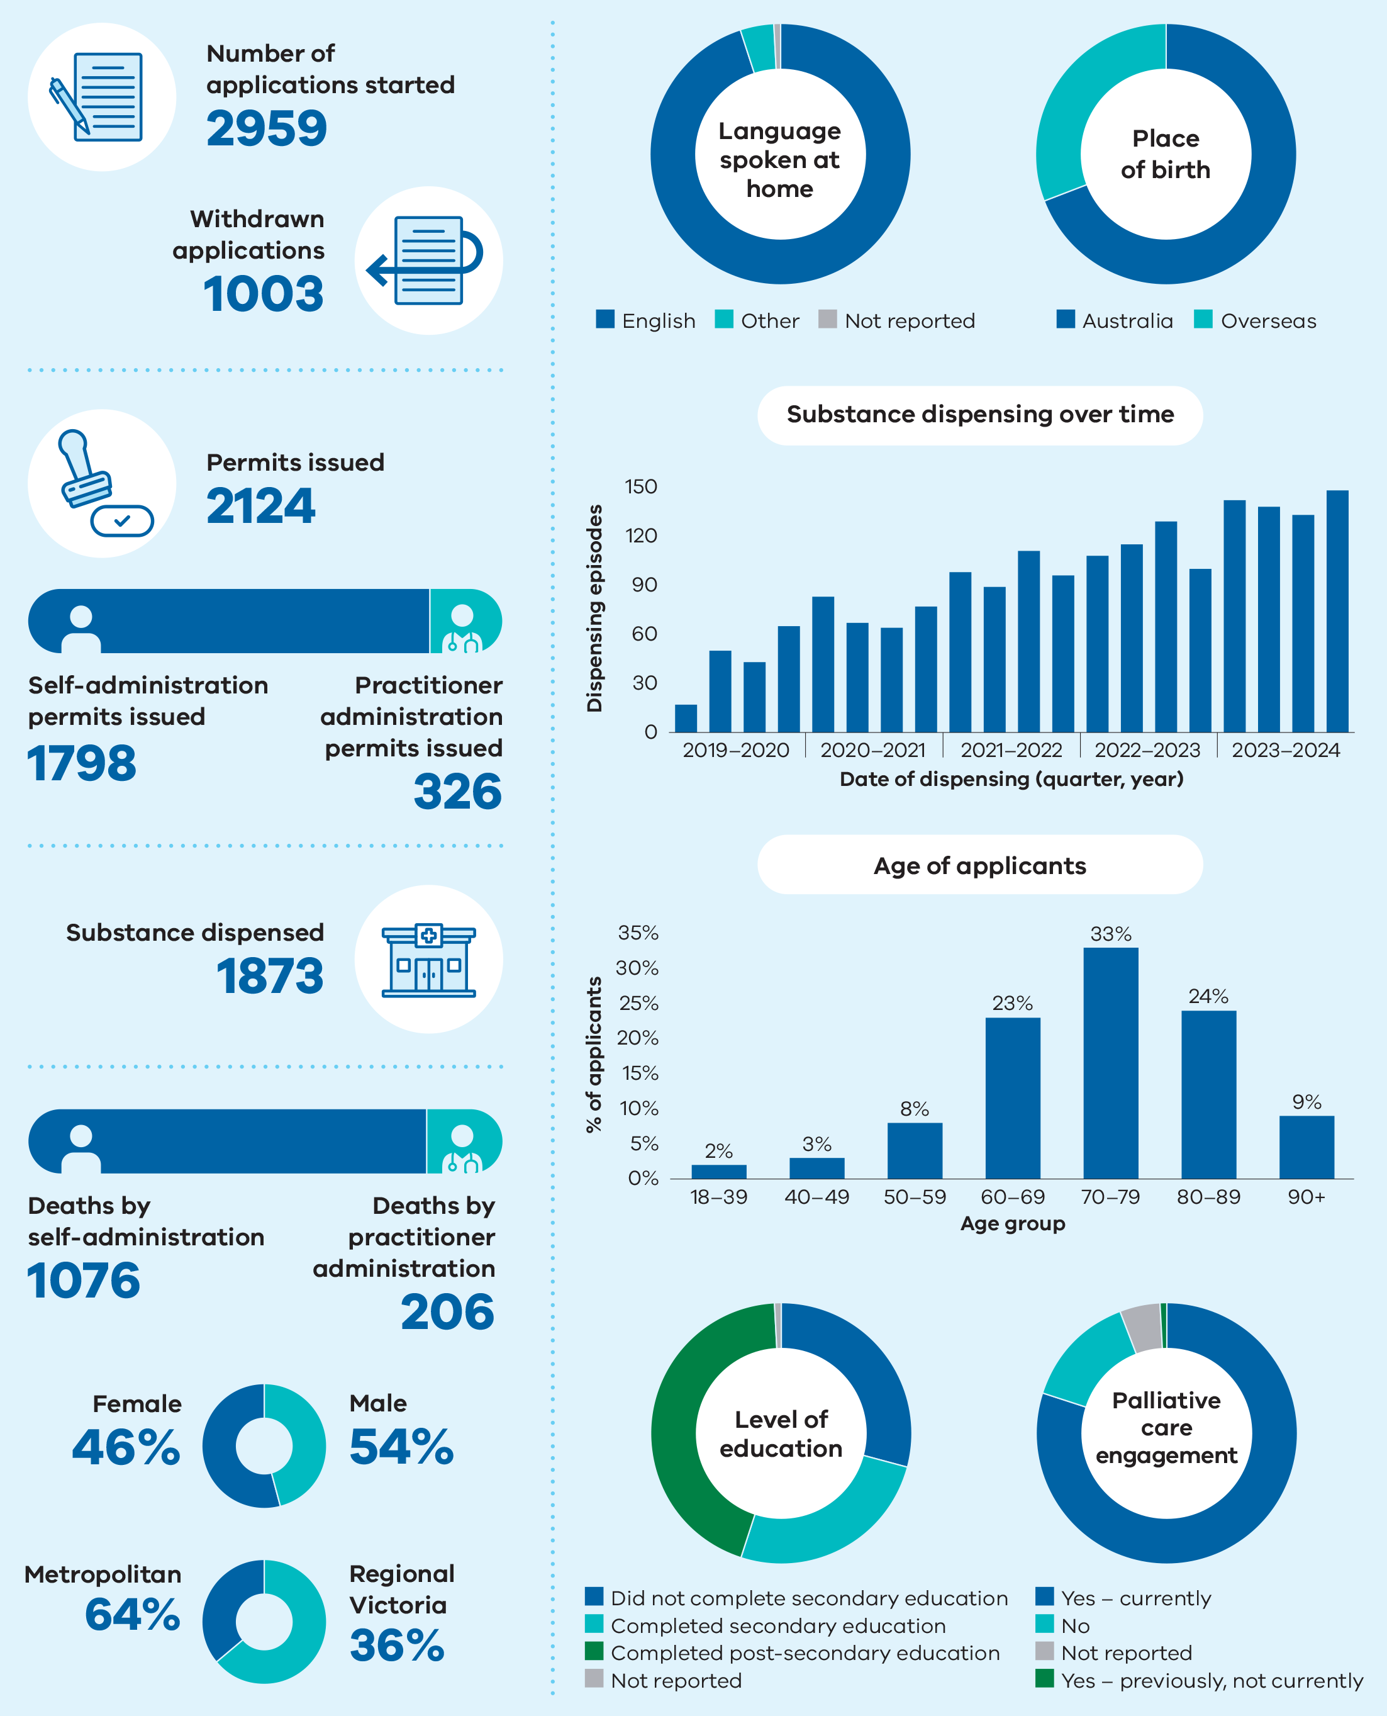

Figure 9 includes the following data:

* Number of applications started – 2959
* Withdrawn applications – 1003
* Permits issued – 2124
* Self-administration permits issued – 1798
* Practitioner administration permits issued – 326
* Substance dispensed – 1873
* Deaths by self‑administration – 1076
* Deaths by practitioner administration – 206
* Female – 46%
* Male – 54%
* Metropolitan – 64%
* Regional Victoria – 36%

## Appendix 2: Applying for voluntary assisted dying

The experience of people who have accessed, supported or provided care to applicants throughout the process provides insight on key considerations related to the process. The information below has been highlighted as important to previous applicants as they have progressed through an application.

### How to access voluntary assisted dying

A person interested in voluntary assisted dying can ask their doctor to help them to access voluntary assisted dying. The Statewide Care Navigator Service can provide information and support to find a trained medical practitioner to discuss the process with you. Contact the service on [vadcarenavigator@petermac.org](http://vadcarenavigator@petermac.org) or call 03 8559 5823 / 0436 848 344.

A potential applicant must ask a medical practitioner directly about voluntary assisted dying to commence a conversation on the subject. Medical practitioners, by law, are unable to start a conversation about the process without a direct request from a person who wishes to make an application.

Seeking support to make a request for voluntary assisted dying from an interpreter or speech pathologist is encouraged should it be required.

### Who is eligible to access voluntary assisted dying?

The Act outlines the eligibility criteria. A medical practitioner who has completed voluntary assisted dying training will conduct an assessment to determine eligibility to progress with a request.

The medical practitioner will need to assess both demographic and medical information. This must determine that an applicant is over 18; an Australian citizen or permanent resident; and has ordinarily been a resident of Victoria for at least 12 months at the time of the first request.

The applicant must have decision-making capacity and be diagnosed with a disease, illness or medical condition that is incurable; which is advanced, progressive and will cause death within 6 months (or 12 months for a neurodegenerative condition); and be causing suffering to the person that cannot be relieved in a manner that the person considers tolerable.

### What should be prepared before a first request?

Preparation of identity documentation is encouraged. An applicant will need to provide documentation to demonstrate they are over 18 years of age, that they are an Australian citizen or permanent resident, and that they have resided in Victoria for 12 months or more in advance of the first request date. Medical practitioners will have to sight and provide a copy of this documentation as part of the process.

### What will the medical practitioner need to assess?

The Act requires that the co-ordinating and consulting medical practitioners assess that the applicant meets the eligibility criteria outlined in the Act. They are also required to assess that a person is acting voluntarily, without coercion and that their request is enduring.

### How long will the process take?

Voluntary assisted dying is not an emergency medical procedure and requires time and thoughtful planning. On average, once a first request is made, it takes applicants 21 days to receive a permit.

The voluntary assisted dying assessments can take time to complete, even if all the documentation and information is available from the initial appointment. There is provision in the Act to shorten the process. However, this is only for people who are unlikely to survive more than 9 days after their first request.

Once the application process is complete, the Permit will take up to 3 business days to be approved and a booking with the Statewide Pharmacy for delivery of the substance can be made.

### Why is a contact person required?

Applicants are required to appoint a contact person. A contact person has the responsibility to return any unused substance to the Statewide Pharmacy. Applicants may wish to have the contact person support them in preparing the substance before it is administered.

The contact person is invited to provide feedback on the process and experience to the Board.

### Access to voluntary assisted dying in aged care or palliative care

Voluntary assisted dying is a legislated process in Victoria. However, individual medical practitioners have the right to conscientiously object to involvement in the process.

Should you be unable to access information or support for progressing an application, contact the Statewide Care Navigator Service to discuss your options. In some cases, they may require you to move to another hospital or palliative care setting to complete the process.

The Board supports the right of individuals to conscientiously object to the process, however, it encourages those who do not wish to be involved to provide information on the Statewide Care Navigator Service to any potential applicant in this circumstance.

### Why do people need to see more than two medical practitioners to complete an application?

Applicants with a neurodegenerative disease, illness or medical condition with a prognosis of 6–12 months will be referred by the co-ordinating medical practitioner for a specialist opinion as part of the assessment process.

A specialist medical opinion may also be sought by either medical practitioner on decision‑making capacity if, for example, the applicant has experienced a past or current mental illness or whose disease, illness or medical condition is known to impact the ability to make decisions.

Should the applicant have a disease, illness or medical condition which is rare or that the assessing medical practitioner does not have the relevant experience or expertise to assess in relation to eligibility to access voluntary assisted dying, the medical practitioner may refer for a specialist opinion to inform their assessment process.

### Why are applicants required to see medical practitioners in person?

Commonwealth law prohibits the use of a carriage service (such as telephone or telehealth) for suicide-related material which may include voluntary assisted dying. This means that across Australia where voluntary assisted dying is legislated, medical practitioners must see an applicant in-person to complete the assessment process.

The Board, alongside our peers in other Australian jurisdictions, is aware of the impact this has on regional and rural patients and for those who are unable to travel due to limited mobility or other reasons. The Board has raised this issue with the Attorney-General and discussed the impact with other jurisdictions. Although we are confident a resolution to this restriction will be reached, we empathise that this currently has an adverse impact on applicants.

People unable to travel to see a medical practitioner in person are encouraged to contact the Statewide Care Navigator Service to see if there are other options to complete an assessment.

## Appendix 3: Statewide services and support organisations

### Voluntary Assisted Dying Review Board Secretariat

[VADboard@health.vic.gov.au](mailto:VADboard@health.vic.gov.au)

03 9668 7016

### Statewide Care Navigator Service

[vadcarenavigator@petermac.org](mailto:vadcarenavigator@petermac.org)

03 8559 5823

0436 848 344

### Statewide Pharmacy Service

[statewidepharmacy@alfred.org.au](mailto:statewidepharmacy@alfred.org.au)

03 9076 5270

### Policy, Engagement and Projects team, Department of Health

[EndofLifecare@health.vic.gov.au](mailto:EndofLifecare@health.vic.gov.au)

### Join a community of practice

For healthcare professionals who support people to access voluntary assisted dying.

[vadcarenavigator@petermac.org](mailto:vadcarenavigator@petermac.org)

For medical practitioners who have completed the voluntary assisted dying training.

[vadcommunity@westvicphn.com.au](mailto:vadcommunity@westvicphn.com.au)

### Grief and bereavement services

**Lifeline** (call 13 11 14) provides telephone or online support and counselling 24 hours a day, 7 days a week.

**13YARN** (www.13yarn.org.au) offer a one-on-one yarning opportunity with Lifeline-trained Aboriginal & Torres Strait Islander Crisis Supporters 24 hours a day, 7 days a week.

**Grief Australia** (call 1800 642 066) provides a statewide specialist bereavement service (including counselling and support groups) for individuals, children, and families.

**Beyond Blue** (call 1300 224 636) provides support 24 hours a day, 7 days a week, with options including telephone, online, email and forums.

**Palliative Care Victoria** (www.pallcarevic.asn.au) provides information and resources about grief and loss, including details for grief and bereavement services.

## Appendix 4: Voluntary Assisted Dying Review Board membership

### Board members

At the end of the 2023–24 reporting year, the Board had seven members representing a wide range of expertise and skills to help perform the functions and duties of the Board.

The Board welcomed new members who were appointed 4 July 2024.

#### Chairperson

**Julian Gardner AM**  
Lawyer

#### Deputy Chairperson

**Charlie Corke**  
Intensive care specialist

#### Members

**Mitchell Chipman**  
Medical oncologist and palliative care physician

**John Clements**  
Consumer and IT consultant

**Paula Shelton**  
Lawyer

#### Retirement on 30 June 2024

**Sally Cockburn**  
Specialist general practitioner (VR) and health educator

**Margaret O’Connor AM**  
Emeritus Professor of Nursing

#### Resignations

**Nirasha Parsotam**   
resigned 31 December 2023  
Medication safety specialist

**Jim Howe**   
resigned 19 April 2024  
Neurologist

#### New members from 4 July 2024

**Emma Felman**  
Lawyer and Teaching Fellow

**Donna Goldsmith**  
Nurse and researcher, consumer

**Geraldine Goss**  
Medical oncologist and palliative care physician

**Nerina Harley AM**  
Intensive care specialist and physician

**Peter Lange**  
Consultant physician in geriatrics and general medicine

**Greg Mewett**Palliative care physician

Table 10: Record of 2023–24 attendance for Board membership on 30 June 2024

| Board member | Julian Gardner | Charlie Corke | Mitchell Chipman | John Clements | Sally Cockburn | Margaret O’Connor | Paula Shelton |
| --- | --- | --- | --- | --- | --- | --- | --- |
| Attendance record | 92% | 83% | 83% | 100% | 100% | 75% | 83% |

1. Based on the number of applicants who were issued a permit, not the number of permits issued.
2. Based on the number of applicants who had a first assessment, not the total number of first assessments completed.