

|  |
| --- |
| Blood Matters on the Bench and Beyond |
| Issue 18 – May 2024 |
|  |

Welcome to the Blood Matters newsletter for Scientists. It is distributed throughout the year to share information that may be helpful to you, and to let you know of upcoming activities which may be of interest.

## Blood Matters online events 2024

Blood Matters online events have become a regular fixture in our education calendar, continuing to support scientists and our multidisciplinary network of transfusion professionals.

Information will be sent as soon as we have another virtual education event confirmed.

## Lifeblood Shipping Configuration changes

Lifeblood documentation for the receipt and use of Lifeblood shippers has been updated and the new version is available on the [Lifeblood website](https://www.lifeblood.com.au/health-professionals/products/storage-and-handling/transport-of-blood) <https://www.lifeblood.com.au/health-professionals/products/storage-and-handling/transport-of-blood>.

Formatting has been updated throughout the document, and there are two changes to content:

1. **Escalation of red cell and platelet shippers in transit for more than 24 hours**

Clarifying direction has been added for escalation to Lifeblood of any platelet or red cell shipper that has been in transit for longer than 24 hours – irrespective of whether there is a temperature alarm.

1. **P2 shipper variation for platelet transport on difficult regional routes**

A “Note” has been added to the P2 platelet shipper configuration section stating that regional customers may receive P2 platelet transport shippers packed inside a CoolPac45 shipper to improve temperature stability.

### For regional customers – P2 platelet shipper configuration variation

Between May – September (inclusive), regional customers may receive platelets in P2 shippers packed inside a CoolPac45 shipper. This additional insulating layer assists with temperature stability and reduces temperature excursions in transit. Please return CoolPac45 and blue securing straps to your local Lifeblood Order Fulfilment as soon as possible.

**Please replace previous versions of the documents and share the updated configurations to relevant departments within your organisation.**

No changes have been made to the R3 shipping configuration, therefore the current Ambulance Victoria packing instructions remain valid.

## Prothrombin complex concentrate (PCC) transition

Prothrombinex-VF will transition to Berlplex P/N from mid-June 2024, as each state/territory depletes their inventory of Prothrombinex-VF.

Please continue to place orders for Prothrombinex-VF until you are notified of the transition in our region.

You will also receive notification via BloodNet when the transition has occurred. Most states/territories are expected to have transitioned by the end of July.

This is a two-phase transition, beginning with an initial short-term transition to the imported Beriplex P/N (manufactured from plasma collected overseas). In late 2024/early 2025 Beriplex P/N will then transition to Beriplex AU, manufactured from Australian donated plasma.



Further information on the transition and what you need to do to prepare can be [downloaded from the NBA](https://www.blood.gov.au/transition-australias-domestic-plasma-products-0) <https://www.blood.gov.au/transition-australias-domestic-plasma-products-0>.

### Contacts

Product and administration queries (including training and training material) and information on reporting adverse events to the manufacturer, CSL Behring on 1800 642 865 or email [medicalinformation@cslbehring.com.au](mailto:medicalinformation@cslbehring.com.au)

BloodNet, ABDR and general questions about the transition to NBA on 13 000 BLOOD (13 000 25663) or email [supply.management.plasma@blood.gov.au](mailto:supply.management.plasma@blood.gov.au)

General questions about product ordering to your local Lifeblood Customer Service team on 03 9694 0200.

### Action items

* Update your Laboratory Information Management Systems (LIS/LIMS) to enable you to receive Beriplex P/N (product codes and test barcodes are attached to this email).
* Update your laboratory and hospital policies and documents, and familiarise your teams with the changes in product, appearance, vial sizes, storage temperature and product administration.
* Share this information with relevant stakeholders within your organisation.

## BloodNet security updates

The National Blood Authority (NBA) will be enhancing the security of the Blood Sector Systems (BSS) in the coming months. The changes directly affecting laboratories are listed below.

* Multi Factor Authentication (MFA) will be implemented for all BloodPortal accounts to comply with the Australian Government security strategies and to mitigate cyber security incidents. This is expected to be implemented in late 2024.
* MFA will mean an authentication code will need to be entered in addition to your Username and Password to log in to BloodPortal accounts. More information on MFA can be found at the [Australian Cyber Security Centre webpage](https://www.cyber.gov.au/protect-yourself/resources-protect-yourself/personal-security-guides/protect-yourself-multi-factor-authentication) <https://www.cyber.gov.au/protect-yourself/resources-protect-yourself/personal-security-guides/protect-yourself-multi-factor-authentication>.

### BloodPortal user account management

* BloodPortal accounts that have not been used or accessed for >45 days will become inactivated.
* BloodNet and BloodSTAR facility access which has not been used in >45 days will become inactivated.
* ‘Generic’ accounts which are not linked to any individual person but are being used by multiple users will become inactivated.

Inactivated accounts can be reactivated via a user-initiated password reset within 12 months of the last login. A notification will be sent to all users of the intent to inactivate a user account.

* Accounts that have not been used in 12 months will be archived.

The Terms and Conditions will be amended to reflect these changes. User support materials and resources will be updated to be more accessible to users, including BloodPortal training and the NBA website.

### Action items

* Review and update your user details before changes are implemented (including security questions, phone number, mobile number and email). This can be done through BloodPortal Account Management.
* Consideration of how the changes might impact the use of BloodNet, particularly where staff at your facility share accounts or use their access infrequently.

Further information will be sent from NBA Blood Operations Centre later.

## 2024 Blood Matters audit

The 2024 Blood Matters audit is ‘**The indications for the use of O RhD negative red blood cells.’**

This audit will compare data collected in the Blood Matters 2017 audit (report published in 2018), for health services to assess compliance or gaps in practice and help identify any ongoing challenges.

Health services/transfusion laboratories are required to enter the fate of **ALL** O RhD negative RBC received into inventory during **March 2024**. The audit is open for data entry from **12 May – 28 June 2024**.

All Victorian transfusion services/blood banks (AHPs) have been supplied with a list of O RhD negative RBC which were received (issued by Lifeblood and transferred in from other AHPs), discarded and recalled (by Lifeblood) during the audit month (March 2024).

*Some O RhD negative RBC will not have had their final fate decided until mid-May. You will be able to search BloodNet for details on those units not captured in the March BloodNet data sent to you.*

Health services and their supplying transfusion service/s will need to collaborate to ensure the fate of ALL these units received is entered into the audit tool.

Each health service/transfusion laboratory will have their own best method for completing the audit. Depending on the computer system interfaces, some health service staff will be able to complete most of the audit themselves, while others will rely heavily on collaboration with their supplying transfusion laboratory to obtain the necessary data.

**A separate audit entry spreadsheet is required to be completed and sent to Blood Matters for each health service. If your laboratory supplies more than one health service, then data must be entered into separate spreadsheets per health service.**

**Please co-ordinate with the health service you provide transfusion services to, to ensure that all audits are completed and returned to Blood Matters by the 28 June 2024 cut-off date. Every Victorian health service is required to complete this audit.**

## Blood 2024

### 27-30 October 2024, Brisbane

Blood 2024 is the combined Annual Scientific Meeting of the:

* Haematology Society of Australia and New Zealand
* Australian and New Zealand Society of Blood Transfusion
* Thrombosis and Haemostasis society of Australia and New Zealand

### Registrations now open

Ealy bird registrations (for discounted registration) are open until 8 August 2024. Register on the [Blood 2024 webpage](https://www.blood2024.com/register-for-the-meeting) <https://www.blood2024.com/register-for-the-meeting>.

### Travel grants available

There are travel grants able to be applied for to attend Blood 2024. More information can be found on the [Blood 2024 webpage](https://www.blood2024.com/awards-and-travel-grants) <https://www.blood2024.com/awards-and-travel-grants> and [ANZSBT webpage](https://anzsbt.org.au/news/) <https://anzsbt.org.au/news/ >.

## ISBT128 barcode implementation

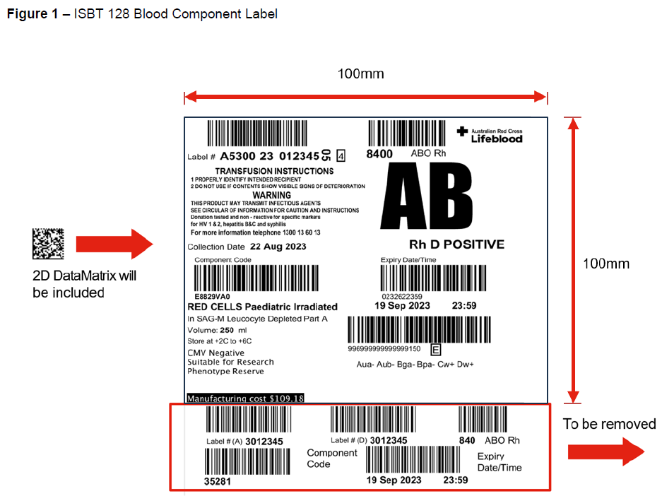The barcode symbology for all fresh blood components will be transitioning to ISBT128 2D DataMatrix on **30 November 2025**.

The Codabar transition label will no longer be available on blood components issued after 30 November 2025.

ISBT128 linear barcodes can continue to be used without utilising the 2D barcode.

**If your transfusion laboratory is yet to implement ISBT 128, the transition must be made prior to 30 November 2025**.

## National certification of the medical scientist profession

The Australian Council for Certification of the Medical Laboratory Scientific Workforce (CMLS) was launched in 2020 as a voluntary national professional certification scheme for Medical Laboratory Scientists.

New applications for certification and renewals are processed by the professional bodies providing CPD. Please contact your relevant association for details. More information and links can be found at [www.cmls.org.au](http://www.cmls.org.au) <https://www.cmls.org.au/>.

#### Why become certified?

* Recognition of our professional standing as part of Australia’s health service workforce.
* Certification will be the best benchmark available to assure competent professional practice.
* With a certified workforce there will be more obligation on the employer to ensure staff have professional development opportunities afforded to them.
* As a nationally certified medical scientist you can demonstrate your ongoing commitment to professional development and self-improvement and be recognised as passionate, progressive and pro-active.

[Click here to view a short video about the certification scheme](https://www.youtube.com/watch?v=6Zc4QQJEijs) (2021) <https://www.youtube.com/watch?v=6Zc4QQJEijs>.

Blood Matters is committed to providing support and education to assist in certification of the medical scientific workforce.

## How can Blood Matters help you?

The Blood Matters team are here to assist health services and laboratories through education and providing resources.

If you have suggestions for tools and resources that could assist in day to day activities and towards achieving accreditation please let Rae French or any of the Blood Matters team know by email [rfrench@redcrossblood.org.au](mailto:rfrench@redcrossblood.org.au) or [bloodmatters@redcrossblood.org.au](mailto:bloodmatters@redcrossblood.org.au) or phone 03 9694 3524.

|  |
| --- |
| To receive this document in another format, phone 03 9694 0102, using the National Relay Service 13 36 77 if required, or [email Blood Matters](mailto:bloodmatters@redcrossblood.org.au?subject=Accessible%20document) <bloodmatters@redcrossblood.org.au>.  Authorised and published by the Victorian Government, 1 Treasury Place, Melbourne.  © State of Victoria, Australia, Department of Health, May 2024.  **ISSN** 2652-7278 – **Online (pdf / word)**  Available at [Blood Matters](https://www.health.vic.gov.au/patient-care/transfusion-science-and-blood-stewardship) <https://www.health.vic.gov.au/patient-care/transfusion-science-and-blood-stewardship> |