

|  |
| --- |
| Pancreatic cancer in Victoria |
| Optimal care pathway data summary report 2022 |
|  |

|  |  |
| --- | --- |
|  | |
|  | |
| To receive this document in another format, phone (03) 9456 3332, using the National Relay Service 13 36 77 if required, or [email the Cancer Support, Treatment and Research unit](mailto:cancerplanning@health.vic.gov.au) <cancerplanning@health.vic.gov.au>.  Authorised and published by the Victorian Government, 1 Treasury Place, Melbourne.  © State of Victoria, Australia, Department of Health, June 2023.  **ISBN** 978-1-76096-993-6 **(pdf/online/MS word)**  Available at [the department’s cancer webpage](https://www.health.vic.gov.au/health-strategies/cancer-care) <www.health.vic.gov.au/health-strategies/cancer-care>. | |
|  | |

# Foreword

This report summarises the data analyses prepared for the second Pancreatic Cancer Summit, which took place online on Friday 26 August 2022. We were pleased and honoured to be able to co-chair the working group that was convened to help guide the analyses of statewide routine datasets presented at the summit. These analyses really helped inform our understanding of current patterns of care delivered to Victorians diagnosed with pancreatic cancer. Importantly it was also an opportunity to consider what may have changed since our first [Pancreatic Cancer Summit](https://www.health.vic.gov.au/publications/pancreatic-cancer-in-victoria-optimal-care-pathway-data-summary-report) <https://www.health.vic.gov.au/publications/pancreatic-cancer-in-victoria-optimal-care-pathway-data-summary-report>, held in late 2017.

While not all our aims from the first summit were demonstrable in the data, there were some pleasing signs of progress:

* 16 per cent of patients undergoing surgery received neoadjuvant therapy (up from 4 per cent)
* a project promoting standardised imaging reporting of whether a tumour is ‘resectable’ will go national
* the introduction of new tools like QOOL-Vic that can support improved multidisciplinary meetings
* work on automatic, universal referral to palliative care shows great promise in improving this aspect of care.

The Victorian Tumour Summits are clinician-led forums to identify unwarranted variations in tumour-based clinical practice and cancer outcomes. We would like to underscore the value of this work in bringing the clinical community together to really identify where, collectively, we can make meaningful change and improvement for our patients. Testament to this is that so many of our busy colleagues engaged with the opportunity. It was in this instance, also providing a chance to celebrate the work undertaken by many to contribute to improvements since 2017.

A very special thanks for the time, effort and thoughtful contributions of our colleagues on the working group and to all who attended and were so active in their participation. Special acknowledgement and thanks to Tyler Lane, Norah Finn and Ella Stuart, who so expertly undertook the data analyses and to the summit project team for their support throughout the process.

We look forward to working collectively to make the most of the opportunities for further improvement that this process has offered and, ultimately, seeing the outcomes of these efforts for our patients from across the state.



**A/Prof. Charles Pilgrim**

**Co-chair, Pancreatic Cancer Summit**

Signature of Professor Niall Tebutt

**Prof. Niall Tebutt**

**Co-chair, Pancreatic Cancer Summit**

Contents

Foreword 3

List of figures 6

List of tables 7

Acknowledgements 8

Introduction 9

More information 10

Data sources 11

Linked dataset 11

Other data sources 12

At a glance 13

Key findings 13

Key variations for action 15

Demographics of PDAC 17

Demographics 17

OCP stage 1: Prevention and early detection 19

Incidence 19

OCP stage 2: Presentation, initial investigation and referral 20

Referrals to health services 20

OCP stage 3: Diagnosis, staging and treatment options 22

Metastatic disease 22

Resectability 23

Treatment modalities 25

MDM and supportive care screening 26

OCP stage 4: Treatment 30

Treatment pathways and timeliness 30

Surgical length of stay 34

Surgical campus volume and mortality 36

Chemotherapy regimens 38

OCP stage 5: Care after initial treatment and recovery 41

Survival 41

OCP stage 7: End-of-life care 45

Palliative care 45

Health service activity prior to death 47

Abbreviations 48

Victorian Integrated Cancer Services 48

Glossary 49

Supplementary material 51

Codes 51

# List of figures

Figure 1: Socioeconomic status of PDAC patients by ICS of residence for patients diagnosed between 2016 and 2019 18

Figure 2: Age-standardised incidence rate of PDAC by ICS of residence for patients diagnosed between 2011 and 2015 and between 2016 and 2019 19

Figure 3: Variation in referral source to treating health service for pancreatic cancer patients, 2020 (*n* = 345) 20

Figure 4: Time from referral to date first seen at a health service for pancreatic cancer patients, by ICS of treatment, 2020 (*n* = 207) 21

Figure 5: Proportion of patients with metastatic disease at diagnosis by ICS of residence, for patients diagnosed between 2011 and 2015 and between 2016 and 2019 22

Figure 6: Adjusted odds of metastatic disease at diagnosis by ICS of residence, for patients diagnosed between 2011 and 2015 and between 2016 and 2019 23

Figure 7: Variation in distribution of tumour resectability in three study cohorts 24

Figure 8: Variation in resectability status by ICS campus and MDM, 2020 (*n* = 343) 24

Figure 9: Surgery, chemotherapy or radiotherapy within one year of non-metastatic PDAC diagnosis by ICS of residence, for patients diagnosed between 2011 and 2015 and between 2016 and 2019 26

Figure 10: Percentage of newly diagnosed pancreatic cancer patients with documented evidence of MDM recommendations for 2017 and 2020 27

Figure 11: Percentage of newly diagnosed pancreatic cancer patients with documented evidence of supportive care screening for 2017 and 2020 28

Figure 12: Non-metastatic PDAC treatment pathways, for patients diagnosed between 2016 and 2019 31

Figure 13: Metastatic PDAC treatment pathways, for patients diagnosed between 2016 and 2019 31

Figure 14: PURPLE registry-recorded localised PDAC outcomes (*n* = 805) 33

Figure 15: Surgical length of stay for pancreaticoduodenectomy patients by ICS campus, for patients diagnosed between 2011 and 2015 and between 2016 and 2019 34

Figure 16: Surgical length of stay for pancreaticoduodenectomy patients by campus, for patients diagnosed between 2016 and 2019 35

Figure 17: Pancreatic resection volume by campus, 2014 to 2015 (calendar years) and 2020 to 2021 (calendar years) 36

Figure 18: Pancreaticoduodenectomy resection volume by campus, 2014 to 2015 (calendar years) and 2020 to 2021 (calendar years) 37

Figure 19: Post-surgical mortality following pancreatectomy by surgical campus, 2016 to 2019 (*n* = 453) 37

Figure 20: Inferred chemotherapy regimens, 2016 to 2019 (*n* = 1448) 39

Figure 21: PURPLE registry-recorded adjuvant regimens (*n* = 487) 39

Figure 22: PURPLE registry-recorded chemotherapy regimens (*n* = 2507) 40

Figure 23: Adjusted survival between ICS, for all patients diagnosed with PDAC between 2011 and 2015 and between 2016 and 2019 42

Figure 24: Adjusted survival between ICS, for non-metastatic patients diagnosed with PDAC between 2011 and 2015 and between 2016 and 2019 43

Figure 25: Adjusted survival between ICS, for metastatic patients diagnosed with PDAC between 2011 and 2015 and between 2016 and 2019 44

Figure 26: Proportion of patients with palliative care, 2020 (*n* = 343) 46

Figure 27: Proportion of pancreatic patients with inpatient palliative care at least three months prior to death (*n* = 3204) 46

Figure 28: Variation in health service activity 30 days prior to death by ICS of residence (*n* = 3,204) 47

# List of tables

Table 1: Demographics of PDAC patients diagnosed between 2011 and 2015 and between 2016 and 2019 17

Table 2: UGICR MDM presentation rates by stage (2016–2019) 27

Table 3: Timeliness between diagnosis and first treatment, or between treatment modalities, for patients diagnosed between 2011 and 2015 32

Table 4: Timeliness between diagnosis and first treatment, or between treatment modalities, for patients diagnosed between 2016 and 2019 32

Table 5: Mortality within 30, 60, 90 and 365 days of pancreatectomy, for patients diagnosed between 2011 and 2015 and between 2016 and 2019 37

Table 6: Unadjusted survival for PDAC patients diagnosed between 2016 and 2019 41

Supplementary Table 1: Pancreatic cancer diagnosis codes 51

Supplementary Table 2: PDAC morphology codes 51

Supplementary Table 3: Pancreatectomy procedure codes used to identify patients who underwent surgery for pancreatic cancer 51

Supplementary Table 4: Diagnosis, procedure and diagnosis related group codes used to identify patients who received chemotherapy 52

# Acknowledgements

The data, analysis and commentary provided in this report represent a joint effort by key contributors from the following groups.

| **Team** | **Membership** |
| --- | --- |
| Pancreatic Cancer Summit Working Party | A/Prof. Saleh Abbas  Dr Rob Blum  Mr Dan Croagh  Dr Michelle Gold  Dr Richard Khor  Dr Belinda Lee  A/Prof. Lara Lipton  Dr Ben Loveday  Mr Andrew Lowe  A/Prof. Paul Mitchell  Prof. Mehrdad Nikfarjam  Prof. Jennifer Philip  A/Prof. Charles Pilgrim (co-chair)  Dr Simone Steele  Prof. Niall Tebbutt (co-chair)  A/Prof. Val Usatoff  Prof. John Zalcberg |
| Data analysis | Ms Norah Finn  Dr Tyler Lane  Ms Ella Stuart |
| Victorian Tumour Summits team | Ms Diana Fayle  Ms Rebecca Miller  Ms Allira Mitchell  Ms Janine Scott  Ms Samantha Whitcher |

We also gratefully acknowledge the providers of the Victorian Cancer Registry data, Victorian Admitted Episodes Dataset and the Victorian Radiotherapy Minimum Dataset, as well as the Centre for Victorian Data Linkage for performing the linkages between the Victorian Cancer Registry and administrative datasets. We also acknowledge providers of the Upper Gastrointestinal Cancer Registry and the PURPLE translational registry data.

To view the pancreatic summit data presentation and related documents, visit the [Pancreatic Summit meeting webpage](https://www.tumoursummits.org.au/pancreatic) <https://www.tumoursummits.org.au/pancreatic>.

# Introduction

The data presented in this report summarise the analyses prepared for the 2022 Pancreatic Cancer Summit. The Pancreatic Cancer Summit is part of the Victorian Tumour Summits program, an initiative of the Victorian Integrated Cancer Services (ICS[1]), delivered in collaboration with the Victorian Department of Health and Cancer Council Victoria. The summits support the broader program of work of implementing the optimal care pathways (OCPs). The 2022 Pancreatic Cancer Summit was held online via a four-hour Zoom session on 26 August 2022, with 90 participants attending.

The first Pancreatic Cancer Summit was held in Melbourne on 24 November 2017. In this first summit, data on cancer care and outcomes for pancreatic cancer patients diagnosed between 2011 and 2015 were presented. Following the first summit, several activities were undertaken to address the recommended priorities from the summit and variations identified.

The previous summit identified that of the non-metastatic pancreatic ductal adenocarcinoma patients who had curative surgery, 23 per cent did not have adjuvant therapy. The OCP states that even if the tumour is deemed surgically curable, chemotherapy should be considered. Post-summit analysis revealed that a higher proportion of patients who did not receive adjuvant therapy underwent surgery at hospitals within NEMICS and BSWRICS. Although the current analysis indicates that adjuvant therapy rates haven’t changed, we have seen an increase in neoadjuvant therapy.

Work was also undertaken to identify why so few patients received neoadjuvant therapy. Neoadjuvant therapy is most beneficial to borderline resectable patients, and this work uncovered a large variation in the classification of what was considered borderline – between hospitals, networks and regions. A subsequent project was undertaken to develop a radiological synoptic report to help standardise the definition of what is considered resectable. This project has now been funded to go nationwide and will be rolling out from 2023 at 40 sites across Australia.

Multidisciplinary meeting (MDM) rates were another key variation identified in the previous summit, with the statewide average of 70 per cent. However, the OCP recommends that all patients with pancreatic cancer should be discussed, and there was strong agreement with this statement at the previous summit. While there has been no shift in the proportion of patients with documented evidence of an MDM, the new MDM software, QOOL-Vic, has a significant ability to improve workflows through the MDM, improving capacity to discuss more patients.

The previous summit identified that a considerable number of patients with pancreatic cancer die in hospital. Palliative care is incredibly important, and timely involvement of palliative care physicians could change patient outcomes for where and how they die. The Cancer Services Performance Indicator (CSPI) audits in 2017 and 2020 captured all eligible pancreatic patients and collected extra data on whether patients were referred to palliative care. These data show there is still more work to be done to ensure patients receive timely access to palliative care support and on documenting advance care directives. Within the linked data, inpatient palliative care data is captured. However, community palliative care is not complete, and this is where we may see more care of patients occurring.

In the 2022 Summit, data on cancer care and outcomes for pancreatic cancer patients diagnosed between 2016 and 2019 were presented, comparing the results against the patients diagnosed between 2011 and 2015. The second summit provided an opportunity to review data that was presented at the first summit and identify whether any improvements have occurred in areas highlighted at the 2017 summit. Extra data was also available through the CSPI audit conducted on patients diagnosed in 2017 and 2020.

## More information

* Find out more about the Pancreatic Cancer Summit from the Tumour Summits website <https://www.tumoursummits.org.au/pancreatic/>.
* The pancreatic cancer OCP can be viewed and downloaded from the [Cancer Council Australia website](http://www.cancer.org.au/OCP) <www.cancer.org.au/OCP>.

# Data sources

There was no data available to present against stage 6 of the OCP, ‘Managing recurrent and residual disease’.

## Linked dataset

### Datasets

The Victorian Cancer Registry (VCR) is a population-based cancer registry that collects demographic and tumour details, including diagnosis date and region of residence, for all Victorian residents diagnosed with cancer. The department’s Centre for Victorian Data Linkage performs an annual data linkage between the VCR and administrative datasets including the Victorian Admitted Episodes Dataset (VAED), the Victorian Radiotherapy Minimum Data Set (VRMDS) and the Victorian Death Index. Linking the VCR to the VAED provides information captured within inpatient settings in all Victorian public and private hospitals such as patient diagnoses (for example, comorbidities, distant metastases) and cancer treatment, including surgery and intravenous chemotherapy (excluding oral chemotherapy). Linking the VCR to the VRMDS provides information on admitted and non-admitted radical and palliative radiotherapy courses provided in Victorian public and private radiotherapy centres. Unless otherwise specified, the data source used for the report analyses was the linked dataset for pancreatic ductal adenocarcinoma cancer (PDAC) patients diagnosed between 2011 and 2019, with a focus on comparing outcomes between two periods – 2011 to 2015 (the period used for the first pancreatic cancer summit) and 2016 to 2019 (the most recent cohort at the time of analysis).

### Patient selection

The VCR was used to identify Victorian residents aged 18 years or older with a primary diagnosis of PDAC (refer to Supplementary Table 1 for diagnosis codes and Supplementary Table 2 for morphology codes) between 2011 and 2019. Patients whose cancer diagnosis was notified to the VCR by death certificate only (2011 to 2015 *n* = 271, 2016 to 2019 *n* = 179, refer to glossary for definition) were excluded.

As a proxy for cancer stage, patients were grouped as having non-metastatic or metastatic disease at diagnosis (see glossary for more information). Treatment utilisation and outcomes were generally presented for these two cohorts separately.

### Data limitations

Victorians with cancer living in HRICS[2] may receive treatment in New South Wales (Albury) hospitals, which is not captured in the VAED. Therefore, variables in this report that are derived using the VAED (comorbidity count, distant metastases, surgery and chemotherapy) are likely to be underestimated for Victorians living in HRICS. Table and figure footnote text highlight where this limitation may apply. This limitation does not affect the VCR (including death notification from the Registry of Births, Deaths and Marriages Victoria) or the VRMDS data collections.

## Other data sources

In addition to the linked dataset, this report includes data from the following sources:

* The CSPI medical record audits from 2017 and 2020 collected data such as MDM use from the medical records of pancreatic cancer patients treated across 47 Victorian hospitals. There were 306 pancreatic cancer patients audited in 2017 and 343 in 2020 across 31 campuses (27 public and four private).
* The Estimated Resident Population, [Australian Bureau of Statistics (ABS)](https://explore.data.abs.gov.au/) <https://explore.data.abs.gov.au/> website includes data on estimated resident population by Statistical Area 2.
* The Pancreatic cancer: Understanding Routine Practice and Lifting End results (PURPLE) translational registry includes a network of more than 48 partners across Australia. PURPLE focuses on clinical and translational research and includes data such as staging, clinic-pathological and genomic data, and treatment, response and survival data.
* The Upper Gastrointestinal Cancer Registry (UGICR) is a clinical quality registry collecting data from across 60 hospital sites in New South Wales and Victoria, including 4,351 patients with pancreatic cancer as of 11 May 2022. The UGICR collects data items to explore 26 quality indicators, including information on MDM presentation.

# At a glance

## Key findings

### Demographics

* Between 2016 and 2019, there were 3,198 incident cases of PDAC across Victoria and 3,293 diagnosed between 2011 to 2015.
  + The median age at diagnosis was 73 years old for both periods.
  + The proportion of males was 51 per cent in 2016 to 2019, down from 53 per cent in 2011 to 2015.
  + The rate of metastatic disease decreased from 67 to 63 per cent between periods.
  + The proportion of patients with no comorbidities decreased from 57 to 53 per cent between periods.

### Incidence

* The age-standardised incidence rate (ASR) of PDAC across Victoria increased slightly from 6.7 cases per 100,000 (95 per cent confidence interval [CI] 6.5–7.0) in 2011 to 2015 and 7.0 cases per 100,000 (95 per cent CI 6.8–7.3) in 2016 to 2019.
* In 2016 to 2019, the ASR for WCMICS was statistically higher than the stage average (8.1 per 100,000 [95 per cent CI 7.5–8.8] compared with 7.0 cases per 100,000 [95 per cent CI 6.8–7.3]).

### Referrals to health services

* A higher proportion of pancreatic cancer patients treated at a regional health service were referred from a general practitioner (GP) compared with patients treated at a metropolitan health service.
* The median time from referral to date first seen by a health service was six days.

### Metastatic disease

* There was a statistically significant reduction in the proportion of patients with metastatic PDAC in 2016 to 2019 compared with 2011 to 2015 (66.8 per cent compared with 63.2 per cent).

### Resectability

* There was variation in the distribution of tumour resectability between the UGICR, PURPLE registry and CSPI.
* Within the 2020 CSPI audit, there was a statistical difference in resectability status between ICS and between MDM status.
  + Nearly all patients treated at a campus in NEMICS had resectability recorded, compared with at least 19 per cent with unknown resectability across SMICS, WMICS and regional ICS.
  + A higher proportion of patients who had documented evidence of MDM recommendations were resectable compared with those with no documented evidence (31 per cent compared with 4 per cent).

### Treatment modalities

* Patients from NEMICS were more likely to receive surgery (pancreatectomy) compared with the Victorian average, whereas patients from GRICS were less likely to receive surgery.
* Patients from BSWRICS were more likely to receive radiotherapy than the Victorian average.

### MDM and supportive care screening

* From the CSPI medical record audits on diagnoses in 2020, 73 per cent of patients audited had documented evidence of an MDM (74 per cent for patients diagnosed in 2017).
  + There was variation in results between campuses and ICS, with several campuses exceeding the target of 85 per cent. Several ICS fell below both the target and significantly below the statewide average.[3]
* From the CSPI medical record audits on diagnoses in 2020, 36 per cent of patients audited had documented evidence of supportive care screening (39 per cent for patients diagnosed in 2017).
  + GRICS was the only ICS to exceed the target of 80 per cent.

### Treatment pathways and timeliness

* Treatment pathways for both metastatic and non-metastatic PDAC patients remained largely unchanged between 2011 to 2015 and 2016 to 2019.
  + For non-metastatic PDAC, the main change in the treatment pathway was an increase in the proportion of surgically treated patients who received neoadjuvant therapy (16 per cent in 2016 to 2019 up from 4 per cent in 2011 to 2015).
  + For non-metastatic PDAC, approximately a third of patients were treated surgically, a third had chemotherapy and/or radiotherapy alone, and a third had no surgery, chemotherapy or radiotherapy.
  + For metastatic PDAC, 55 per cent of patients had no surgery, chemotherapy or radiotherapy; 43 per cent of patients had chemotherapy and/or radiotherapy alone, and the remaining 2 per cent were treated surgically.
* 41 per cent of patients treated with chemotherapy and/or radiotherapy alone were treated within four weeks of diagnosis (for patients diagnosed in both 2011 to 2015 and 2016 to 2019).

### Surgical length of stay

* The median length of stay following pancreaticoduodenectomy was 14 days for patients diagnosed in both 2011 to 2015 and 2016 to 2019, with the length of inpatient stay tending to be higher for those treated at a regional ICS compared with metropolitan ICS.
* There was significant variation between campuses in the proportion of patients with a length of stay longer than 14 days.

### Surgical campus volume and mortality

* For pancreatectomies and pancreaticoduodenectomies, between 2014 to 2015 and 2020 to 2021 the median volume of surgeries performed at a campus increased, and there were fewer low-volume campuses.
* Mortality rates following pancreatectomy remained low at 2 per cent for both 30- and 90-day mortality, and there was no significant variation between campuses.

### Chemotherapy regimens

* Inferring chemotherapy regimen based on the time interval between the first and second chemotherapy admission, the use of gemcitabine has remained fairly stable from 2016 to 2019, and the use of 5FU has increased.
* Data from the PURPLE registry indicated an increase in neoadjuvant chemotherapy, an increase in adjuvant FOLFIRINOX, and a decrease in adjuvant gemcitabine between 2015 and 2021.

### Survival

* In 2016 to 2019, PDAC patients living in NEMICS and WCMICS had statistically better survival compared with the Victorian average, after adjusting for age, sex, comorbidities, metastatic disease and socioeconomic status.
  + When broken down by metastatic disease status, residents from WCMICS had statistically better survival for non-metastatic PDAC, and residents from NEMICS had statistically better survival for metastatic PDAC, after adjusting for the same variables (excluding metastatic disease).

### Palliative care

* From the 2020 CSPI audit, 52 per cent of all pancreatic cancer patients audited were referred to or received palliative care, with this number increasing to 73 per cent for just metastatic patients.
* For PDAC patients diagnosed between 2016 and 2019 who died within the study period, only 11.6 per cent had timely palliative care (defined for this work as inpatient palliative care received at least three months prior to death).

### Health service activity prior to death

* For PDAC patients who died between 2016 and 2020, within the 30 days prior to death, 54 per cent had an emergency admission, 42 per cent had an emergency presentation and 42 per cent had an acute stay longer than 14 days.
  + Some variation existed between ICS of residence. GRICS had a higher proportion of residents with an emergency presentation and a lower proportion with an acute stay longer than 14 days. WCMICS had a higher proportion of residents with an emergency presentation, and SMICS had a lower proportion of residents with an emergency presentation.

## Key variations for action

* Variation in the MDM participation rates across ICS and campuses within ICS.
* Variation in documented supportive care screening rates across and within ICS.
* Statewide timeliness of care could be improved (treatment was received within four weeks for 59 per cent who had neoadjuvant chemotherapy, 41 per cent who had chemotherapy/radiotherapy and 60 per cent of patients who had surgery) – does longer time to treatment have an impact on patient outcomes and experience?
* Statewide rates of palliative care and timely palliative care are low (noting there are data limitations because community palliative care data is not captured).

## 

# Demographics of PDAC

## Demographics

* Between 2016 and 2019, there were 3,198 incident cases of PDAC diagnosed in Victoria and 3,293 diagnosed between 2011 and 2015 (Table 1).
  + The median age at diagnosis was 73 years old for both periods.
  + There was a higher proportion of males diagnosed in both periods, with 53 per cent in 2011 to 2015 and 51 per cent in 2016 to 2019.
  + The proportion of patients with metastatic disease at diagnosis decreased from 67 to 63 per cent between periods.
  + The proportion of patients with no comorbidities decreased between periods, with 57 per cent in 2011 to 2015 and 53 per cent in 2016 to 2019.
* The distribution of socioeconomic status varied significantly between ICS (*p* < 0.001, Figure 1).
  + NEMICS and SMICS had more than 25 per cent of patients living in areas of least disadvantage compared with WCMICS and all regional ICS, with more than 25 per cent in areas of most disadvantage.

Table : Demographics of PDAC patients diagnosed between 2011 and 2015 and between 2016 and 2019

|  |  |  |
| --- | --- | --- |
| Variable | 2011–15 (5-year period) | 2016–19 (4-year period) |
| PDAC diagnoses, *n* | 3,293 | 3,138 |
| Age at diagnosis, median (IQR) | 73 (64–81) | 73 (65–81) |
| Male, % (*n*) | 53% (1,732) | 51% (1,609) |
| Metastatic at diagnosis, % (*n*) | 67% (2,199) | 63% (1,974) |
| No comorbidities, % (*n*) | 57% (1,863) | 53% (1,652) |
| 1 comorbidity, % (*n*) | 24% (800) | 26% (819) |
| 2+ comorbidities, % (*n*) | 19% (630) | 21% (667) |

Note: Comorbidity count derived from admission in the VAED from one year before diagnosis to one month after diagnosis; Quan 2011;[4] excluding cancer

Figure : Socioeconomic status of PDAC patients by ICS of residence for patients diagnosed between 2016 and 2019

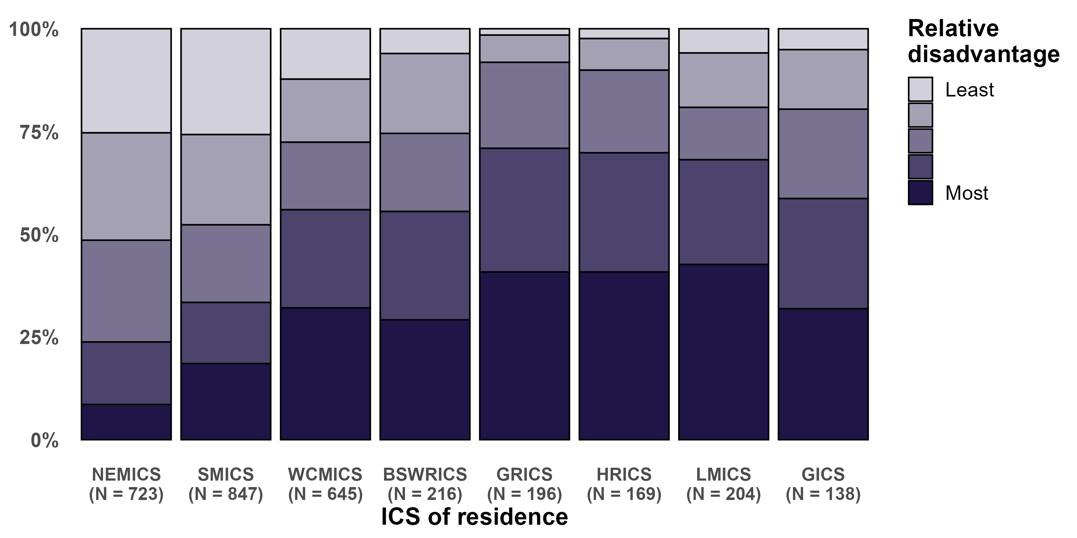

Note: Socioeconomic status based on the Index of Relative Socioeconomic Disadvantage of patients’ statistical area level 1 at diagnosis.

### Clinical commentary – demographics

The demographics of PDAC patients remains largely unchanged since the previous summit. Approximately two-thirds of patients had metastatic disease at diagnosis, although we have seen a slight reduction between periods.

There is significant variation in the socioeconomic status of patients with pancreatic cancer across the ICS, which most likely reflects the general socioeconomic status of patients within those ICS. It is important to understand these variations in the underlying populations when considering further analysis.

# OCP stage 1: Prevention and early detection

## Incidence

* The ASR of PDAC across Victoria was 6.7 cases per 100,000 (95 per cent CI 6.5–7.0) between 2011 and 2015 and 7.0 cases per 100,000 (95 per cent CI 6.8–7.3) between 2016 and 2019 (Figure 2).
  + There was no statistically significant variation in ASR between ICS for patients diagnosed between 2011 and 2015.
  + For patients diagnosed between 2016 and 2019, the was a higher ASR in WCMICS compared with the state average (8.1 per 100,000 [95 per cent CI 7.5–8.8] compared with 7.0 cases per 100,000 [95 per cent CI 6.8–7.3]).

Figure : Age-standardised incidence rate of PDAC by ICS of residence for patients diagnosed between 2011 and 2015 and between 2016 and 2019

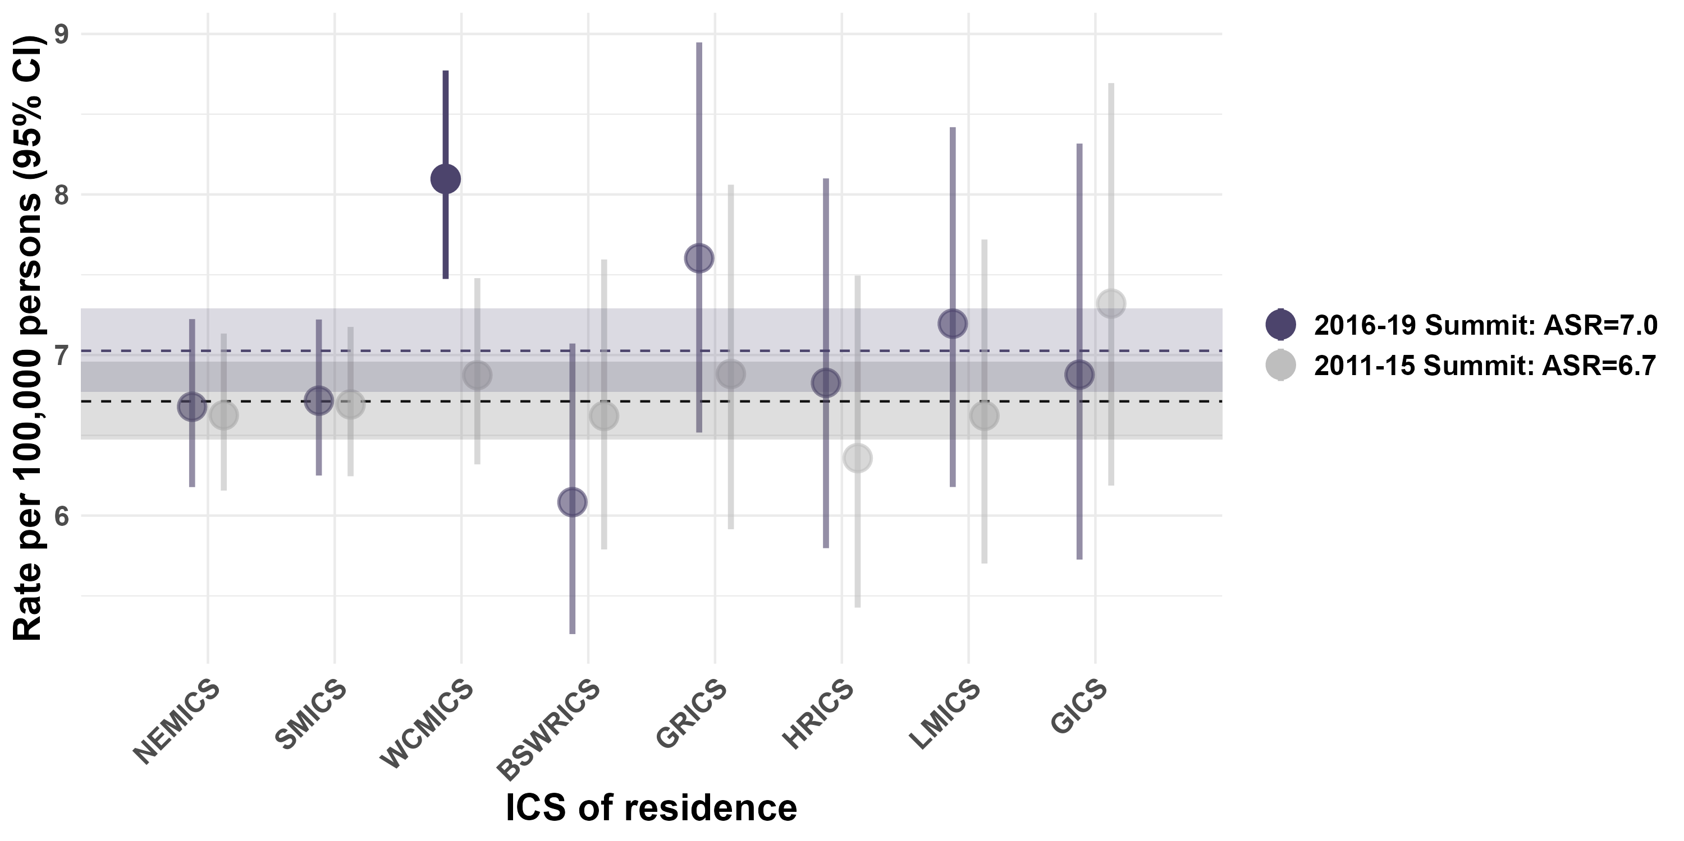

Sources: VCR; ABS population data

Standardised to the World Standard Population.

### Clinical commentary – incidence

The age-standardised incidence rate hasn’t changed significantly between periods. The WCMICS age-standardised incidence rate varies significantly from the statewide rate, but the driver for this is unclear.

# OCP stage 2: Presentation, initial investigation and referral

## Referrals to health services

* There was variation between ICS in the referral source to the treating health service for pancreatic cancer patients (*p* < 0.001; Figure 3).
  + Regional ICS had the highest proportion of patients referred from a GP (49 per cent).
* There was no statistically significant variation between ICS in the median time from referral to date first seen at a health service (*p* = 0.13; Figure 4).
  + The overall median time was six days, ranging from a median of two days in NEMICS to eight days in SMICS.

Figure 3: Variation in referral source to treating health service for pancreatic cancer patients, 2020 (*n* = 345)

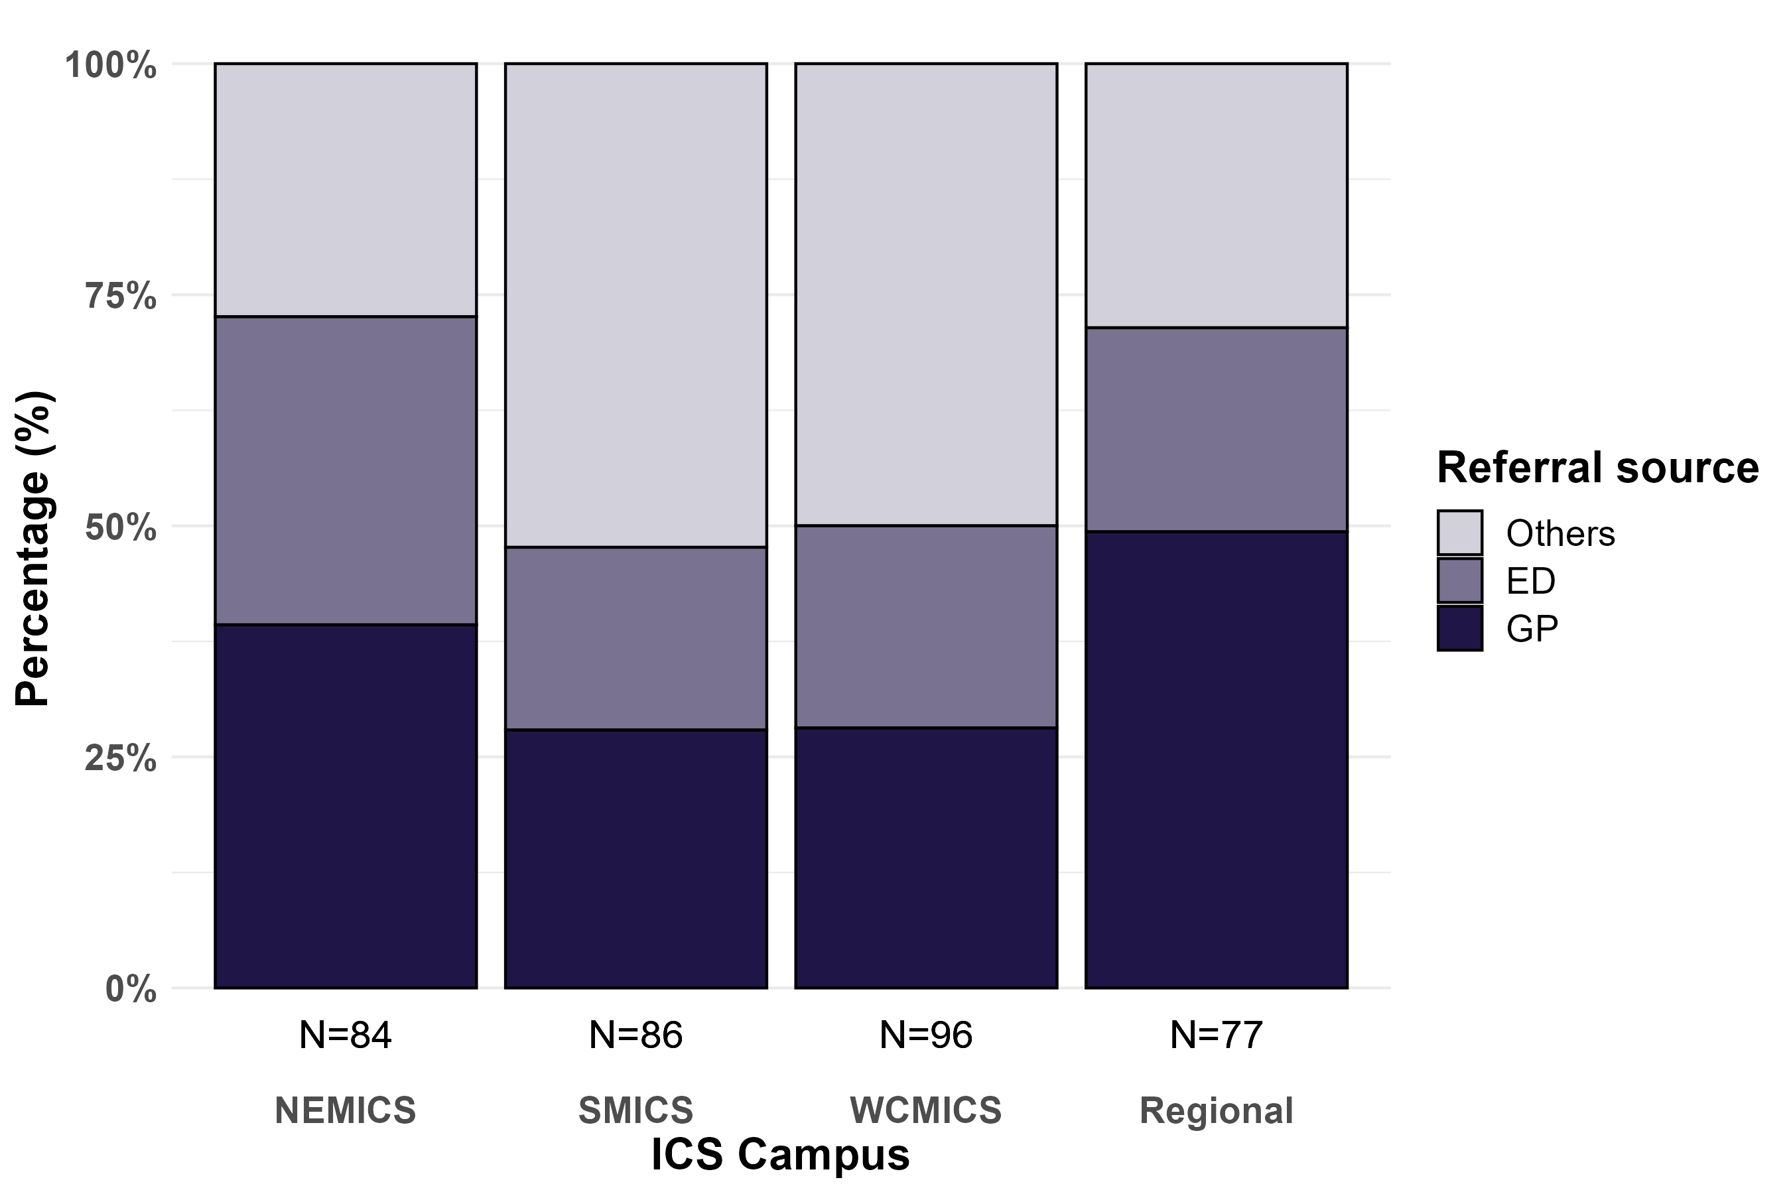

Source: CSPI Audit 2020; all pancreatic cancer types

‘Other’ referral source includes medical oncologist, surgeon and other specialists.

Regional ICS have been grouped together due to low numbers.

Patients are assigned to the health service where they received their **first treatment**.

Some regional patients will be audited at a metro ICS health service.

Figure : Time from referral to date first seen at a health service for pancreatic cancer patients, by ICS of treatment, 2020 (*n* = 207)

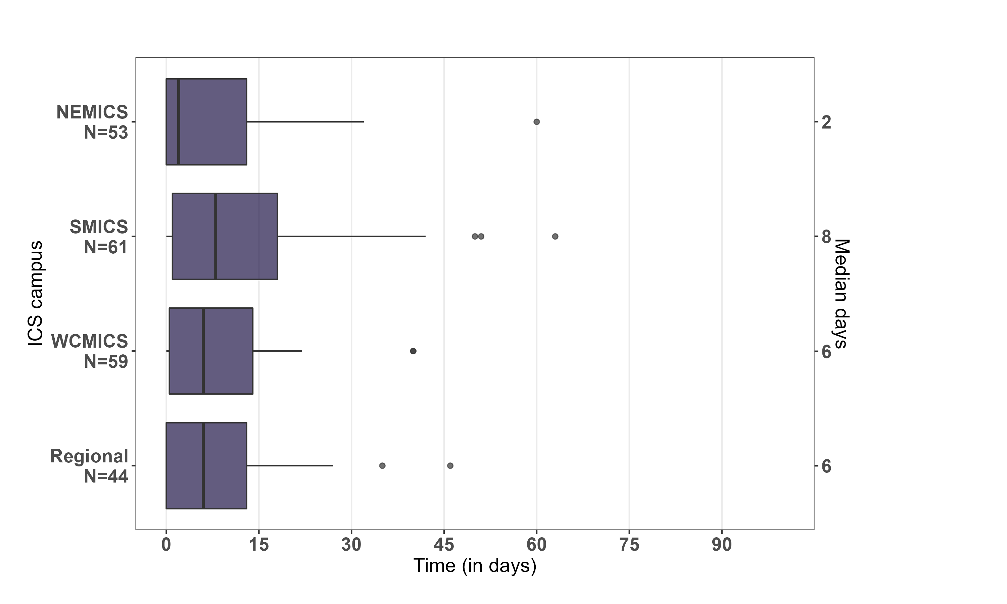

Source: CSPI audit 2020; all pancreatic cancer types

Excluded: Referral source = ‘Emergency department’ and negative time from referral to first seen.

Five patients not plotted because their time was longer than 100 days.

Regional ICS have been grouped together due to low numbers.

Patients are assigned to the health service where they received their **first treatment**.

Some regional patients will be audited at a metro ICS health service.

### Clinical commentary – referrals to health services

From the comprehensive audits on pancreatic cancer patients diagnosed in 2017 and 2020, we have new data that was not available at the previous summit. This shows quite a difference in referral sources to treating health services. For patients treated at regional ICS, half of the patients were referred through a GP compared with patients treated in SMICS and WCMICS where half of the referrals came directly from surgeons, medical oncologists and other specialists. While there was some variation in time between referral and the date first seen, it is quite positive to see that most of patients were seen within two weeks, with the median being just one week.

# OCP stage 3: Diagnosis, staging and treatment options

## Metastatic disease

* 63.2 per cent of PDAC patients between 2016 and 2019 had metastatic disease at diagnosis, which was significantly lower than between 2011 and 2015, with 66.8 per cent (*p* = 0.001).
* There was no significant variation between ICS in either period (2011 to 2015: *p* = 0.685; 2016 to 2019: *p* = 0.117; Figure 5).
  + There was no difference in the odds of metastatic disease at diagnosis by ICS of residence (compared with the Victorian average) after adjusting for age, sex and comorbidities (Figure 6).

Figure : Proportion of patients with metastatic disease at diagnosis by ICS of residence, for patients diagnosed between 2011 and 2015 and between 2016 and 2019

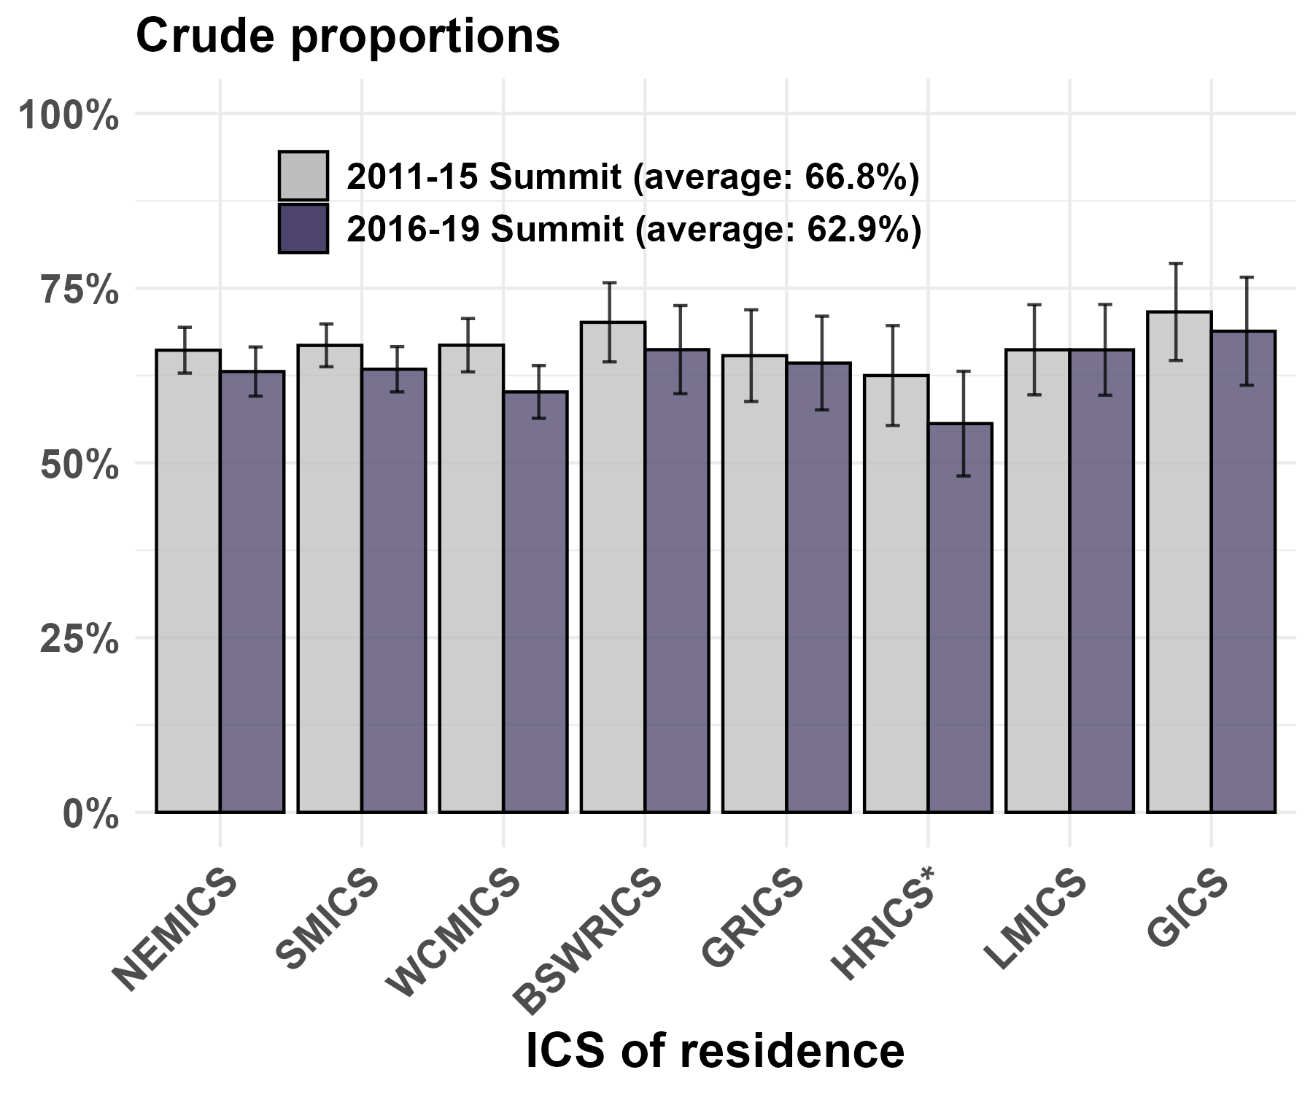

Figure : Adjusted odds of metastatic disease at diagnosis by ICS of residence, for patients diagnosed between 2011 and 2015 and between 2016 and 2019

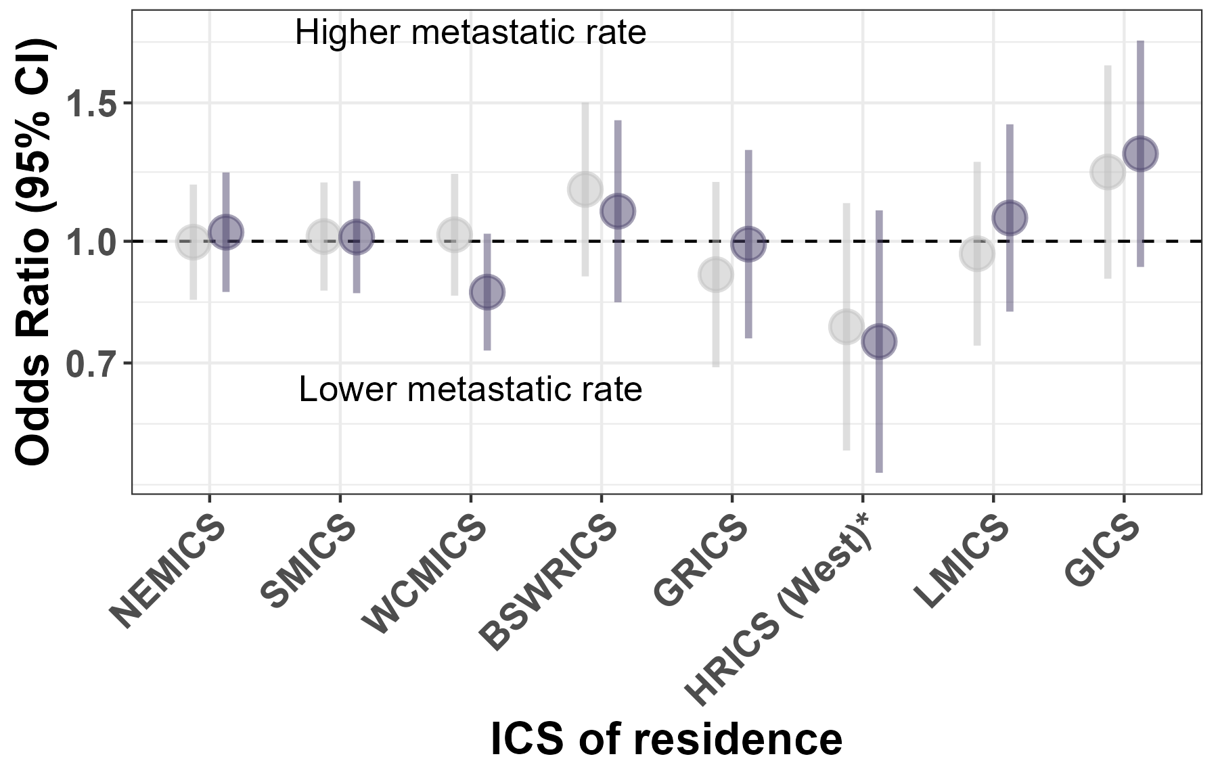

Note: Adjusted for age, sex and comorbidities.

Victorian average = 1.0

### Clinical commentary – metastatic disease

There was no significant variation in metastatic disease at diagnosis by ICS of residence for crude estimates nor when adjusted for age, sex and comorbidities.

There was a statistically significant difference in the proportion of metastatic disease at diagnosis, reducing from 66.8 per cent to 63.2 per cent in the current period.

## Resectability

* There was variation in the distribution of tumour resectability in three study cohorts (UGI Cancer Registry, PURPLE Registry and CSPI; Figure 7).
  + The proportion of resectable patients ranged from 17 per cent in UGICR to 29 per cent in PURPLE.
  + The proportion of unsectable metastatic patients ranged from 31 per cent in CSPI to 43 per cent in UGICR.
  + The proportion of patients with unclear or unknown resectablity ranged from 8 per cent in PURPLE to 19 per cent in CSPI.
* From the 2020 CSPI audit, there was statistically significant variation in the resectability status between ICS (*p* < 0.001, Figure 8).
  + Nearly all patients in NEMICS had their resectability status recorded, compared with at least 19 per cent of patients from SMICS, WCMICS and regional ICS with unknown resectability.
  + Excluding those with unknown resectability, the average proportion of resectable patients was 29 per cent and ranged from 12 to 39 per cent. The average proportion of borderline resectable patients was 14 per cent and ranged from 6 to 25 per cent across ICS.
* From the 2020 CSPI audit, there was a statistically significant variation in the resectability status between MDM status (*p* < 0.001, Figure 8).
  + A higher proportion of patients who did not have an MDM were unresectable metastatic compared with those who had an MDM (48 per cent compared with 25 per cent).
  + A higher proportion of patients who had an MDM were resectable compared with those without an MDM (31 per cent compared with 4 per cent).

Figure : Variation in distribution of tumour resectability in three study cohorts

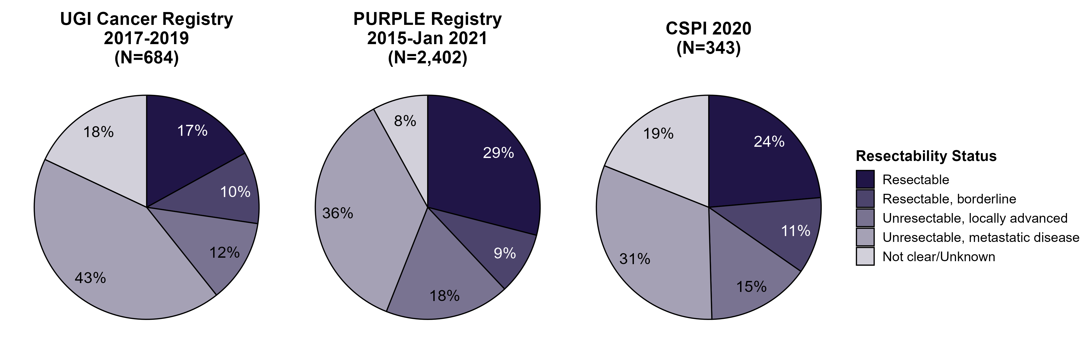

Note: Differences in resectability proportions among the data sources may be due to:

* different time periods.
* different levels of population coverage/random selection.

PURPLE is a prospectively collected database, and resectability status represents the initial categorical staging at the point of first presentation/MDM discussion.

PURPLE incorporates data from centres across Australia, New Zealand and Singapore.

Figure : Variation in resectability status by ICS campus and MDM, 2020 (*n* = 343)

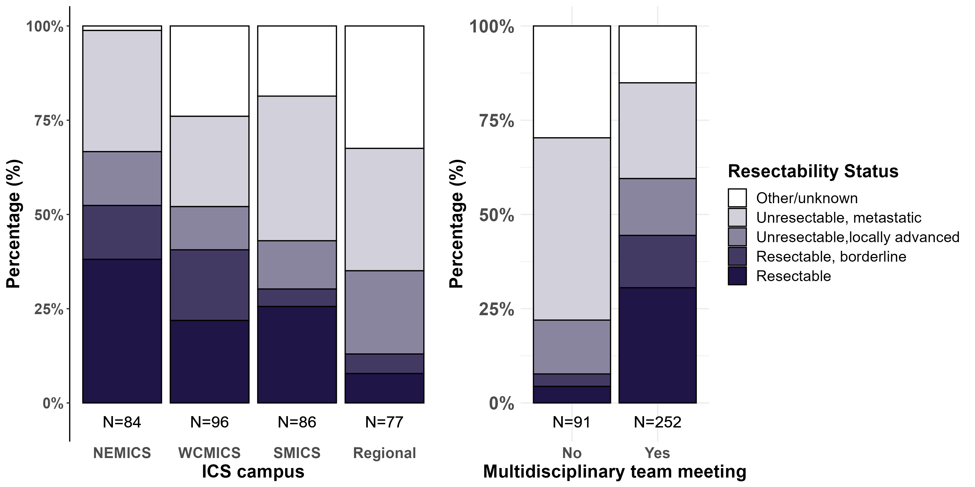

Source: CSPI Audit 2020; all pancreatic cancer types

Regional ICS have been grouped together due to low numbers.

### Clinical commentary – resectability

While the rates of metastatic disease are fairly consistent across the state, there is great variability in the classification of resectability. This variation in the ability to determine whether patients are resectable, borderline resectable or locally advanced is based on treatment location and is a significant and unwarranted variation. This variation prompted the resectability project from the previous summit with the intention to introduce synoptic reporting and achieving agreement on a statewide definition of resectability.

From the CSPI audit, there were considerable differences in the proportion of patients considered resectable, with a much smaller proportion in patients treated at a regional ICS than for those at a metropolitan ICS. The data also shows that if patients have metastases, they are much less likely to be discussed in an MDM, which supports what was assumed within the clinical working party. Following the great work of the resectability project and agreeing on a statewide definition of resectability, we will hopefully see a shift towards consistency in resectability status reporting in future.

## Treatment modalities

* There was variation between ICS of residence in the odds of being treated with surgery, after adjusting for age, sex and comorbidities (Figure 9).
  + Patients who lived in NEMICS were more likely to receive surgery compared with the Victorian average, which was consistent for patients diagnosed between 2011 and 2015 and between 2016 and 2019.
  + Patients from GRICS diagnosed between 2016 and 2019 were less likely to receive surgery than the Victorian average.
* There was no variation between ICS of residence in the odds of being treated with chemotherapy after adjusting for age, sex and comorbidities. This was consistent between the two periods assessed.
* There was variation between ICS of residence in the odds of being treated with radiotherapy, after adjusting for age, sex and comorbidities.
  + Patients from BSWRICS were more likely to receive radiotherapy than the Victorian average, which was consistent for patients diagnosed between 2011 and 2015 and between 2016 and 2019.

Figure : Surgery, chemotherapy or radiotherapy within one year of non-metastatic PDAC diagnosis by ICS of residence, for patients diagnosed between 2011 and 2015 and between 2016 and 2019

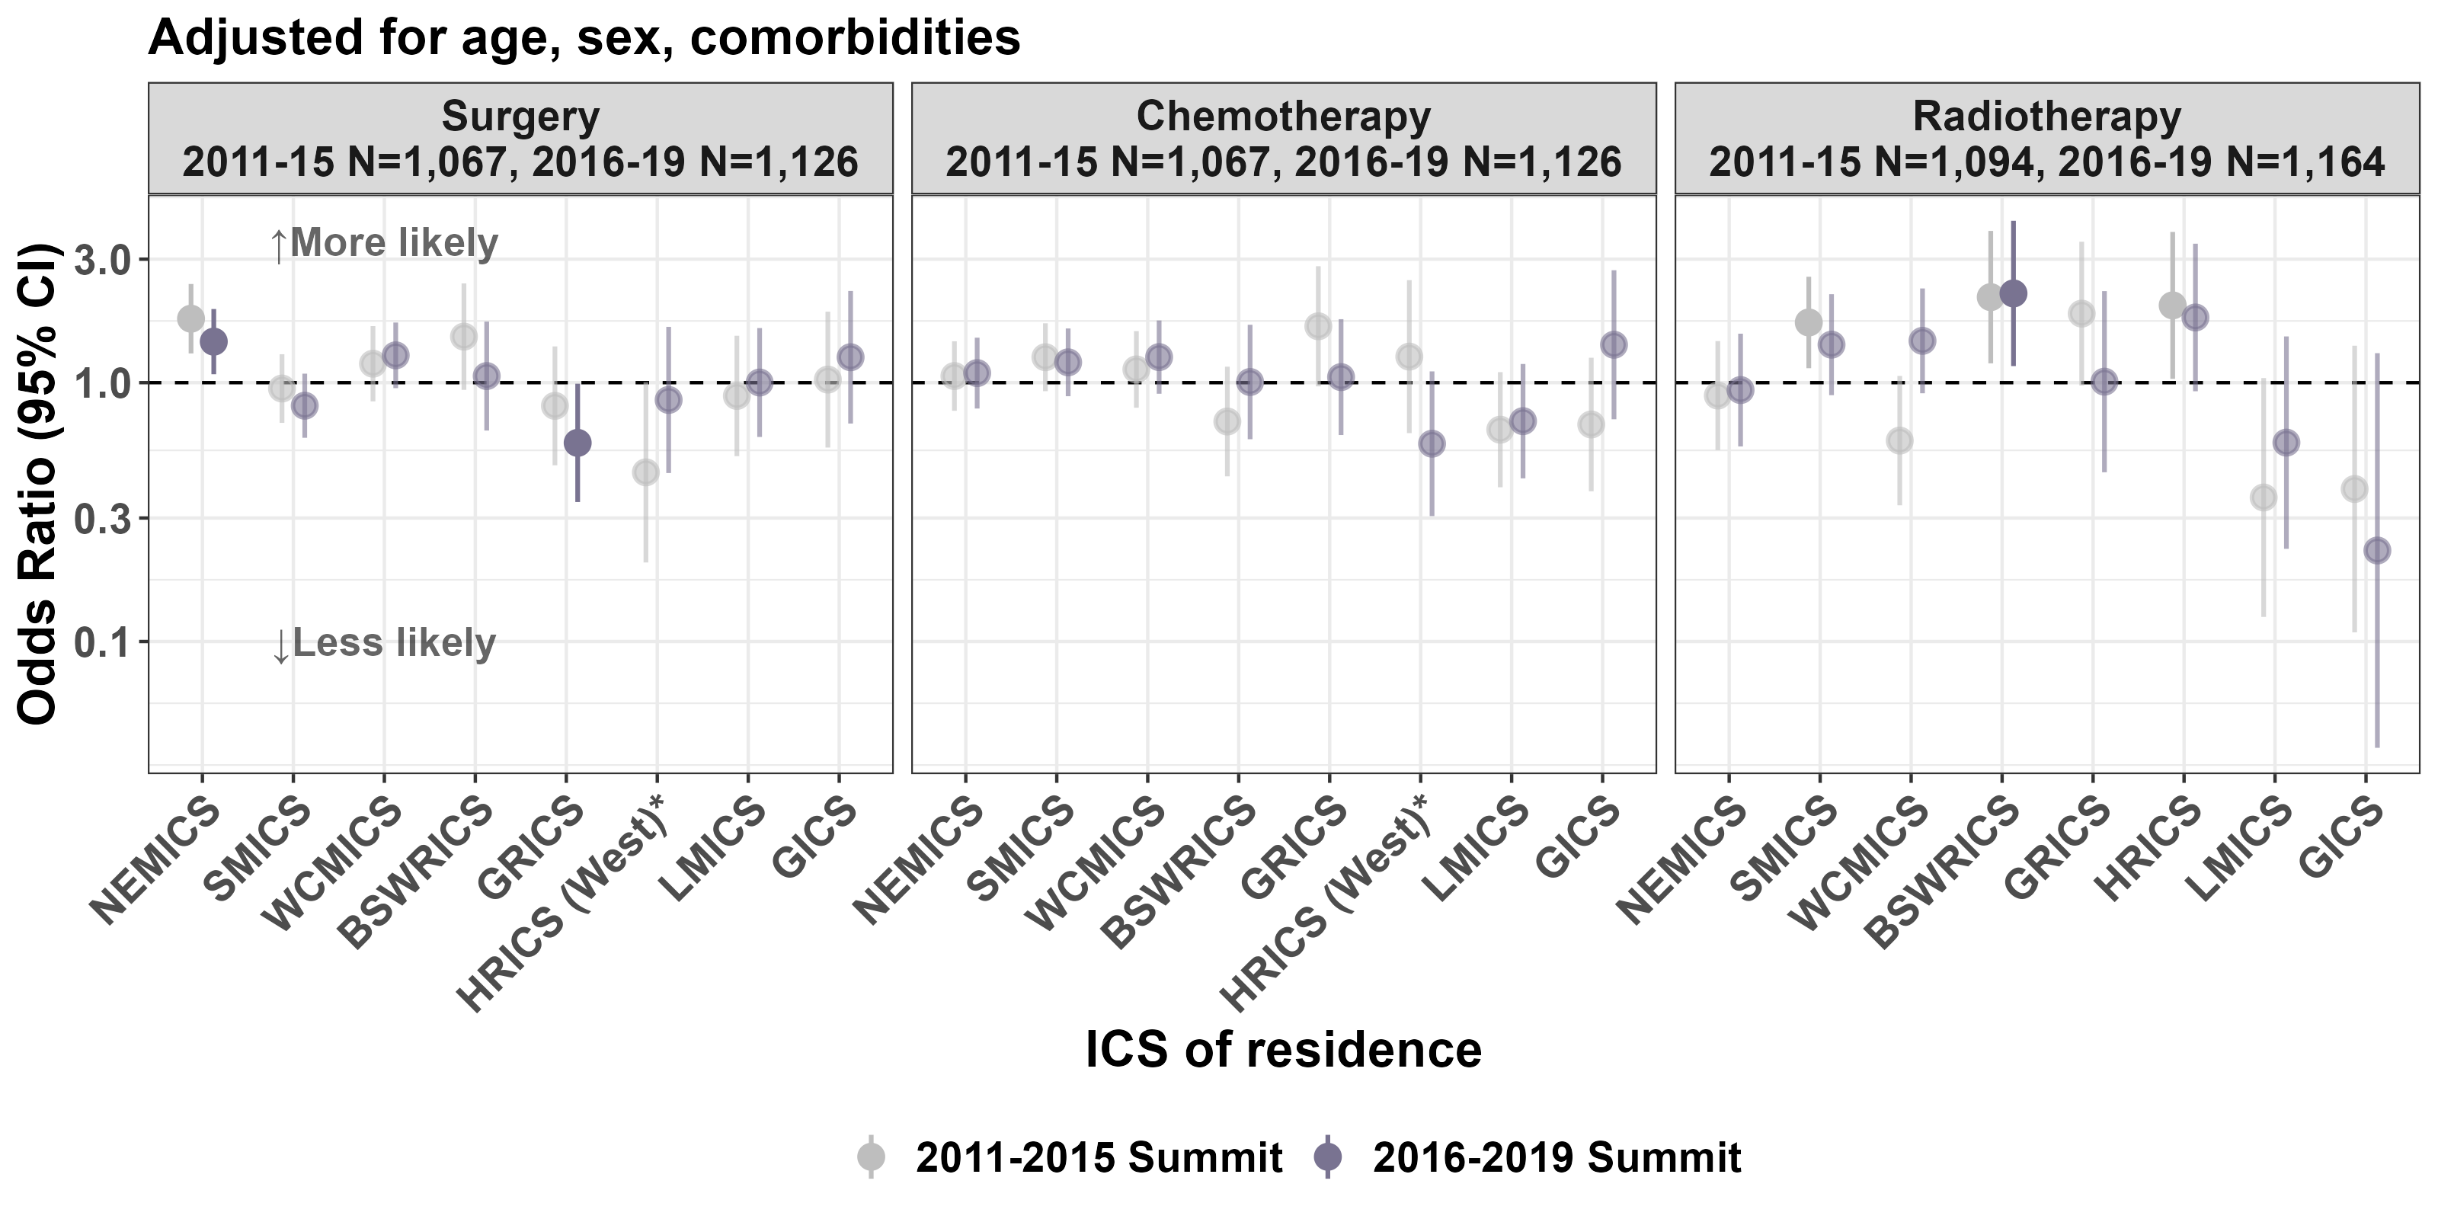

Sources: VCR, VAED, VRMDS (2011–2019); PDAC only

* HRICS data limitation – residents from Hume Border East excluded for surgery and chemotherapy plots. Limitation does not apply to radiotherapy.

### Clinical commentary – treatment modalities

It is pleasing to see little variation between ICS of residence in the odds of receiving different treatment modalities, with only a few ICS deviating from the Victorian average. There was some variability in radiotherapy, with patients from BSWRICS having higher odds compared with the Victorian average. But we also see some larger confidence intervals in this cohort, reflecting a smaller number of patients receiving radiotherapy overall. Patients living in NEMICS were more likely to receive surgery, but this may reflect the fact that more patients treated at NEMCIS campuses are classified as resectable, as shown in the CSPI audit (Figure 8).

## MDM and supportive care screening

Documenting MDM recommendations and supportive care screening in the medical record ensures this important information is accessible to all team members. For the CSPI audit, targets of 85 per cent for MDM recommendations and 80 per cent for supportive care screening have been set. These targets aim to drive quality improvement and equity of access to MDMs and applies to all tumour streams.

* From the CSPI medical record audits on diagnoses in 2017 and 2020, 74 per cent of patients audited from 2017 and 73 per cent of patients audited from 2020 had documented evidence of an MDM (Figure 10).
  + In 2020, six metropolitan campuses met or exceeded the target of 85 per cent.
  + In 2020, there was one campus in NEMICS and one campus in WCMICS with a statistically significant higher proportion of patients with evidence of MDM compared with the statewide average.
  + In 2020, there was a statistically significantly lower proportion of patients with evidence of MDM compared with the statewide average treated in BSWRICS, LMICS and GICS.
* For diagnoses between 2016 and 2019 in the UGICR, 63 per cent of non-metastatic patients presented at an MDM compared with 38.6 per cent of metastatic patients (Table 2).
* Overall, in 2020, 36 per cent of patients had documented evidence of supportive care screening, which is lower than the rate of 39 per cent in 2017, and well below the target of 80 per cent (Figure 11).
  + In 2020, GRICS was the only ICS to exceed the target, noting there were only five patients audited.
  + In 2020, there was a significantly higher proportion of patients with evidence of supportive care screening treated at two health services in SMICS, and treated in GRICS (Gippsland), HRICS (Hume) and LMICS (Loddon Mallee) compared with the statewide average.
  + In 2020, there was a significantly lower proportion of patients with evidence of supportive care screening treated at three health services in WCMICS compared with the statewide average.

Figure : Percentage of newly diagnosed pancreatic cancer patients with documented evidence of MDM recommendations for 2017 and 2020

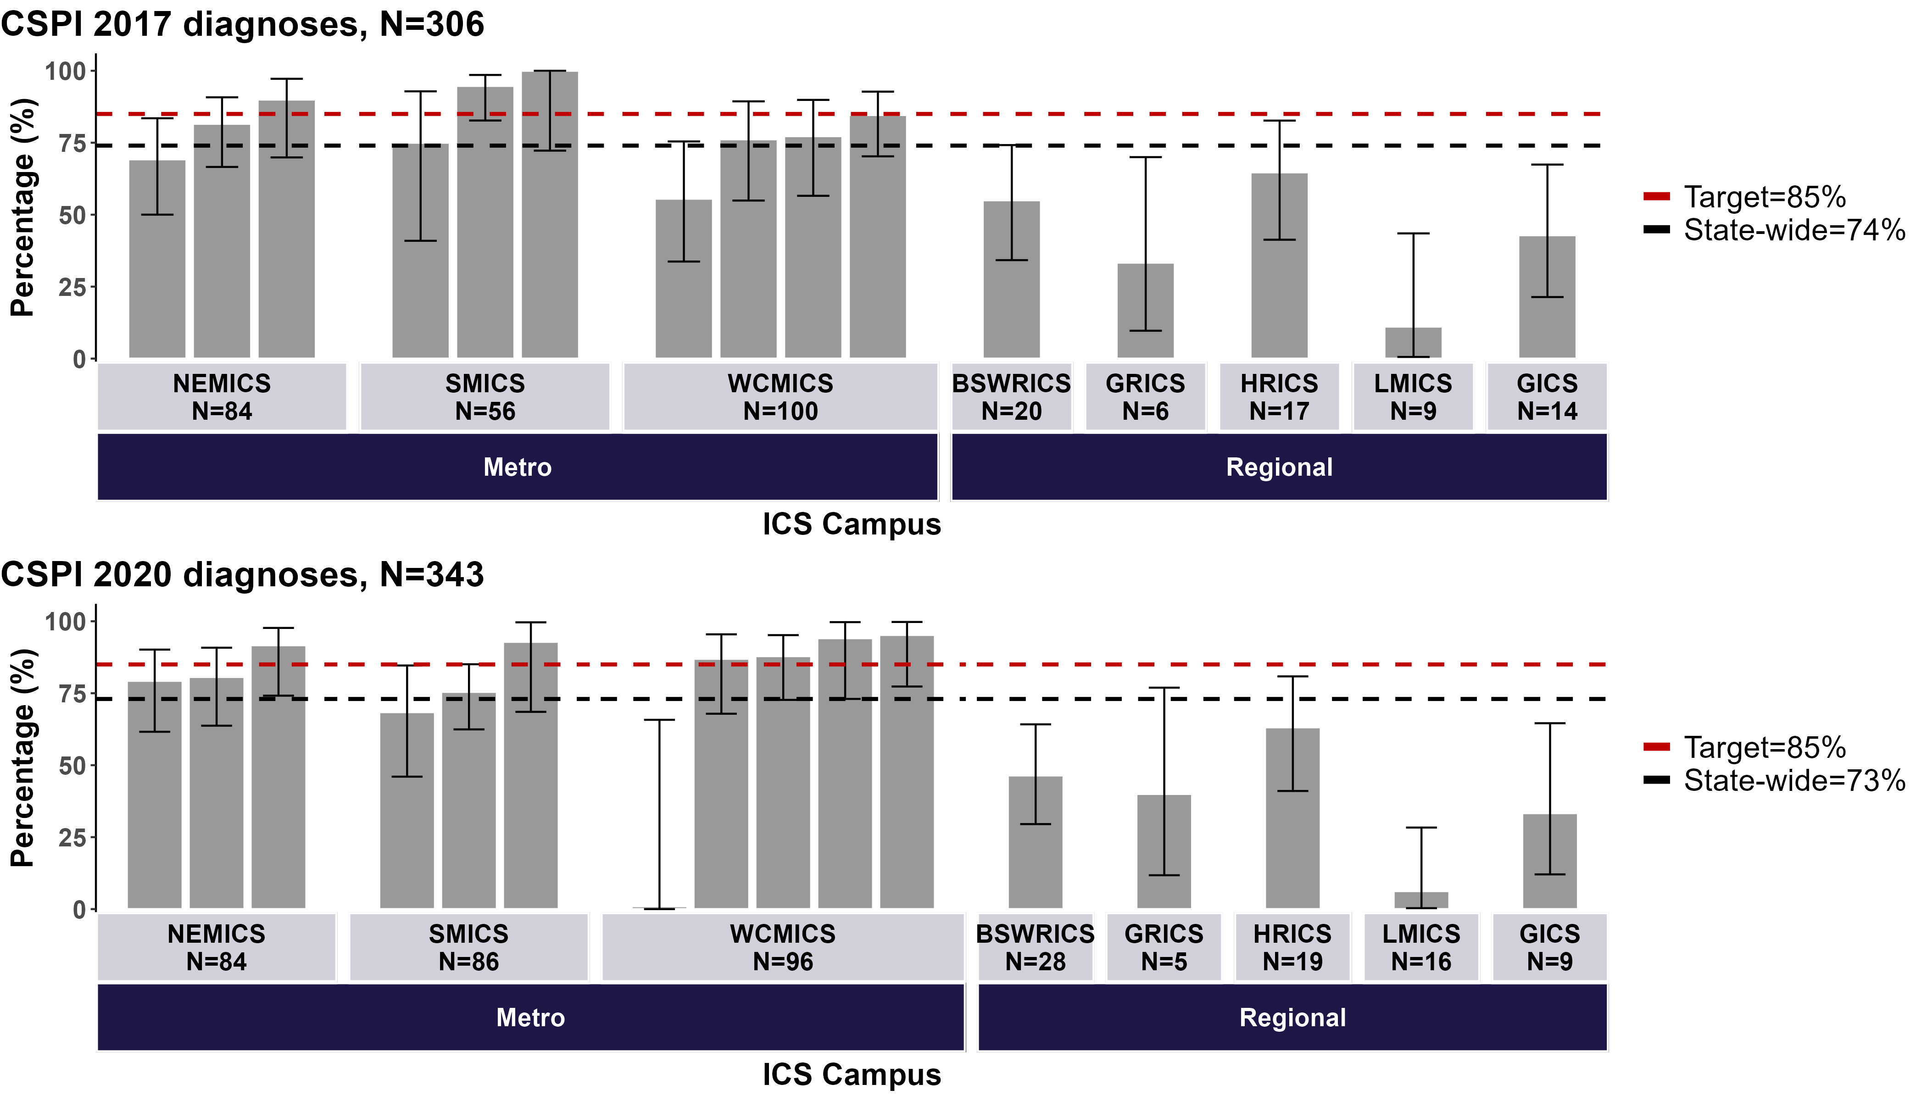

Sources: CSPI audits 2017 and 2020; all pancreatic cancer types  
Regional campuses were grouped due to low numbers.

Table : UGICR MDM presentation rates by stage (2016–2019)

| Metastatic status | Presented at MDM | Not presented at MDM |
| --- | --- | --- |
| Non-metastatic at diagnosis, % (*n*) | 63.0% (689) | 37.0% (404) |
| Metastatic at diagnosis, % (*n*) | 38.6% (354) | 61.4% (564) |

Figure : Percentage of newly diagnosed pancreatic cancer patients with documented evidence of supportive care screening for 2017 and 2020

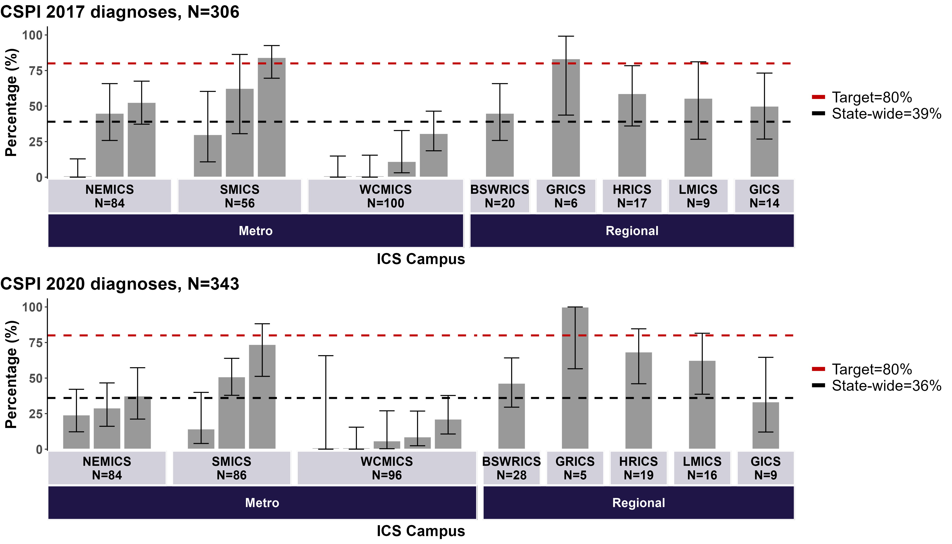

Sources: CSPI audits 2017 and 2020; all pancreatic cancer types  
Regional campuses were grouped due to low numbers.

### Clinical commentary – MDM and supportive care screening

The proportion of patients discussed at MDMs is still below the target and have not shifted between 2017 and 2020. Although the numbers in the metropolitan centres are higher than regional ICS, it is likely that this is an overestimate because the cohort sampled were more likely to be non-metastatic, and metastatic patients are rarely discussed in MDMs. Quite often when metastatic patients are presented at an MDM, they are generally presented as a suspected borderline case. The data from the UGICR highlights this point, with many metastatic patients not presenting at an MDM. However, the data shows we’re not discussing every patient. This has been highlighted from work looking at palliative care and supportive care and from consumer groups.

The Queensland Oncology On-Line-Victoria (QOOL-Vic) is a new MDM software[5] In future, QOOL-Vic will be an excellent tool to track patients from one MDM to the next. This tool will provide a way to better understand the patient movement where patients are discussed at one MDM and treated in another ICS.

Supportive care screening rates were extremely poor and have even decreased between 2017 and 2020. There are potentially more patients being assessed, but a validated screening tool has not been used in these instances. For example, when a clinician assesses a patient’s history and determines problems with nutrition, diabetes management or social issues that need support, they would be automatically referred to the appropriate areas without using a screening tool. However, it’s important that supportive care screening occurs and is documented to ensure all patients are being screened and that supportive care needs are being met.

# OCP stage 4: Treatment

## Treatment pathways and timeliness

* In the first year following a non-metastatic PDAC diagnosis between 2016 to 2019 (Figure 12):
  + 35 per cent of patients had surgery (compared with 31 per cent in 2011 to 2015).
  + Of those treated surgically, 75 per cent received adjuvant chemotherapy and/or radiotherapy (down from 77 per cent in 2011 to 2015).
  + Of those treated surgically, 16 per cent received neoadjuvant therapy (an increase from 4 per in 2011 to 2015).
  + 33 per cent of patients had chemotherapy and/or radiotherapy alone (no surgical treatment), which was similar to the 32 per cent of patients between 2011 and 2015. Forty-one per cent died within a year of diagnosis.
  + 31 per cent of patients had no surgery, chemotherapy or radiotherapy, which was a decrease from 37 per cent for patients diagnosed between 2011 and 2015. Of these patients, 75 per cent were aged over 80 years, had at least one comorbidity, or died within one month of diagnosis.
* In the first year following a metastatic PDAC diagnosis between 2016 and 2019 (Figure 13):
  + 43 per cent of patients had chemotherapy and/or radiotherapy alone (no surgical treatment), which was similar to the 44 per cent of patients between 2011 and 2015. Seventy-three per cent died within a year of diagnosis.
  + 55 per cent of patients had no surgery, chemotherapy or radiotherapy, which was similar to the 53 per cent between 2011 and 2015. Of these patients, 79 per cent were aged over 80 years, had at least one comorbidity or died within a month of diagnosis.
  + 2 per cent of patients had surgery (compared with 4 per cent between 2011 and 2015).
  + Of those treated surgically, 78 per cent received adjuvant chemotherapy and/or radiotherapy (up from 65 per cent between 2011 and 2015).
  + Of those treated surgically, 15 per cent received neoadjuvant therapy (and increase from 2 per cent between 2011 and 2015).
* The OCP indicates that initial treatment should start within four weeks of diagnosis (Table 3 and Table 4).
  + For the neoadjuvant chemotherapy cohort, 59 per cent were treated within four weeks between 2016 and 2019, which is a decrease from 73 per cent between 2011 and 2015. However, the number of patients receiving this treatment was quite low and has increased between periods, from 15 to 66 patients.
  + For the chemotherapy and/or radiotherapy only cohort, 41 per cent were treated within four weeks, which is unchanged from the previous summit.
  + For the surgical cohort (who did not receive neoadjuvant chemotherapy), 79 per cent of patients were treated within four weeks, which is down slightly from 82 per cent at the previous summit (including patients whose surgery was the same date as diagnosis).
* From the PURPLE registry, 28 per cent of patients (698 of 2,507) had surgery completed and 32 per cent (805 of 2,507) had attempted surgery (Figure 14).
  + Of those with completed surgery, 78 per cent (547 of 698) had a Whipple procedure (pancreaticoduodenectomy).

Figure : Non-metastatic PDAC treatment pathways, for patients diagnosed between 2016 and 2019

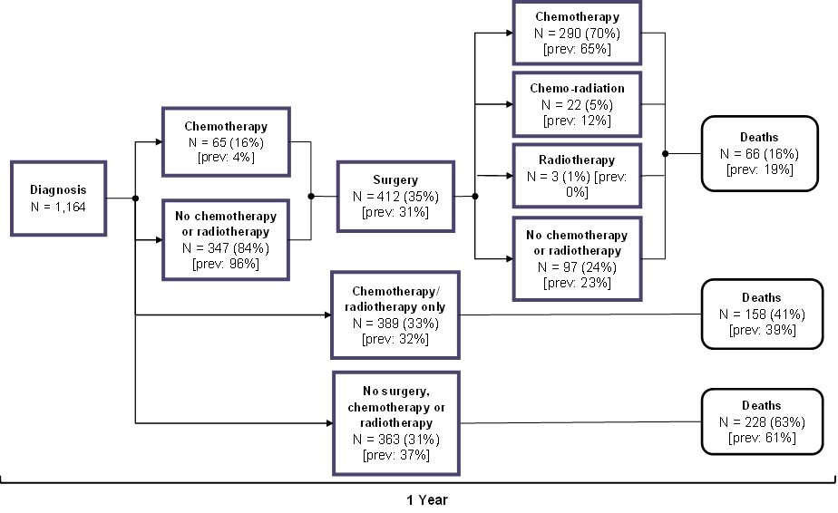

Sources: VCR, VAED, VRMDS 2011–2019; PDAC only

All treatment and deaths recorded within one year of diagnosis.

Comorbidity count: Charlson Comorbidity Index derived from VAED admissions one year before diagnosis to one month after diagnosis (excluding cancer).

‘Previous’ results recorded are for patients diagnosed from 2011 to 2015.

Figure 13: Metastatic PDAC treatment pathways, for patients diagnosed between 2016 and 2019

A flow chart outlining the treatment pathway for metastatic PDAC patients diagnosed in 2016 to 2019

Sources: VCR, VAED, VRMDS 2011–2019; PDAC only

All treatment and deaths recorded within one year of diagnosis.

Comorbidity count: Charlson Comorbidity Index derived from VAED admissions one year before diagnosis to one month after diagnosis (excluding cancer).

‘Previous’ results recorded are for patients diagnosed from 2011 to 2015.

Table : Timeliness between diagnosis and first treatment, or between treatment modalities, for patients diagnosed between 2011 and 2015

| From | To | Number | Time (days): median [IQR] | Treated within 28 days, *n* (%) |
| --- | --- | --- | --- | --- |
| VCR diagnosis | Neoadjuvant chemotherapy | 15 | 22 (14–36.5) | 11 (73%) |
| VCR diagnosis | Chemotherapy and/or radiation only | 401 | 35 (16–67) | 165 (41%) |
| VCR diagnosis | Surgery (excl. same day) | 166 | 21 (12–32.75) | 108 (65%) |
| VCR diagnosis | Surgery (inc. same day) | 323 | 4 (–22) | 265 (82%) |
| Chemotherapy | Surgery | 15 | 127 (86.5–171) | N/A |
| Surgery | Chemotherapy or chemoradiation | 259 | 55 (46–70) | N/A |

Table : Timeliness between diagnosis and first treatment, or between treatment modalities, for patients diagnosed between 2016 and 2019

| From | To | Number | Time (days): median [IQR] | Treated within 28 days, *n* (%) |
| --- | --- | --- | --- | --- |
| VCR diagnosis | Neoadjuvant chemotherapy | 66 | 25 (15.25–35) | 39 (59%) |
| VCR diagnosis | Chemotherapy and/or radiation only | 424 | 34 (20–58) | 174 (41%) |
| VCR diagnosis | Surgery (excl. same day) | 183 | 24 (15–36) | 109 (60%) |
| VCR diagnosis | Surgery (inc. same day) | 350 | 3 (0–25.75) | 276 (79%) |
| Chemotherapy | Surgery | 66 | 118 (103.25–166) | N/A |
| Surgery | Chemotherapy or chemoradiation | 318 | 57.5 (47–71.75) | N/A |

Figure 14: PURPLE registry-recorded localised PDAC outcomes (*n* = 805)

A bar chart showing the number of PDAC patients undergoing different treatment, for patients in the PURPLE Registry 

Source: PURPLE registry 2015 – January 2021

### Clinical commentary – treatment pathways and timeliness

The treatment pathways are mostly in line with what was seen at the previous summit, with a few exceptions. Neoadjuvant chemotherapy utilisation for non-metastatic patients increased from 4 to 16 per cent of surgically treated patients, which is a significant change. Approximately a quarter of patients did not receive adjuvant therapy, and there appeared to be a slight shift away from radiation, which is in line with data suggesting that it is not the most effective adjuvant therapy. Without resectability linked into this data, it’s not possible to comment on the appropriateness of treatment and whether those who received chemotherapy alone were treated appropriately. This is another potential advantage of the QOOL-Vic MDM software because it allows for the capture of this data at the point of MDM discussion.

More than half of the metastatic patients did not receive any active treatment (surgery, intravenous chemotherapy or radiotherapy), with many of these patients being elderly, having comorbidities or dying within a month of diagnosis. This equates to approximately 1,000 patients not receiving treatment and highlights the importance of palliative care and supportive care in treating pancreatic cancer. Patients often perceive palliative care as end-of-life care, but studies such as the Care Plus Study are working towards reframing the narrative and promoting improved patient access.[6]

## Surgical length of stay

* The median length of stay following pancreaticoduodenectomy was 14 days for patients diagnosed between 2011 and 2015 and patients diagnosed between 2016 and 2019 (Figure 15).
  + The length of stay for patients treated at a regional ICS tended to be higher than those treated at a metropolitan ICS, with the median length of stay ranging from 12 days in NEMICS to 25 days in BSWRICS for patients diagnosed between 2016 and 2019.
  + Variation in the proportion of patients with a length of stay longer than 14 days existed between campuses. Three campuses had a significantly higher proportion of patients with a length of stay longer than 14 days and three campuses had a significantly smaller proportion of patients with a length of stay longer than 14 days compared with the Victorian average (Figure 16).

Figure : Surgical length of stay for pancreaticoduodenectomy patients by ICS campus, for patients diagnosed between 2011 and 2015 and between 2016 and 2019

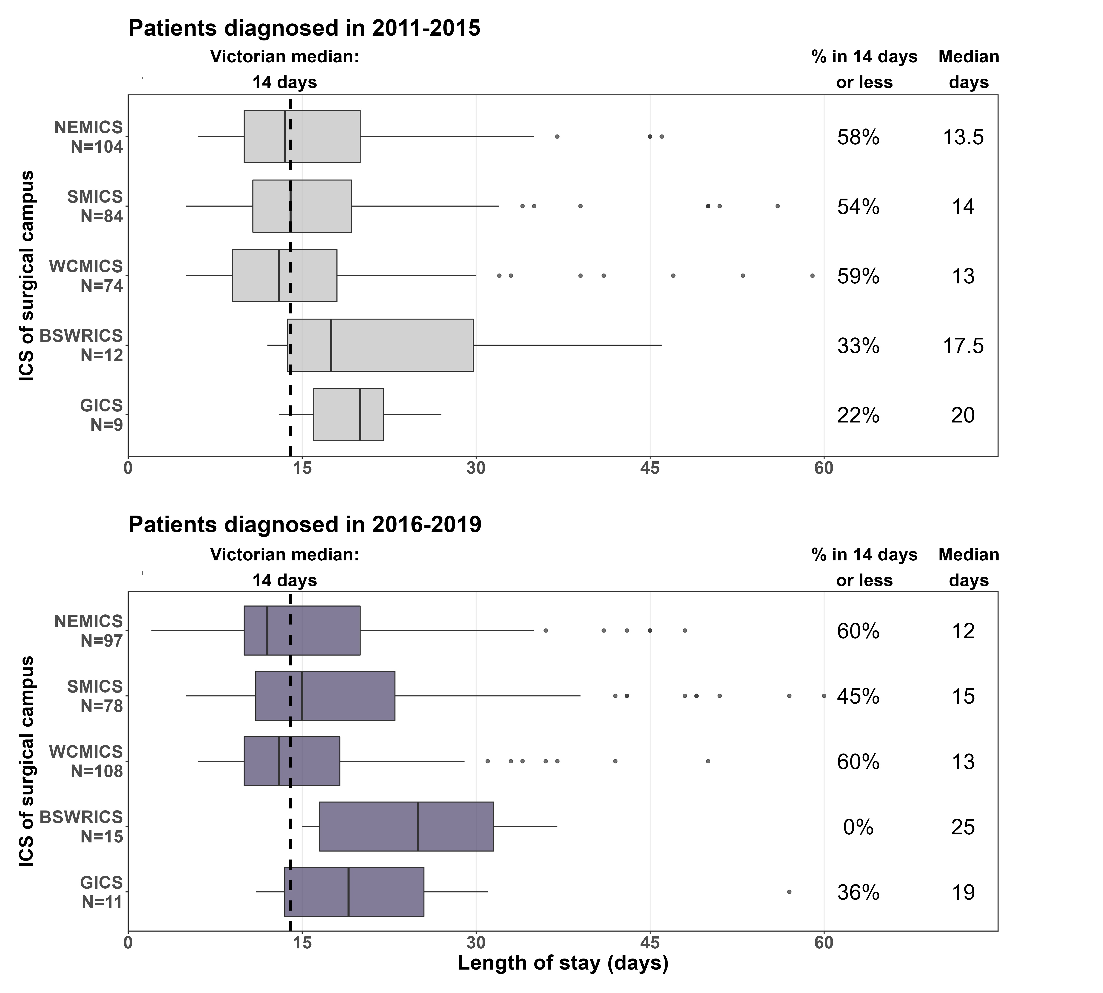

Figure : Surgical length of stay for pancreaticoduodenectomy patients by campus, for patients diagnosed between 2016 and 2019

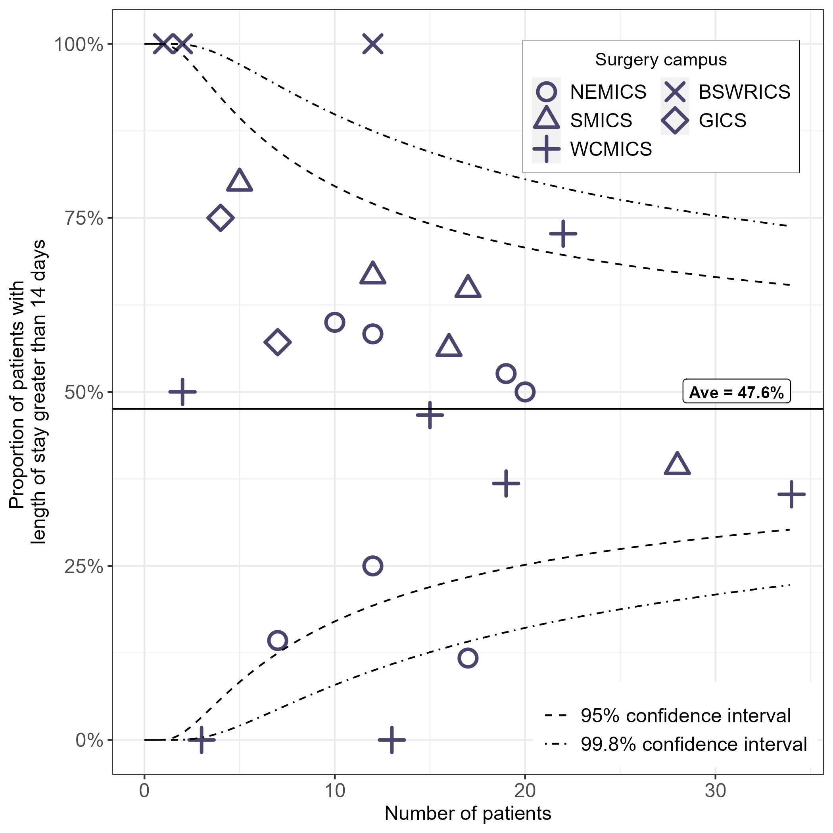

### Clinical commentary – surgical length of stay

The length of stay following surgery has stayed fairly consistent between summits,[7] although the median length of stay was higher at the two regional ICS with surgical admissions. This may be due to regional areas servicing such broad regions and so it may not be reasonable to send patients home if they’re not entirely sure that the patient is well, rather than trying to make an early discharge. Local attention to potential issues associated with outlier patient hospital stays may identify opportunities to address this.

## Surgical campus volume and mortality

* For pancreatectomies, there were fewer low-volume campuses in the calendar years 2020 and 2021 compared with calendar years 2014 and 2015, with the median volume increasing from three to 12 in public campuses and six to 12.25 in private campuses (Figure 17).
  + Across the calendar years 2020 and 2021, there were 31 hospitals in Victoria that performed pancreatic surgery, ranging from an annual average volume of one to 30 (public) and 34 (private).
  + Across the calendar years 2014 and 2015, there were 37 hospitals in Victoria that performed pancreatic surgery, ranging from an annual average volume of one to 35 (public) and 46 (private).
* For pancreaticoduodenectomies, there were fewer low-volume private campuses in the calendar years 2020 and 2021 compared with calendar years 2014 and 2015, with the median volume increasing from 4.5 to 13. For public campuses, the median volume remained stable at 10.5 surgeries (Figure 18).
  + Across the calendar years 2014 and 2015, there were 37 hospitals in Victoria that performed pancreatic surgery, ranging from an annual average volume of one to 21 (public) and 25 (private).
  + Across the calendar years 2020 and 2021, there were 31 hospitals in Victoria that performed pancreatic surgery, ranging from an annual average volume of one to 20 (public and private).
* There was no variation between campuses in mortality following pancreatectomy (Figure 19).
  + Mortality rates did not change significantly between the two summit periods (Table 5). Thirty-day mortality decreased from 3 per cent for patients diagnosed between 2011 and 2015 to 2 per cent between 2016 and 2019 (*p* = 0.375). Ninety-day mortality decreased from 4 per cent between 2011 and 2015, to 2 per cent between 2016 and 2019 (*p* = 42).

Figure : Pancreatic resection volume by campus, 2014 to 2015 (calendar years) and 2020 to 2021 (calendar years)

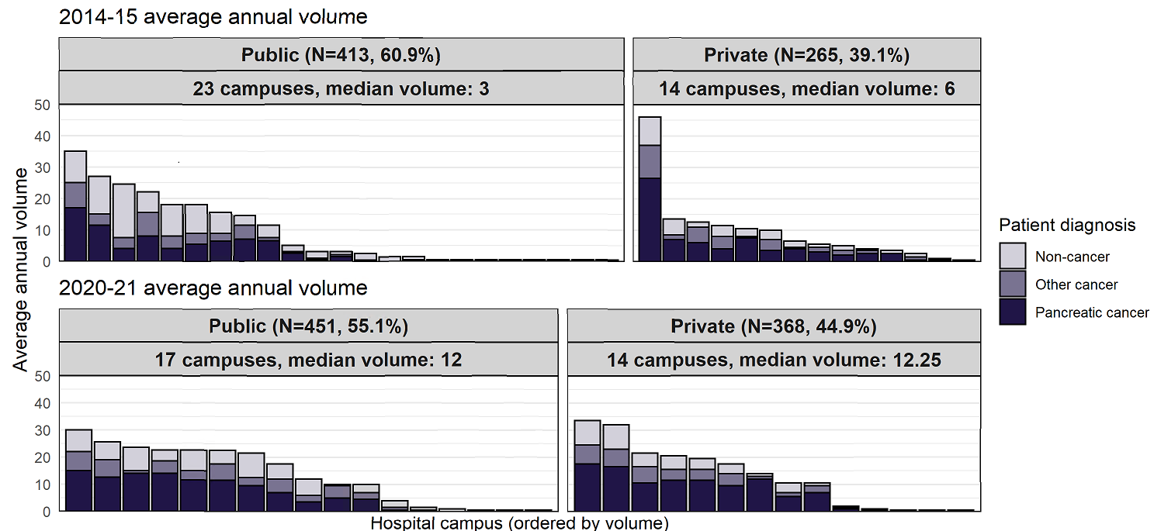•

Figure : Pancreaticoduodenectomy resection volume by campus, 2014 to 2015 (calendar years) and 2020 to 2021 (calendar years)

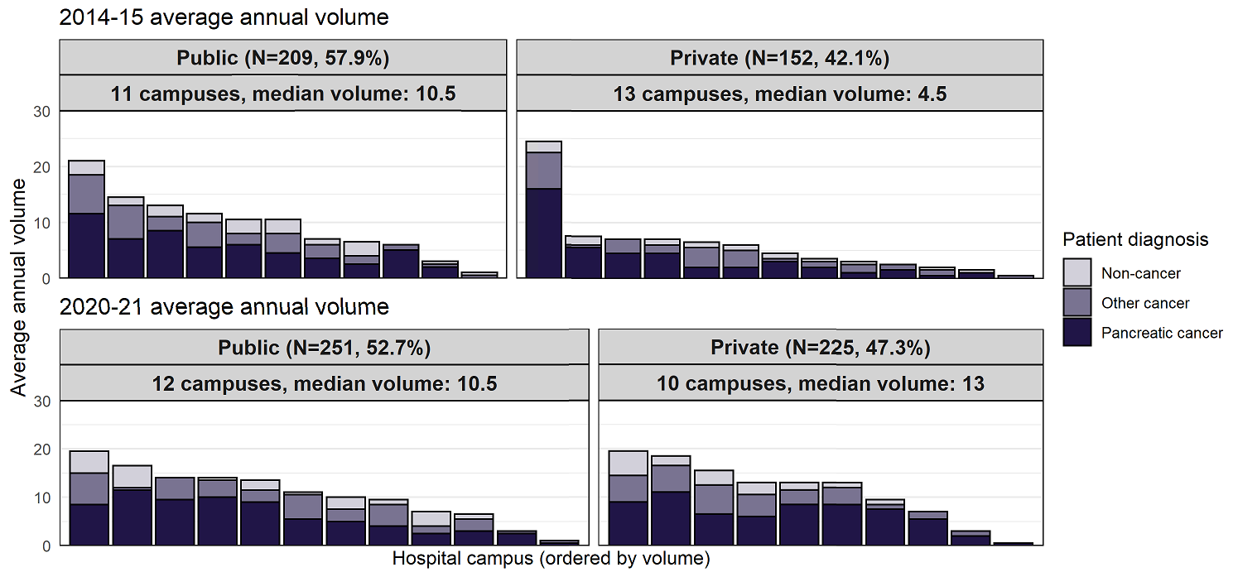

Figure : Post-surgical mortality following pancreatectomy by surgical campus, 2016 to 2019 (*n* = 453)

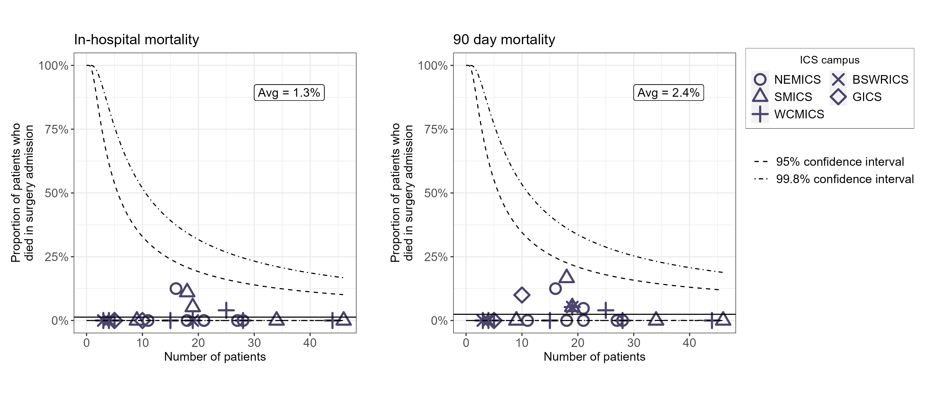

Table : Mortality within 30, 60, 90 and 365 days of pancreatectomy, for patients diagnosed between 2011 and 2015 and between 2016 and 2019

| Survival timeframe | 2011–2015, % (*n*) | 2016–2020, % (*n*) |
| --- | --- | --- |
| Died < 30 days | 3% (11) | 2% (7) |
| Died < 90 days | 4% (15) | 2% (11) |
| Died < one year | 26% (109) | 19% (86) |
| Survived ≥ one year | 74% (308) | 81% (366) |
| **Total patients** | **417** | **453** |

### Clinical commentary – surgical campus volume

Pleasingly, the number of low-volume campuses performing pancreatic surgery has decreased in public hospitals between periods. Although the total number of campuses performing surgery in private campuses has stayed the same, we’ve seen a doubling of the median volume.

Similar trends can be seen when considering pancreaticoduodenectomy procedures only. There has been some shift in the overall proportion of procedures performed in private campuses. However, it is worth noting that this may have been impacted by COVID-19 and private campuses taking on some of the public campus workload.

The surgical mortality is world class, with 2 per cent 30-day and 90-day mortality. For comparison, the 90-day surgical mortality in the United States has been shown to be between 4.7 and 9.6 per cent for high-volume campuses.[8] There are no outlier campuses, and the overall crude number of patients dying is very small, which is fantastic considering it is a major surgical endeavour.

## Chemotherapy regimens

* Time between the first two admissions for chemotherapy was used to attempt to categorise chemotherapy regimens, with the distribution of time between indicating two clear peaks (Figure 20).
  + Those with 10 days or fewer between the first two treatments were classified as gemcitabine regimen and those with 11 days or more between classified as 5FU.
  + There was an increasing trend in 5FU use over the period from 2016 to 2019.
* Between 2015 and January 2021, 72 per cent of adjuvant regimens recorded in the PURPLE registry included gemcitabine, with 32 per cent being single-agent, 32 per cent combined gemcitabine and capecitabine, and 8 per cent combined gemcitabine and Abraxane (Figure 21).
* From the PURPLE registry, an increase in neoadjuvant chemotherapy was seen between 2015 and 2021 (Figure 22). Adjuvant FOLFIRINOX utilisation also increased over this period, with adjuvant gemcitabine use decreasing.

Figure : Inferred chemotherapy regimens, 2016 to 2019 (*n* = 1448)

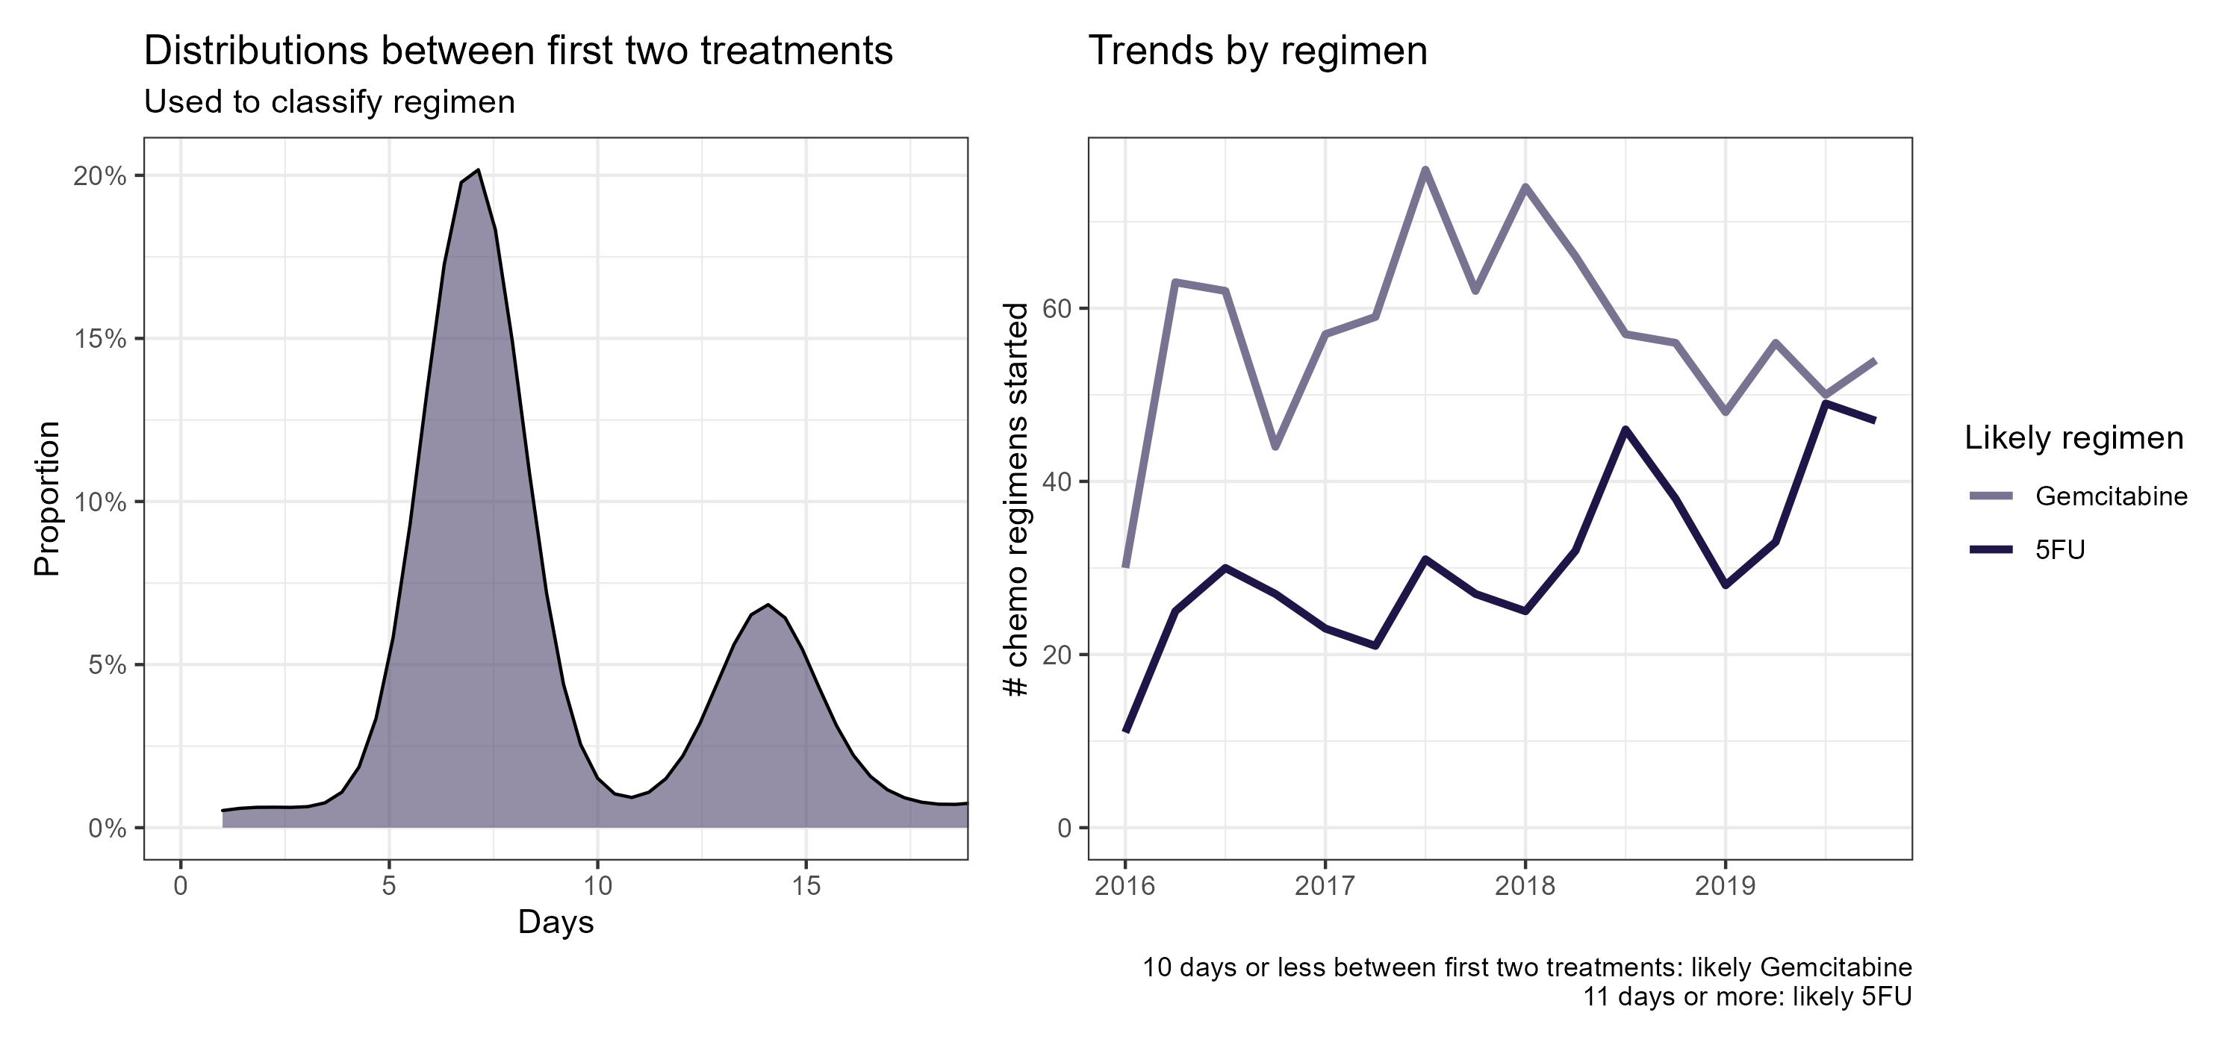

Note: First chemotherapy received within one year of diagnosis.

Figure : PURPLE registry-recorded adjuvant regimens (*n* = 487)

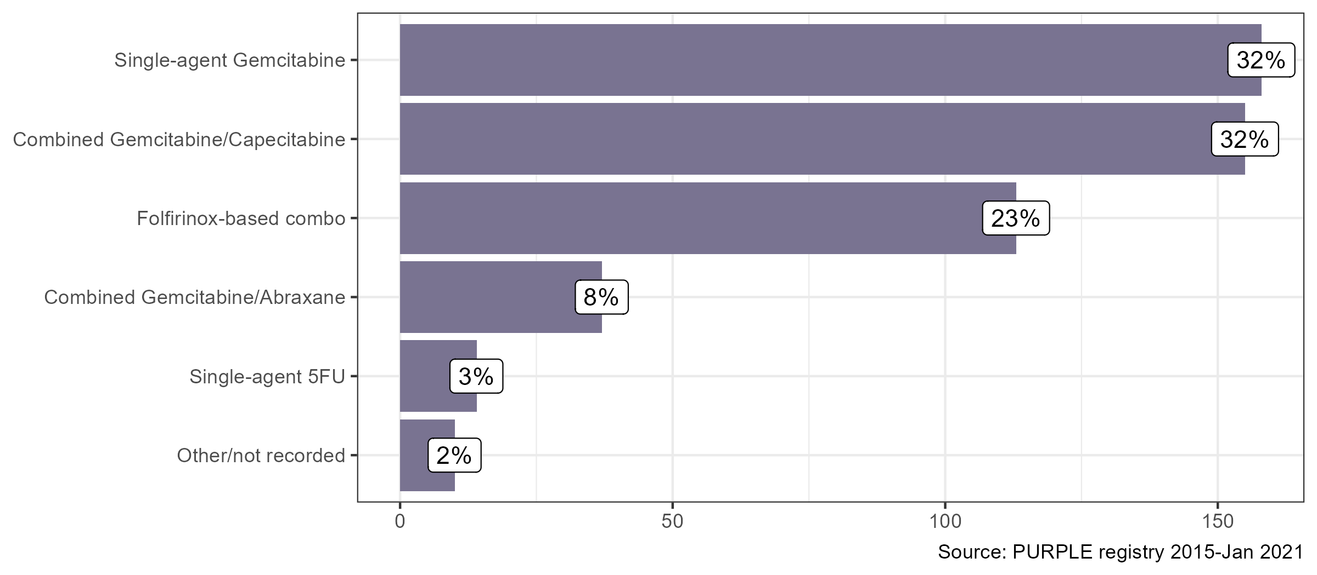

Source: PURPLE registry 2015 – January 2021

Figure : PURPLE registry-recorded chemotherapy regimens (*n* = 2507)

A line chart showing the trends in chemotherapy regimens from 2015 to 2021, from the PURPLE registry

Source: PURPLE registry 2015 – January 2021

ESPAC-4, presented ASCO June 2016, *Lancet* 2017)

PRODIGE-24, presented ASCO June 2018, NEJM, December 2018)

### Clinical commentary – chemotherapy regimens

We have seen an evolution of chemotherapy treatment over the past decade or so. Ten years ago, gemcitabine monotherapy was the only agent available for either the metastatic or adjuvant setting. We’ve seen changes since then, such as increasing the use of gemcitabine-based doublets. Gemcitabine-capecitabine in the adjuvant setting and gemcitabine-Abraxane in the metastatic setting and, of course, increasing use of FOLFIRINOX. We don’t have specific data on what regimens are being used but can to a degree infer this from the schedule of these agents with gemcitabine given weekly (or gemcitabine-based therapy) and FOLFIRINOX on a fortnightly basis. The implementation of improved chemotherapy regimens into practice is apparent, with maintenance of utilisation of gemcitabine-based regimens and an increase in 5FU-based regimens over time, presumably reflecting increased use of FOLFIRINOX-based chemotherapy.

From the PURPLE registry, we can see that the trial data is leading to a change in clinical practice. Following data from the ESPAC-4 trial, we can see increased use of gemcitabine and capecitabine as adjuvant treatment. Similarly following the PRODIGE-24 trial data for FOLFIRINOX, increased use of FOLFIRINOX-based chemotherapy is seen over time. There was also an increased use of neoadjuvant chemotherapy over time, supporting the observations from the linked data.

# OCP stage 5: Care after initial treatment and recovery

## Survival

* Unadjusted one- and two-year survival varied between ICS of residence for PDAC patients diagnosed between 2016 and 2019 (*p* < 0.001; Table 6).
  + One-year survival ranged from 25 per cent in GICS to 38 per cent in WCMICS and HRICS.
  + Two-year survival ranged from 11 per cent in GICS to 21 per cent in WCMICS.
* For patients diagnosed between 2016 and 2019, residents of NEMICS and WCMICS had statistically better survival compared with the Victorian average, after adjusting for age, sex, comorbidities, metastatic disease and socioeconomic status (Figure 23).
* For non-metastatic PDAC diagnosed between 2016 and 2019, residents of WCMICS had statistically better survival compared with the Victorian average, after adjusting for age, sex, comorbidities and socioeconomic status (Figure 24).
* For metastatic PDAC diagnosed between 2016 and 2019, residents of NEMICS had statistically better survival compared with the Victorian average, after adjusting for age, sex, comorbidities and socioeconomic status (Figure 25).
  + For the cohort diagnosed between 2011 and 2015, residents of SMICS had statistically better survival compared with the Victorian average.

Table : Unadjusted survival for PDAC patients diagnosed between 2016 and 2019

| ICS of residence | 1-year survival % (95% CI) | 2-year survival % (95% CI) | Median survival, months (IQR) |
| --- | --- | --- | --- |
| NEMICS | 34 (31–38) | 19 (16–22) | 7.2 (6.2–8.0) |
| SMICS | 29 (27–33) | 13 (11–16) | 6.3 (5.4–7.2) |
| WCMICS | 38 (34–42) | 21 (18–24) | 7.4 (6.2–8.3) |
| BSWRICS | 30 (25–37) | 12 (8–18) | 6 (5.3–7.3) |
| GRICS | 31 (25–38) | 12 (8–18) | 5 (4.4–7.4) |
| HRICS | 38 (31–46) | 15 (10–22) | 7.9 (6.0–10.3) |
| LMICS | 28 (22–35) | 15 (11–21) | 5.1 (3.8–7.0) |
| GICS | 25 (19–34) | 11 (6–18) | 6 (4.0–8.5) |
| **All PDAC** | **33 (31–34)** | **16 (15–17)** | **6.6 (6.1–7.1)** |

Figure : Adjusted survival between ICS, for all patients diagnosed with PDAC between 2011 and 2015 and between 2016 and 2019

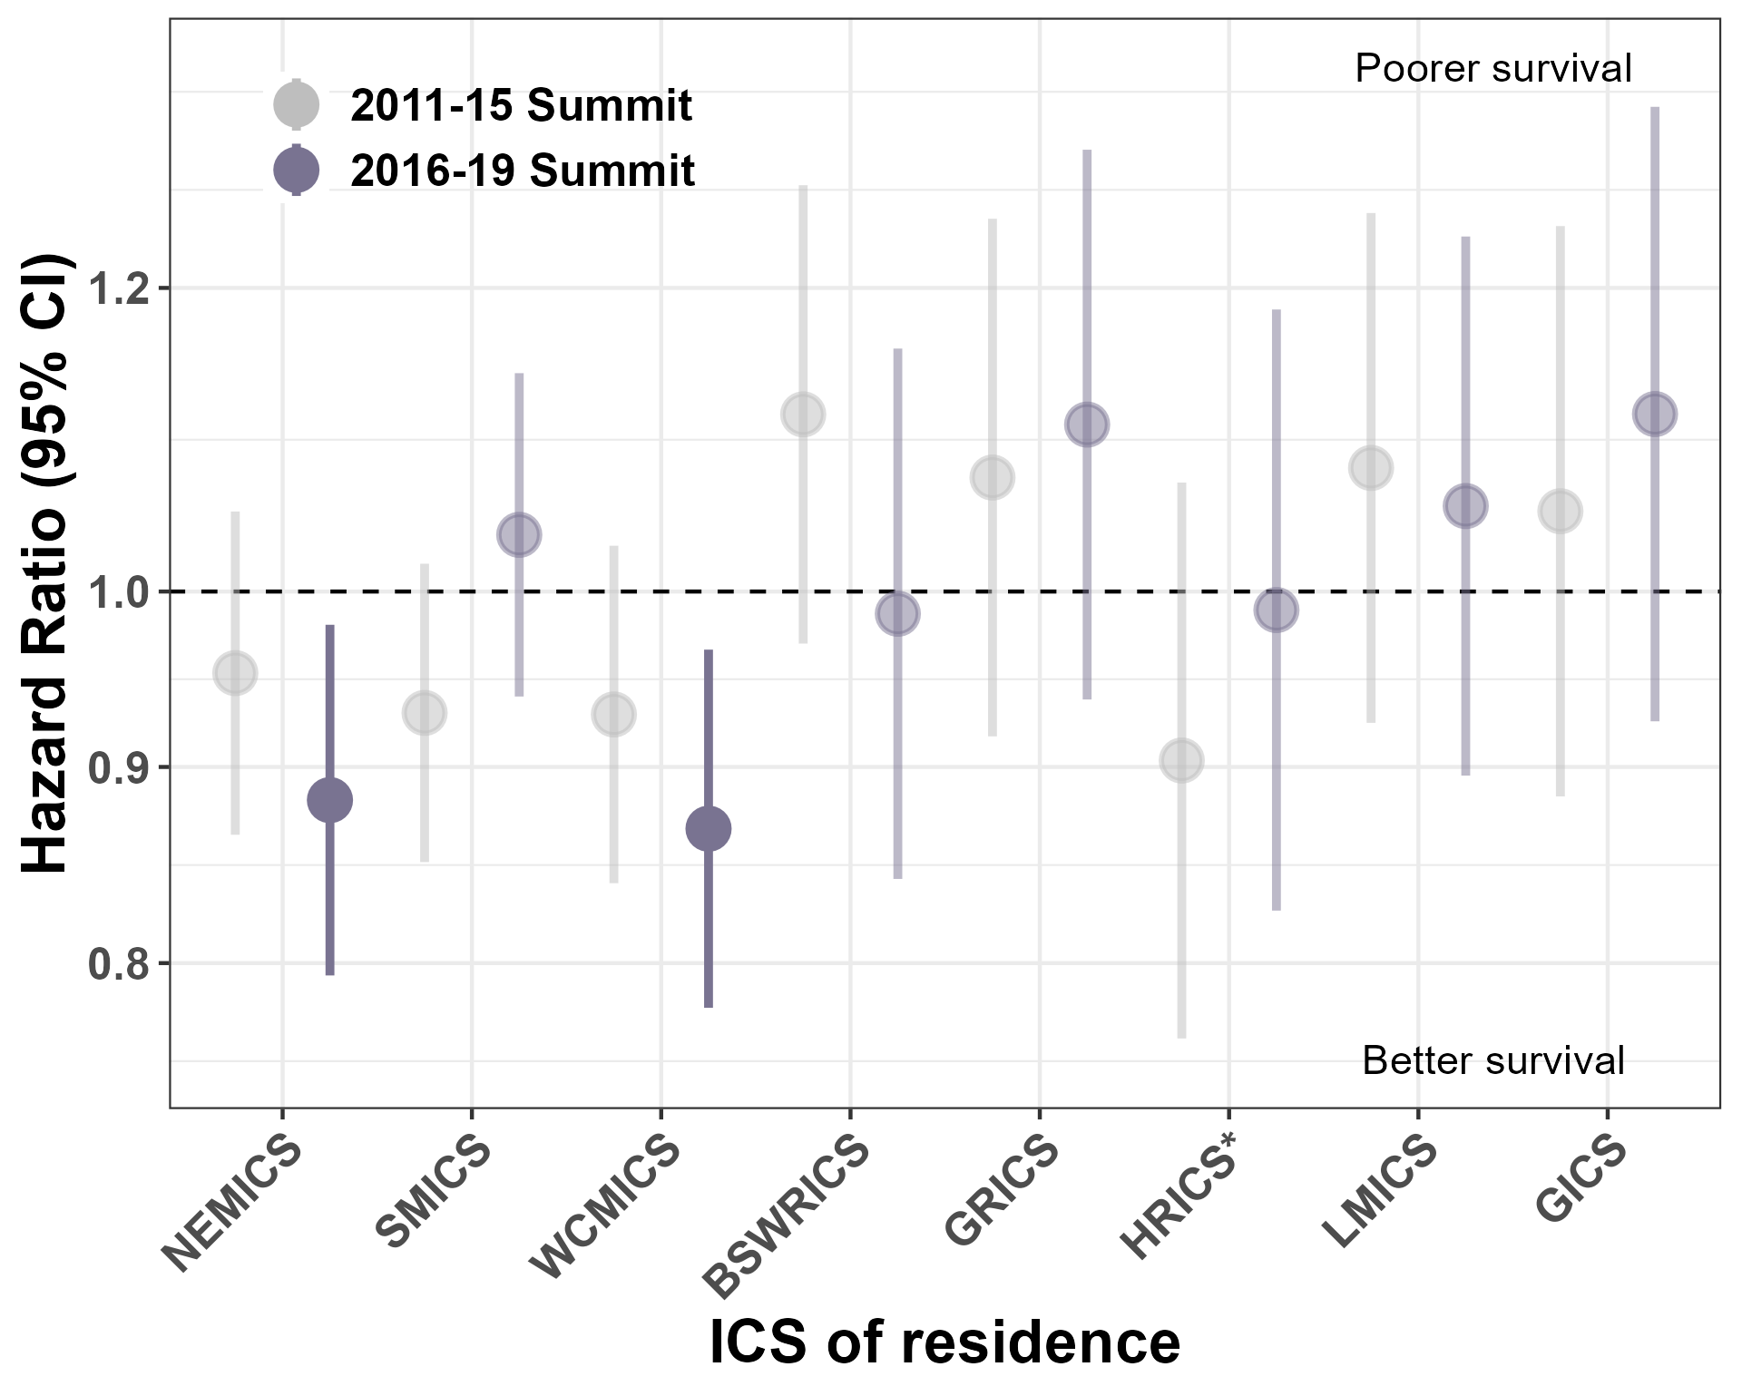

Adjusted for age, sex, comorbidities, metastatic disease and socioeconomic status.

Figure : Adjusted survival between ICS, for non-metastatic patients diagnosed with PDAC between 2011 and 2015 and between 2016 and 2019

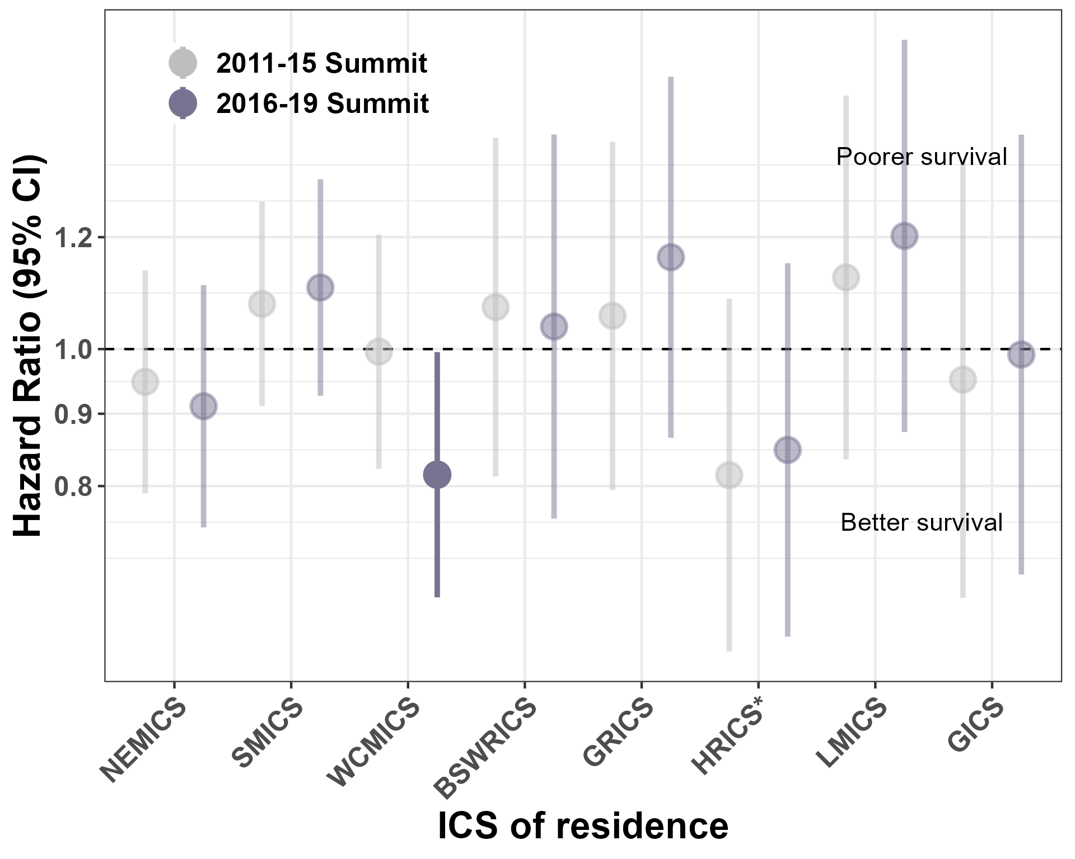

Adjusted for age, sex, comorbidities, metastatic disease and socioeconomic status.

Figure : Adjusted survival between ICS, for metastatic patients diagnosed with PDAC between 2011 and 2015 and between 2016 and 2019

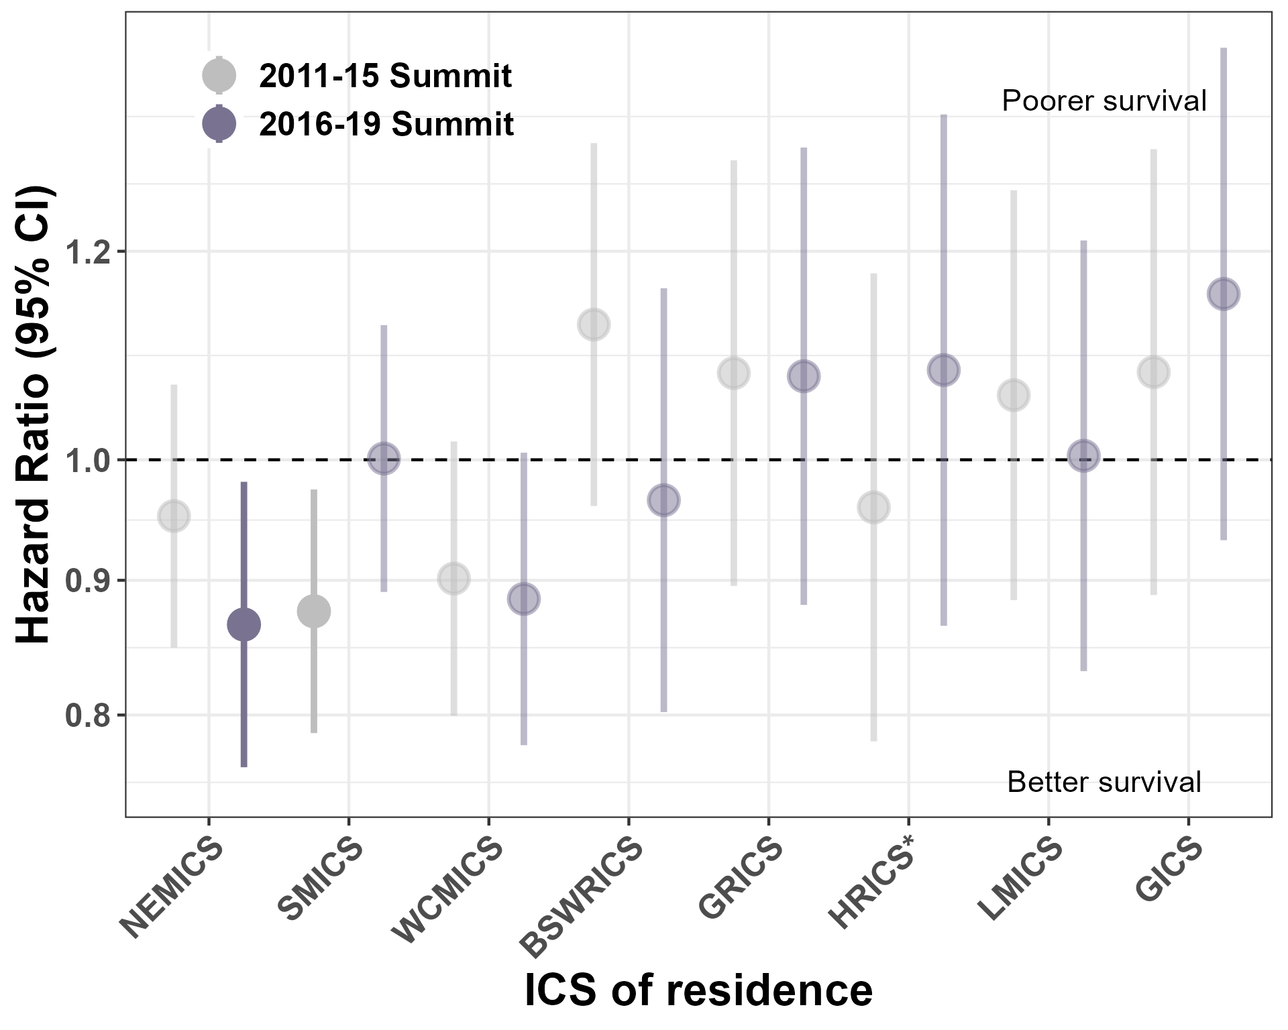

Adjusted for age, sex, comorbidities, metastatic disease and socioeconomic status.

### Clinical commentary – survival

We’ve seen a small but statistically significant increase in overall survival. However, it’s difficult to shift overall survival and, generally, the gains tend to be incremental. For adjusted survival, NEMICS and WCMICS appear to have significantly improved overall survival in the current cohort compared with the Victorian average, although it isn’t clear why. When considering median survival times, these are lower than typically seen in studies, which reflects that this is real-world data, and we know that real-world data will always show inferiority compared with clinical trial data because the cohort that go into clinical trials don’t really reflect real-life practice.

When we drill down a bit further into the adjusted survival by metastatic and non-metastatic, we see improved survival for WCMICS in the non-metastatic cohort, and improved survival for metastatic patients in NEMICS. It’s not clear what is driving this improved survival, but while we do know that the medical oncology care is excellent in NEMICS, we’re not sure that’s necessarily the explanation.

# OCP stage 7: End-of-life care

## Palliative care

There are several recommendations from the *Palliative care and advance care planning* summary report for patients with metastatic or advanced cancer of all cancer types.[9] These patients should receive a timely referral to specialist palliative care (defined as a referral at least three months before death), with a target of 80 per cent. The rate is currently at 15.4 per cent. Patients should also be given the opportunity to undertake advance care planning early in their pathway of care. The target for advance care directive documentation is 40 per cent and is currently at 11.7 per cent (in public hospitals only). Patients with advanced disease should also have their medical treatment decision-maker captured on admission. The recommended target is 100 per cent, with the rate currently at 10.1 per cent.

* From the CSPI 2020 audit, 52 per cent of pancreatic cancer patients audited were referred to or received palliative care at some time after diagnosis (Figure 26).
  + This ranged from 18 per cent of early stage patients to 73 per cent of metastatic patients.
* For PDAC patients diagnosed between 2016 and 2019 who died within the study period, only 11.6 per cent had timely palliative care, which was well below the benchmark of 80 per cent (Figure 27).
  + Timely palliative was defined as inpatient palliative care received at least three months prior to death.
  + This figure is an underestimate of the true number because some patients may be receiving palliative care in an outpatient or community setting.

Figure : Proportion of patients with palliative care, 2020 (*n* = 343)

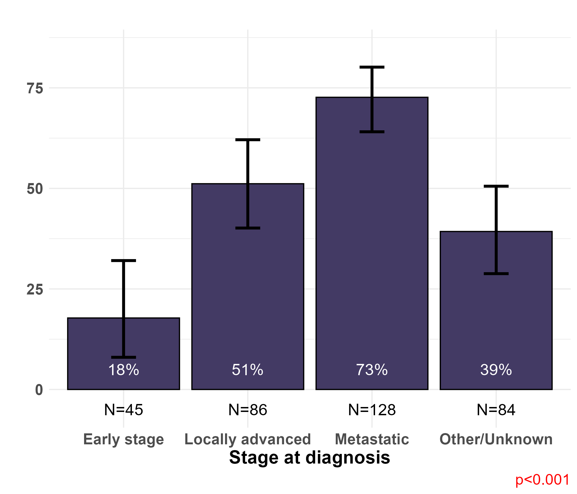

Source: CSPI 2020; all pancreatic cancer types

Note: Palliative care defined as patients who were referred to or received palliative care at any time post-diagnosis.

Figure 27: Proportion of pancreatic patients with inpatient palliative care at least three months prior to death (*n* = 3204)

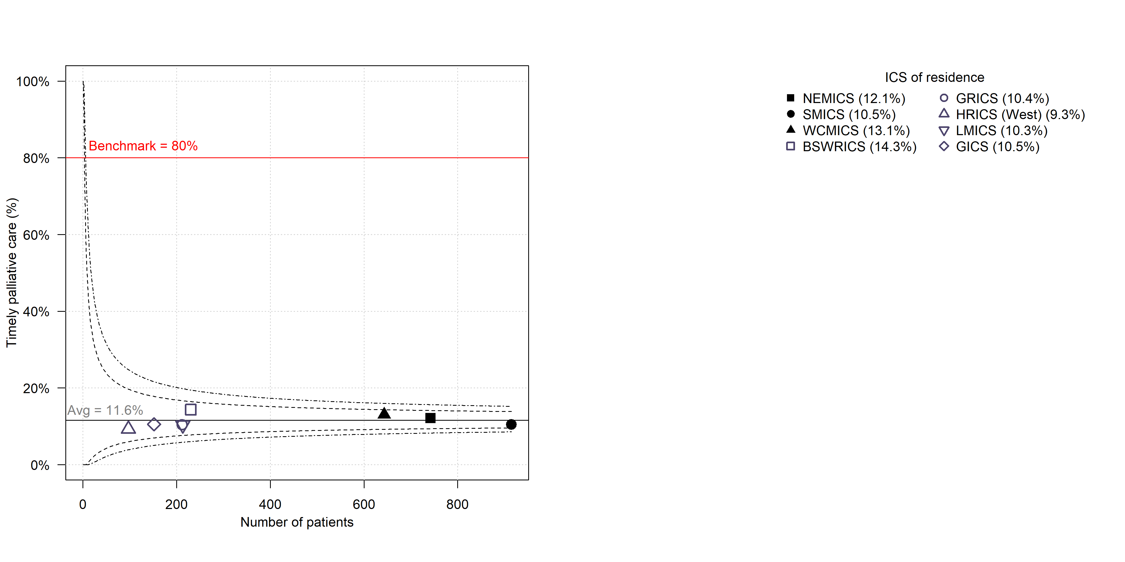

Sources: VCR, VAED (2016–2019); PDAC only

Hume data limitation – residents from Hume Border East excluded.

Benchmark based on recommendations from ‘Report of VICS Palliative Care and Advance Care Planning Project’ (unpublished).

### Clinical commentary – palliative care

The CSPI showed that referral to palliative care was low for patients with early-stage pancreatic cancer and the proportion with a referral increased for both locally advanced and metastatic disease. However, not all patients in the metastatic setting had documentation of receiving a palliative care referral.

From the linked data, although there were limitations in the capture of palliative care (because only inpatient palliative care was captured) timely palliative care was low across all ICS. This could reflect a resourcing issue in the palliative care setting, a lack of early referral or other factors.

## Health service activity prior to death

* There was some variation between ICS of residence when considering health service activity in the 30 days prior to death (Figure 28).
  + Overall, 54 per cent of patients had an emergency admission within 30 days of death.
  + 42 per cent of patients had an emergency presentation within 30 days of death. The proportion was higher for residents in GRICS and WCMICS and lower for residents in SMICS.
  + Within 30 days of death, 42 per cent of patients had an acute stay longer than 14 days, which was lower for residents in GRICS.

Figure 28: Variation in health service activity 30 days prior to death by ICS of residence (*n* = 3,204)

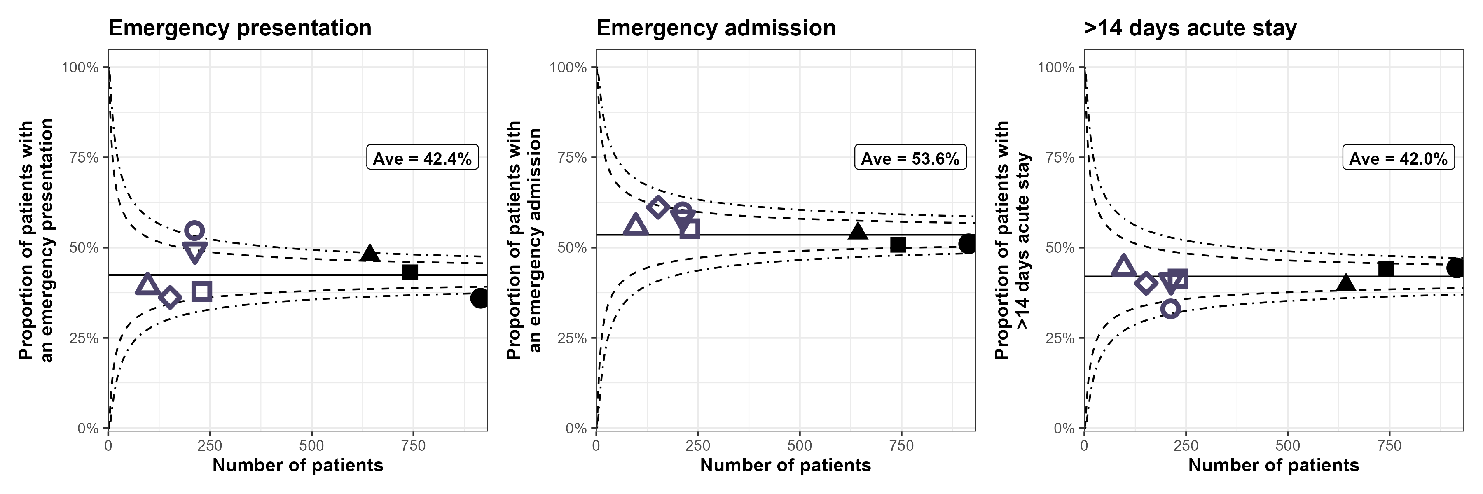

Sources: VCR, VAED, VEMD; PDAC only; deaths between 2016 and 2020

Hume data limitation – residents from Hume Border East excluded.

### Clinical commentary – health service activity prior to death

Health service activity in the 30 days prior to death is an indicator of quality of life. More than 50 per cent of those who died had an emergency admission in the 30 days prior to death, as well as more than 40 per cent with an emergency presentation and 40 per cent with an acute stay of more than 14 days, which is a considerable proportion of the cohort.

# Abbreviations

|  |  |
| --- | --- |
| ABS | Australian Bureau of Statistics |
| ASR | age-standardised incidence rate |
| CI | confidence interval |
| CSPI | Cancer Services Performance Indicator |
| GP | general practitioner |
| ICS | Integrated Cancer Service |
| MDM | multidisciplinary meeting |
| OCP | optimal care pathway |
| PDAC | pancreatic ductal adenocarcinoma |
| PURPLE | Pancreatic cancer: Understanding Routine Practice and Lifting End results |
| QOOL-Vic | Queensland Oncology On-Line-Victoria |
| UGICR | Upper Gastrointestinal Cancer Registry |
| VAED | Victorian Admitted Episodes Dataset |
| VCR | Victorian Cancer Registry |
| VRMDS | Victorian Radiotherapy Minimum Data Set |

## Victorian Integrated Cancer Services

|  |  |
| --- | --- |
| NEMICS | North Eastern Melbourne Integrated Cancer Service |
| SMICS | Southern Melbourne Integrated Cancer Service |
| WCMICS | Western and Central Melbourne Integrated Cancer Service |
| BSWRICS | Barwon South Western Regional Integrated Cancer Service |
| GRICS | Gippsland Regional Integrated Cancer Services |
| HRICS | Hume Regional Integrated Cancer Service |
| LMICS | Loddon Mallee Integrated Cancer Service |
| GICS | Grampians Integrated Cancer Service |

# Glossary

|  |  |
| --- | --- |
| **Chemotherapy** | An admitted episode in the VAED where the admission date was between 30 days prior and one year after the patient’s pancreatic cancer diagnosis date and included a chemotherapy diagnosis code, procedure code or diagnosis related group code (Supplementary Table 4). |
| **Comorbidity count** | A count measuring the number of comorbid conditions a patient has at diagnosis, which may influence their prognosis. Data on patient comorbidities was extracted from diagnosis codes of admitted episodes in the VAED in the year prior up until 30 days after the patient’s pancreatic cancer diagnosis date. Patients without admitted episodes were assumed to have no comorbidities. The comorbidity count was calculated for each patient according to Quan et al.[10] (excluding cancer and metastases) and grouped into four categories (0, 1, 2 and 3+).  Diagnosis codes for comorbidities can only be assigned in the admitted episode when the comorbidities meet criteria for coding in line with the Australian Coding Standards.[11] As a result, the identification of comorbidities is underestimated.  Conditions included in the comorbidity count:   * AIDS/HIV * congestive heart failure * chronic pulmonary disease * dementia * diabetes with chronic complications * hemiplegia or paraplegia * mild liver disease * moderate/severe liver disease * renal disease * rheumatic disease. |
| **Death certificate only** | A method of cancer notification to the VCR whereby the death certificate provides the only notification of a person’s cancer to the registry. |
| **Diagnosis date** | The date of the pathology report or other investigative report where the diagnosis of pancreatic cancer was first confirmed to the VCR. |
| **Metastatic disease** | Patients who had distant metastases at diagnosis were identified from the VCR TNM-M variable and from metastatic cancer diagnosis codes (ICD-10-AM C78 and C79) in admitted episodes in the VAED between 30 days before and four months after diagnosis date, or a palliative care diagnosis code (ICD-10-AM Z515) or admission care type ‘Palliative care program’ in the VAED between 30 days before and four months after diagnosis. |
| **Neoadjuvant chemotherapy** | Chemotherapy was considered neoadjuvant where there was at least one chemotherapy admission following diagnosis and before surgery. |
| **Radiotherapy** | Radiotherapy courses in the VRMDS were included where the *start date* was between 30 days before and one year after the patient’s pancreatic cancer diagnosis date. Additionally, for non-metastatic patients, it was required that the *primary site* was pancreatic cancer (ICD-10-AM C25), the *target site* was ‘abdomen’ or ‘pancreas’, and the *treatment intent* was radical. |
| **Pancreatectomy (surgery)** | An admitted episode in the VAED where the admission date was between 30 days before and one year after the patient’s pancreatic cancer diagnosis date and the episode included a pancreatic cancer surgery procedure code (Supplementary Table 3). |
| **Pancreaticoduo-denectomy (surgery)** | An admitted episode in the VAED where the admission date was between 30 days before and one year after the patient’s pancreatic cancer diagnosis date and the episode included a pancreaticoduodenectomy procedure code (Supplementary Table 3). Pancreaticoduodenectomy is a subset of pancreatectomy, and hence any figures reporting on pancreatectomy also include pancreaticoduodenectomy. |
| **Socioeconomic status** | A measure of a person’s economic and social position within society, which tends to be positively associated with better health. In this report socioeconomic status is based on the Index of Relative Socio-Economic Disadvantage (IRSD) included in the Socio-Economic Index of Areas published by the Australian Bureau of Statistics. Victorians were assigned an IRSD score using their residential address at the time of their diagnosis. IRSD scores have been grouped into quintiles (from 1 – most disadvantaged, to 5 – least disadvantaged). |
| **Surgery** | Used in reference to either pancreatectomy or pancreaticoduodenectomy. |
| **VCR diagnosis date** | The date of the pathology report or other investigative report where the diagnosis of cancer was first confirmed to the VCR. |

# Supplementary material

## Codes

### Diagnosis

Supplementary Table 1: Pancreatic cancer diagnosis codes

| ICD-10-AM | Description |
| --- | --- |
| C250 | Malignant neoplasm of head of pancreas |
| C251 | Malignant neoplasm of body of pancreas |
| C252 | Malignant neoplasm of tail of pancreas |
| C253 | Malignant neoplasm of pancreatic duct |
| C254 | Malignant neoplasm of endocrine pancreas |
| C257 | Malignant neoplasm of other parts of pancreas |
| C258 | Overlapping malignant lesion of pancreas |
| C259 | Malignant neoplasm of pancreas, part unspecified |

Supplementary Table : PDAC morphology codes

| ICD-10-AM | Description |
| --- | --- |
| 8000 | Neoplasm, malignant |
| 8010 | Carcinoma |
| 8140 | Adenocarcinoma |
| 8500 | Infiltrating duct carcinoma |
| 9990 | No histological confirmation |

### Surgery

Supplementary Table : Pancreatectomy procedure codes used to identify patients who underwent surgery for pancreatic cancer

| ICD-10-AM/ ACHI/ACS code | Description | Pancreaticoduodenectomy |
| --- | --- | --- |
| 3058300 | Distal pancreatectomy | No |
| 3058400 | Pancreaticoduodenectomy with formation of stoma | Yes |
| 3059300 | Pancreatectomy | No |
| 3059301 | Pancreatectomy with splenectomy | No |

### Chemotherapy

Supplementary Table 4: Diagnosis, procedure and diagnosis related group codes used to identify patients who received chemotherapy

| Code group | Code | Description |
| --- | --- | --- |
| Diagnosis | Z511 | Pharmacotherapy session for neoplasm |
| Procedure | 9619600 | Intra-arterial administration of pharmacological agent, antineoplastic agent |
| Procedure | 9619700 | Intramuscular administration of pharmacological agent, antineoplastic agent |
| Procedure | 9619800 | Intrathecal administration of pharmacological agent, antineoplastic agent |
| Procedure | 9619900 | Intravenous administration of pharmacological agent, antineoplastic agent |
| Procedure | 9620000 | Subcutaneous administration of pharmacological agent, antineoplastic agent |
| Procedure | 9620100 | Intracavitary administration of pharmacological agent, antineoplastic agent |
| Procedure | 9620200 | Enteral administration of pharmacological agent, antineoplastic agent |
| Procedure | 9620300 | Oral administration of pharmacological agent, antineoplastic agent |
| Procedure | 9620500 | Other administration of pharmacological agent, antineoplastic agent |
| Procedure | 9620600 | Unspecified administration of pharmacological agent, antineoplastic agent |
| Procedure | 9620900 | Loading of drug delivery device, antineoplastic agent |
| Diagnosis related group | R63Z | Chemotherapy |

Where an admission had one of the codes listed in Supplementary Table 4 and also had a diagnosis code ‘Z53’, the admission was not included as a chemotherapy admission.

| Code group | Code | Description |
| --- | --- | --- |
| Diagnosis | Z53 | Procedure not carried out |

1. Refer to the ‘Abbreviations’ page for the naming of the eight Victorian ICS.
2. Refer to the ‘Abbreviations’ page for a list of Victoria’s Integrated Cancer Services.
3. Documenting MDM recommendations in the medical record ensures such information is accessible to all team members. The target of 85 per cent aims to drive quality improvement and equity of access to MDMs and applies to all tumour streams.
4. Quan H, Li B, Couris C, et al. 2011, ‘Updating and validating the Charlson comorbidity index and score for risk adjustment in hospital discharge abstracts using data from 6 countries’, *American Journal of Epidemiology*, vol. 173, no. 6, pp. 676–682.
5. Department of Health Victoria 2022, *QOOL-Vic MDM software*, accessed 25 January 2023, <https://www.health.vic.gov.au/health-strategies/qool-vic-mdm-software>.
6. The University of Melbourne, *The Care Plus Study: a multi-site implementation of early palliative care in routine practice to improve health outcomes for people with advanced cancer*, accessed 25 January 2023, <https://mdhs.unimelb.edu.au/centre-for-cancer-research/flagships/the-care-plus-study>.
7. Note that Victorian Cancer Quality Index <https://www.health.vic.gov.au/publications/victorian-cancer-quality-index-2008-2015> reports median length of stay of 19 days for the period from 2008 to 2011, and 16 days for the period from 2012 to 2016.
8. Papageorge, M. et al. 2022, *The impact of upper gastrointestinal surgical volume on short term pancreaticoduodenectomy outcomes for pancreatic adenocarcinoma in the SEER-Medicare population*, HPB (online) 24 (6), pp. 868–874.
9. Victorian Integrated Cancer Services 2023, *Palliative care and advance care planning: current practices in Victorian cancer services. A summary report.* Melbourne, Australia.
10. Quan H, Li B, Couris C, et al. 2011, ‘Updating and validating the Charlson comorbidity index and score for risk adjustment in hospital discharge abstracts using data from 6 countries’, *American Journal of Epidemiology*, vol. 173, no. 6, pp. 676–682.
11. Australian Coding Standard ACS 0002 Additional Diagnoses.